What is Energy? 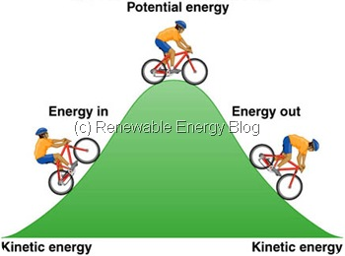
Name ____________________________________________
You should be in a group with 3 to 4 partners,
In the box below, brainstorm ideas to complete this sentence. Energy is……
Your answers.

Class answers.

Energy can be divided into two categories:
Potential energy is: (your definition) | Kinetic energy is: (your definition)
Potential energy is: (class definition) | Kinetic energy is: (class definition)

Observe the demonstration of the animal slingshot. Describe it below in terms of kinetic and potential energy.

Your teacher will demonstrate some materials.
In the table below, list the object in the box that best describes the category of energy used.
POTENTIAL | BOTH | KINETIC

EXTENSION: For homework, find one example of potential energy and show how it can be changed to kinetic energy. Be prepared to share this example with classmates on the following day.

