Energy Explorations Outline
Station 9
Light Reflection Station
Materials:
Laser & Light Angles Diagram Laser Maze Game
Mirrors Reverse Writing Graphics
Introduction to Light Reflection:
- We use light energy every day. What are some ways we use light? (various answers: so we can see, plants can grow-photosynthesis, to generate electricity-solar panel, etc.)
- Light energy travels in waves. And those waves always travel in straight lines unless they are reflected or refracted. At this station we are exploring light reflection.
- How do we see things? We see the light waves that bounce off of things. Look at me. You are really seeing reflected light waves. Think about it. When there are no light waves, you can’t see anything.

Activity #1: Mirrors & Reflection
- How does a mirror work? It is a thin piece of aluminum or silver on the back of a piece of high quality glass. It reflects most of the light that hits it.
- Light reflects in a predictable manner. When light hits a mirror, there are two light rays: incoming and outgoing. Let’s see how this works.
  - Have the students work in pairs. You might need to participate when your group has an uneven number. Each pair gets one mirror.
  - Partners stand shoulder to shoulder. Have one partner look at himself in the mirror.
  - Without moving, what do you need to do to the mirror so you can see your partner and your partner can see you? (Move the mirror at an angle)
  - Pass the mirror to the other partner and repeat so every student gets an opportunity to try.
- Let’s try something else. Do you look exactly like your image in a mirror? No-your reflection is the reverse of your image. Show the two pictures of President Lincoln. Does one of them look “right”? One is how people saw Lincoln. The other is how he saw himself in a mirror. Can you tell which one is right?
- Have you ever looked at the front of an ambulance and wondered what it says? Hold up Reverse Writing Graphic #1 Why do you think it is printed like this? So that when you are driving and look in your mirror, you are reading it the correct way. Show Reverse Writing Graphic #2
- Let’s see how it works.
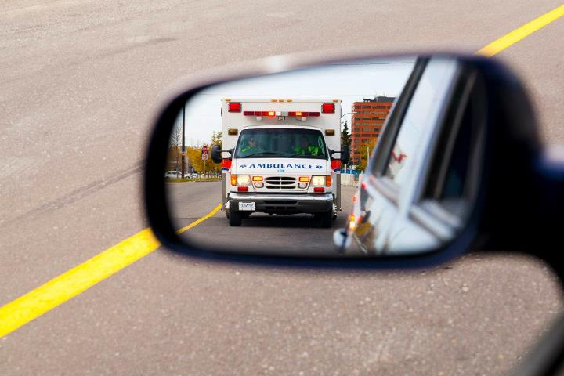
  - Show students how it is done, then give them the mirrors and let them experiment with the different graphics.
  - Hold the graphic in front of your chest with the text pointing away from you.
  - Hold the mirror facing you angled so you can read the text.
  - Looking in the mirror, you can read the text correctly.

Activity #2: Measuring Angles of Reflection
Note to Leaders: Lasers are fun. But they can also be dangerous. For the safety of everyone in the room, we expect you to use the laser properly for this activity. If we see you using the laser improperly (pointing the laser at people or around the room), you will be removed from this station.
- Since light reflects in predictable ways, we can compare the incoming light ray (angle of incidence) to the angle of reflection.
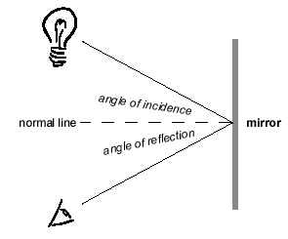
  - Using the Light Angles Diagram, place the mirror in the correct spot.
  - Place the laser on the Light Angles Diagram on the incoming ray line.
  - Place the wooden block on the reflected ray line.
  - Where is the reflected ray? (If the incoming ray is lined up correctly on the line, the reflected ray you see will be on the reflected ray line. You may need to slightly adjust the position of the laser to make sure the incoming ray is exactly on the line.)

Activity #3: Laser Maze
- This activity puts into practice what you have learned about light reflections and mirrors. You will manipulate the game pieces in different challenges to light up a target. Students work together as a group to complete as many puzzles in the time that is remaining. Work to make sure than all students are engaged and it is not just one student making all the decisions. If you have more than 3 students, use a second game board.

Note to Leaders-Helpful Tips with Laser Maze:
- You don’t want more than three students working on one game. Divide your students into groups if you have more than three.
- Each challenge card slides into a slit in the game board. The correct side of the game board is marked.
- Place pieces on the game board to mark the location and orientation of the symbols on the challenge card.
- Look closely at the target. One side of it is more open that the other three. The open side of the target must be placed in the correct orientation on the game board.
- Select the game pieces on the “Add to Grid” tab of the challenge card. Determine where they should go on the game board to light up the target.
- The green piece is a beam splitter. It splits the beam in two directions. One path passes straight through the piece AND one is reflected 90°.
- The black piece is a space holder and will block the path of the laser.
- The higher the number on the challenge card, the more difficult the puzzle.

Complete Student Worksheet Questions:
Note to Leaders: Ask these questions to the students. Do not just give them the answer. If incorrect answers are given, talk the students through the correct answer. You may need to refer back to the definition.

What is light bouncing off of a surface called? LIGHT REFLECTION

What type of lines does light always travel in? STRAIGHT

