States of Matter Student Lab Sheet Name __________________________
ACTION | SOLID | LIQUID | GAS
Describe the movement of molecules.
Describe the shape of each state of matter.

Describe the volume or space taken by each state of matter.

1 - Draw an example of each state of matter.
2 - List as many examples as you can.

Life Cycle of an Ice Cube – complete the following sentences to show how water changes states of matter due to the transfer of energy.
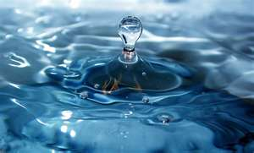
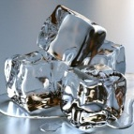

- Changing from a solid to a liquid is called ______________________.

- Changing from a liquid to a solid is called ______________________.
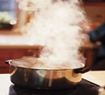
- Changing from a liquid to a gas is called _______________________.
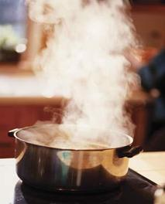
- Changing from a gas to a liquid is called _______________________.

The Water Cycle
Using the words from Life Cycle of an Ice Cube above, describe the water cycle as it is happening in nature.

The Mystery Tablet
- Predict what will happen when you drop the tablet in water.

- Record what happened and make a drawing of the cup labeling the three states of matter.

