Squishy Circuits

University of St. Thomas

http://courseweb.stthomas.edu/apthomas/SquishyCircuits/howTo.htm

Making Conductive Dough

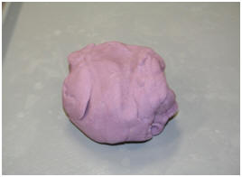

Materials:
1 cup Water
1 1/2 cups Flour
(A gluten free version of this dough can be made by replacing the flour with gluten-free flour.)
1/4 cup Salt
3 Tbsp. Cream of Tartar*
1 Tbsp. Vegetable Oil
Food Coloring (optional)
*9Tbsp. of Lemon Juice may be Substituted
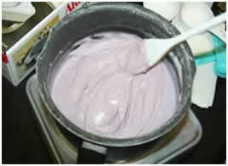
Procedure:
1. Mix water, 1cup of flour, salt, cream of tartar, vegetable oil, and food coloring in a medium sized pot.

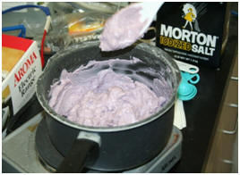
2. Cook over medium heat and stir continuously.
3. The mixture will begin to boil and start to get chunky.
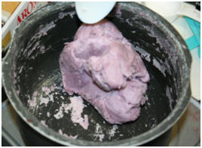
4. Keep stirring the mixture until it forms a ball in the center of the pot.
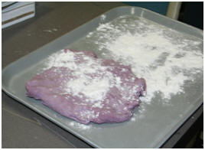
5. Once a ball forms, place the ball on a lightly floured surface.
WARNING: The ball will be very hot. We suggest flattening it out and letting it cool for a couple minutes before handling.

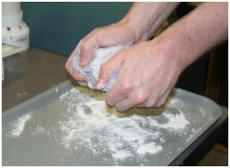
6. Slowly knead the remaining flour into the ball until you’ve reached a desired consistency.
7. Store in an airtight container or plastic bag. While in the bag, water from the dough will create condensation. This is normal. Just knead the dough after removing it from the bag, and it will be as good as new. If stored properly, the dough should keep for several weeks.

Making Insulating Dough

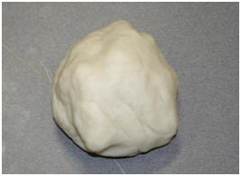

Materials:
1 1/2 cup Flour
1/2 cup Sugar
3 Tbsp. Vegetable Oil
1/2 cup Deionized (or Distilled) Water
(Regular tap water can be used, but the resistance of the dough will be lower.)
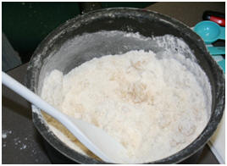
Procedure:
1. Mix solid ingredients and oil in a pot or large bowl, setting aside ½ cup flour to be used later.
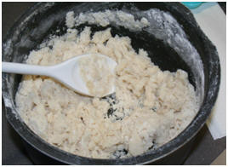
2. Mix with this mixture a small amount of deionized water (about 1 Tbsp.) and stir.
3. Repeat this step until a majority water is absorbed by the mixture.
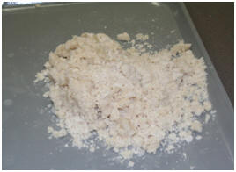
4. Once your mixture is at this consistency, knead the mixture into one “lump”.
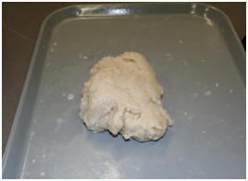
5. Knead more water into the dough until it has a sticky, dough-like texture.
6. Now, knead in flour to the dough, until a desired texture is reached.
7. Store in an airtight container or plastic bag. While in the bag, water from the dough will create condensation. This is normal. Just knead the dough after removing it from the bag, and it will be as good as new. If stored properly, the dough should keep for several weeks.

