Name __________________________________________

Light Reflection: Can You See Me Now?

Background: Have you ever wondered why you can see yourself in a mirror? When you see your face in a mirror you are seeing light from your face reflecting off the flat, shiny surface. Light travels in straight lines. What happens when you are NOT standing directly in front of a mirror? What can you see?

Hypothesis: Can two people see each other in a mirror if they are not standing directly in front of it?
Yes or No Explain your answer. __________________________________________________________________________________________________________________________________________________________________________

Materials:
4” square mirror
Masking Tape (to hold mirror to wall)
4” square paper
Protractor with hole for drawing circles
10 feet of string

Set Up:
- You will need to work with a group to do this activity.
- Double tape mirror on the wall at eye level. Cover with the paper on top so you can lift it to see the mirror.
- Tape a 5 foot line on the floor perpendicular to the wall directly under the mirror.
- Thread the string through the hole in the protractor.
Tape
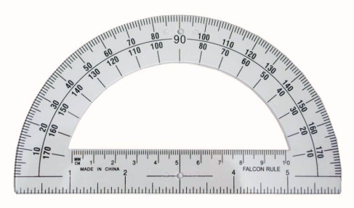
This hole
wall
- Tape the protractor to the floor so the ruler part is next to the wall with the 90° mark on the center of the masking tape. Be sure to be able to adjust the string so that half of it is on each side.
- Both you and your partner need to hypothesize where to stand to see each other’s reflection in the mirror. When you agree on the places, mark them on the floor with a small (3 inch) piece of masking tape.
- Remove the paper from the mirror. Stand at your spot and check if you can see your partner.
- If you cannot see your partner’s eyes, move your spot. When you can see each other’s eyes, adjust the tape.
- Each partner now should gently pull the string so it goes from the protractor to your spot that you marked on the floor.
- Measure the angles made by the string. Remember to measure each side from the zero mark.

My angle is ______________________ My partner’s angle is _______________________

- Repeat the activity again. Cover the mirror and stand at a different angle.

Results of second measurement:

My angle is ______________________ My partner’s angle is _______________________

How do your measurements compare? If the angles are slightly off, what may attribute to that situation?
__________________________________________________________________________________
_________________________________________________________________________

Lab Summary:
- Explain how light is reflected off a mirror.
___________________________________________________________________________________________________________________________________________________________________________________________________________________________

- Describe two real life situations where this can be used.
___________________________________________________________________________________________________________________________________________________________________________________________________________________________

- Draw a diagram with lines showing how light is reflected off a mirror.

