KEY: LESSON 1: Circuits Exploration

Activity 1: Circuits in Series

Build Project 1 – Electric Light and Switch
- This is an example of a SERIES (series or parallel) circuit.
- When the circuit is open, the light is OFF (on or off).
- What is the voltage supplied in this circuit? (look at batteries) 3 V (1.5V per battery x 2 batteries)

Build Project 2 – DC Motor and Switch
Note: Confirm the motor is placed in the same direction as the diagram. The negative terminal of the battery goes toward the negative terminal of the motor. This controls the direction the motor is spinning.
- Describe the energy transformation that is occurring when the circuit is closed.

CHEMICAL → ELECTRICAL → MECHANICAL + SOUND + THERMAL

Build Project 11 – An Extension of Project 2
Note: This is the same circuit as Project 2 except the direction of the motor is switched
- What is difference between Projects 2 and 11? THE FAN FLIES OFF THE MOTOR
- Why does this happen? THE DIRECTION OF THE MOTOR HAS CHANGED
Note: Try adding a second battery set in series. Compare the flight of the fan with a single battery set.
- The total voltage of both battery sets = 6V (1.5V PER BATTERY X 4 BATTERIES)
- Describe the height of the fan with one vs two battery sets. THE FAN WILL FLY MUCH HIGHER WITH THE 2ND BATTERY SET BECAUSE OF THE HIGHER VOLTAGE

Build Project 5 – Lamp and Fan in Series
- This is an example of a SERIES (series or parallel) circuit. Explain why? The electrons have only one path to flow. Part of the voltage goes to the lamp and the rest to the motor.
- Compare the brightness of the bulb in this circuit with the fan on the motor vs the fan off the motor. BULB IS OFF WITH THE FAN OFF THE MOTOR; BULB IS DIMLY LIT WITH THE FAN ON THE MOTOR.
- Compare the speed of the motor with the fan on the motor vs the fan off the motor. THE MOTOR IS SPINNING SLOWER THE FAN ON.
- The voltage from the batteries is divided between the light and motor. Which load will use more voltage? MOTOR
- Without the fan, the motor spins faster and requires more voltage. That means there is LESS (more or less) available to the light.
- Can you get the fan to launch? NO Why or why not? THERE ARE TWO FORCES ACTIVING ON THE FAN BLADE, LIFT AND GRAVITY. THE FAN IS NOT SPINNING FAST ENOUGH TO OVERCOME GRAVITY. THE FORCE OF GRAVITY IS GREATER THAN THE FORCE OF LIFT.

- What would happen if you removed the snap that connected the lamp with the switch? NEITHER WOULD WORK Why? THERE IS ONLY ONE PATEH FOR THE ELECTRONS AND IT IS INCOMPLETE WITHOUT THE SNAP CONNECTION.

- Change the position of the light and motor. Do you get the same results? NO Why? SINCE THE LAMP IS FIRST IN THE CIRCUIT, IT USES THE VOLTAGE AND PASSES THE REMAINING ON TO THE MOTOR.

Activity 2: Circuits in Parallel

Build Project 6 – Fan and Lamp in Parallel
  - This is an example of a PARALLEL (series or parallel) circuit.
  - Compare the brightness of the bulb in this circuit with the fan on the motor and with the fan off the motor. Describe your results. THEY ARE THE SAME BRIGHTNESS
  - The voltage from the batteries in this circuit is 3 volts. What is the voltage applied to each device? 3V
  - In this circuit, will the fan launch? YES NOTE: Be sure you are using new batteries and the motor is in the proper direction for lift to occur.
  - Remove one of the snaps (wires) connecting the lamp. Describe what happens to the motor when the lamp is disconnected. IT REMAINS ON.

Extension: Build Project 19 – Space War
  - Does the circuit produce sound when the slide switch (S1) is turned on? YES
  - Turn off the slide switch (S1) and push the press switch (S2). Is the sound the same? NO
  - Turn on the slide switch (S1) AND the press switch (S2). Describe the sounds. THEY EACH MAKE THEIR OWN UNIQUE SOUNDS AT THE SAME TIME.
  - In parts B and C, are the sounds the same as you alternate between switches? NO, THEY CAN BE DIFFERENT Why does this occur? THERE ARE MANY SOUNDS POSSIBLE IN THIS INTEGRATED CIRCUIT.
  - The switches are wired in a PARALLEL (series or parallel) circuit.

Activity 3: Design Challenge

- Using two bulbs (L1 and L2), a switch (S1 or S2), snap connectors and a battery set, make a circuit in both series and parallel.
- Using the symbols below, draw the schematics for each.
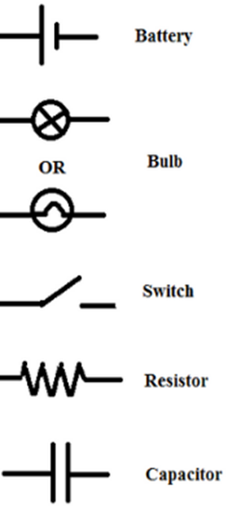
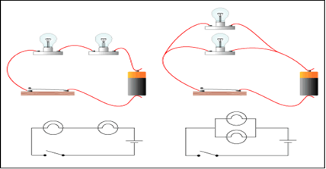
Parallel Circuit
Series Circuit

