Name ____________________________________ Class __________

LESSON 1: Circuits Exploration

Activity 1: Circuits in Series

Series Circuit - There is a single path for electrons to flow when electrical components are connected in sequence. The current is the same through each resistor.

Build Project 1 – Electric Light and Switch
- This is an example of a ___________________ (series or parallel) circuit.
- When the circuit is open, the light is ______________________ (on or off).
- What is the voltage supplied in this circuit? (look at batteries) ________________

Build Project 2 – DC Motor and Switch
Note: Confirm the motor is placed in the same direction as the diagram. The negative terminal of the battery goes toward the negative terminal of the motor. This controls the direction the motor is spinning.
- Describe the energy transformation that is occurring when the circuit is closed.

_______________ → _______________ → ________________ + _______________ + _____________

Build Project 11 – An Extension of Project 2
Note: This is the same circuit as Project 2 except the direction of the motor is switched
- What is difference between Projects 2 and 11? _________________________________________
- Why does this happen? _____________________________________________________________
Note: Try adding a second battery set in series. Compare the flight of the fan with a single battery set.
- The total voltage of both battery sets = ____________________ volts
- Describe the height of the fan with one vs two battery sets. ________________________________

Build Project 5 – Lamp and Fan in Series
- This is an example of a ________________ (series or parallel) circuit. Explain why? ___________
_______________________________________________________________________________
- Compare the brightness of the bulb in this circuit with the fan ON the motor vs the fan OFF the motor. ____________________________________________________________________________
- Compare the speed of the motor with the fan ON the motor vs the fan OFF the motor. ____________________________________________________________________________
- The voltage from the batteries is divided between the light and motor. Which load will use more voltage? _______________________________________________________________________
- Without the fan, the motor spins faster and requires more voltage. That means there is _______________ (more or less) available to the light.
- Can you get the fan to launch? ________ Why or why not? ______________________________
- What would happen if you removed the snap that connected the lamp with the switch? _____________________________ Why? ______________________________________________
- Change the position of the light and motor. Do you get the same results? _______________________ Why? ______________________________________________________________________________

Activity 2: Circuits in Parallel

Parallel Circuit – If there is more than one complete path for the electrons to flow it is a parallel circuit. The current divides into two or more paths before recombining to complete the circuit. Each load connected in a separate path receives the full circuit voltage, while the total circuit current is equal to the sum of the individual branch currents.

Build Project 6 – Fan and Lamp in Parallel
  - This is an example of a ________________ (series or parallel) circuit.
  - Compare the brightness of the bulb in this circuit with the fan ON the motor and with the fan OFF the motor. Describe your results. ________________________________________________
  - The voltage from the batteries in this circuit is _________ volts. What is the voltage applied to each device? __________________
  - In this circuit, will the fan launch? _______________________
  - Remove one of the snaps (wires) connecting the lamp. Describe what happens to the motor when the lamp is disconnected. ________________________________________________________

Extension: Build Project 19 – Space War
U3 Space Wars IC is an integrated circuit. An integrated circuit is made of interconnected electronic components, such as transistors, capacitors and resistors. They are etched or imprinted onto a tiny slice of a semiconducting material, such as silicon or germanium. An integrated circuit, which can be smaller than a fingernail, can hold millions of circuits. They complete a specific job such as to produce or amplify a sound.
  - Does the circuit produce sound when the slide switch (S1) is turned on? ______________________
  - Turn off the slide switch (S1) and push the press switch (S2). Is the sound the same? ____________
  - Turn on the slide switch (S1) AND the press switch (S2). Describe the sounds. __________________ _________________________________________________________________________________
  - In parts B and C, are the sounds the same as you alternate between switches? _________________ Why does this occur? _______________________________________________________________
  - The switches are wired in a _____________________ (series or parallel) circuit.

Activity 3: Design Challenge

- Using two bulbs (L1 and L2), a switch (S1 or S2), snap connectors and a battery set, make a circuit in both series and parallel.
- Using the symbols below, draw the schematics for each.
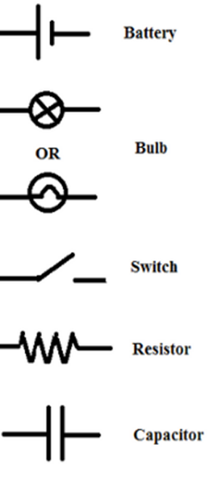
Parallel Circuit
Series Circuit

