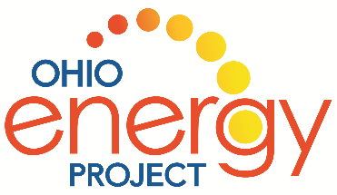
Welcome to Energy Jenga
The goal of Energy Jenga is…to work as a TEAM to answer light and sound questions correctly and collect the most Jenga pieces before the tower falls!
SET UP: Set up the Jenga tower. Place three blocks per layer, alternating direction by layer. Mix up the sound and light pieces, colored red and blue on the ends. Three black blocks form the top layer.
DIRECTIONS:
- Divide group into two teams. Select a team to go first.

- One player removes a block. He/she can only use one hand. Blocks can only be selected under the layer of black blocks. No black blocks can be removed. Each round, a different team member selects the block.

- After the block is selected, ask the team the corresponding Light or Sound question from the question page. For example: L1 on the block is Light question number 1.
  - If the team gets the question correct, they get to keep the game piece.
  - If the team gets the question incorrect, they must place the game piece on top of the tower.

- The team with the most blocks when the tower falls or time runs out is the winner.

- If the tower falls before time is called, continue to have the teams select blocks and answer questions. The team with the most blocks when time is called wins.

- Reset the tower for the next group.

Note to Leaders:

Be excellent clue givers and encourage teamwork with all kids involved in the game.

ANY QUESTIONS?

