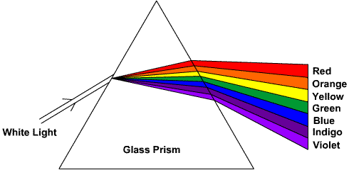
REFRACTION OF WHITE LIGHT
BY A PRISM

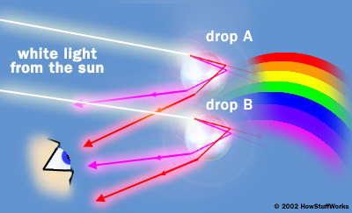
RAINBOW FORMATION

