[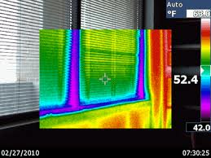](http://www.google.com/imgres?q=thermal+images&start=101&hl=en&qscrl=1&rlz=1T4GGHP_enUS447US447&biw=1366&bih=540&tbm=isch&tbnid=jkqcw-jtGJfj8M:&imgrefurl=http://www.mdhli.com/Baltimore_Maryland_Thermal_Imaging-Inspections.html&docid=DVmLs3I3AD_14M&imgurl=http://www.mdhli.com/img/Thermal/maryland_thermal_image_wind.gif&w=400&h=300&ei=B0WRULLnMoOa0QH6n4HoDg&zoom=1&iact=hc&vpx=308&vpy=156&dur=11787&hovh=194&hovw=259&tx=151&ty=131&sig=117007229393919364895&page=6&tbnh=139&tbnw=179&ndsp=18&ved=1t:429,i:46)

