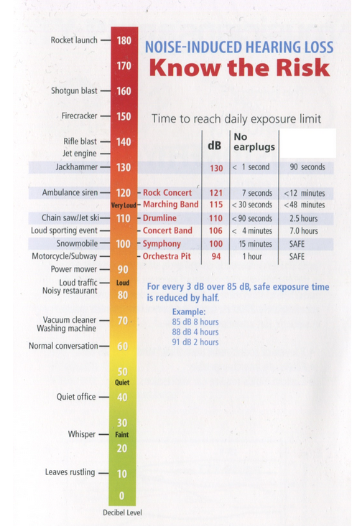
Sound Level Activity Name __________________________________
Using the decibel meter, record the noise level in 10 areas of your school. Record on the chart below.
Decibel Level | Sound Location
30
40
50
60
70
80
90
100
110
120
120+

- Underline softest sound. Circle the loudest sound.

- List any areas above the recommended exposure level.

- Choose one room and look around. Are there any measures designed to lessen the noise levels?

- Optional Investigation: Does your city or community have a noise ordinance?

