ALL ABOUT THE BULB
Directions & Answer Key

Directions: Create a Venn diagram like the one below for students to place their clues. You can use tape, hula hoops or anything in your classroom. Have the students place the number of the clue in the appropriate part of the Venn diagram.
1. Soon these will not be sold anymore | 5. Transforms electrical energy to radiant energy | 9. Contains small amounts of mercury
2. Often spiral shaped | 6. Energy efficient | 10. Holiday light strands
3. Glass, easily broken | 7. Produces 90% heat | 11. Last the longest time
4. The light bulb of the future | 8. Most durable and versatile | 12. A metal filament gets so hot it gives off light

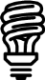
7
3
9
12
INCANDESCENT LIGHT BULB
(IL)
IL and CFL
2
COMPACT FLUORESCENT LIGHT BULB
(CFL)
1
ALL
LIGHT BULBS
5
6
IL and LED
10
LED and CFL
11
4
8
LIGHT EMITTING DIODE
(LED)

INCANDESCENT
LIGHT BULB

(IL)

COMPACT FLUORESCENT LIGHT BULB

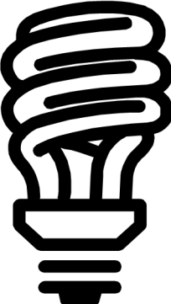(CFL)

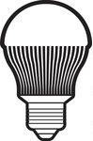

(LED)
LIGHT EMITTING
DIODE

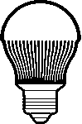ALL LIGHT BULBS

IL CFL LED

IL and CFL

IL and LED

and
CFL
LED

1. Soon these will not be sold anymore
2. Often spiral shaped
3. Made of glass, easily broken
4. The light bulb of the future

5. Transform electrical energy to radiant energy
6. Energy efficient
7. Produces 90% heat energy
8. Most durable and versatile

9. Contains small amounts of mercury
10. Holiday light strands
11. Last the longest time
12. A metal filament gets so hot it gives off
light

