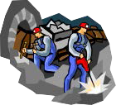
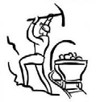
Coal Sequence

OBJECTIVE: Students will demonstrate the correct order to show the sequence of events that takes place to produce electricity from burning coal.
PROCEDURE:
- Introduce the idea that there are many steps in the production of electricity from burning coal.
- Distribute sets of Coal Sequence Cards to small groups depending on class size.
- Ask students to arrange the cards in order from the beginning to the end of the process.
- Cards can be moved or adjusted as needed throughout the discussion.
- Ask students to explain what is happening in each step. The teacher can elaborate with the information below.
6. If appropriate, ask students to describe the energy transformation that is occurring at steps that include a transformation. Energy transformations are in BOLD print in the answer key below.

Radiant Energy from the Sun | Nuclear fusion on the sun produces energy. Hydrogen atoms fuse to form helium and energy is released. The radiant energy travels through space. (Nuclear to Radiant)
Plants and Animals Live and Die | The radiant energy is absorbed by green plants. Through the process of photosynthesis, the radiant energy powers the molecules of carbon dioxide and water in plants to split and form sugar which is chemical energy used and stored by the plant.  (Radiant to Chemical)
Millions of Years Go By  Coal is Formed | Green plants die. More plants die and are covered with water and soil. The dead plants form layers and are compressed under extreme pressure and heat for a LONG period of time. The oxygen is squeezed out. There are physical and chemical changes and the material becomes coal. The chemical energy from the plants is stored in the coal. (Chemical to Chemical - new compounds formed.)
Geologists Locate Coal | Geologists make surface observations looking for non-marine sediments. After studying surface rocks, the geologists will drill areas to test and study core samples. Many times, coal deposits have been located as outcrops along a river.
Coal Mining | Surface mining and deep underground mining are the two basic methods of mining. The choice of mining method depends primarily on depth of burial, density of the rocks above the deposit and thickness of the coal seam. In general, the deeper the mine, the better quality coal.
Coal is Transported  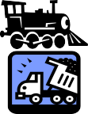  To the Power Plant | Most coal delivered in the United States is transported by train. Coal can also be transported by barge, ship, truck, and even by pipeline! Coal can be crushed, mixed with water and sent through a slurry pipeline. (Chemical to Mechanical used in transportation.)

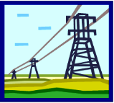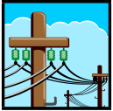Coal is Pulverized The coal is ground into a fine power. Pulverizing increases the surface area of the coal particles. Pulverizing is done at the power plant because it is easier and safer to transport the rocks than powder. The purpose is to have all the carbon particles come in contact with oxygen (in the air) so it burns more completely.

Boiler The pulverized coal is blown into the boiler. The heat from the combustion of coal is used to heat water to generate steam. (Chemical to Thermal)

Steam High pressure steam travels down the pipes to reach the turbine.

Turbine A turbine is a spinning wheel that gets its energy from the steam moving past it. It has a center axle (rotor) with blades attached. A windmill is another example of a turbine. (Thermal to Mechanical)

Generator The turbine is connected to the generator causing magnets to spin around coils of copper wire producing electricity. (Mechanical to Electrical)

High Voltage Transmission Lines
Electricity loses some of its energy as it travels down wire cables. To prevent this, the electricity generated in the plant is stepped-up (boosted) to a very high voltage as it leaves the power plant. High-voltage electricity loses less energy than low-voltage electricity. Voltage is a measure of electrical pressure.

Neighborhood Distribution Lines
Electricity travels down power lines to our homes. Once the electricity reaches its destination, another transformer converts the electricity back to a lower voltage safe for homes to use.

Home Wiring and Circuits
Our homes are wired in circuits to safely use the electrical power.

Lighting and Appliances
The appliances in our homes use electricity to transform it to light, heat, sound and mechanical energy to help us in our daily living.

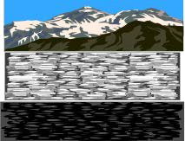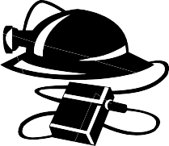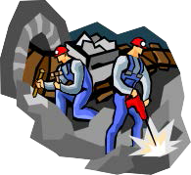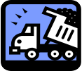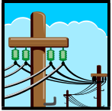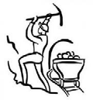Coal Sequence

COAL SEQUENCE
Place the steps in the correct order to show the sequence of events that takes place for us to enjoy a world with electricity always at the ready!

Radiant Energy from the Sun
Plants and Animals Live and Die

Millions of Years Go By
Geologists Locate Coal
Coal Mining Coal is Transported to the Power Plant

Coal is Formed

Coal is Pulverized

Boiler Steam Turbine

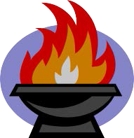

Generator High Voltage
Transmission Lines
Neighborhood Distribution Lines
Home Wiring and Circuits

Lighting and Appliances

