Energy Flows: Answer Key

How is energy transformed? Compare and contrast energy transformations below. Directions:
After your teacher hands out a set of energy source transformation cards to your group, sequence the cards in the order that they happen. The initial card should begin on the left with the subsequent cards following to the right.

What do the sources have in common?
Sun is the beginning, many use radiant energy to produce chemical energy in plants, heat and pressure are used in producing fossil fuels, power plants use a generator to transform the energy sourcetoelectricity.

Can each of these sources produce the same end product?
Yes,electricity can be used for many things from lighting a bulb to powering an electric car.

Is electricity a primary or secondary source of energy?
Electricity is the flow of electrical power or charge. It is a secondary energy source because we get it from the conversion of other sources of energy, like coal, natural gas, oil, nuclear power and other natural sources, which are called primary sources.

Tropic of Cancer
Equator
Tropic of Capricorn

TheNEED Project www.NEED.org Ohio Energy Project www.ohioenergy.org

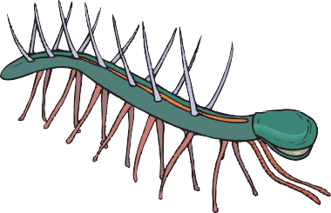
+ Radiant Energy  Sun | Through the process of fusion, I convert nuclear energy into radiant energy.
Ancient Sea Plant | Through the process of photosynthesis, I converted  radiant energy into chemical energy and stored it in my cells.
 | I stored chemical energy from food—ancient sea plants—in my cells.
Ancient Sea Animal
HEAT AND PRESSURE | I turned ancient plants and animals into fossil fuels.
Petroleum | I am a fossil fuel. The chemical energy stored in me came from the remains of ancient sea plants and animals.
Automobile | I convert chemical energy in petroleum into motion, sound, and heat.

+ Radiant Energy  Sun | Through the process of fusion, I convert nuclear energy into radiant energy.
Ancient Fern  HEAT AND PRESSURE | Through the process of photosynthesis, I converted radiant energy into chemical energyand stored it in my cells.
 | I turned ancient plants into fossil fuels.
Coal | I am a fossil fuel. The chemical energy stored in me came from the remains of ancient ferns.
Thermal Power Plant | I convert chemical or nuclear energy in fuels into thermal energy then into electrical energy.
Television | I convert electrical energy into light, heat, and sound.

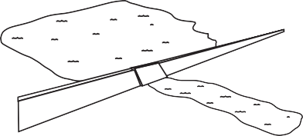
+ Radiant Energy  Sun | Through the process of fusion, I convert nuclear energy into radiant energy.
Water | I am a renewable energy source. The sun drives the water cycle and keeps me replenished in lakes, rivers, and oceans.
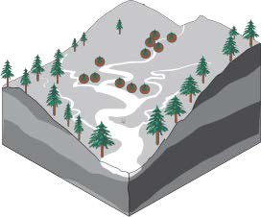  River | Through the water cycle I am always flowing and am fed by smaller streams and creeks.
Reservoir
 | I stay full because of the water cycle. I hold water as gravitational potential energy.
ESERVOIR  DAM GENERATOR  makes POWER LINES  electricity carryelectricity  GATE  TURBINE RIVER  spins generator  Hydropower Plant | I convert the kinetic energy of moving water into electrical energy.
Light Bulb | I convert electrical energy intoradiant and thermal energy.

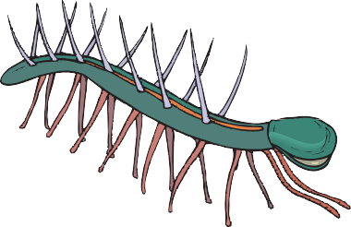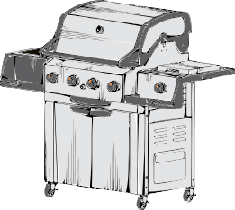
+ Radiant Energy  Sun | Through the process of fusion, I convert nuclear energy into radiant energy.
Ancient Sea Plant  Ancient Sea Animal  HEAT AND PRESSURE | Through the process of photosynthesis, I converted radiant energy into chemical energy and stored it in my cells.  I stored chemical energy from food—ancient sea plants—in my cells.  I turned ancient plants and animals into fossil fuels.
Propane | I am a fossil fuel. The chemical energy stored in me came from theremainsof ancient sea plants and animals.  I convert the chemical energy in propane into thermal energy.
Propane Grill

+ Radiant Energy  Sun | Through the process of fusion, I convert nuclear energy into radiant energy.
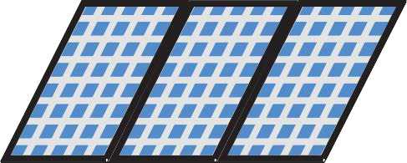  Photovoltaic Solar Panel | I absorb sunlight as a source of energy to generate direct current electricity.  I convert direct current to alternating current.
Inverter
Light Bulb | I convert electrical energy intoradiant and thermal energy.

+ Radiant Energy  Sun | Through the process of fusion, I convert nuclear energy into radiant energy.
Green Plant | Through the process of photosynthesis, I convert radiant energy into chemical energy and store it in my cells.  I burn the biomass and steam is generated to turn a turbine. The turbine generator generates electrical energy.
Combustor or Furnace
Light Bulb | I convert electrical energy intoradiant and thermal energy.

+ Radiant Energy  Sun | Through the process of fusion, I convert nuclear energy into radiant energy.
Wind | The sun heats land and water unevenly. Warm (less dense) air rises, Cold (more dense)  air sinks.  I convert the kinetic energy in wind into electrical energy.
Wind Turbine
Light Bulb | I convert electrical energy intoradiant and thermal energy.

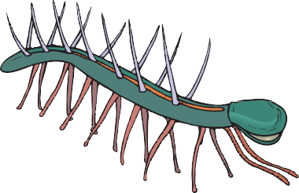
+ Radiant Energy  Sun | Through the process of fusion, I convert nuclear energy into radiant energy.
 | Through the process of photosynthesis, I converted radiant energy into chemical
Ancient Sea Plant | energy and stored it in my cells.
 | I stored chemical energy
 | from food—ancient sea
 | plants—in my cells.
Ancient Sea Animal
HEAT AND PRESSURE | I turned ancient plants and animals into fossil fuels.
Natural Gas | I am a fossil fuel. My chemical energy came from the remains of ancient sea plants and animals.
Home | I convert the chemical energy in natural gas into thermal energy.

Uranium | I am a common rock found around the world. My nuclear energy comes from the splitting of my atoms.
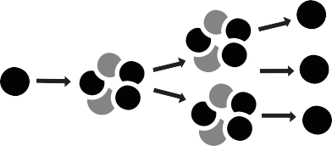  Splitting Atom | A uranium atom is split (fission) releasing thermal energy to produce steam.
Thermal Power Plant | I convert chemical or nuclear energy in fuels into thermal energy then into electrical energy.
Light Bulb | I convert electrical energy intoradiant and thermal energy.

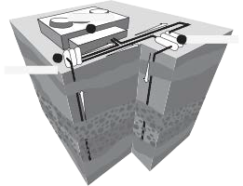
MANTLE  magma and soft rock  OUTER CORE  magma  INNER CORE  hot, solid metal  Earth | Much of the heat from the Earth’s interior is left over from its formation and from ongoing radioactive decay.
POWER PLANT 2  3 INJECTION WELL | Steam from underground
1  PRODUCTION WELL | reservoirs is pumped directly
 | into turbine generators in
 | the power plant. The steam
Geothermal Power Plant | generatorsprovideelectricity.
Light Bulb | I convert electrical energy intoradiant and thermal energy.

