Energy Source Match-Up
t Background
Students form teams of four by matching pictures and clues about a renewable or nonrenewable energy source. Then, as a team, students consider the safety, availability, economic, and environmental issues surrounding a particular energy source. Prior to game play, students should be familiar with the 10 sources of energy. See NEED’s Energy Infobook and Energy Infobook Activities for possible introductory activities on the sources of energy.

Objectives
Students will be able to identify renewable and nonrenewable sources of energy.
Students will be able to list and discuss advantages and disadvantages of energy sources with respect to safety, environment, economics, and availability.
Students will be able to work together effectively in a group setting.

Time
1 class period, depending on depth of discussion.

Materials
Clue Cards
Student Recording Sheet

Preparation
Cut apart each set of Clue Cards and group them by source.
Make a copy of the Student Recording Sheet for each team of students. Each team will have 4 students.
Adjust the cards so that you have enough cards for the number of students in your class. The maximum number of cards is 40. Set aside as many source sets as needed.

Procedure
- Explain to students that they will be working to make a team of four that represents one of the 10 energy sources.
- Show students a sample set of Clue Cards. Show how each card contains a CLUE sentence and a SEARCH sentence. The CLUE tells something about the energy source. The SEARCH tells the cardholder what CLUE to look for.
- Explain that each student will get a clue card and their goal is to find the other three pieces of their source. As a group, they will identify their source and complete the recording sheet.
- Distribute cards randomly to students.
- Give students 5 minutes to find their groups and about 10-15 minutes to complete the recording sheet. If groups finish early, have copies of NEED’s Energy Infobook available for students to begin researching their questions.
- As a class, discuss the energy sources and how they relate to the categories of environment, availability, safety, and economics. Some suggested class discussion approaches include:

  - Use chart paper to make four posters, one for each of the categories: environment, availability, safety, and economics. Give each source a different color marker. Have students add a fact or statistic about their source to each poster. As a class, have students read posters and decide on the “most economic” or “most environmentally safe” etc. source.
  - Create a jigsaw and ask one member of each group to share their findings with other students in their category. All environment students may be grouped together, for example, to share info about their source in all four areas. Require each student to create a sheet of notes with facts about each source as well as a comparison of sources under one or all of the topics.
  - Place a large bowl or container out in front of the class. Ask students to create a question bowl from all the questions their group has. Students should write their questions on slips of paper and place them in the large bowl. Have students draw questions from the bowl and research them for homework.
  - Create a bar graph for cost of electricity generated from each source and determine which source currently generates the most or least costly electricity.

- Some general trends to point out for each topic: Environment – CO2 emissions are a concern. Availability – Non-renewables are currently somewhat plentiful, but they will run out. Renewables are more difficult to harness. Safety – Transportation of the source and the equipment used/waste created from generating electricity are concerns. Economics – Cost / kWh is emphasized on the cards, but ask students to brainstorm other economic connections.

Note: Unless otherwise indicated, facts and statistics were collected from NEED's Secondary and Intermediate Energy Infobooks.

Student Recording Sheet
1. What energy source is your team?
- Is it RENEWABLE or NONRENEWABLE?
- Provide a definition of the source:

- List your team members:






- Complete the table below by filling in information for each category to describe the advantages and disadvantages of your source.

Source | Advantages | Disadvantages
Environment
Availability
Safety
Economics
- On the back of this sheet, brainstorm 5 questions to investigate about your source. At least 3 of the questions must begin with “how” or “why.”

Clue cards for HYDROPOWER

Environment Clue:  I am a renewable energy source whose power plants can harm the environment even though I burn no fuel to generate electricity.  Damming rivers to use my energy may disrupt wildlife or flood nearby areas. On the other hand, since I burn no fuel, I do not contribute to air pollution.  Search:  Find the renewable energy source that is currently the cheapest way to generate electricity. | Availability Clue:  I am a renewable energy source that can be used to generate electricity near a waterfall or river.  Depending on the amount of rainfall each year, I can provide 5-10% of the United States’ electricity. In states like Oregon, Washington, and Idaho, I supply as much as 69% of the electricity used each year.  Search:  Find the renewable energy source whose power plants worldwide have had the highest number of deaths per amount of electricity generated since 1977.
Economics Clue:  I am a renewable energy source that can be used to generate electricity for as little as 1 cent / kWh. Compared to 4 cents/kWh for coal and 2.5 cents/ kWh for uranium, I am the cheapest electricity source.  However, costs for using me to generate electricity may rise due to the environmental impacts of my power plants, or when power plants need to apply for new licenses.  Search:  Find the renewable energy source that can be used to generate electricity near a waterfall or river. | Safety Clue:  I am the renewable energy source whose power plants can be dangerous to construct.*  My power plants and the surrounding areas can sometimes flood, or be subjected to strong currents, eddies, and sudden changes in water levels.  *Source: Hydroworld, IHA.  Search:  Find the renewable energy source whose power plants can damage the environment even though no fuel is burned to generate electricity.

Clue cards for NATURAL GAS

Environment Clue:  I am a nonrenewable energy source that is the cleanest burning fossil fuel. I am most often used by industry for manufacturing or for home heating.  When I am burned to generate electricity, I do emit carbon dioxide, a greenhouse gas. However, compared to coal and petroleum, I release much less sulfur, carbon, and ash.  Search:  Find the nonrenewable energy source whose power plants generate electricity for about the same cost as coal, but are more efficient. | Availability Clue:  I am the nonrenewable energy source that the United States currently has enough of to last another 80 years.  Although I am mostly found underground as a fossil fuel, I can also be collected in coal mines and from landfill gases. When collected from a landfill, I am considered a renewable source since decaying organic matter produces me.  Search:  Find the nonrenewable energy source that smells like rotten eggs.
Economics Clue:  I am the nonrenewable energy source whose power plants generate electricity for about the same cost as coal, 4 cents per kilowatt-hour.  However, my power plants convert my energy into electricity more efficiently than coal power plants. This means more of my energy is turned into electricity and less is lost as heat.  Search:  Find the nonrenewable energy source that has a 80 year supply in the United States. | Safety Clue:  When found in nature, I am a colorless and odorless fossil fuel. For safety, companies add mercaptan (a chemical) to me that makes me smell like rotten eggs.  I travel across the country through more than 2.5 million miles of pipeline. If you smell me leaking anywhere, I can be dangerous. Leave the area, tell an adult, and have someone call the gas company immediately.  Search:  Find the nonrenewable energy source that is known as the cleanest burning fossil fuel.

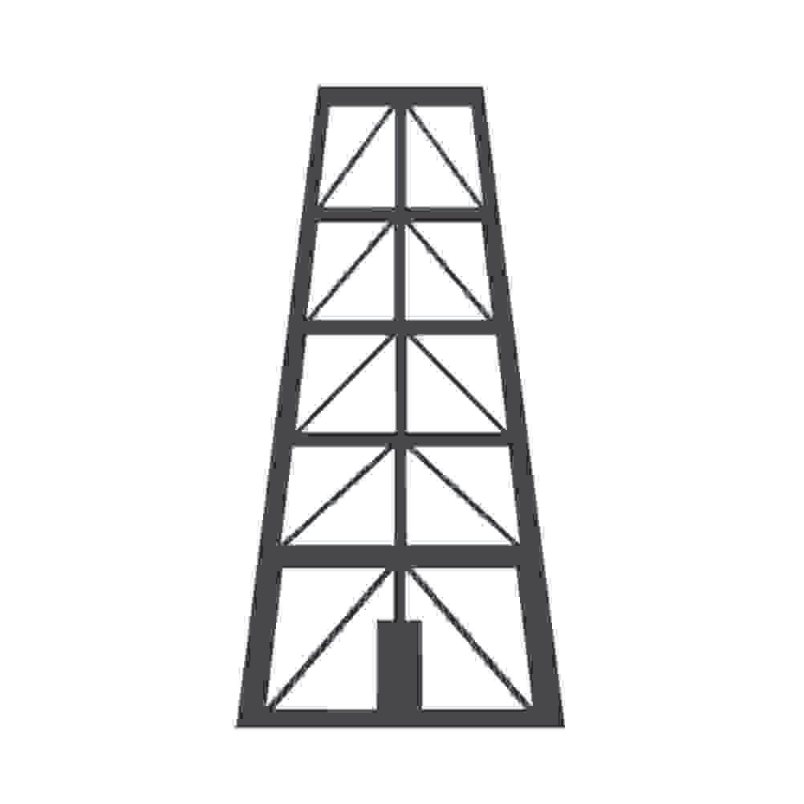Clue cards for PETROLEUM

Environment Clue:  I am the nonrenewable energy source whose biggest environmental challenge has been producing and transporting me over large distances without any spills. However, even careless disposal of me in small amounts can still damage the environment.  Since I am a fossil fuel, I release carbon dioxide (CO2) when burned. CO2 is a gas that contributes to the greenhouse effect.  Search:  Find a nonrenewable energy source that can be safely transported across land through underground pipelines. | Availability Clue:  I am a nonrenewable energy source that is the most used energy source in the United States. My principal use is for transportation, but I am also used to make many consumer products including plastics, crayons, and toothpaste.  Some of the best places in the world to find me are the United States, Russia, and Saudi Arabia.  Search:  Find the nonrenewable energy source whose price per barrel can fluctuate often.
Economics Clue:  I am the nonrenewable energy source whose price per barrel can fluctuate from $35 to over $130 on average.  The cost for me depends on many factors: the relations between countries that have me and those that need me, government regulations, supply and demand, and even weather events.  Search:  Find the nonrenewable energy source whose biggest environmental challenge has been production and transportation without any spills. | Safety Clue:  I am a nonrenewable energy source that can be safely transported across land through underground pipelines.  Because I travel underground, people planning to dig deep holes for foundations need to know if I am in the area. The best way to find out where I am is to call 811 before digging.  Search:  Find the nonrenewable energy source that is the most used energy source in the United States.

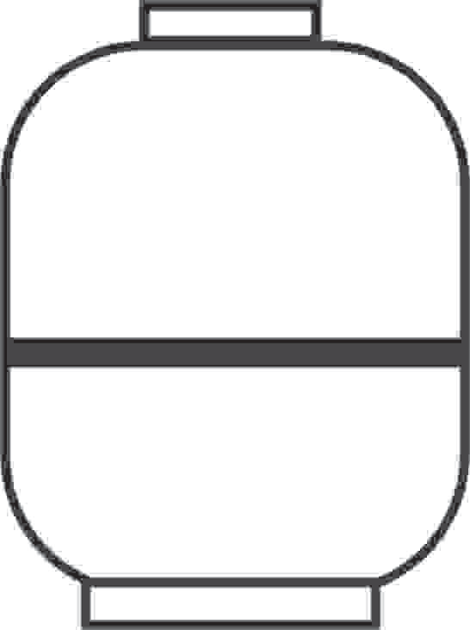Clue cards for PROPANE

Environment Clue:  I am a very clean burning nonrenewable energy source. In fact, I am often used in indoor settings.  I am so much cleaner to burn than gasoline that the Clean Air Act has approved me as an alternative transportation fuel. However, since I am a fossil fuel, I do emit carbon dioxide when burned.  Search:  Find the nonrenewable energy source that has the lowest flammability range of any fossil fuel. | Availability Clue:  I am a nonrenewable energy source that can be extracted from natural gas or petroleum. I am available wherever those two fossil fuels are found.  Although I am a cleaner and safer fuel to burn than gasoline, I am not as widely available. Also, there are not as many vehicles that have engines that can burn me.  Search:  Find the nonrenewable energy source whose use as a vehicle fuel requires costly adjustments to a conventional car engine.
Economics Clue:  In order for drivers to use me as an alternative fuel, their vehicles must be converted to a special type of engine. This can be a costly adjustment.  Also, filling stations that provide me as a fuel are not as widespread and convenient as gas stations.  Search:  Find the nonrenewable energy source that has been approved as an alternative transportation fuel by the Clean Air Act. | Safety Clue:  I am the nonrenewable energy source that has the lowest flammability range of any fossil fuel. One safety advantage of my low flammability range is that compared with gasoline, chances of a vehicle fire in a crash are much lower.  In addition, my storage tanks are less puncture- resistant than a typical gasoline tank.  Search:  Find the nonrenewable energy source that can be extracted from natural gas or petroleum.

Clue cards for WIND

Environment Clue:

Developers seeking to use my power plants must conduct research to ensure power plants are not in migratory paths of birds, bats, fish, and even frogs.

Because nothing is burned when I generate electricity, I do not release carbon dioxide. I create very clean electricity.

Search:

ind the renewable energy source whose cost dropped from 80 cents/kWh in 1980 to less than 5 cent /kWh.
Availability Clue:

I am a renewable energy source whose power plants are best built on top of smooth, rounded hills, open plains, shorelines, offshore and in mountain gaps.

I am the fastest growing energy technology in the world. I currently supply about 6% of the United States’ electricity each year. Experts expect the production of electricity from me will continue to grow.

Search:

Find a renewable energy source that needs no transportation of fuel to and from its power plants.

Economics Clue:

I am the renewable energy source whose power plants can produce electricity for less than 5 cents/ kWh. In the 1980s, I generated electricity at a cost of 80 cents/kWh.

I’m a great example of how technology can both improve and become less costly with research and development over time.

Search:

Find the renewable energy source whose power plants are best built on smooth, rounded hills, open plains, shorelines, offshore, and in mountain gaps.
Safety Clue:

I am a renewable energy source that needs no transportation of fuel to and from its power plants.
Because I do not need to be moved by pipelines, in trains, on trucks, boats, or planes, many of the hazards associated with transporting fuels do not apply to me.

Most of my safety concerns focus on the durability and strength of the equipment used to generate electricity from me.

Search:

Find the renewable energy source whose power plants must avoid migratory animal populations.

Clue cards for SOLAR

Environment Clue:  I am a renewable energy source that can be used to create electricity without producing any air or water pollution. I have few negative impacts on the land when used to generate heat, light, or electricity.  However, some of the technology used to harness my energy consumes silicon and produces chemical and technological waste products.  Search:  Find the renewable energy source that is free and available everywhere. | Availability Clue:  I am the renewable energy source that is free and available everywhere. However, I am not available at all times.  The technology used to transform my energy into electricity can easily be set up at remote locations.  Search:  Find the renewable energy source whose cost per kilowatt-hour to produce electricity can be as high as 3 times as expensive as from conventional sources.
Economics Clue:  I am the renewable energy source whose cost per kilowatt-hour to produce electricity can be as high as 3 times as expensive as from conventional sources.  In addition, current technology can only convert 18-24% of me to electricity, compared with a fossil fuel power plant that converts 30-40% of its fuel’s energy into electricity or hydropower at 80-90%.  Search:  Find a renewable energy source whose main safety concerns focus on the durability and strength of the equipment used to generate electricity from it. | Safety Clue:  I am a renewable energy source. Most of my safety concerns focus on the durability and strength of the equipment used to generate electricity from me.  Because I do not need to be moved by pipelines, in trains, on trucks, boats, or planes, many of the hazards associated with transporting fuels do not apply to me.  Search:  Find a renewable energy source that has few negative impacts on the land when used to create light, heat, and electricity.

Clue cards for GEOTHERMAL

Environment Clue:  I am a renewable energy source whose power plants do not burn fossil fuels. My power plants release no carbon dioxide (CO2) and less than 5% of the sulfur released by coal or natural gas power plants.  Power plants that I fuel have been built in deserts, on mountains, and in farmland.  Search:  Find the renewable energy source whose power plants are located directly above the fuel source. | Availability Clue:  There is no shortage of me in the earth, but not all sources of me are easy to reach or economical to use.  I am most abundant in regions along major tectonic plate boundaries where earthquakes and volcanoes are common. You can find me in the area known as the Ring of Fire.  Search:  Find the renewable energy source whose average cost per kilowatt-hour of electricity is similar to other conventional sources.
Economics Clue:  I am the renewable energy source whose average cost per kilowatt-hour (kWh) ranges from one to five cents/kWh.  In comparison, new coal and natural gas power plants can generate electricity at cost of around 4 cents/kWh, and wind at a cost of 5 cents/kwh.  Search:  Find the renewable energy source whose power plants do not burn fossil fuels so they release no carbon dioxide and less than 5% of the sulfur released by coal or natural gas. | Safety Clue:  I am a renewable source of energy whose power plants are located directly above the fuel source.  Because my fuel does not need to travel far distances to the power plant, I don’t have to worry about transportation hazards such as oil spills, gas leaks, or pipeline damage.  Search:  Find the renewable energy source that is found near earthquakes and volcanoes. It is plentiful but not always easy to reach or economical to use.

Clue cards for URANIUM-235

Environment Clue:  I am a nonrenewable source of energy whose power plants burn no fossil fuels and therefore release no carbon dioxide.  One of my advantages is my ability to generate amounts of electricity comparable to coal or natural gas power plants without the same environmental impacts.  Search:  Find the nonrenewable energy source whose greatest safety risk is the accidental release of high-level radiation. | Availability Clue:  I am the nonrenewable energy source that can be mined in the U.S. easily in several locations, however a large majority of me is imported from other countries.  Search:  Find the nonrenewable energy source whose greatest costs in generating electricity come from building the power plant and following strict safety regulations.
Economics Clue:  I am the nonrenewable source of energy whose greatest costs in generating electricity come from building the power plant and following strict safety regulations.  If only the operating costs are considered, I can produce electricity at about 2.5 cents / kilowatt- hour (kWh), compared with coal or natural gas plants at 4 cents/kilowatt-hour (kWh).  Search:  Find the nonrenewable source of energy whose power plants burn no fossil fuels and therefore release no carbon dioxide. | Safety Clue:  I am the nonrenewable  energy source whose greatest safety risk is the accidental release of high-level radiation.  Power plants that use me to generate electricity have greatly improved their safety features since they were first built. There is also much debate about the safety of transporting and storing my waste products.  Search:  Find the nonrenewable energy source that is mostly imported.

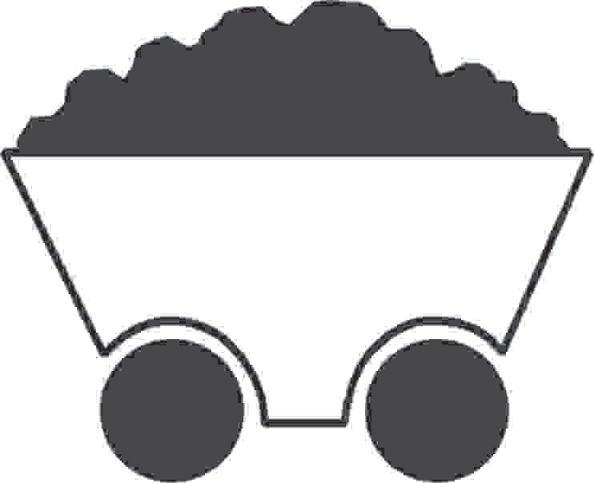Clue cards for COAL

Environment Clue:  I am a nonrenewable energy source whose power plants are challenged with removing the sulfur that is chemically bound to me.  If this sulfur is not removed, I will pollute the air when I am burned and can cause acid rain. I also release carbon dioxide (CO2) when I am burned, contributing to the greenhouse effect and global climate change.  Search:  Find the nonrenewable energy source that is the United States’ most plentiful fossil fuel. | Availability Clue:  I am the nonrenewable energy source that is the United State’s most plentiful fossil fuel. The United States is the world leader in known reserves of me.  Experts estimate there is enough of me left to last almost 300 years at current rates of use.  Search:  Find the nonrenewable energy source that generates about 30% of the electricity used in the United States.
Economics Clue:  I am the nonrenewable energy source that generates about 30% of the electricity used in the United States.  Two reasons why I am so popular are that I am relatively inexpensive and I am very abundant.  Search:  Find the nonrenewable energy source whose safety record has evolved and improved over time. | Safety Clue:  I am a nonrenewable energy source whose safety record has evolved and improved over time. When I was first collected, many workers were injured or killed. In response, the U.S. government passed the Federal Mine Safety and Health Act in 1977.  Currently, continuous and extensive training is required of all employees, mines are inspected 2 to 4 times per year, and working conditions are monitored closely. In spite of all these measures and advancements, accidents can still occur in this dangerous industry.  Search:  Find the nonrenewable energy source whose biggest environmental challenge is removing the sulfur that is chemically bound to it.

Clue cards for BIOMASS

Environment Clue:  I am a renewable energy source that helps keep carbon dioxide levels in the atmosphere balanced by absorbing CO2 when I grow.  I contain very little sulfur and nitrogen. So, if you burn me to create heat or electricity, I won’t produce acid rain.  Search:  Find the renewable energy source that used to provide 90% of the United States’ energy until the mid-1800’s and now provides 5% of the energy we use. | Availability Clue:  I am a renewable energy source that is no longer used as much in the United States as I was before 1850.  I am still widely available, and many developing countries depend on me. However, in America I have mostly been replaced by the use of coal, natural gas, coal, and petroleum.  Search:  Find the renewable energy source that could be the answer to an inexpensive, renewable energy supply.
Economics Clue:  I am the renewable energy source that serves as an important alternative transportation fuel, and a possible answer to an inexpensive, renewable domestic energy supply.  My future uses may include using ethanol and biodiesel for fuel. Ethanol can be produced by America’s farmers who grow energy crops such as corn and special fast-growing trees and grasses. Biodiesel can be made from waste oil and grease.  Search:  Find the renewable energy source that is produced when organic waste decays. | Safety Clue:  I am a renewable energy source produced when organic waste decays. I am called methane and I’m also the main ingredient in the non-renewable fossil fuel, natural gas.  If not collected, I can cause accidental fires or explosions. However, if I am collected and purified, I can safely be used to produce electricity, heating, or light.  Search:  Find the renewable energy source that helps keep carbon dioxide (CO2) levels balanced in the earth’s atmosphere.

