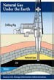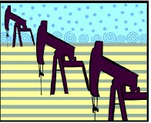
Natural Gas Sequence

OBJECTIVE: Students will demonstrate the correct order to show the sequence of events that takes place when using gas as a source to generate energy.
PROCEDURE:
- Introduce the idea that there are many steps in the production of energy from natural gas.
- Distribute sets of Natural Gas Sequence Cards to small groups depending on class size.
- Ask students to arrange the cards in order from the beginning to the end of the process.
- Cards can be moved or adjusted as needed throughout the discussion.
- Ask students to explain what is happening in each step. The teacher can elaborate with the information below.
6. If appropriate, ask students to describe the energy transformation that is occurring at steps that include a transformation. Energy transformations are in BOLD print in the answer key below.

Energy from the Sun | Nuclear fusion on the sun produces energy. Hydrogen atoms fuse to form helium and energy is released. The radiant energy travels through space. (Nuclear to Radiant)
Plants and Animals Live and Die | The radiant energy is absorbed by green plants. Through the process of photosynthesis, the radiant energy powers the molecules of carbon dioxide and water in plants to split and form sugar which is chemical energy used and stored by the plant. Tiny animals, living in the ocean, ate the plants and stored the carbon in their bodies. (Radiant to Chemical)
Millions of Years Go By | Green plants and the animals that eat the plants live and die. When they died, they sank to the bottom of the sea. This organic material mixed with mud, silt, and sand on the sea floor, gradually becoming buried over time and forming layers. (Chemical to Mechanical as it sinks)
Oil and Natural Gas Form | As the sediment is buried ever deeper, heat and pressure increases. Because it is sealed off in an environment without oxygen, the organic matter does not decompose. With the rising amounts of heat and pressure, the organic matter changes due to a thermal breakdown process that converts it into gas and oil (hydrocarbons). The lighter gas rises to the top and sometimes escapes through porous rock. (Chemical to Chemical - different compounds)
Producing Well is Drilled | Engineers and geologists use clues to pinpoint potential natural gas reserves. The drilling derrick is used to position and support the long pipe and drill bit. Natural gas tends to be contained within the underground rock itself. The rock must be broken to release the gas.
Gas and Oil Are Brought to the Surface | In the primary recovery, gas and oil come to the surface through natural underground pressure. Gas and water are pumped into the well to bring more oil to the surface. Enhanced recovery techniques such as thermal, gas injection and chemical flooding are currently used to bring up 60% more of the resource.

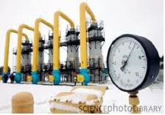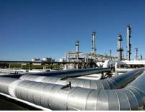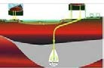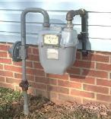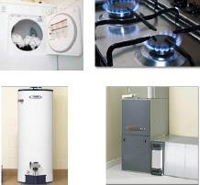
Compressor Forces Gas Through Pipelines | “Gathering pipelines” collect natural gas from wells in a given region and deliver it to the local processing plant. A compressor creates the pressure to move the gas along in the pipeline.
Impurities are Removed at Processing Plant | The natural gas that we use in our homes is 90% methane. It is important to remove the impurities before it enters the main interstate pipeline system. Depending on the location of the well and the geologic conditions that created the gas in the first place, contaminants such as water, sulfur and natural gas liquids (including ethane, propane and butane) may be present and must be removed.
Gas Moves through Transmission Lines | Transmission systems carry the processed natural gas over long distances, from the producing region to local distribution systems around the country.  Compressors placed at key intervals, usually every 40 to 100 miles along the pipeline network, keep the natural gas moving. The pressure of the natural gas in the transmission system is from 200 to 1,500 pounds per square inch of pressure (or psi).
Gas is Stored in Underground Rock Formations and Reservoirs | Natural gas is most often stored in empty natural gas or oil wells. These underground formations have proven they can trap and contain natural gas, so they make useful reservoirs for natural gas delivered through the interstate pipeline. Natural gas may also be stored in underground salt caverns - geologic formations whose walls are impermeable to natural gas.
Mercaptan is Added for Detection | Natural gas is odorless, colorless and tasteless. Mercaptan, the harmless chemical that is added to natural gas, contains sulfur which makes it smell like rotten eggs. It is used to alert users of a gas leak. This is an important safety feature since natural gas is flammable.
Gas Mains Carry Gas to Your Community | The local utility reduces the pressure of the natural gas from its transmission rate (from 200 to 1,500 pounds per square inch) down to a rate more appropriate to consumer usage (as low as 3 pounds per square inch).
Gas is Measured by a Meter | A gas meter is a specialized flow meter used to measure the volume of fuel gases such as natural gas. Gas meters are used at residential, commercial, and industrial buildings that consume fuel gas supplied by a gas utility. Natural gas is priced per cubic foot of fuel used.
Natural Gas Powers Appliances | Home furnaces, stoves and ranges, water heaters, clothes dryer and fireplaces are typical appliances that use natural gas and allow consumers to enjoy a comfortable home. (Chemical to Thermal)

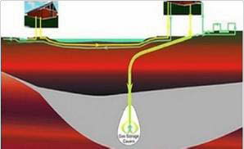
Gas Sequence | These 14 steps can be cut and used by  individual students and small groups | Place the 14 steps in the correct order to show the sequence of events that takes place when using gas as a source to generate energy. | Energy from the Sun
Plants and Animals Live and Die | Millions of Years Go By | Oil and Natural Gas Form  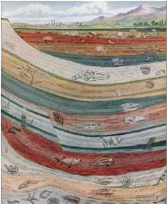 | Producing Well is Drilled  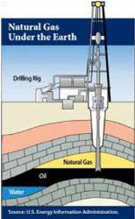
Gas and Oil Are Brought to the Surface  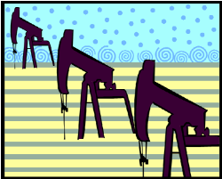 | Compressor Forces Gas through Pipelines  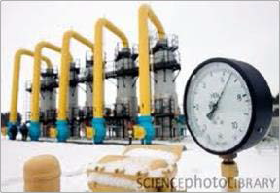 | Impurities are Removed at Processing Plant  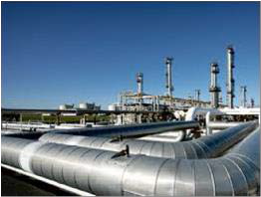 | Gas Moves through Transmission Lines  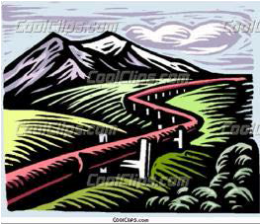
Gas is Stored in Underground Rock Formations & Reservoirs | Mercaptan is Added for Detection | Gas Mains Carry Gas to Your Community | Gas is Measured by a Meter  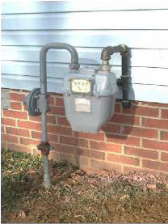
Natural Gas Powers Appliances
