SAVING ENERGY
STUDENT AND FAMILY GUIDE
Elementary
2019-2020

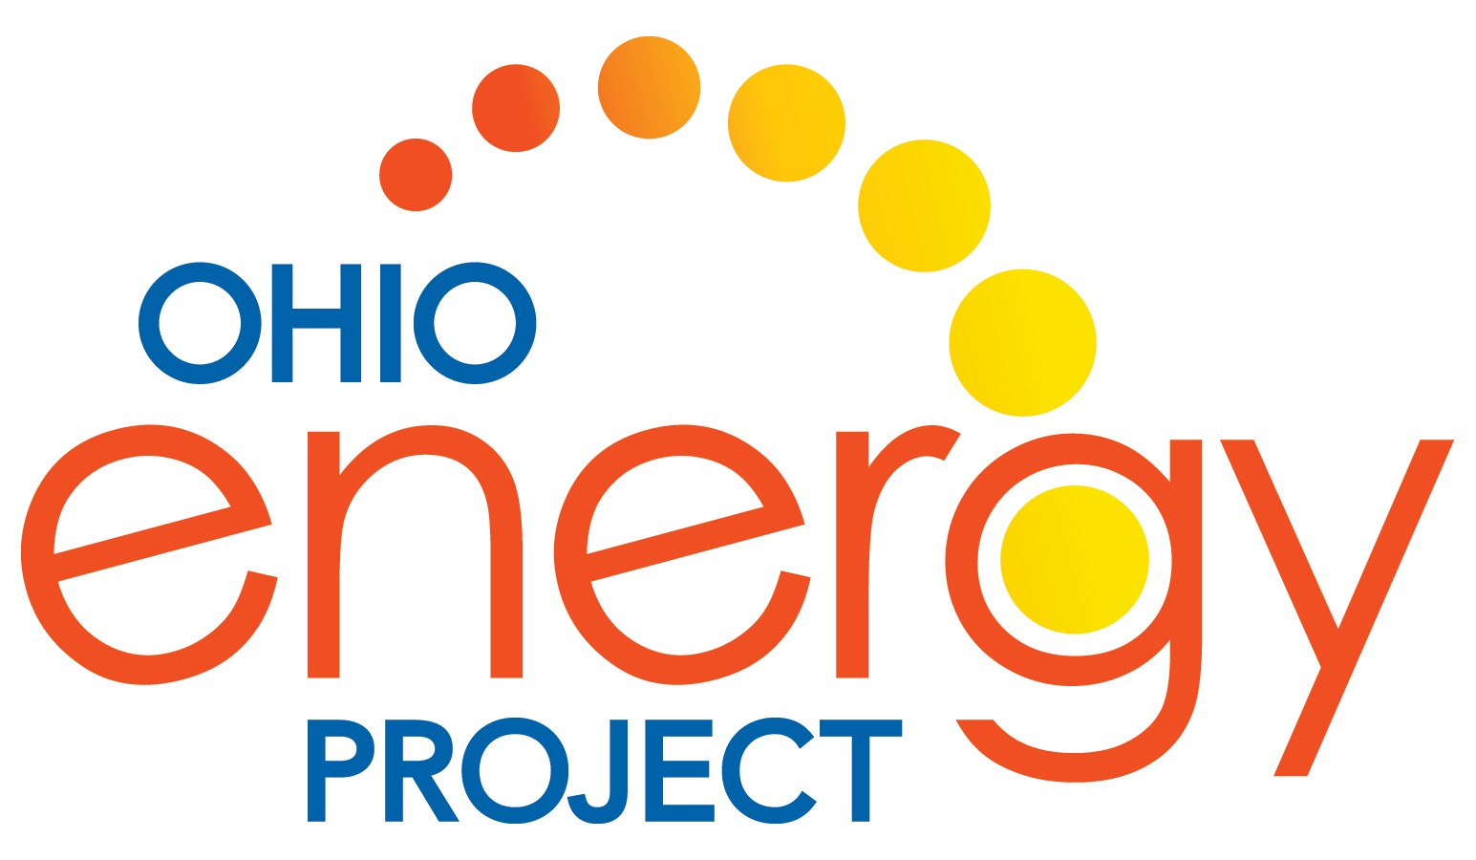

ENERGY EFFICIENCY EDUCATION

Brought to you by:

We spark curiosity about energy.

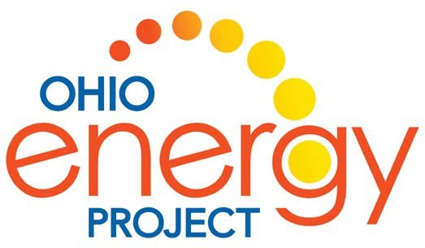

Message to Families
Ohio Energy Project (OEP) is proud to partner with your local electric and/or natural gas provider to bring our award-winning energy efficiency program to your student’s classroom. As a non-profit organization, OEP’s goal is to spark curiosity about energy in every student that we reach. Our energy efficiency program affords students the opportunity to explore energy science in the classroom and put their knowledge to the test at home, connecting science content standards with real world experiences.
With your support, students will be able to engage with science at home by installing energy saving measures from the Energy Efficiency Kit provided by your sponsoring utility. Once installed, these energy saving measures provide families the opportunity to see how low-cost and no-cost measures can make a substantial difference in lowering energy usage. If you rent your
home, we recommend that you check with your landlord prior to making any modifications.
This Student and Family Guide will allow your student to do additional research on energy usage and will help demonstrate how efforts to save energy can make a difference. At the end of the lessons there is a Family Installation Survey to be completed. This survey, found at www.ohioenergy.org, will allow your student to report on the measures installed and is completely anonymous.
We are thrilled that your family will be participating in this educational opportunity with thousands of other families across Ohio. We encourage you to contact your student’s teacher with any questions you might have. If you are not interested in receiving a free Energy Efficiency Kit, please contact your student’s teacher.

2 ©2019 The NEED Project www.NEED.org Ohio Energy Project www.ohioenergy.org

SAVING ENERGY

STUDENT AND FAMILY GUIDE

Table of Contents

Lesson One – What is Energy?
Lesson 1A: Energy Sources
Background Information 5
Energy Source Matching 8

Lesson 1B: Energy Forms
Lesson Four – Insulation, Heating and Cooling
Background Information 36
Heat Transfer 38
Insulation, Heating and Cooling Investigation, Part 1 39
Insulation, Heating and Cooling Investigation, Part 2 41
Home Activity 44

Background Information 9

Energy Forms Matching 11

Lesson 1C: Energy Efficiency and Conservation
Background Information 12
Lesson Five - Appliances
Background Information 45
Appliances and Machines Investigation 47
Home Activity 50

The Energy I Used Today 14

Efficiency vs. Conservation 16

Lesson Two - Lighting
Background Information 19
Lighting Investigation 21
Facts of Light 25
Home Activity 30

Lesson Three – Water Heating
Background Information 31
Water Heating Investigation 32
Home Activity 35
Lesson Six - What Have We Learned?
Connections 51
Home Activity 52
Family Installation Survey 53
Post-Poll 54

©2019 The NEED Project www.NEED.org Ohio Energy Project www.ohioenergy.org 3

Energy Efficiency Pre-Poll
- What is energy?
  - The ability to produce change or do work b. An odorless fossil fuel c. Organic matter d. Technology

- is a form of kinetic energy.

  - Petroleum b. Elastic Energy c. Thermal Energy d. Chemical Energy

- Energy is an action or behavior that results in using less energy.
  - Efficiency b. Conservation c. Sustainability d. Transformations

- What is the amount of light or brightness of a light bulb measured in?
  - Amps b. Watts c. Inches d. Lumens

- percent of energy consumed by an incandescent bulb produces light.
a. 25 b. 10 c. 70 d. 90

- A water heater should be set at .
a. 120 °F b. 65 °F c. 150 °F d. 100 °F

- Mercaptan is added to natural gas to give it a “ ” smell.
  - Mint b. Skunk c. Sweet d. Rotten Eggs

- Heat flows from areas of to areas of .
  - Higher energy; Lower energy b. Moisture; Dryness c. Lower energy; Higher energy d. Solid; Liquid

- refers to electricity loss when appliances are in standby mode.
  - Energy Star b. Kilowatt-hour c. Vampire Power d. Fuel Cost

- What is the unit of measure of the electric power an appliance uses?
a. Joule b. Volt c. Foot-candle d. Watt

4 ©2019 The NEED Project www.NEED.org Ohio Energy Project www.ohioenergy.org

LESSON 1A: Energy Sources
Background Information: What is Energy?

What Is Energy?
Energy makes change; it does things for us. It moves cars along the road and boats over the water. It bakes a cake in the oven and keeps ice frozen in the freezer. It plays our favorite songs and lights our homes. Energy makes our bodies grow and allows our minds to think. Scientists define energy as the ability to do work or cause a change in an object, such as position, shape, or state of matter.
The United States uses a lot of energy—over two million dollars worth of energy per minute, 24 hours a day, 365 days a year. With just less than 4.5 percent of the world’s population, we consume about 18.6 percent of the world’s energy resources.
All of us use energy every day—for getting from one place to another, cooking, heating and cooling rooms, making products, lighting, heating water, and entertainment.
We use a lot of energy to make our lives comfortable, productive, and enjoyable. Most of that energy is from nonrenewable energy sources. It is important that we use our energy resources wisely.

Population Versus Energy Consumption, 2016
UNITED STATES 4.34%
UNITED STATES 17.82%
WORLD
POPULATION
WORLD
ENERGY CONSUMPTION
REST OF THE WORLD 95.66% REST OF THE WORLD 82.18%
Data: Energy Information Administration

©2019 The NEED Project www.NEED.org Ohio Energy Project www.ohioenergy.org 5

Sources of Energy
We use many different energy sources to do work for us. They are classified into two groups—renewable and nonrenewable.
In the United States, most of our energy comes from nonrenewable energy sources. Coal, natural gas, petroleum, propane, and uranium are nonrenewable energy sources. They are used to make electricity, heat our homes, move our cars, and make all kinds of products. These energy sources are called nonrenewable because their supplies are limited. Petroleum, a fossil fuel, for example, was formed hundreds of millions of years ago from the remains of ancient sea plants and animals. We can’t make more petroleum deposits in a short time.
Renewable energy sources include biomass, geothermal energy, hydropower, solar energy, and wind energy. They are called renewable because they are replenished in a short time. Day after day, the sun shines, the wind blows, and the rivers flow. We use renewable energy sources mainly to make electricity.

RENEWABLE energy sources are replenished in a short period of time.
NONRENEWABLE energy sources are limited since it takes a very long time to replenish their supply.

WIND is energy from moving air.
GEOTHERMAL energy is heat from within the earth.

HYDROPOWER is energy that comes from the force of moving water.

SOLAR energy is energy from the sun.

BIOMASS is any organic matter (anything that was once alive) that can be used as an energy source, such as wood, crops, and yard waste.
COAL is a solid, black fossil fuel formed from the remains of plants that lived and died millions of years ago.

NATURAL GAS is a colorless, odorless fossil fuel made mostly of methane.

PETROLEUM is a fossil fuel that looks like a black liquid. It is also known as crude oil.

PROPANE is a fossil fuel refined from natural gas and petroleum.

URANIUM is the fuel used by most nuclear power plants.
During nuclear fission, atoms are split apart to form smaller atoms, which releases energy.

6 ©2019 The NEED Project www.NEED.org Ohio Energy Project www.ohioenergy.org

Burning Fossil Fuels to Generate Electricity

HOW WE USE OUR ENERGY SOURCES

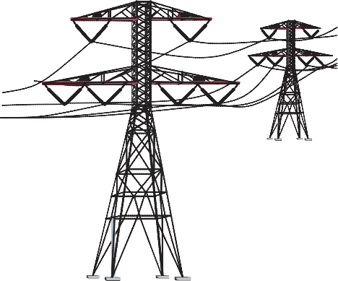FUEL BURNING ELECTRICITY GENERATION
ELECTRICITY TRANSMISSION

COAL
or
3 STEAM LINE
BOILER

TURBINE
GENERATOR

SWITCHYARD

NATURAL
GAS
2

FEED
5
4

6

or
PETROLEUM 1
WATER
CONDENSER

A fossil fuel is fed into a boiler, where it is burned to release thermal energy.

Water is piped into the boiler and heated, turning it into steam.

The steam travels at high pressure through a steam line.

The high pressure steam turns a turbine, which spins a shaft inside a generator.

Inside the generator, the shaft spins coils of copper wire inside

MAGNETS COPPER COILS
ROTATING SHAFT

GENERATOR

a ring of magnets. This creates an electric field, producing electricity.
7
©2019 The NEED Project www.NEED.org Ohio Energy Project www.ohioenergy.org

Electricity is sent to a switchyard, where a transformer increases the voltage, allowing it to travel through the electric grid.

Energy Source Matching

Procedure
- Match the source of energy with the definition and complete the chart.

Wind | Natural Gas | Solar
Uranium | Coal | Geothermal
Biomass | Propane | Hydropower
Petroleum

 | Energy Source | Definition | Example
 |  | A solid, black fossil fuel that formed from the remains of plants that lived and died millions of years ago
 |  | Energy from the sun
 |  | Any organic matter that can be used as an energy source, such as wood or crops
 |  | A fossil fuel that looks like a thick, black liquid
 |  | A colorless, flammable gas, refined from petroleum and natural gas
 |  | The fuel used by nuclear power plants to produce steam
 |  | Energy in moving air
 |  | A colorless, odorless fossil fuel made mostly of methane
 |  | Energy that comes from the force of falling water
 |  | Energy from the heat within the Earth
- Match each example with the energy source and complete the chart.
  - Turbines can be located on land or offshore
  - Fuel mainly used for heating or transportation
  - Volcanoes and geysers are evidence
  - Can be refined to gasoline and diesel fuel
  - Dams built to create a reservoir
  - Atoms split (fission) forming smaller atoms and releasing energy
  - Energy transformed by photosynthesis in plants
  - Travels to the Earth as radiant energy
  - Can be mined on surface or deep from within the Earth
  - Can be compressed into tanks for grilling food

8 ©2019 The NEED Project www.NEED.org Ohio Energy Project www.ohioenergy.org

LESSON 1B: Energy Forms

Background Information

All forms of energy fall under two categories:

POTENTIAL
Stored energy and the energy of position (gravitational).

CHEMICAL ENERGY is the energy stored in the bonds between atoms in molecules.
Gasoline and a piece of pizza are examples.

NUCLEAR ENERGY is the energy stored in the nucleus, or center, of an atom – the energy that holds the nucleus together. The energy in the nucleus of a plutonium atom is an example.

ELASTIC ENERGY is energy stored in objects by the application of force. Compressed springs and stretched rubber bands are examples.

GRAVITATIONAL POTENTIAL ENERGY is
the energy of place or position. A child at the top of a slide is an example.

KINETIC
The motion of waves, electrons, atoms, molecules, and substances.

RADIANT ENERGY is electromagnetic energy that travels in transverse waves. Light and x-rays are examples.

THERMAL ENERGY, or heat, is the internal energy in substances – the vibration or movement of atoms and molecules in substances. The heat from a fire is an example.

MECHANICAL ENERGY is the movement of a substance from one place to another. Wind and moving water are examples.

SOUND ENERGY is the movement of energy through substances in longitudinal waves.
Echoes and music are examples.

ELECTRICAL ENERGY is the movement of electrons. Lightning and electricity are examples.

©2019 The NEED Project www.NEED.org Ohio Energy Project www.ohioenergy.org 9

Energy Transformations
Conservation of Energy
Yourparentsmaytellyoutoconserveenergy.“Turnoffthelights,”they say.Toscientists, energyconservation is not just about turning off the lights. The Law of Conservation of Energy says that energy is neither created nor destroyed. When we use energy, it doesn’t disappear. We change one form of energy into another form.

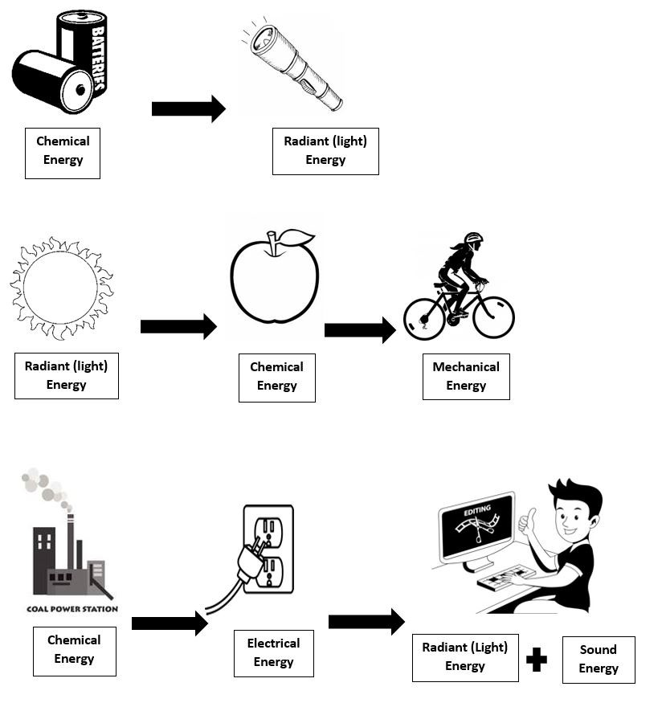

10 ©2019 The NEED Project www.NEED.org Ohio Energy Project www.ohioenergy.org

Energy Forms Matching

Procedure
- Match the form of energy with the definition and complete the chart.

Chemical | Nuclear | Gravitational Potential Energy
Elastic | Radiant | Thermal
Mechanical | Sound | Electrical

 | Energy Form | Definition | Example
 |  | The energy stored in the bond between molecules
 |  | Energy in the form of electromagnetic waves
 |  | The energy of place or position
 |  | The movement of energy through a substance in a longitudinal wave
 |  | The energy stored in the nucleus of an atom
 |  | The movement of an object from one place to another
 |  | The movement of electrons
 |  | Energy stored by applying force, such as squeezing
 |  | The internal energy in a substance due to the movement of particles

- Match each example with the energy form and complete the chart.

Gasoline, food, battery Uranium and plutonium atomic nucleus

Music, shouting Lightning, electricity

Stretched rubber band Rubbing your hands together, heat from fire

Sunlight and X-rays A boulder on top of a hill Walking, riding a bicycle

©2019 The NEED Project www.NEED.org Ohio Energy Project www.ohioenergy.org 11

LESSON 1C: Energy Efficiency and Conservation
Background Information

Energy Efficiency and Conservation
The choices we make about how we use energy have environmental and economic impacts. There are many things we can do to use less energy and use it more wisely. These actions include both energy conservation and energy efficiency.
Energy conservation is any action or behavior that results in using less energy. Drying clothes outside on sunny days is an example of energy conservation. Energy efficiency focuses on technologies that use less energy to perform the same tasks or the same amount of work. Buying a dryer that uses less energy is an example of energy efficiency.

Who Uses Energy?
The U.S. Department of Energy uses categories to classify energy users—residential, commercial, industrial, electric power, and transportation. These categories are called the sectors of the economy.
The residential sector includes houses, apartments, and other places where people live. The commercial sector includes schools, businesses, and hospitals. The residential and commercial sectors are put together because they use energy for similar tasks—for heating, air conditioning, water heating, lighting, and operating appliances.

Home Energy Expenditures
HEATING
29.3%

COOLING
14.3%
REFRIGERATION
5.6%
Data: EIA 2015 RECS
WATER HEATING
16.0%
COMPUTERS/ ELECTRONICS COOKING,
CLEANING, & OTHER 27.0%
LIGHTING 7.9%

U.S. Energy Consumption by Sector, 2016

TRANSPORTATION
28.5%
Top Transportation Sources:
 Petroleum
 Biomass
 Natural Gas
INDUSTRIAL 22.0%
Top Industrial Sources:
RESIDENTIAL 6.2%
Top Residential Sources:
 Natural Gas
 Biomass
 Petroleum

ELECTRIC POWER 38.7%
Top Electric Power Sources:

 Natural Gas
 Petroleum
 Propane
COMMERCIAL 4.5%
Top Commercial Sources:
 Natural Gas
 Petroleum
 Propane
 Natural Gas
 Coal
 Uranium

The residential, commercial, and industrial sectors use electricity. This graph depicts their energy source consumption outside of electricity.
Data: Energy Information Administration
*Total does not equal 100% due to independent rounding.
12 ©2019 The NEED Project www.NEED.org Ohio Energy Project www.ohioenergy.org

Industrial Sector
Making the goods we use every day consumes an enormous amount of energy. The industrial sector of the economy consumes almost one-third of the nation’s energy. In industry, energy efficiency and conservation are driven by economics—money. Manufacturers know that they must keep their product costs low so people will buy them.
Since energy is one of the biggest costs in many industries, manufacturers must use as little energy as possible. Their demand for energy efficient equipment has resulted in many new technologies in the last decades. Consumers can have an effect on industrial energy use through the product choices we make and what we do with the packaging and the products we no longer use.

A Consumer Society
Not only is America a consumer society, it is also a ‘throw away’ society. Americans produce more trash than any other developed country. The average person throws away approximately 1,600 pounds of trash a year!
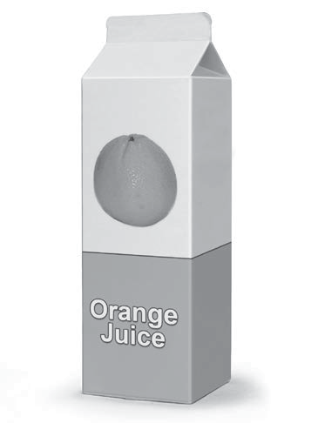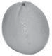The best way for consumers to reduce the amount of energy used by industry is to avoid buying unnecessary products and to repair and reuse items wherever possible. Buying only those items you need, as well as reusing and recycling products, can reduce energy use in the industrial sector. The 4 R's of an energy-wise consumer are easy to put into practice. Managing waste saves money, energy, and natural resources, and it helps protect the environment.
Reduce
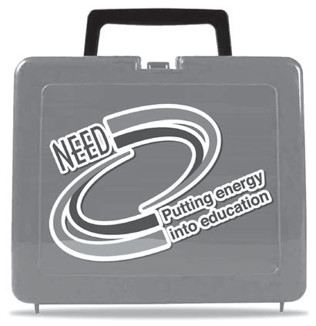Buy only what you need. Buying fewer goods means less to throw away. It also means fewer goods are produced and less energy is used to manufacture them. Buying goods with less packaging also reduces the amount of waste and the amount of energy used.
Reuse
Buy products that can be used more than once. If you buy things that can be reused rather than disposable items that are used once and thrown away, you save natural resources. You will also save the energy used to
make them and reduce the amount of landfill space needed to contain the waste. Savings also result when you buy things that are durable. They may cost more, but they last a long time and do not need to be replaced often, saving money and energy.
Repair
Many people throw away products when they break and buy new ones. Many of these products could be easily and cheaply repaired. Always consider repairing a product before throwing it away. It saves energy, money, and natural resources.

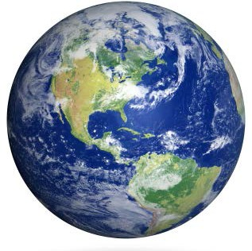
Recycle
Make it a priority to recycle all materials that you can. Using recycled material to make new products almost always consumes less energy than using new materials. Recycling reduces energy needs for mining, refining, and many other manufacturing processes.
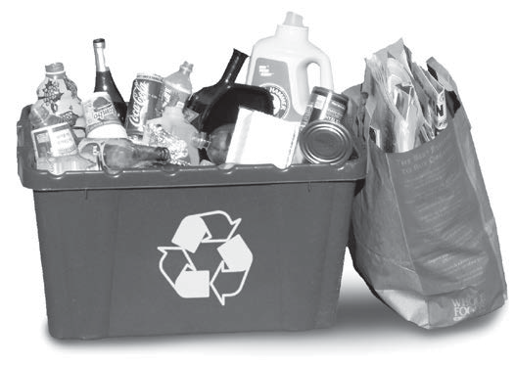Recycling steel saves 75 percent of the energy needed to make products from raw iron ore.
Recycling aluminum cans saves 92 percent of the energy required to produce aluminum from bauxite. Many other products can also be recycled and contribute to savings in energy and resources.
Recycling is only part of the process to save energy. Consumers also need to make an effort to buy recycled goods. Many products now have labels that tell consumers how much recycled material they contain.

Energy Sustainability

Efficiency and conservation are key components of energy sustainability—the concept that every generation should meet its energy needs without compromising the needs of future generations. Sustainability focuses on long-term actions that make sure there is enough energy to meet today’s needs as well as tomorrow’s.
Sustainability also includes the development of new clean technologies for using fossil fuels, promoting the use of renewable energy sources, and encouraging policies that protect the environment.

©2019 The NEED Project www.NEED.org Ohio Energy Project www.ohioenergy.org 13

The Energy I Used Today
Circle the things you used or did today in the left column. For each item circled, write the number of Energy Bucks (in parenthesis) in the Energy Bucks column. Add them together to find your Total Energy Bucks Used. List the transformation of energy in the right column. The first example has been completed for you.
What device woke me up this morning? ENERGY BUCKS TRANSFORMATION

Alarm Clock/Radio/Cell phone (2 bucks)
What devices were used to make

2 E S

my breakfast?
Microwave (2 bucks)
Stove/Oven (5 bucks)
Toaster Oven/Toaster (3 bucks) Refrigerator (3 bucks)
What devices did I use as I got ready for
school this morning?
Air Conditioning/Heating (10 bucks) Gaming System (3 bucks)
TV/DVD Player (3 bucks) Shower/Bath (3 bucks) Hair Dryer (3 bucks)
Curling Iron/Curlers/Flat Iron (3 bucks) Telephone/Cell Phone (2 bucks) Computer (3 bucks)
iPad/Tablet (2 bucks)
What rooms had lights turned on this morning?
Bedroom (2 bucks)
Bathroom (2 bucks)
Kitchen (2 bucks) Family Room (2 bucks) Other (2 bucks)

14 ©2019 The NEED Project www.NEED.org Ohio Energy Project www.ohioenergy.org

How did I get to school today? | ENERGY BUCKS | TRANSFORMATION
Walk (0 bucks)
Bicycle (0 bucks)
School Bus (1 buck)
Carpool (2 bucks)
Family Vehicle (5 bucks)
What devices did I use after school
yesterday?
Air Conditioning/Heating (10 bucks) Travel in Vehicle (5 bucks)
Lights (2 bucks)
Computer (3 bucks)
iPad/Tablet (2 bucks) Gaming System (3 bucks) TV/DVD Player (3 bucks)
Telephone/Cell phone (2 bucks)
What devices were used at home last night?
Air Conditioning/Heating (10 bucks) Microwave (2 bucks)
Stove/Oven (5 bucks)
Toaster Oven/Toaster (3 bucks) Refrigerator (3 bucks)
Grill (2 bucks)
Lights (2 bucks) TV/DVD Player (3 bucks)
Gaming System (3 bucks) Shower/Bath (3 bucks) Hair Dryer (3 bucks)
Telephone/Cell Phone (2 bucks) Computer (3 bucks)
iPad/Tablet (2 bucks)
Total Energy Bucks Used

©2019 The NEED Project www.NEED.org Ohio Energy Project www.ohioenergy.org 15

Efficiency vs. Conservation
16
©2019 The NEED Project www.NEED.org Ohio Energy Project www.ohioenergy.org
Energy efficiency and conservation are both important ways to save energy. Write the definitions for each in the top boxes and examples in the bottom boxes.

EFFICIENCY
CONSERVATION
EXAMPLES
EXAMPLES

Lesson 1 – What is Energy?

ASSESSMENT

- The energy in petroleum, natural gas, coal and biomass is stored as ?
  - thermal energy b. chemical energy c. kinetic energy d. sound energy

- The energy source that provides most of our transportation needs is ?
  - wind b. petroleum c. propane d. coal

- Which energy source is a type of mechanical energy?
  - uranium b. geothermal c. solar d. hydropower

- Which conservation behavior would save the most energy in your home?
  - turn off an LED light b. open the window instead c. driving to school d. turn off the TV for of turning on the air conditioning one hour

- What is the most energy efficient way to dry your hair? Explain.

- You ate a banana for breakfast. List the transformation steps involved in giving you energy for your morning at school.

- Appliances are one of the “Top Five” energy users in your home. Describe two ways you can conserve energy with the appliances you use most at home.

©2019 The NEED Project www.NEED.org Ohio Energy Project www.ohioenergy.org 17

Lesson 1 – What is Energy?

CONNECTIONS

- If you could decide on the source of energy used to generate electricity for your community, which energy source(s) would you choose and why?

- Using the forms of energy, describe the transformation of energy in a car.

- After completing The Energy I Used Today, list 5 things you would change to save energy.

18 ©2019 The NEED Project www.NEED.org Ohio Energy Project www.ohioenergy.org

LESSON 2

Background Information: Lighting
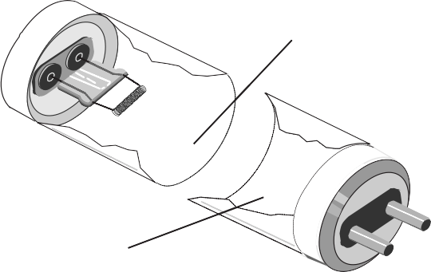Lighting is one of the most important ways we use energy every day. Lighting helps us see our surroundings and can help prevent us from straining our eyes. Traditional light bulbs, called incandescent bulbs, have been replaced by more efficient bulbs like halogens, compact fluorescents, and light emitting diodes (LEDs) on store shelves recently. Let’s read further to investigate why.
Fluorescent Tube Lamp
Mercury and
inert gases
Phosphor coating

Base with bi-pin plug
In fluorescent tubes, a very small amount of mercury mixes with inert gases to conduct the electric current. This allows the phosphor coating on the glass tube to emit light.
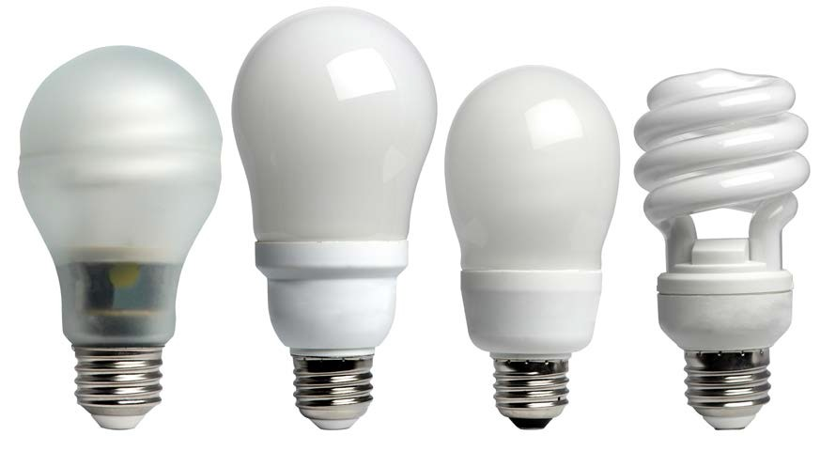Lighting accounts for five percent of a home's energy use, which translates to about 11% of the home's electricity bill. Much of this is the result of using inefficient lighting. Many homes still use incandescent lighting. Only 10 percent of the energy consumed by an incandescent bulb actually produces light; the rest is given off as heat. There are other more efficient lighting choices on the market, including halogens, fluorescents, and LEDs. Halogens are sometimes called energy-saving incandescent bulbs because they last slightly longer, and use less energy than traditional incandescent bulbs, however they can burn hotter than incandescent lights do. Fluorescent lights produce very little heat and are even more efficient. Most schools use fluorescent tube lighting throughout the building, but may use incandescent bulbs in other spaces around the school.
Compact Fluorescent Light Bulbs
CFLs come in a variety of styles for different purposes. CFLs
use about one-third the energy of a halogen incandescent.
Fluorescent lights use 75 percent less energy than traditional incandescents and reduce environmental impacts. Converting to compact fluorescent light bulbs (CFLs) in your home is one of the quickest and easiest ways to decrease your electricity bill. You will save a $30-$80 in electricity costs over the lifetime of every 100- watt incandescent bulb you replace. CFLs provide the same amount of light and save energy.
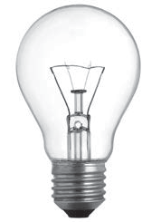A fluorescent lamp is a glass tube lined inside with a phosphor coating. The tube is filled with argon gas and a small amount of mercury. At the ends of the tube are electrodes that generate an electric field when electricity flows through them. The energized electrons cause the mercury gas to emit UV (ultra violet) light. The invisible UV light strikes the phosphor coating, which emits visible light.
Compact fluorescent light bulbs (CFLs) come in a variety of styles for different purposes. CFLs cut lighting costs about 75 percent.
Did You Know?
Only 10 percent of the energy used by a traditional incandescent bulb produces light. The rest is given off as heat.
Fluorescent lights have ballasts that help move the electricity through the gas inside the bulb. There are two types of ballasts, magnetic and electronic. Electronic ballasts are more efficient than magnetic ballasts and can eliminate flickering and noise.

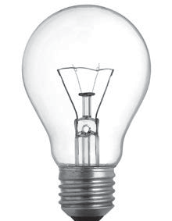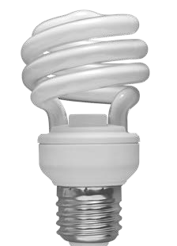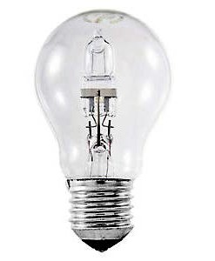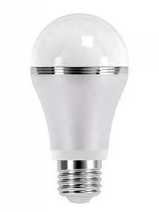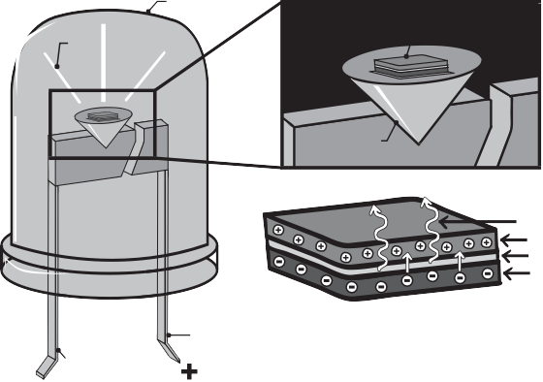Inside an LED
INCANDESCENT BULB HALOGEN BULB CFL BULB LED BULB
LEDs offer better light quality than incandescent bulbs and
halogens, last 25 times as long, and use even less energy than CFLs. LEDs now have a wide array of uses because technology has improved and costs have decreased. It is possible to see CFL use decrease as LED costs continue to improve.

epoxy case

emitted light

LED chip

reflecting cup

photons
p-type layer
p-n type junction n-type layer

cathode lead

anode lead

©2019 The NEED Project www.NEED.org Ohio Energy Project www.ohioenergy.org 19

LEDs have been commonly found in electronic devices and exit signs. Now they are offered as affordable options for lighting in homes and businesses. Light emitting diodes contain semiconductors like solar panels; the difference is in the way the electrical energy is used by the LED. Three layers within the LED – p-type, n-type, and a depletion zone – combine to produce light. A minimum voltage is needed to energize electrons and they move from the n-type layer to the p-type layer. When the electrons move back again, they emit light that we see.
One of the quickest and easiest ways to immediately decrease your electricity bill is to install CFL or LED bulbs in the place of incandescent or halogen bulbs. For every 100-watt incandescent bulb replaced, a savings of $30-$80 can be realized over the lifetime of the bulb. A CFL uses 75 percent less energy than an incandescent, and an LED bulb uses even less energy. CFL and LED bulbs last longer than incandescent bulbs, too. Each type of bulb has benefits as well as drawbacks. For example, a CFL is less expensive than an LED, but it is more fragile, contains mercury, and is not always dimmable. An LED is more durable than a CFL, but it is heavier and is sometimes more expensive. Both types are available in a wide variety of shapes and light colors. When shopping for a replacement bulb, look for ENERGY STAR® rated bulbs for the best quality and energy efficiency ratings, and make sure the bulb you buy produces the same brightness of light, as measured in lumens.
There are a few ways you can save energy on lighting in the home:
switch incandescent bulbs to CFLs or LEDs;
shut off lighting when exiting the room; and
use natural light by opening blinds or curtains when possible.

Facts of Light
Light bulbs can be compared in a variety of ways. When looking at different light bulbs you must consider:
- Lumens: a measure of the amount of light falling on an object at a given distance, often referred to as “brightness.“
- Watts: unit of power, the rate at which a bulb or appliance uses energy.
- Kilowatts: 1000 watts (It is more useful when talking about electricity use than a single watt because we use so many thousands of watts.)
- Kilowatt-hour: the unit in which we buy electricity. It is a unit for energy. It is equal to 1000 watts used for one hour. Kilowatt-hours are calculated by muiltiplying kilowatts by hours used.

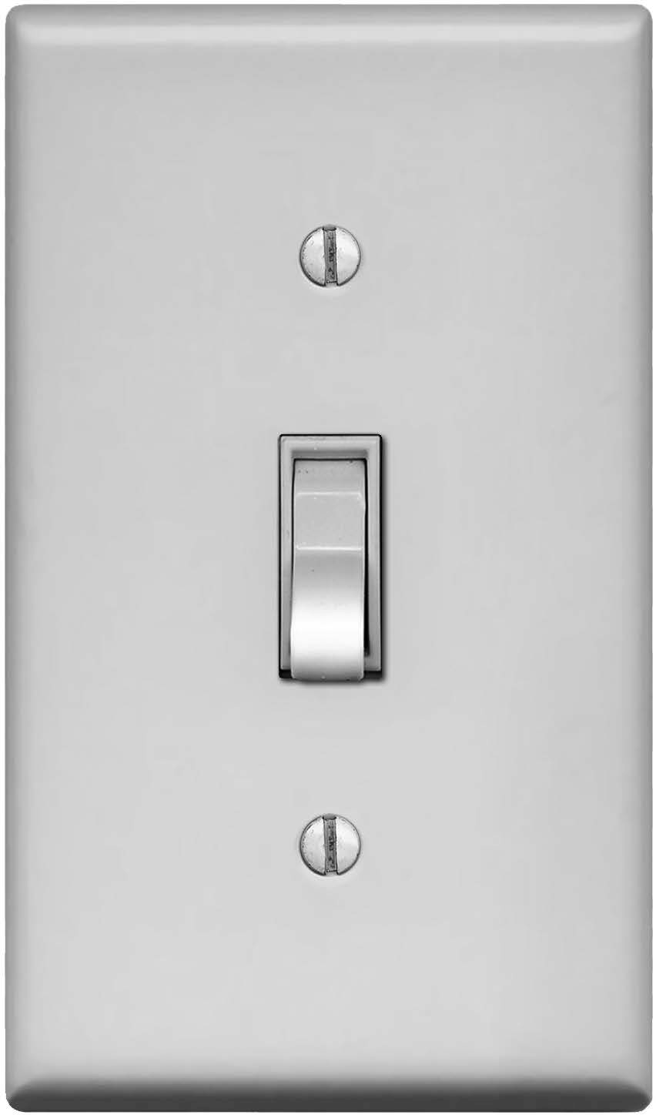

When you leave a room, remember to turn the lights off.

20 ©2019 The NEED Project www.NEED.org Ohio Energy Project www.ohioenergy.org

LESSON 2
Lighting Investigation

? Question
Of the three types of light bulbs, incandescent, CFL, and LED, which produces the greatest temperature change in ten minutes?

 Materials

3 lamp bases 1 Light emitting diode bulb (LED)
1 Incandescent bulb (IL) 3 Digital thermometers
1 Fluorescent bulb (CFL) Ruler
Powerstrip, if available Timer
 Hypothesis

Procedure

- Record student roles for each member in the group:

  - CFL Thermometer Reader
  - IL Thermometer Reader
  - LED Thermometer Reader
  - Timer
  - Data Recorder

- Set up all three light bulbs in their lamp bases and plug each into an outlet.

- Place the digital thermometers on the table beneath each bulb. Be sure to keep everything the same for all three bulbs. Taping the thermometers down works well.

- Take the initial temperature of all three thermometers before turning on the bulbs and record on the data sheet at time“0”. Turn all 3 bulbs on at the same time and begin recording the temperature every minute for 10 minutes.

- After 10 minutes, calculate the change in temperature for each bulb and record.

- Make a line graph of your results. Use a different color line for each of the bulbs. Make a key showing which bulb each color represents. Label the graph and give it a title.

- With your group, answer the questions regarding the results of your temperature investigation.

©2019 The NEED Project www.NEED.org Ohio Energy Project www.ohioenergy.org 21

LESSON 2
Lighting Investigation

DATA SHEET

 | Time (min) | Temperature of IL Bulb (°F) | Temperature of CFL Bulb (°F) | Temperature of LED Bulb (°F)
 | 0
 | 1
 | 2
 | 3
 | 4
 | 5
 | 6
 | 7
 | 8
 | 9
 | 10
 | Change in Temperature ∆T

22 ©2019 The NEED Project www.NEED.org Ohio Energy Project www.ohioenergy.org

Lighting Investigation

GRAPH TITLE

0 1 2 3 4 5 6 7 8 9 10

COLOR KEY: IL CFL LED

©2019 The NEED Project www.NEED.org Ohio Energy Project www.ohioenergy.org 23

LESSON 2
Lighting Investigation Results

- Do your results support your hypothesis? Explain.

- What characteristics do the light bulbs have in common?

- How do the light bulbs differ?

- Which light bulb is coolest in temperature when in use?

- Which bulb is truly a “heat bulb“ not a “light bulb“? Explain your answer.

- What variables remain controlled?

- What was your independent variable?

- What is the dependent variable?

24 ©2019 The NEED Project www.NEED.org Ohio Energy Project www.ohioenergy.org

LESSON 2
25
©2019 The NEED Project www.NEED.org Ohio Energy Project www.ohioenergy.org
Facts of Light Worksheet

How Much Can You Save With Energy Efficient Bulbs?
The graphic on the next page shows three light bulbs that produce the same amount of light. You might put bulbs like these into a bright overhead light. One bulb is an incandescent light bulb, one is a compact fluorescent light bulb (CFL), and another is a light emitting diode (LED). Which one is the better bargain? Let’s do the math and compare the three light bulbs using the residential cost of electricity at $0.11/kWh in Ohio.

- Determine how many bulbs you will need to produce 25,000 hours of light by dividing 25,000 by the number of hours each bulb produces light.

- The price of each bulb has been given to you in the chart on the next page.

- Multiply the number of bulbs you will need by the cost of each bulb to determine the cost of bulbs to produce 25,000 hours of light.

- Multiply the number of kilowatt-hours given to you on the next page by the cost per kilowatt-hour to determine the cost of electricity to produce 25,000 hours of light.

- Add the cost of the bulbs plus the cost of electricity to determine the life cycle cost for each bulb.

LESSON 2
LIFE CYCLE COST
INCANDESCENT BULB (IL)
COMPACT FLUORESCENT (CFL)
LIGHT EMITTING DIODE (LED)
26
©2019 The NEED Project www.NEED.org Ohio Energy Project www.ohioenergy.org
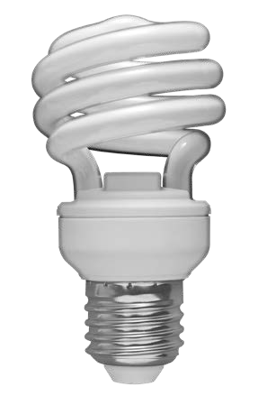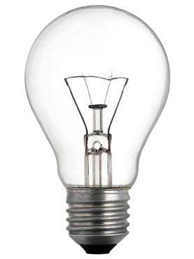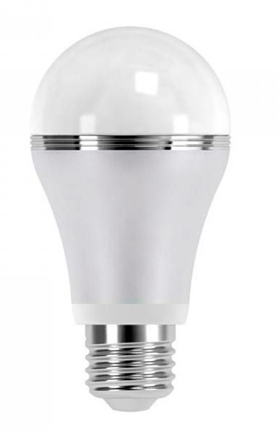Facts of Light

All bulbs provide about 850 lumens of light.
NOTE: When calculating number of bulbs, round up to the nearest whole Number.
COST OF BULB
INCANDESCENT (IL)
COMPACT FLUORESCENT (CFL)
LIGHT EMITTING DIODE (LED)
COST OF ELECTRICITY
INCANDESCENT BULB (IL)
COMPACT FLUORESCENT (CFL)
LIGHT EMITTING DIODE (LED)

Life of bulb (how long it will light) | 1,000 hours | 10,000 hours | 25,000 hours
Number of bulbs to get 25,000 hours
x Price per bulb | $0.50 | $1.50 | $1.33
= Cost of bulbs for 25,000 hours of light

Total Hours |  | 25,000 hours | 25,000 hours | 25,000 hours
x | Wattage | 60 watts = 0.060 kW | 13 watts = 0.013 kW | 12 watts = 0.012 kW
= | Total kWh consumption | 1,500 | 325 | 300
x | Price of electricity per kWh | $0.11 | $0.11 | $0.11
= | Cost of Electricity

Cost of bulbs
+ Cost of electricity
= Life cycle cost

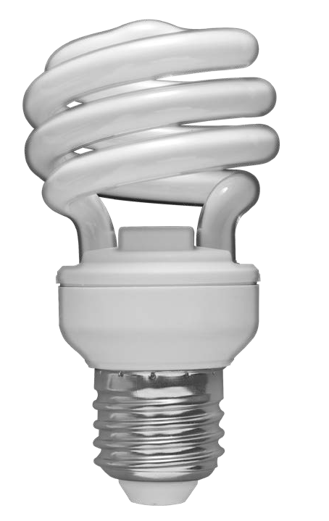LESSON 2
Facts of Light Summary
Use the Facts of Light data to show the life cycle cost of each bulb when used for 25,000 hours.

INCANDESCENT  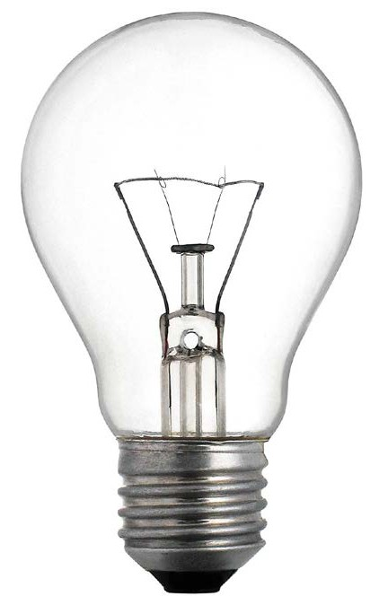 | COST OF INCANDESCENT BULBS | COST OF ELECTRICITY | INCANDESCENT LIFE CYCLE COST
CFL | COST OF CFL BULBS | COST OF ELECTRICITY | CFL LIFE CYCLE COST
LED  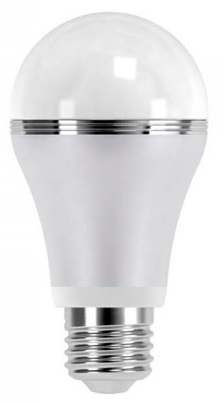 | COST OF LED BULBS | COST OF ELECTRICITY | LED LIFE CYCLE COST
©2019 The NEED Project www.NEED.org Ohio Energy Project www.ohioenergy.org 27

LESSON 2 – Lighting Investigation

ASSESSMENT

  - A CFL uses about of the energy used by an incandescent light bulb.

    - one fourth b. one tenth c. one half d. the same amount

  - An incandescent light bulb converts most of its energy into .

    - light energy b. nuclear energy c. thermal energy d. mechanical energy

  - The average cost of one kilowatt-hour of electricity for homes in Ohio is .

    - 25 cents b. $1.00 c. 11 cents d. 2 cents

  - One of the easiest and cheapest ways to reduce electricity use at home is to .

    - replace windows b. add insulation to the attic

c. replace an old refrigerator d. change an IL to a CFL

  - What do the letters LED stand for? Why are LEDs more efficient?

  - Why should you replace incandescent light bulbs with CFLs or LEDs and not wait until they burn out?

  - How do you calculate the life cycle cost of a light bulb?

28 ©2019 The NEED Project www.NEED.org Ohio Energy Project www.ohioenergy.org

LESSON 2 – Lighting Investigation

CONNECTIONS
- Explain how you would convince someone to replace an incandescent bulb with CFLs or LEDs.

- Discuss the energy consumption of a LED versus an IL using the results of the Lighting Investigation.

- How did you calculate how much money you could save your family by replacing one incandescent bulb with a LED?

©2019 The NEED Project www.NEED.org Ohio Energy Project www.ohioenergy.org 29

LESSON 2
Home Activity

Installing Light Bulbs

Safety note: Be sure to have an ADULT help with the installation of all light bulbs.

 Materials

Light Bulbs
LED Nightlight (if available)
Procedure

  - Share your Facts of Light Summary with your family. Explain how you collected your data and calculated the life cycle cost of each bulb.

  - How many total light bulbs are in your home?

family/living rooms
kitchen (including appliances)
all closets
garage
bathrooms
bedrooms
basement

  - How many CFLs or LEDs are in your home?

No CFLs or LEDs 0 points

1-2 CFLs or LEDs 2 points

3-4 CFLs or LEDs 4 points

> 4 CFLs or LEDs 6 points

  - Look at the nightlight (if available). The cost per year in electricity for an LED nightlight (plugged in constantly) is about $0.02. If you use the nightlight for 80 years, what would the electricity cost you?

  - Install your lightbulb(s) with an adult.

  - When you replace an incandescent bulb with a CFL or LED, what measurement should you use to make sure you are getting a comparable light bulb?

  - Below, complete the sentences with the type of bulb and wattage for each of the bulbs that you replaced in your home.

    - I replaced a watt bulb with an bulb.

    - I replaced a watt bulb with an bulb.

    - I replaced a watt bulb with an bulb.

30 ©2019 The NEED Project www.NEED.org Ohio Energy Project www.ohioenergy.org

LESSON 3

Background Information: Water Heating
Water Heating
Water Consumption of Common Devices
Clothes
Washer
Shower
= 2 Gallons
Dishwasher
Kitchen/
Bathroom Sink
per minute
Gallons Per Use
Data: DOE, Energy Savers Guide

When appliances and faucets use hot water, you pay for the water and the utility costs to heat the water. Save hot water whenever possible.

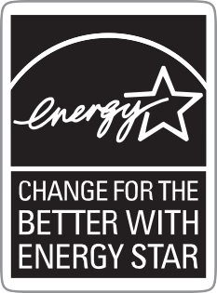Water heating is a significant energy expense in homes. It typically accounts for about 18 percent of the average utility bill. Heated water is used for showers, baths, laundry, dish washing, and cleaning. The greatest cost of washing dishes, bathing, and washing clothes comes from the energy required to heat the water. There are four main ways you can lower your water heating bills:
use less hot water;
turn down the thermostat on your water heater;
insulate your water heater and water pipes; and
buy an ENERGY STAR® or energy efficient water heater, dishwasher, and washing machine.
The easiest way to cut the cost of heating water is to reduce the amount of hot water you use. This can be done with little cost and minor changes in lifestyle. For example, a five minute shower uses 10-25 gallons of water. You can cut that amount in half by using a low-flow shower head.
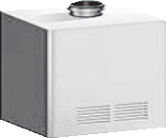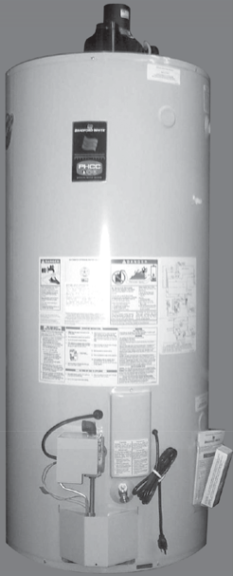Other ways to conserve hot water include taking showers instead of baths, taking shorter showers, fixing leaks in faucets and pipes, and using the lowest temperature wash and rinse settings on clothes washers.
Water Heater Comparison
ANNUAL ENERGY COSTS PER YEAR
$400

$350

$300

$250

$200

$150

$100

$50

$0
STANDARD GAS ENERGY STAR WATER HEATER QUALIFIED GAS TANKLESS
WATER HEATER
Data: ENERGY STAR®
Most water heater thermostats are set much higher than necessary. Lowering the temperature setting on your water heater to 120°F (49°C) saves energy. Lowering the temperature 10 degrees Fahrenheit (6°C) can result in energy savings of $12-
$30 annually. Buying a high efficiency water heater can save
$40-$140 a year.

Natural Gas Safety
Because natural gas is colorless, odorless and tasteless, a chemical called mercaptan is added to the gas before distribution. Mercaptan gives it a “rotten eggs“ smell so that people can detect natural gas leaks.
Natural gas lines are buried underground going to your home. Before your family begins any digging project, be sure to call 811. Local utility companies will mark the utility lines in your yard within 2-3 days of your call so that you can dig safely. It is a law in Ohio to call before you dig!

EnergyGuide Labels

Another way to determine which appliance is more energy efficient is to compare energy usage using EnergyGuide labels. The government requires most appliances to display bright yellow and black EnergyGuide labels. Although these labels do not tell you which appliance is the most efficient, they will tell you the annual energy consumption and operating cost of each appliance so you can compare them.
©2019 The NEED Project www.NEED.org Ohio Energy Project www.ohioenergy.org 31

LESSON 3
Water Heating Investigation

? Question
Is water temperature constant throughout the school and is it set correctly?

 Materials

1 Flow meter bag
1 Hot water gauge
 Hypothesis
Digital thermometer

Procedure

- What energy source fuels the water heating system?
- Record the temperature setting of the hot water thermostat:
With the help of an adult:
- Identify water sources in your school and list them below.
  - With the flow meter bag, measure the water flow of all sources and record on the chart below. FOR YOUR SAFETY: Measure ONLY COLD water with the flow meter bag.
  - With the hot water gauge or digital thermometer, measure the temperature of the hot water at all sources and record on the chart. FOR YOUR SAFETY: BE CAREFUL not to touch the water. NOTE: if there is no color change on the hot water gauge, the temperature is below 120°F.
- Compare the actual temperature to the recommended temperature of 120°F.
- Gather data from the other teams and add below.

LOCATION | WATER FLOW | ACTUAL TEMPERATURE | >, <, OR = TO RECOMMENDED TEMPERATURE OF 120ºF

32 ©2019 The NEED Project www.NEED.org Ohio Energy Project www.ohioenergy.org

Lesson 3 – Water Heating

ASSESSMENT

- The second largest energy expense in your home is .

  - lighting b. heating water c. computers d. refrigeration

- For maximum energy efficiency, the ideal temperature for a water heater is .

a. 100⁰ F b. 200⁰ F c. 120⁰ F d. 180⁰ F

- A device used on a faucet that maintains pressure while conserving water is .

  - an aerator b. a water heater c. a flow meter bag d. a filter

- Which of the following is not a possible energy source for a water heater? .

  - natural gas b. electricity c. propane d. wind

- Identify two ways you can save energy while taking a shower.

- Describe a flow meter bag and how it is used. When measuring water flow rate, what units are used to describe it? Identify an efficient flow rate for a showerhead.

©2019 The NEED Project www.NEED.org Ohio Energy Project www.ohioenergy.org 33

Lesson 3 – Water Heating

CONNECTIONS

- What did you learn using the hot water gauge and the flow meter bag?

- Describe 3 ways your family could reduce your hot water use.

34 ©2019 The NEED Project www.NEED.org Ohio Energy Project www.ohioenergy.org

LESSON 3
Home Activity

Investigating Home Water Heating and Usage
 Materials

Hot water gauge
Flow meter bag
Kitchen sink aerator (if available)
Bathroom sink aerator (if available)
Low flow showerhead (if available)
Teflon tape (if available)
Natural gas scratch n’ sniff card (if available)
Procedure

With the help of an adult:
- Locate the water heater. Read and record the temperature setting of the water heater.
- Locate the EnergyGuide label and record the estimated yearly energy cost.
- Locate the EnergyGuide label and record the efficiency rating.
uses the most energy 0 points
uses more than average energy 2 points
uses average energy 3 points
uses less than average energy 4 points
uses the least energy 6 points
- Use the hot water gauge to measure the temperature of the hot water in your bathroom sink. Is the temp greater than 120°F?
- Use the flow meter bag to measure how much COLD water your main shower uses. If the showerhead is NOT efficient based on the chart on the bag, install the low flow showerhead, if available. Measure again.
- Use the flow meter bag to measure how much COLD water your main bathroom sink and kitchen sink use. If they are NOT efficient based on the chart on the bag, install the energy efficient aerators, if available. Measure again.

WATER FLOW
Main Shower Main Bathroom Sink
Kitchen Sink
BEFORE INSTALLATION
AFTER INSTALLATION
- Share the natural gas scratch n’ sniff card (if available) with family members to ensure everyone can recognize the smell of a gas leak.
- Visit your local utility’s website (listed on the front cover) to find out about other residential energy saving programs, including rebates and online audits.

The Tools
Hot Water Gauge: Measures the temperature of your hot water. See instructions on plastic card.
Flow Meter Bag: Measures the amount of water flow. Instructions are on the bag.
Aerators and Showerheads: Reduce the water flow without reducing pressure. The smaller aerator is for the main bathroom sink; the larger aerator is for the kitchen sink. Install using instructions for the showerhead.
Teflon Tape: Ensures a tight seal for showerhead and aerators.

©2019 The NEED Project www.NEED.org Ohio Energy Project www.ohioenergy.org 35

LESSON 4

Background Information: Insulation, Heating and Cooling
Heat Seeks Balance
Everything in nature seeks balance. Heat seeks balance, too. Heat flows from areas of higher energy to areas of lower energy and from hotter substances to colder substances. What happens if you pour hot water into a cold tub? The molecules of hot water have more energy. They are fast moving. They crash into the colder molecules and give them some of their energy.

Conductors and Insulators
In some materials, heat flows easily from molecule to molecule. These materials are called conductors. They conduct—or move— heat energy well. Materials that don’t conduct heat well are called insulators.
The molecules in good conductors are close together. There is very little space between them. When they vibrate, they push against the molecules near them. The energy flows between them easily.
The molecules in insulators are not so close together. It is harder for energy to flow from one molecule to another in insulators.
Good Conductor
Good Insulator
Heat and Temperature
Heat and temperature are different things. Two cups of boiling water would have twice as much heat as one cup of boiling water, but the water would be at the same temperature.
Temperature is a measure of the average kinetic energy of molecules. The faster the molecules move, the greater the temperature. Heat (thermal energy) is a form of energy that incorporates both the temperature (the speed of the molecules) and the amount of material, or mass of the substance. A bathtub filled with hot water will have more heat (thermal energy) than a cup of hot water at the same temperature because every drop of water has some heat and the bath tub has many more drops.
Cold things have thermal energy, or heat, even though the molecules are moving slowly and the temperature is low. A giant iceberg would have more heat (thermal energy) than a cup of boiling water, even though its temperature is lower. Each frozen particle in the iceberg has a very tiny amount of heat, but when you add them all together it becomes a significant amount of heat (thermal energy).

We Can Measure Temperature
We use thermometers to measure temperature. Thermometers can measure temperature using different scales. In the United States, we typically use the Fahrenheit (F) scale in our daily lives. Scientists typically use the Celsius (C) scale, as do people in most other countries.

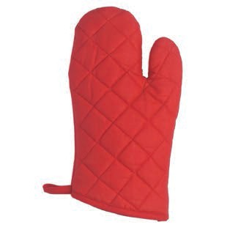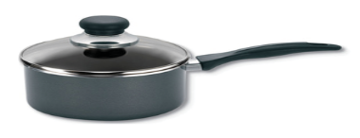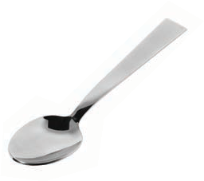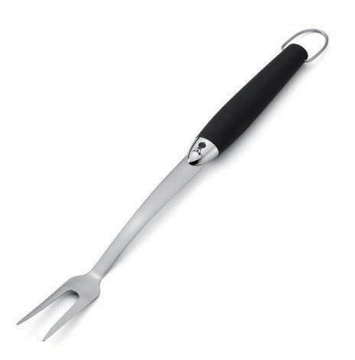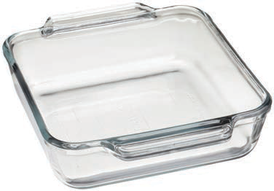Look at the objects to the right. The pot, the spoon, and the fork are made of metal. The pot and the fork have plastic handles. The dish is made of glass. The oven mitt is made of cotton fabric.
Conductors and Insulators
Which materials are the insulators? The insulators are the materials that don’t move heat. They protect us from heat. Our experience tells us that wood, plastic, and cotton are all good insulators. Metals are good conductors. The metal part of the pan moves heat to the food inside to cook the food. The plastic handle protects our hands. The cotton glove protects our hands, too.
What about glass? It is not as good of a conductor or insulator as the other materials. It is used to conduct heat in pots and pans, and can also be used to insulate. Glass was once used on power and telephone lines as an insulator.

36 ©2019 The NEED Project www.NEED.org Ohio Energy Project www.ohioenergy.org

Heating and Cooling Systems

Heating and cooling systems use more energy than any other systems in our homes. Natural gas and electricity are used to heat most homes and electricity is used to cool almost all homes. About half of the costs for the average family’s utility bills are for keeping homes at comfortable temperatures. The energy sources that power these heating and cooling systems can contribute carbon dioxide emissions to the atmosphere. Using these systems wisely can reduce environmental emissions.

With all heating and air conditioning systems, you can save energy and money too by having proper insulation, sealing air leaks, maintaining the equipment, and practicing energy-saving behaviors.
AIR CONDITIONING SYSTEM

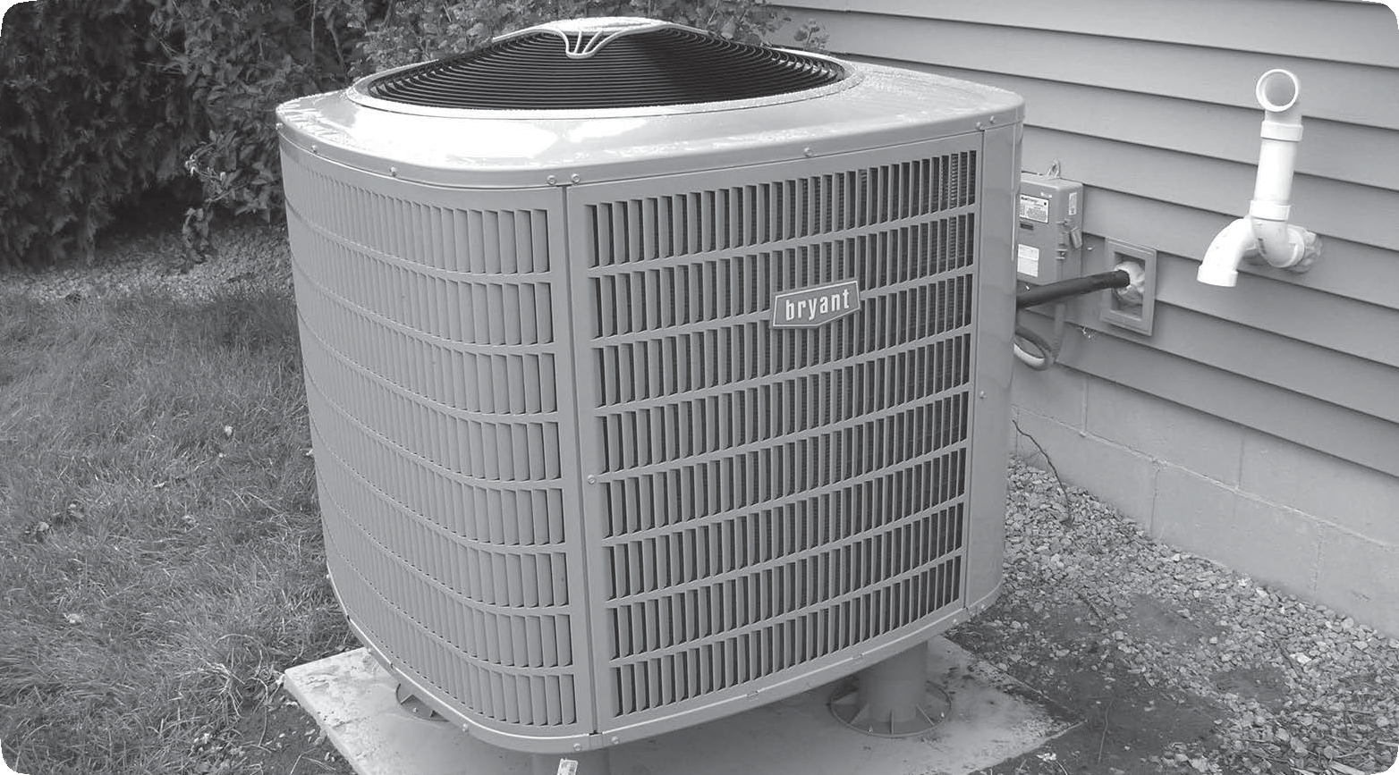

PROGRAMMABLE THERMOSTAT

Programmable Thermostats
Programmable thermostats automatically control the temperature of buildings for time of day and can save energy and money. During heating seasons, for example, they can lower the temperature during the day when no one is home and at night when people are sleeping. In the morning and evening, when people are awake at home, they can automatically raise the temperature. Most consumers set the temperature higher than recommended during heating seasons and lower than recommended during cooling seasons. A temperature setting of 68°F (20°C) during the day and 60-62°F (13-14°C) at night during heating seasons is comfortable, if people dress warmly and use warm blankets. During cooling seasons, a temperature setting of 78°F (25°C) is comfortable, if people dress appropriately and use fans to circulate air. Many programmable thermostats come with pre-loaded settings. Proper use of the pre-programmed settings on a programmable thermostat can save your family about $180 every year in energy costs.
Insulation and Weatherization
Warm air leaking into your home in cooling seasons and out of your home in heating seasons wastes energy. You can reduce heating and cooling costs by investing a few hundred dollars in proper insulation and weatherization products. Insulation is rated using an R-value that indicates the resistance of the material to heat flow. The R-value needed varies, depending on the climate, ceilings, walls, attics, and floors. In very cold climates, a higher R-value is recommended.
Insulation wraps your house in a blanket, but air can still leak in or out through small cracks. Often the effect of many small leaks equals a wide open door. One of the easiest energy-saving measures is to caulk, seal, and weather-strip cracks and openings to the outside. Home performance professionals can seal air leaks in attics and basements. Homeowners typically save up to $200 a

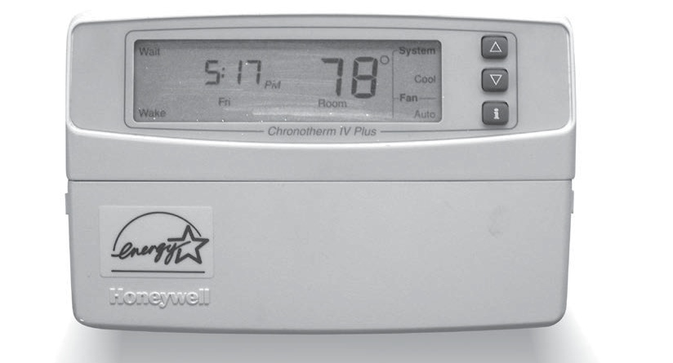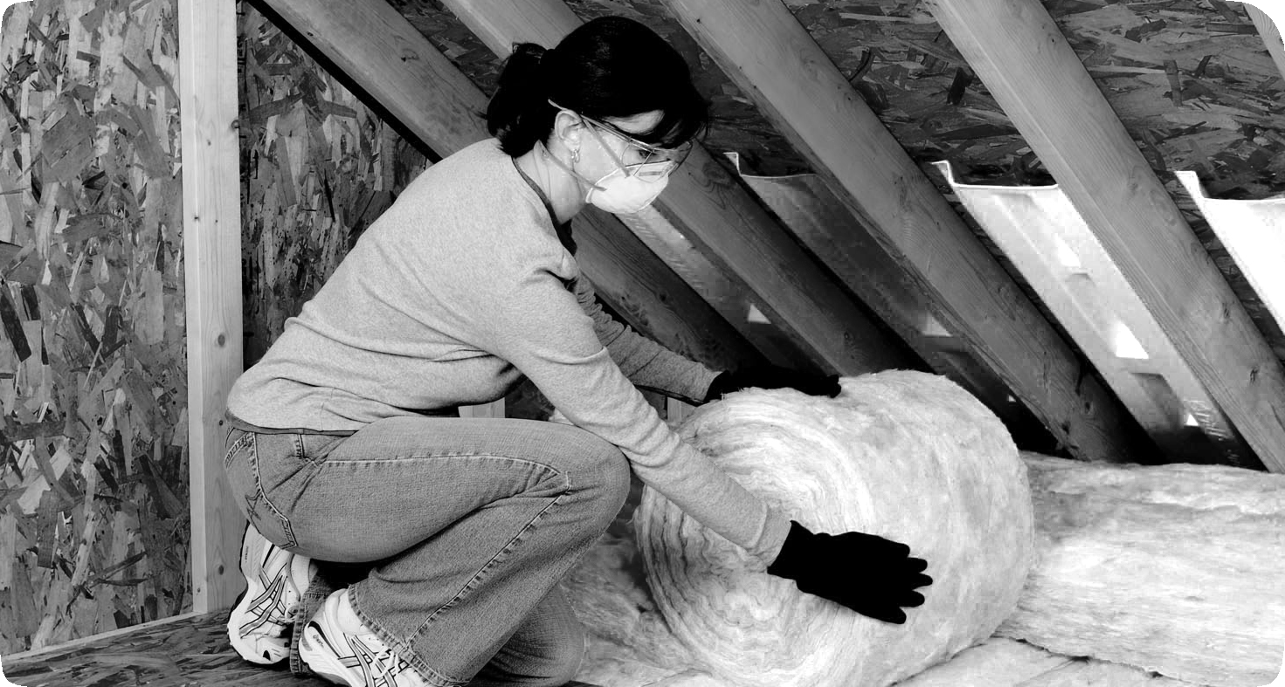INSULATION

Image courtesy of Owens Corning

Major Sources of Air Leaks

Fans and Vents 4%

Doors
11%

Floors, Walls, and Ceilings 31%

year in heating and cooling costs by air sealing their homes and adding insulation.
Doors and Windows
Some of a home’s air leaks occur around and through the doors and windows. Doors should seal tightly and have door sweeps at the bottom to prevent air leaks. Insulated storm doors provide added barriers to leaking air.
Electrical Outlets 2%

Windows
10%

Ducts
15%
Fireplace
14%

Plumbing Entries 13%

Data: U.S. Department of Energy, Energy Savers
©2019 The NEED Project www.NEED.org Ohio Energy Project www.ohioenergy.org 37

Heat Transfer
38

WHAT IS THE DIRECTION OF HEAT TRANSFER?

Draw arrows to show the direction the heat (thermal energy) is moving in the pictures below.

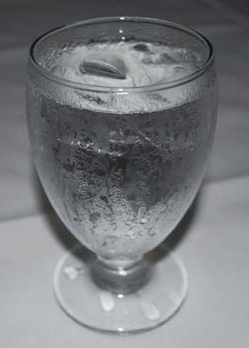Cup of Coffee Glass of Ice Water House on a Summer Day

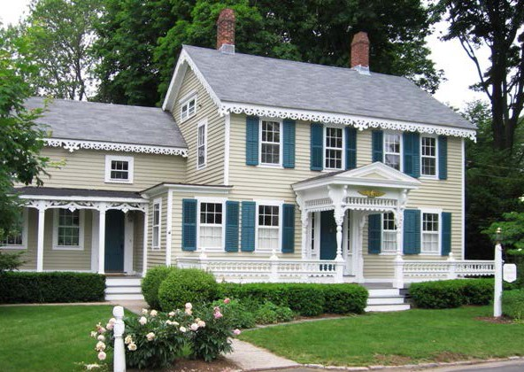

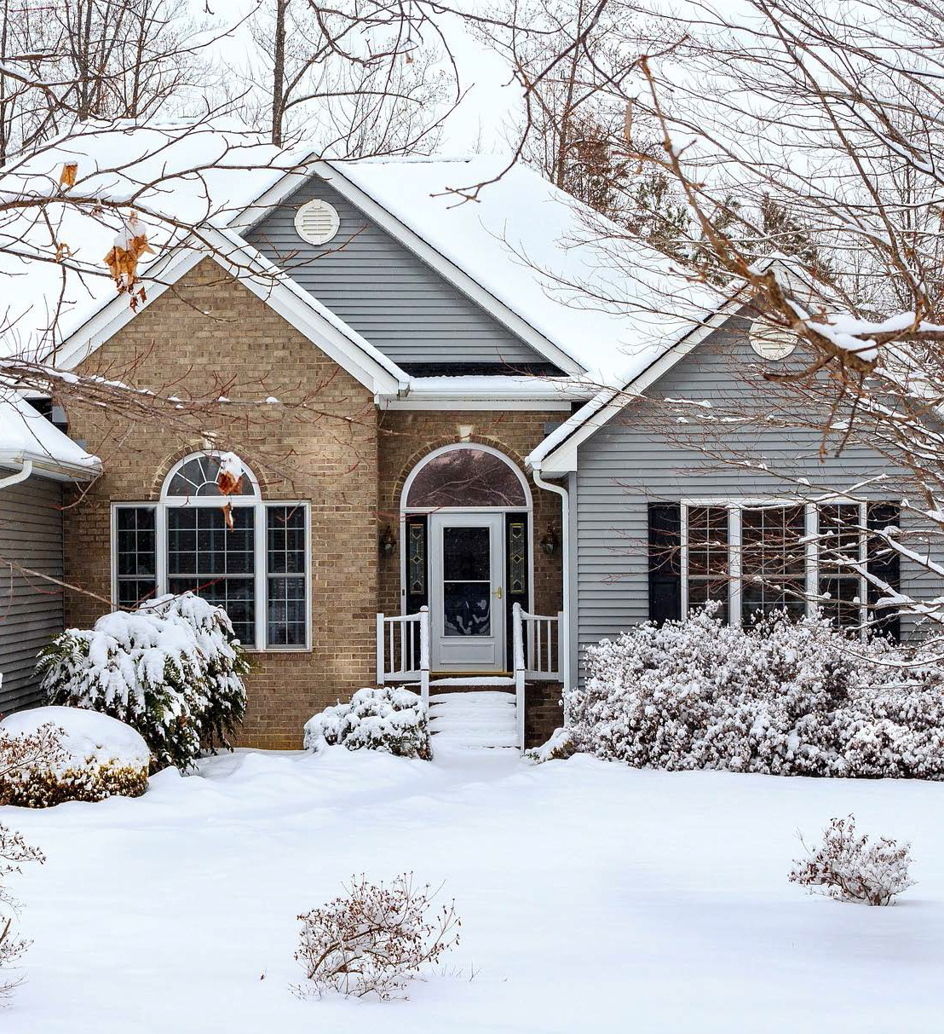House on a Winter Day
©2019 The NEED Project www.NEED.org Ohio Energy Project www.ohioenergy.org

Bathtub of Hot Water

Child in the Snow

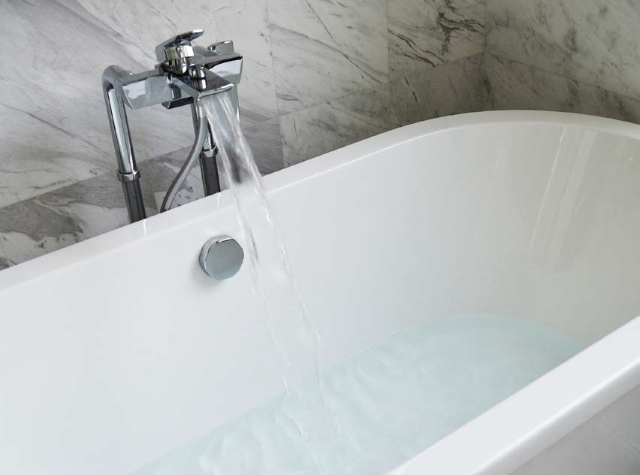

LESSON 4
Insulation, Heating and Cooling Investigation (part 1)

? Question
Are certain materials better for insulating than others?
 Materials

2 Insulation containers
2 Thermometers
Insulating material
 Hypothesis
Masking tape
1 Rubber band
Hot water

Procedure

- Remove the tops from the containers.
- Use the insulating material to insulate one container on the sides only. Use the rubber bands or masking tape to hold the insulation in place.
- Ask your teacher to fill both of your containers with hot water. Replace the tops.
- Suspend a thermometer through the hole in each top, making sure it does not touch the bottom or the sides of the containers.
- In the chart below, record the initial temperature (°F) of the water in the container.
- Record the temperature at one-minute intervals for 10 minutes. Calculate the overall change in temperature (∆T) for both containers.
- Graph the results on the space below.

 Data Table

TYPE OF INSULATION:

TIME (MIN)
0
1
2
3
4
5
6
7
8
9
10
∆T
Insulated temperature
Uninsulated temperature

0 1 2 3 4 5 6 7 8 9 10
©2019 The NEED Project www.NEED.org Ohio Energy Project www.ohioenergy.org 39

LESSON 4
Insulation Investigation Questions
  - In 10 minutes, how much did the temperature of the water in the uninsulated container change?
  - In 10 minutes, how much did the temperature of the water in the insulated container change?
  - After 10 minutes, what was the difference in temperature between the insulated and uninsulated container?
  - Comparing the class data, which material was the best insulator?
  - Which material was the worst
insulator?

  - Draw arrows to show the direction of heat transfer in the experiment.

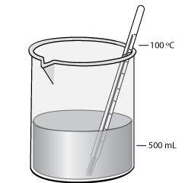

  - Heat transfers from areas of temperature to areas of temperature.

  - What variables in the experiment might make the results unreliable?

  - How might you change the experiment to get more reliable results?

40 ©2019 The NEED Project www.NEED.org Ohio Energy Project www.ohioenergy.org

LESSON 4
Insulation, Heating and Cooling Investigation (part 2)
? Questions
Which rooms in the school will have the highest and lowest temperature?
Which room in the school will have the most heat?
 Materials

Digital thermometer or Thermostat Temperature Guide
 Hypothesis

Procedure

- Find out the answers to the following questions:
Which system is in operation (heating or cooling)?

What energy source fuels the heating system?

What energy source fuels the cooling system?

- Locate the thermostat in the classroom. Record the temperature setting of the thermostat.
- Using the thermometer, record the actual temperature of the classroom.
- Using the Thermostat Temperature Guide at the bottom of the page, determine whether your classroom is saving or wasting energy and by how much.
- Visit other rooms in the school and record the temperature, thermostat setting, and percent of energy saved or wasted in the chart below.

Room | Thermostat Setting (°F) | Actual Temperature (°F) | Energy Saving/Wasting Percentage

- Which room in the school had the highest temperature? The lowest temperature? The most heat (thermal energy)?

- Is your school saving or wasting energy today with heating and cooling?

Thermostat Temperature Guide IN FAHRENHEIT

-20% -10% 0% +10% +20% +30% +40% +50%
+30% +20% +10% 0 -10% -20%
RECOMMENDED HEATING
ENERGY SAVING ENERGY WASTING
ENERGY WASTING
ENERGY SAVING

RECOMMENDED COOLING
©2019 The NEED Project www.NEED.org Ohio Energy Project www.ohioenergy.org 41

Lesson 4 - Insulation, Heating and Cooling

ASSESSMENT

  - Draw an arrow to show how heat will transfer for the following items:

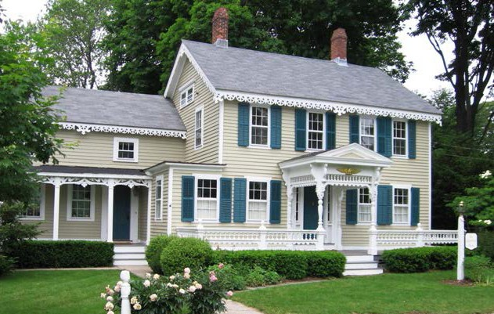Cup of Coffee
House on a Summer Day

  - Weatherstripping resists the transfer of heat and works as a thermal .

    - conductor b. insulator c. contact d. covering

  - A material that allows heat to transfer easily (such as a metal pan) is a thermal .

    - conductor b. wave c. insulator d. coat

  - Which item would have a higher temperature?

    - small flame from a match c. a jug of water

    - glacier d. car

  - Which item would have more thermal or heat energy?

    - small flame from a match c. a jug of water

    - glacier d. car

  - Explain why insulation is important in your home.

  - Explain where the heat energy travels when you leave the refrigerator door open.

42 ©2019 The NEED Project www.NEED.org Ohio Energy Project www.ohioenergy.org

Lesson 4 - Insulation, Heating and Cooling

CONNECTIONS
- List two animals and discuss how they use “natural “insulation to maintain body temperature.

- What are some ways you can be comfortable in your home without adjusting the temperature and using more energy?

- List and explain two ways your family could save energy when heating and cooling your home.

©2019 The NEED Project www.NEED.org Ohio Energy Project www.ohioenergy.org 43

LESSON 4
Home Activity

Investigating Home Insulation and Thermostats
 Materials

Weather stripping
Door sweep and draft stoppers (if available)
Thermostat Temperature Guide on page 41
Procedure

  - Open your outside doors and check the condition of the weather stripping between the doors and the door-frame.
none 0 points
poor 2 points
fair 4 points
good 6 points

  - Using the graphic below, How Air Escapes, decide with your family the five areas of your home you will check for air leaks.

    - V.

  - With the help of an adult, record the thermostat settings for your home:
Cooling Season: Heating Season:

< 74° 0 points
74°-75° 2 points
76°-77° 4 points
> 77° 6 points
>74° 0 points
72°-74° 2 points
69°-71° 4 points
< 69° 6 points

  - Using the Thermostat Temperature Guide on page 41, calculate the percent of energy saved or wasted at this temperature setting.

% energy saved OR % energy wasted

  - Decide with your family two ways you can save energy on heating and cooling.

How Air Escapes

Windows
10%

Doors 11%

Fans and Vents
4%

Electric Outlets
2%

Floors, Walls,
Ceilings
31%

Actions

- With an adult, install the weather stripping (and door sweep and draft stoppers if available).

- Discuss changing the thermostat to the recommended settings of 68°F in the winter and 78°F in the summer.

Plumbing
13%

Fireplaces
14%

Ductwork
15%

Data: DOE, Energy Savers Guide

44 ©2019 The NEED Project www.NEED.org Ohio Energy Project www.ohioenergy.org

LESSON 5

Background Information: Appliances and Machines

Electricity - What’s a Watt?
We use electricity to perform many tasks. We use units called watts, kilowatts, and kilowatt-hours to measure the electricity that we use.
A watt is a measure of the electric power an appliance uses. Every appliance requires a certain number of watts to work correctly. Traditional light bulbs, as well as home appliances, are rated by watts (60, 75, 100), such as a 1500-watt hairdryer. A kilowatt is 1,000 watts. It is used to measure larger amounts of electricity.
A kilowatt-hour (kWh) measures the amount of electricity used in one hour. Sometimes it’s easier to understand these terms if you compare them to a car. A kilowatt is the rate of electric flow, or how much energy you are consuming at a specific instant. In a car, it would be similar to how fast you are driving at one instant. A kilowatt-hour is a quantity or amount of energy, or how much you consumed over a period of time. A kWh is like the distance traveled in a car.
We pay for the electricity we use in kilowatt-hours. Our power company sends us a bill for the number of kilowatt-hours we use every month. Most residential consumers in Ohio pay about 11 cents per kilowatt-hour of electricity. In 2018, Washington state residents paid the least for electricity: 7.94 cents per kilowatt-hour. Hawaii residents paid the most: over 26 cents per kilowatt-hour.
Cost of Electricity
How much does it cost to make electricity? It depends on several factors, such as:
Fuel Cost: The major cost of generating electricity is the cost of the fuel. Many energy sources can be used.
Building Cost: Another key is the cost of building the power plant itself. A plant may be very expensive to build, but the low cost of the fuel can make the electricity economical to produce. Nuclear power plants, for example, are very expensive to build, but their fuel—uranium—is inexpensive. Coal-fired plants, on the other hand, are cheaper to build, but their fuel—coal—is more expensive.
Efficiency: When figuring cost, you must also consider a plant’s efficiency. Efficiency is the amount of useful energy you get out of a system. A totally efficient machine would change all the energy put in it into useful work. Changing one form of energy into another always involves a loss of usable energy.
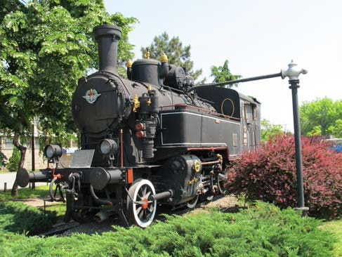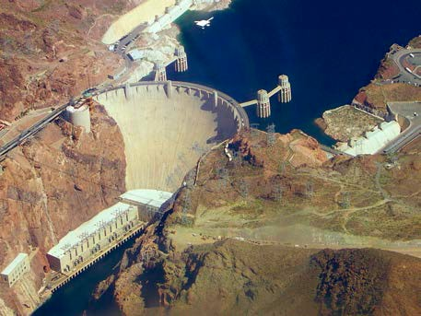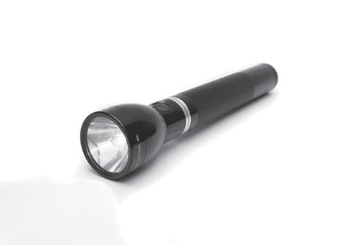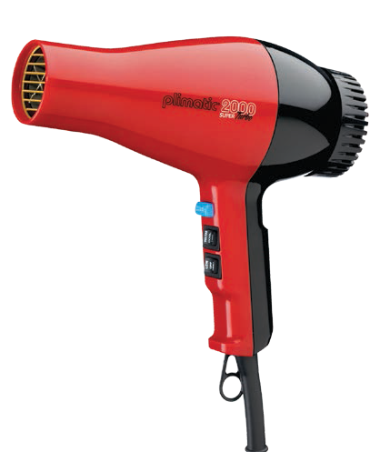In general, today’s power plants use three units of fuel to produce one unit of electricity. Most of the lost energy is waste heat. You can see this waste heat in the great clouds of steam pouring out of giant cooling towers on some power plants. A typical coal plant burns about 4,500 tons of coal each day. About two-thirds of the chemical energy in the coal (3,000 tons) is lost as it is converted first to thermal energy, and then to motion energy, and finally into electrical energy.
How Much Is a Watt?
1 WATT
Small, LED fl t
1.5 KILOWATTS = 1500 WATTS
Blow dryer
3 TO 5 MEGAWATTS = 2 GIGAWATTS =
3,000,000 to 5,000,000 WATTS 2,000,000,000 WATTS
Diesel-electric locomotive engines Peak output of the Hoover Dam

How Much Electricity Do Appliances Use?
Coffee Maker Dishwasher Microwave Refrigerator/Freezer
Hair Dryer Desktop Computer
Laptop Television
Video Game System

Vacuum

0 100 200 300 400 500 600 700 800
kW/Year
Data: DOE, Buildings Data Book

©2019 The NEED Project www.NEED.org Ohio Energy Project www.ohioenergy.org 45

LESSON 5: BACKGROUND INFORMATION
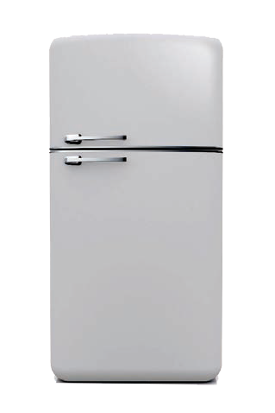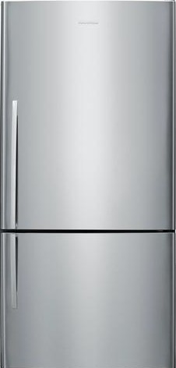Appliances and Machines
Refrigerator Efficiency
2,500 kWh per year
2,000
2,215 kWh
1,500
1,000
500
0
REFRIGERATORS MADE BEFORE 1980

Data: ENERGY STAR®
420 kWh
2014 ENERGY STAR® QUALIFIED REFRIGERATORS
Appliances, machines, and electronic devices use about 24 percent of a typical household’s energy, with refrigerators, freezers, clothes washers and dryers at the top of the list. Any appliance that is designed to change temperature uses a lot of energy. You can save energy by:
turning off appliances and machines when you aren’t using them;
using the energy-saver setting on dishwashers and refrigerators;
keeping the doors closed as much as possible on refrigerators and freezers—know what you want before you open the doors;
being aware that many machines use energy even when turned off—save energy by unplugging them; and
using machines and appliances during the morning and evening, not during peak demand time.
When you shop for a new appliance, you should think of two price tags. The first one covers the purchase price—the down
payment. The second price tag is the cost of operating the SMART POWER STRIPS
appliance. You’ll pay the second price tag on your utility bill every
month for the next 10 to 20 years. An energy efficient appliance will usually cost more, but it will save a lot of money in energy costs. An energy efficient model is almost always a better deal.

Many electronics go into standby mode when turned off. Reduce vampire power by plugging electronics into a smart power strip, which can turn electronics off completely.
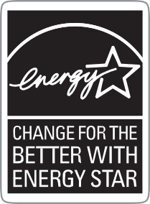ENERGY STAR®
When you shop for a new appliance, look for the blue ENERGY STAR® label—your guarantee that the product saves energy. ENERGY STAR® qualified appliances incorporate advanced technologies that use less energy and water than standard models. A list of energy efficient appliances can be found on the ENERGYSTAR® website at www.energystar.gov.
Vampire Power
Household appliances and electronics contribute to a significant portion of the expenses seen on monthly electric bills. What consumers may not know is a large part of that expense could be a result of items that are not even used. According to energy experts, about 5 to 10 percent of a home’s electricity is used by appliances that are in standby mode. In Ohio, that means approximately $55 to $110 per year could be saved on your electric bill if you knew which electronics and other household items have standby modes and took action to lower this power use. This electricity “loss” is referred to as vampire power.
Many everyday appliances and electronics use significant power while in standby mode. The use and amount depends on the individual product; however, some of these appliances that use vampire power include: clock radios, satellite/cable boxes and digital video recorder (DVR) equipment, televisions, DVD and VCR players, video game consoles, computers and monitors, printers, and microwaves.

46 ©2019 The NEED Project www.NEED.org Ohio Energy Project www.ohioenergy.org

LESSON 5
Appliances and Machines Investigation
? Question
Which items are the largest energy consumers in your home?
 Materials
Kill A Watt® meter
Pluggable appliances

 Hypothesis

Procedure

Calculate how much it costs to operate the machines in your classroom or home. You need to know the wattage, the cost of electricity, and the number of hours a week each machine is used. You can find the wattage by plugging the machine into the watt meter.
You can estimate the number of hours the machine is used each week, then multiply by 52 to get the yearly use. Using the desk lamp as an example, if it is used for twenty hours each week, we can find the yearly use like this:
Yearly use = 20 hours/week x 52 weeks/year = 1,040 hours/year

Remember that electricity is measured in kilowatt-hours. You will need to change the reading from the watt meter (in watts) to kilowatts. One kilowatt is equal to 1,000 watts. To get kilowatts, you must divide the watts by 1,000. For example, if the desk lamp used 12 watts on the watt meter you would divide like this:
kW = W/1,000 kW = 12/1,000 = 0.012
The average cost of electricity in Ohio is about eleven cents ($0.11) a kilowatt-hour. You can use this rate or find out the actual rate from your home’s electric bill. Using the average cost of electricity, we can figure out how much it costs to run the desk lamp for a year by using this formula:
Yearly cost | = | Hours used | x | Kilowatts | x | Cost of electricity (kWh)
Yearly cost | = | 1040 hours/year | x | 0.012 kW | x | $0.11/kWh
Yearly cost | = | 1040 | x | 0.012 | x | $0.11/kWh = | $1.37
*Hint: multiply shaded areas to calculate annual cost.

MACHINE OR APPLIANCE | HOURS PER WEEK  (estimate) | HOURS PER YEAR  (x52) | WATTS (W)  (measured) | KILOWATTS (kW)  (/1000) | RATE ($/kWh)  ($0.11) | ANNUAL COST
Desk lamp | 20 | 1040 hours | 12 W | 0.012 kW | $0.11 | $1.37

©2019 The NEED Project www.NEED.org Ohio Energy Project www.ohioenergy.org 47

LESSON 5 – APPLIANCES AND MACHINES

ASSESSMENT

- Most appliances are powered by .

  - natural gas b. electricity c. propane d. petroleum

- One of the appliances that uses the most energy in your home is the .

  - refrigerator b. computer c. radio d. television

- One kilowatt is equal to watts.

a. 10 b. 100 c. 1000 d. 10,000

- A fan and a hair dryer both move air. How do the watts used by each compare? Explain why there is such a difference.

- Explain how an appliance could have a lower wattage than another but still cost more per year for electricity. Give examples.

48 ©2019 The NEED Project www.NEED.org Ohio Energy Project www.ohioenergy.org

LESSON 5 – APPLIANCES AND MACHINES

CONNECTIONS
- Describe a Kill A WattTM monitor and explain how it can be used to help save energy.

- Looking at the appliances in your home, how can you make your current appliances more efficient? What will you look for when your family purchases a new one?

©2019 The NEED Project www.NEED.org Ohio Energy Project www.ohioenergy.org 49

LESSON 5
Home Activity

APPLIANCES AND ENERGY STAR® LOGOS
 Materials
Refrigerator / freezer thermometer, if available
Dollar bill
Procedure
  - With the help of an adult, test the seal on the door of your refrigerator. To do this, you will need a dollar bill. Close the door over the dollar bill so that it is half in and half out of the refrigerator. Grasp the end of the bill with both hands by the corners and pull slowly and steadily. Do not try to jerk it; it might tear. A refrigerator with a tighter seal (dollar bill does not move) is more efficient and uses less energy. You can save energy and money by keeping the refrigerator door closed tightly.
comes out easily 0 points
comes out fairly easily 2 points
comes out with difficulty 4 points
does not move 6 points

  - Use the refrigerator thermometer to measure the temperature of your refrigerator and freezer and record in the chart below. Leave the thermometer in place 24 hours to get an accurate reading.

APPLIANCE TEMPERATURE SAFE ZONE (oF)
Refrigerator 37°-40°
Freezer Section 0°-5°
Separate Freezer (if applicable) 0° or Colder

  - Look around your house for large or small appliances that have ENERGY STAR® logos on them. Explain to your family that the ENERGY STAR® means the appliances meet strict energy efficiency standards. What ENERGY STAR® appliances did you find?

50 ©2019 The NEED Project www.NEED.org Ohio Energy Project www.ohioenergy.org

LESSON 6 – What Have We Learned?

CONNECTIONS

- What are the most important things you have learned about energy and how to save it?

- What energy concepts would you like to learn more about?

- What things do you think you and your family will do to save energy at home?

- How will saving energy now impact your life later as an adult?

©2019 The NEED Project www.NEED.org Ohio Energy Project www.ohioenergy.org 51

LESSON 6
Home Activity – Your Family Rating

In many of the activities, you and your family rated your energy consumption and efficiency. Now you will add all of those points together to determine your family’s overall rating. Share this information with your family.

Your Ratings
Page 44: Weatherstripping Points: Cooling Points:
Heating Points: Page 35: Water Heater Points: Page 30: Lighting Points: Page 50: Refrigerator Points: TOTAL Points
Rating Guide
28 - 36 EXCELLENT
21 - 27 GOOD START but there’s more we can do
20 or fewer Make a commitment today to save energy at home and at school
Savings Plan
Make a list of things your family can do to save energy and money.

52 ©2019 The NEED Project www.NEED.org Ohio Energy Project www.ohioenergy.org

LESSON 6
What Have We Learned – Family Installation Survey

This program is funded through your local electric and/or natural gas provider. We ask all families to complete this survey to measure the energy savings from the program. Thank you for making a difference and saving money with your energy efficiency actions.
Please visit www.ohioenergy.org to complete the survey.

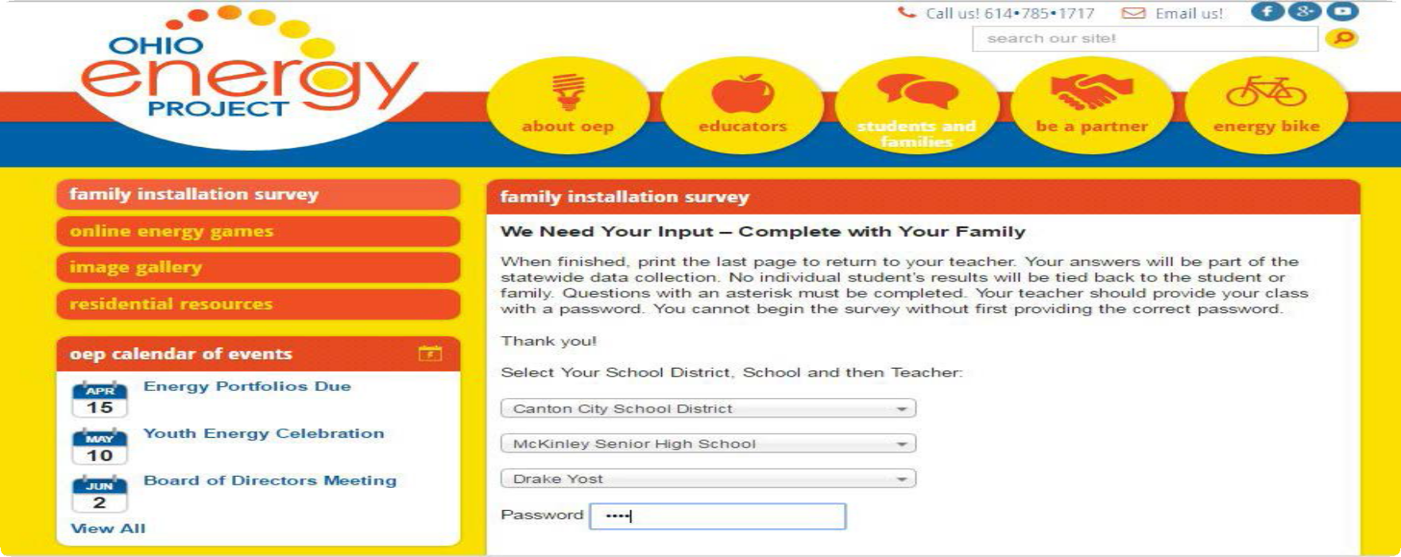

©2019 The NEED Project www.NEED.org Ohio Energy Project www.ohioenergy.org 53

Energy Efficiency Post-Poll
- What is energy?
  - The ability to produce change or do work b. An odorless fossil fuel c. Organic matter d. Technology

- is a form of kinetic energy.

  - Petroleum b. Elastic Energy c. Thermal Energy d. Chemical Energy

- Energy is an action or behavior that results in using less energy.
  - Efficiency b. Conservation c. Sustainability d. Transformations

- What is the amount of light or brightness of a light bulb measured in?
  - Amps b. Watts c. Inches d. Lumens

- percent of energy consumed by an incandescent bulb produces light.
a. 25 b. 10 c. 70 d. 90

- A water heater should be set at .
a. 120 °F b. 65 °F c. 150 °F d. 100 °F

- Mercaptan is added to natural gas to give it a “ ” smell.
  - Mint b. Skunk c. Sweet d. Rotten Eggs

- Heat flows from areas of to areas of .
  - Higher energy; Lower energy b. Moisture; Dryness c. Lower energy; Higher energy d. Solid; Liquid

- refers to electricity loss when appliances are in standby mode.
  - Energy Star b. Kilowatt-hour c. Vampire Power d. Fuel Cost

- What is the unit of measure of the electric power an appliance uses?
a. Joule b. Volt c. Foot-candle d. Watt

54 ©2019 The NEED Project www.NEED.org Ohio Energy Project www.ohioenergy.org

Internet Resources

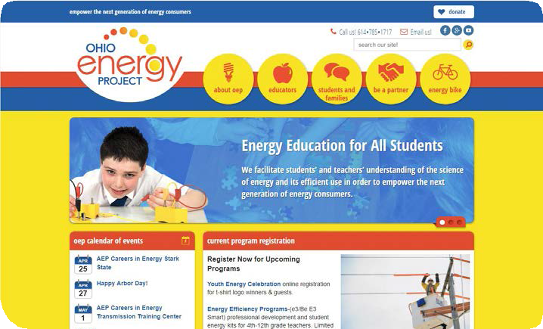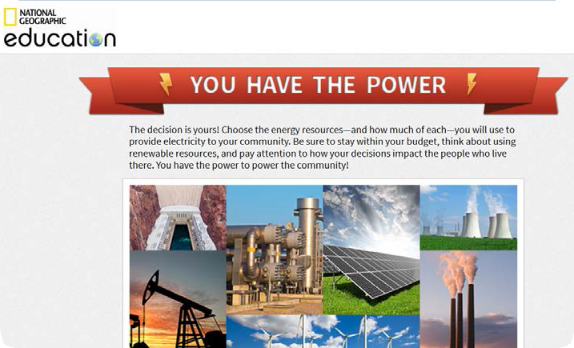

The National Energy Education Development Project
Energy information and activities for students and teachers.
www.need.org
Energy Savings at Home
Ohio Energy Project Programs and resources for teachers in grades 3-12. www.ohioenergy.org.
National Geographic
The decision is yours! Choose the energy resources—and how much of each—you will use to provide electricity to your community.
http://media.education. nationalgeographic.com/assets/ richmedia/0/213/project/index. html?page=intro

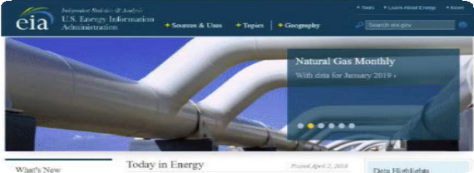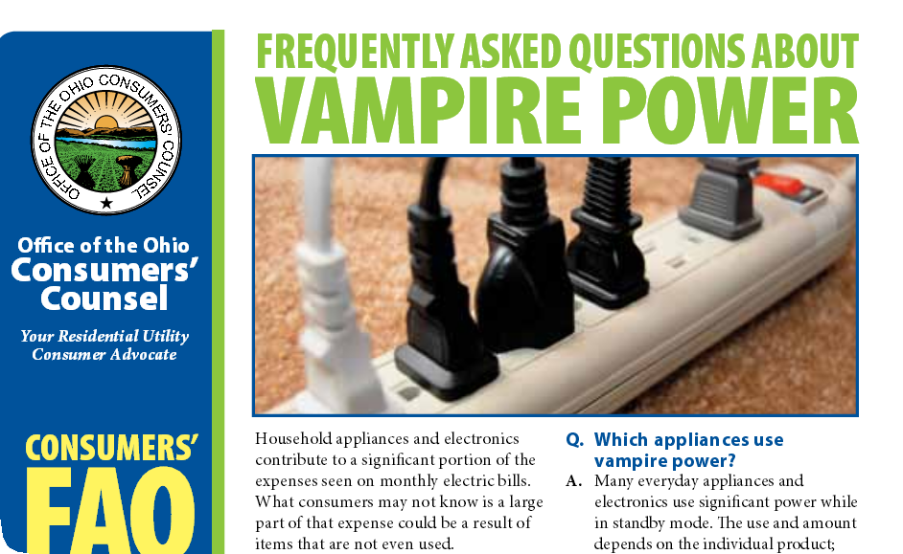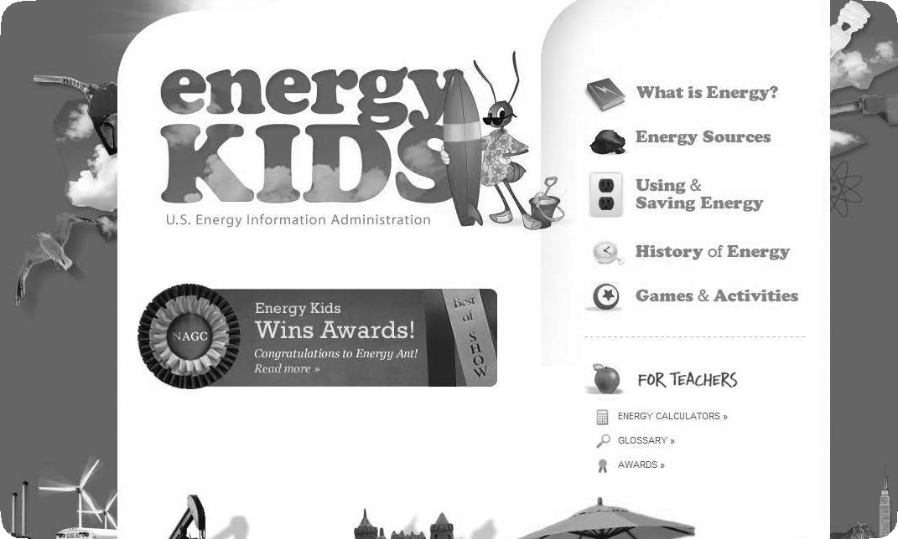

U.S. Energy Information Administration
Learn about the various ways the U.S. uses energy every day.
https://www.eia.gov/
Ohio Consumers Council
Learn ways to save 5-10% of your electric bill by turning off appliances instead of using standby mode.
http://www.occ.ohio.gov/publications/ electric/Vampire_Power.pdf
Energy Kid’s Page
Energy Ant hosts this site containing energy facts, fun and games, classroom activities, and more.
www.eia.gov/kids

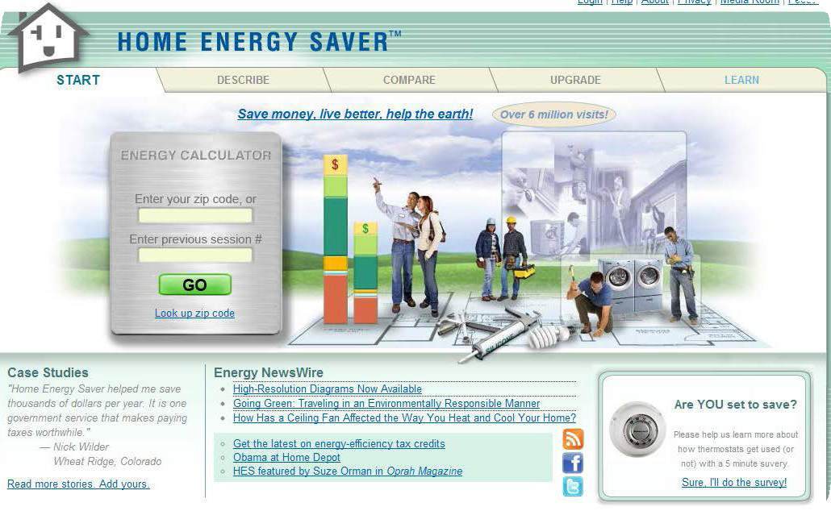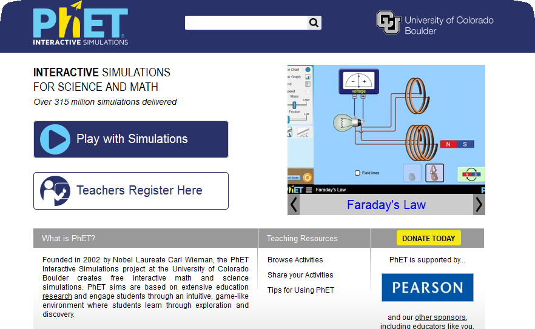

Find Your Efficiency Zone Based on the zip code entered, it will provide a comparison of the energy
costs of an average home and an energy-
efficient home in your area. http://homeenergysaver.lbl.gov/consumer
Argonne National Library STEM resources for both student and teacher.
https://www.anl.gov/education/stem- outreach
Phet
Interactive simulations show how energy works.
http://phet.colorado.edu

©2019 The NEED Project www.NEED.org Ohio Energy Project www.ohioenergy.org 55

The Ohio Energy Project thanks The NEED Project for permission to adapt NEED’s Saving Energy curriculum for use with OEP’s energy efficiency education programs.

AEP - 700 Morrison Drive Gahanna, Oh 43230
Columbia Gas of Ohio - 290 W. Nationwide Blvd Columbus, OH 43215 Dayton Power & Light - 1900 Dryden Road Dayton, Oh 45439
Vectren, A CenterPoint Energy Company - 6500 Clyo Rd. Dayton, OH 45459 Ohio’s Electric Cooperatives - 6677 Busch Blvd. Columbus, OH 43229

