SAVING ENERGY
STUDENT AND FAMILY GUIDE
Secondary
2019-2020

ENERGY EFFICIENCY EDUCATION

Brought to you by:

We spark curiosity about energy.

Message to Families
Ohio Energy Project (OEP) is proud to partner with your local electric and/or natural gas provider to bring our award-winning energy efficiency program to your student’s classroom. As a non-profit organization, OEP’s goal is to spark curiosity about energy in every student that we reach. Our energy efficiency program affords students the opportunity to explore energy science in the classroom and put their knowledge to the test at home, connecting science content standards with real world experiences.
With your support, students will be able to engage with science at home by installing energy saving measures from the Energy Efficiency Kit provided by your sponsoring utility. Once installed, these energy saving measures provide families the opportunity to see how low-cost and no-cost measures can make a substantial difference in lowering energy usage. If you rent your
home, we recommend that you check with your landlord prior to making any modifications.
This Student and Family Guide will allow your student to do additional research on energy usage and will help demonstrate how efforts to save energy can make a difference. At the end of the lessons there is a Family Installation Survey to be completed. This survey, found at www.ohioenergy.org, will allow your student to report on the measures installed and is completely anonymous.
We are thrilled that your family will be participating in this educational opportunity with thousands of other families across Ohio. We encourage you to contact your student’s teacher with any questions you might have. If you are not interested in receiving a free Energy Efficiency Kit, please contact your student’s teacher.

2 ©2019 The NEED Project www.NEED.org Ohio Energy Project www.ohioenergy.org

Energy Efficiency Pre-Poll

is an example of a form of energy.

a. Thermal b. Biomass c. LED d. Lumens

What unit measures power?

  - Inch b. Foot-candle c. Watt d. Work

Which energy sector includes schools?

  - Transportation b. Industrial c. Commercial d. Residential

Energy refers to a behavior that reduces energy usage.

  - Conservation b. Efficiency c. Transformation d. Awareness

refers to the capacity of an insulating material to resist heat flow.

a. Building Envelope b. R-Value c. Weatherization d. System

Of the following, which is the largest consumer of water?

a. Thermoelectric Power Plant b. Residential Homes c. Restaurants d. Schools

The is a nationwide network of transmission lines.

  - Transformer b. Substation c. Distribution Line d. Grid

What label ensures consumers that a product saves energy?

  - Energy Star b. EnergyGuide c. Energy Smart d. Energy Aware

On average, schools use 17% of their electricity consumption to do what?

  - Cook Food b. Operate Computers c. Light Buildings d. Heat Rooms

Which of the following is a career involved with the energy industry?

- Recycling Coordinator b. LEED Construction c. Mechanical Engineer d. All

©2019 The NEED Project www.NEED.org Ohio Energy Project www.ohioenergy.org 3

SAVING ENERGY AT HOME
STUDENT AND FAMILY GUIDE

Table of Contents
Message to Families 2

Pre-Proll 3
Lesson 1: What is Energy? A Review
A. Energy Forms and Sources 5
B. Measuring Energy 8
Lesson 4: Energy as a System 42
A. Energy Audit 43
B. Culminating Projects 50
Home and Community Action 52

C. Energy Economics 10

D. Energy Efficiency and Conservation 13
Home and Community Action 15
Lesson 5: What We Have Learned
A. Post-Poll 53

B. Installation Survey 54
Lesson 2: Thermal Energy 16
A. Heating and Cooling 17
B. Water 24
Home and Community Action 28
Lesson 3: Electrical Energy 29
  - Appliances 32
  - Lighting 36
Home and Community Action 41

4 ©2019 The NEED Project www.NEED.org Ohio Energy Project www.ohioenergy.org

LESSON 1A:
Background Information: What is Energy? A Review

What Is Energy?
Energy allows us to do the things we do every day. Transportation, cooking, even the functioning of your body are all dependent upon energy. Energy changes forms, can be stored, and is almost always in flux.
Energy is defined as the ability to do work or produce change. When energy is stored, we refer to it as potential energy. When it is currently in use, it is called kinetic energy.
Forms of Energy

Energy is found in different forms, such as light, heat, sound, and motion. There are many forms of energy, but they can all be put into two categories: potential and kinetic.

POTENTIAL ENERGY
Potential energy is stored energy and the energy of position, or gravitational potential energy. There are several forms of potential energy.
Chemical energy is energy stored in the bonds of atoms and molecules. It is the energy that holds these particles together. Biomass, petroleum, natural gas, propane, and the foods we eat are examples of stored chemical energy.
Elastic energy is energy stored in objects by the application of a force. Compressed springs and stretched rubber bands are examples of elastic energy.
Nuclear energy is energy stored in the nucleus of an atom; it is the energy that holds the nucleus together. The energy can be released when the nuclei are combined or split apart. Nuclear power plants split the nuclei of uranium atoms in a process called fission. The sun combines the nuclei of hydrogen atoms in a process called fusion.
Gravitational potential energy is the energy of position or place. A rock resting at the top of a hill contains gravitational potential energy because of its position. Hydropower, such as water in a reservoir behind a dam, is an example of gravitational potential energy.

KINETIC ENERGY
Kinetic energy is motion; it is the motion of waves, electrons, atoms, molecules, substances, and objects.
Electrical energy is the movement of electrons. Everything is made of tiny particles called atoms. Atoms are made of even smaller particles called electrons, protons, and neutrons. Applying a force can make some of the electrons move. Electrons moving through a wire are called electricity. Lightning is another example of electrical energy.

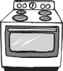
Forms of Energy
POTENTIAL KINETIC
Chemical Energy
Electrical Energy
Elastic Energy
Radiant Energy
Nuclear Energy
Thermal Energy
Motion Energy
Gravitational Potential Energy
Sound Energy

Radiant energy is electromagnetic energy that travels in vertical (transverse) waves. Radiant energy includes visible light, x-rays, gamma rays, and radio waves. Solar energy is an example of radiant energy.
Thermal energy, or heat, is the internal energy in substances; it is the vibration and movement of the atoms and molecules within a substance. The more thermal energy in a substance, the faster the atoms and molecules vibrate and move. Geothermal energy is an example of thermal energy.
Motion energy is the movement of objects and substances from one place to another. Objects and substances move when an unbalanced force is applied according to Newton’s Laws of Motion. Wind is an example of motion energy.

Sound energy is the movement of energy through substances in longitudinal (compression/rarefaction) waves. Sound is produced when a force causes an object or substance to vibrate; the energy is transferred through the substance in a longitudinal wave.

©2019 The NEED Project www.NEED.org Ohio Energy Project www.ohioenergy.org 5

Energy Transformations
The Law of Conservation of Energy says that energy is neither created nor destroyed.
When we use energy, we do not use it completely — we change its form. That’s really what we mean when we say we are using energy. We are changing one form of energy into another. A car engine burns gasoline, converting the chemical energy in the gasoline to motion energy that makes the car move. Old-fashioned windmills changed the kinetic energy of the wind into motion energy to grind grain. Solar cells change radiant energy into electrical energy. Energy changes form but the total energy in the system remains the same.

Sources of Energy
We use many different energy sources to do work for us. They are classified into two groups — renewable and nonrenewable.

RENEWABLE ENERGY
Renewable energy sources are replenished in a short period of time.
- Biomass is any organic matter that can be used as an energy source, such as wood, crops, and yard waste.
- Geothermal energy is heat from within the earth.
- Hydropower is energy that comes from the force of moving water.
- Solar energy is radiant energy from the sun.
U.S. Energy Consumption by Source, 2016
NONRENEWABLE, 89.5%
RENEWABLE, 10.4%
Petroleum
Uses: transportation,
37%
Biomass
4.9%
manufacturing - Includes Propane
Uses: electricity, heating,
transportation
Natural Gas 29.2%
Hydropower 2.5%
Uses: electricity
Uses: electricity, heating,
manufacturing - Includes Propane
Coal
14.6%
Uses: electricity, manufacturing
Wind 2.2%
Uses: electricity
Uranium
Uses: electricity
8.7%
Solar
0.6%
Uses: electricity, heating
*Propane consumption
is included in petroleum and natural gas figures.

Propane
Uses: heating, manufacturing
Geothermal 0.2%
Uses: electricity, heating
Data: Energy Information Administration
**Total does not equal 100% due to independent rounding.
- Wind is energy from moving air.

NONRENEWABLE ENERGY
Nonrenewable energy sources are limited since it takes a very long time to replenish their supply.
- Coal is a solid, black fossil fuel formed from the remains of plants that lived and died millions of years ago.
- Natural Gas is a colorless, odorless fossil fuel made mostly of methane.
- Petroleum is a fossil fuel that looks like a black liquid. It is also known as crude oil.
- Propane is a fossil fuel refined from natural gas and petroleum.
- Uranium is the fuel used by most nuclear power plants. During nuclear fission, atoms are split apart to form smaller atoms, which releases energy.

6 ©2019 The NEED Project www.NEED.org Ohio Energy Project www.ohioenergy.org

LESSON 1A:
Forms and Sources of Energy

In the United States we use a variety of resources to meet our energy needs. Use the information below to analyze how each energy source is stored and delivered.

Using the information from the Forms of Energy section and the graphic below, determine how energy is stored or delivered in each of the sources of energy. Remember, if the source of energy must be burned, the energy is stored as chemical energy.
1

NONRENEWABLE
Petroleum Coal Natural Gas Uranium Propane

2
RENEWABLE
Biomass Hydropower Wind
Solar Geothermal

Look at the U.S. Energy Consumption by Source graphic below and calculate the percentage of the nation’s energy use that each form of energy provides.

What percentage of the nation’s energy is provided
U.S. Energy Consumption by Source, 2016

by each form of energy?

Chemical

Nuclear Motion Thermal Radiant
What percentage of the nation’s energy is provided

By nonrenewables? By renewables?
NONRENEWABLE
PETROLEUM 37%
Uses: transportation, manufacturing - includes propane
NATURAL GAS 29.2%
Uses: heating, manufacturing, electricity - includes propane
COAL 14.6%
Uses: electricity, manufacturing

URANIUM 8.7%
Uses: electricity
RENEWABLE
BIOMASS 4.9%
Uses: heating, electricity, transportation

HYDROPOWER 2.5%
Uses: electricity

WIND 2.2%
Uses: electricity

SOLAR 0.6%
Uses: heating, electricity

PROPANE
Uses: heating, manufacturing
*Propane consumption is included in petroleum and natural gas totals.
GEOTHERMAL 0.2%
Uses: heating, electricity

**Total does not add up to 100% due to independent rounding. Data: Energy Information Administration

©2019 The NEED Project www.NEED.org Ohio Energy Project www.ohioenergy.org 7

LESSON 1B: Measuring Energy

The following are common terms that pertain to energy. You may recognize a few of these terms and formulas as you progress through this guidebook.

 | Term | Definition | Formula  (if applicable) | Unit  (if applicable)
 | Energy | The ability to do work or produce change.
 | Work | A force causing the movement of an object. | = force x distance | Joule
 | Power | The rate at which work is done. | = work / avg. time | Watt
 | Mass | The amount of matter in an object.
 | Force | The push or pull on an object that causes it to accelerate. | = mass x acceleration (a=9.81 m/s2) | Newton
 | Joule | The amount of energy exerted when a force of one newton is applied over one meter.
 | Watt | Unit of power; one watt is equal to one joule of work done per second.
 | Kilowatt | 1,000 watts. | = watt(s) x 1000
 | Kilowatt-hour | The amount of electricity used in one hour. | = kilowatt(s) / # of hours
 | Foot-candle | Measurement of light intensity; the illuminance of one square foot surface from a uniform light source.
 | Volt | Unit of electric potential; often referred to as a ‘push’ that causes electric charges to move. | = current x resistance
 | Ampere | Standard unit of electric current. | = watts / volts
 | Lumen | The measure of brightness from a light source.
 | BTU (British Thermal Unit) | The amount of heat required to raise the temperature of one pound of water by one degree Fahrenheit.
 | Therm | A unit of heat equal to 100,000 BTUs. | = BTU(s) x 100,000
 | Quad | A unit of energy equal to 1 quadrillion (1015) BTUs.  *Quadrillion = 10,000,000,000,000,000 | = BTU(s) x 1015

8 ©2019 The NEED Project www.NEED.org Ohio Energy Project www.ohioenergy.org

LESSON 1B
Human Power

Purpose

Work and power are important energy concepts and both are defined on the previous page. The goal of this experiment is to get familiar with these concepts.

Materials

Scale
Stopwatch
1 - 2 Liter bottle filled with water

Procedure
- Find the mass of the bottle of water in kilograms.
Meter Stick
Pole (such as 1” dowel rod)
Thin rope

- Attach one end of the rope to the bottle and the other end of the rope to the middle of the pole.
- Measure the distance of the rope from the pole to the bottle and record on the chart below.
- Have each person hold the pole horizontally so that the bottle is suspended. Twist the pole so the rope winds around it, lifting the bottle. Time how fast each person can wind the rope to bring the bottle all the way up to the pole. Record your data in seconds.
- Repeat so that each person has 3 tries.
- Using the given mass for your bottle, calculate Force using the chart below.
- Use the chart to calculate average time for each person, work, and power in watts

Person | Mass (kg) | Force (N)  = mass x acceleration (a = 9.81 m/s2) | Distance (m) | Time (sec) | Average Time (sec) | Work (Joule)  = force x distance | Power (Watts)  = work ÷ avg. time
 |  |  |  | 1.
 |  |  |  | 2.
 |  |  |  | 3.
 |  |  |  | 1.
 |  |  |  | 2.
 |  |  |  | 3.
 |  |  |  | 1.
 |  |  |  | 2.
 |  |  |  | 3.

? Questions

- What does it mean if one person has a higher value for power?

- How many of you would it take to light a 60W bulb?

©2019 The NEED Project www.NEED.org Ohio Energy Project www.ohioenergy.org 9

LESSON 1C
U.S. Energy Consumption by Sector, 2016
TRANSPORTATION
28.5%
Top Transportation Sources:
 Petroleum
 Biomass
 Natural Gas
INDUSTRIAL 22.0%
Top Industrial Sources:
RESIDENTIAL 6.2%
Top Residential Sources:
 Natural Gas
 Biomass
 Petroleum
 Natural Gas
 Petroleum
 Propane
COMMERCIAL 4.5%
Top Commercial Sources:
 Natural Gas
 Petroleum
 Propane
ELECTRIC POWER 38.7%
Top Electric Power Sources:
 Coal
 Naturals Gas
 Uranium
The residential, commercial, and industrial sectors use electricity. This graph
depicts their energy source consumption outside of electricity.
Data: Energy Information Administration
*Total does not equal 100% due to independent rounding.
Energy Economics
Imagine how much energy you use every day. You wake up to an electric alarm clock and charge your cell phone. You take a shower with water warmed by a hot water heater using electricity or natural gas. You listen to music on your device as you catch the bus to school. And that’s just some of the energy you use to get you through the first part of your day!
Every day, the average American uses about as much energy as is stored in a little more than seven gallons of gasoline. That’s every person, every day. Over a course of one year, the sum of this energy is equal to a little more than 2,500 gallons of gasoline per person. This use of energy is called energy consumption.
The U.S. Department of Energy uses categories to classify energy users — residential, commercial, industrial, transportation, and electric power generation. These categories are called the sectors of the economy.
U.S. School Energy Consumption
Cooling 10.81%
Space Heating 35.51%
Ventilation
8.08%
Water Heating 8.08%

Lighting 9.26%
Cooking 1.78%

Refrigeration 4.75%
Other 9.98%
Computing 9.26%
Office Equipment 2.49%
Data: EIA Commercial Building Energy Survey

Residential/Commercial Sector
The residential sector includes houses, apartments, and other places where people live. The commercial sector includes schools, businesses, and hospitals. The residential and commercial sectors are put together because they use energy for similar tasks — for heating, air conditioning, water heating, lighting, and operating appliances. Schools use energy a little differently than homes. By far, the greatest energy users in schools are space heating and cooling, making up almost half the energy used in schools. The other big energy users are ventilation, water heating, lighting, and computing.

Transportation Sector

Americans make up about 4.3 percent of the world’s population, yet we own nearly 16 percent of the world’s automobiles. The transportation sector of the economy accounts for more than 28 percent of total energy use. America is a country on the move. For model year 2016, the average motor vehicle uses 665 gallons of gasoline every year. You can achieve 10 percent fuel savings by improving your driving habits and keeping your car properly maintained. Over the life of a vehicle, your family can save a lot of money on gas by choosing a fuel-efficient model.

Electric Power Generation

The electric power sector includes electricity generation facilities and power plants. All of the other sectors consume electricity generated by the electric power sector. The electric power sector consumed 38.71 percent of the total energy supply in 2016, more than any of the other sectors, with a total of 37.71 quads.

Industrial Sector

Manufacturing the goods we use every day consumes an enormous amount of energy. The industrial sector of the economy consumes about one-fifth of the nation’s energy. In industry, energy efficiency and conservation are driven by economics — money. Manufacturers know that they must keep their product costs low so people will buy them.
Since energy is one of the biggest costs in many industries, manufacturers must use as little energy as possible. Their demand for energy efficient equipment has resulted in many new technologies in the last decades. Consumers can have an effect on industrial energy use through the product choices we make and what we do with the packaging and the products we no longer use.
10 ©2019 The NEED Project www.NEED.org Ohio Energy Project www.ohioenergy.org

LESSON 1C
Energy Through the Decades
In the United States, energy production and consumption have changed over time. Due to technological advancements, a growing population, and the shifting social and political climates, these changes have transformed the energy landscape over the last five decades. Let’s explore how and why below.
Directions: Study the timeline and charts below to answer the questions in the spaces provided on the next page.

Timeline

1970s
1970 – Environmental Protection Agency (EPA) created.
1977– Department of Energy created.
1978– U.S. Department of Energy (DOE) funding for geothermal research and development was increased substantially.
1980s
1982 – First solar-thermal power plant opened in California.
1986– The Perry power plant in Ohio became the 100th U.S. nuclear power plant in operation.
1989– High efficiency PV cells developed.
1990s
1990– Iraq invades Kuwait causing crude oil price increase.
1992– President Bush issues Executive Order 12780, which stimulates waste reduction, recycling, and the buying of recycled goods in all federal agencies.
1999– First hybrid electric vehicle, powered by both a rechargeable battery and gasoline, becomes available in the U.S.
2000s
2000– EPA establishes a link between global climate change and solid waste management, noting that waste reduction and recycling can help reduce greenhouse gas emissions.
2005– Energy Policy Act promotes the use of coal through clean coal technologies.
2006– The U.S. ranks among the top 4 countries in the world for hydroelectric generation, along with China, Canada, and Brazil, generating 44% of the world’s electricity from hydropower.
2010s
2011– Natural gas fracking booms in Ohio as the use of horizontal drilling in conjunction with hydraulic fracturing begins.
2016– Wind power surpasses hydropower to become nation’s leading renewable resource.
2017– Renewable energy production and consumption reach record highs at 11 quadrillion Btu.

©2019 The NEED Project www.NEED.org Ohio Energy Project www.ohioenergy.org 11

LESSON 1:

Basic Energy Information - United States
DATE | POPULATION | CHANGE PER DECADE | PRODUCTION (IN QUADS) | CHANGE PER DECADE | CONSUMPTION (IN QUADS) | CHANGE PER DECADE
1970 | 205,100,000 | X | 63.5 | X | 67.8 | X
1980 | 227,200,000 | 22,100,000 | 67.2 | 3.7 | 78.1 | 10.3
1990 | 249,600,000 |  | 70.7 |  | 84.5
2000 | 282,200,000 |  | 71.3 |  | 98.8
2010 | 309,100,000 |  | 75.0 |  | 98.0
2017 | 325,700,000 |  | 88.1 |  | 97.7
Energy Production By Source (Quadrillion Btu) - United States
DATE | COAL | NATURAL GAS | PETROLEUM | URANIUM (NUCLEAR) | RENEWABLES
1970 | 14.6 | 21.7 | 20.4 | 0.2 | 4.1
1980 | 18.6 | 19.9 | 18.2 | 2.7 | 5.4
1990 | 22.5 | 18.3 | 15.6 | 6.1 | 6.0
2000 | 22.7 | 19.7 | 12.4 | 7.9 | 6.1
2010 | 22.1 | 22.1 | 11.7 | 8.4 | 8.1
2017 | 15.6 | 28.3 | 19.5 | 8.4 | 11.2

Energy Consumption By Source (Quadrillion Btu) - United States
DATE | COAL | NATURAL GAS | PETROLEUM | URANIUM (NUCLEAR) | RENEWABLES
1970 | 12.3 | 21.8 | 29.5 | 0.2 | 4.1
1980 | 15.4 | 20.2 | 34.2 | 2.7 | 5.4
1990 | 19.2 | 19.6 | 33.6 | 6.1 | 6.0
2000 | 22.6 | 23.8 | 38.3 | 7.9 | 6.1
2010 | 20.8 | 24.5 | 36.0 | 8.4 | 8.0
Data: EIA2017 | 13.9 | 28.0 | 36.2 | 8.4 | 11.0

Questions

- Calculate the changes per decade in Population, Energy Production, and Energy Consumption by completing the Basic Energy Information Chart above.

- What event(s) may have led to the steady rise of renewable energy production and consumption?

- Has our consumption ever outweighed our production of energy? Explain how this can occur.

- Pick an event from the timeline and describe its relationship to the tables above. How was this event significant to our production and/or consumption of energy?

- Add an event to the energy timeline above. How was this event significant to our production and/or consumption of energy?

12 ©2019 The NEED Project www.NEED.org Ohio Energy Project www.ohioenergy.org

LESSON 1D
Energy Efficiency and Conservation

Efficiency

Energy efficiency is the amount of useful energy you get from a system. A perfect, energy efficient machine would change all the energy put into it into useful work – a technological impossibility today. Converting one form of energy into another form always involves a loss of usable energy.
When we discuss energy efficiency, we really are talking about the machines or equipment we are using to complete a task. It might be a washing machine, a light bulb, or your family’s vehicle, but they’re all some kind of device that does work for us. If we say we are being more energy efficient, we are using devices that use less energy to perform the work. For example, a heavy-duty pickup truck and a small sedan will both carry two people to work. However, the small sedan will use less fuel to do so, so it is more efficient. The ENERGY STAR® program identifies which devices are most efficient. We discuss this program further in Lesson 3.

Energy Conservation

When discussing how much energy we use, conservation refers to how we behave while using that energy. For example, the owners of the most efficiently built home can still waste energy if they leave the lights on and the refrigerator door open while pouring a glass of milk. People who have older, less efficient appliances can still save energy by using them wisely. Energy conservation refers to the things we choose to do that use less energy.

Did You Know?

Some buildings right here in Ohio are working to become LEED certified. What does this mean and why should we care? LEED (Leadership in Energy and Environmental Design) certification is a commonly used green building certification throughout the U.S. Green buildings are known to use fewer resources, reduce waste, and minimize environmental impacts in their regions. Talk about energy efficiency! To learn more about green buildings and LEED certification, visit the U.S. Green Building Council’s website at www.new.usgbc.org.

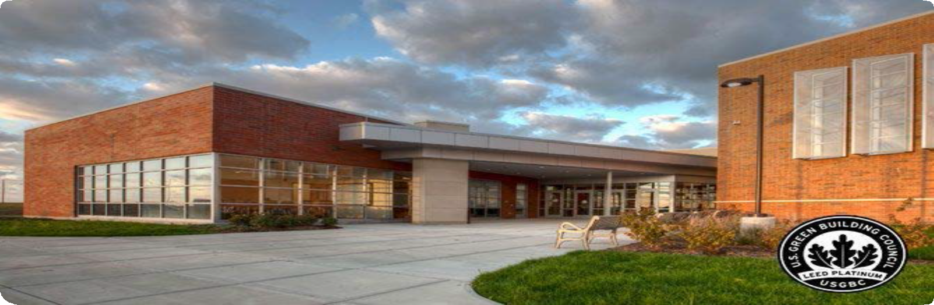

London Middle School of Madison County, OH is one of the many LEED certified schools in Ohio.

©2019 The NEED Project www.NEED.org Ohio Energy Project www.ohioenergy.org 13

LESSON 1D
Efficiency vs. Conservation
- Choose a sector of the economy. Create a fictitious scenario from that sector that describes good energy efficiency but bad energy conservation.

- Choose a sector of the economy different from what you used in number 1. Create a fictitious scenario from that sector that describes bad energy efficiency but good energy conservation.

GOOD ENERGY EFFICIENCY BUT BAD ENERGY CONSERVATION
BAD ENERGY EFFICIENCY BUT GOOD ENERGY CONSERVATION

- Re-read the two scenarios you created in numbers 1 and 2 above. Using evidence from the text, explain which scenario you believe would have the greatest impact (reduction or increase) on our total energy use as a nation if everyone in that sector employed it. Explain your reasoning well.

14 ©2019 The NEED Project www.NEED.org Ohio Energy Project www.ohioenergy.org

LESSON 1
Home & Community

Energy in Action:

- What energy sources are used to generate electricity for your home and community?

- Share your knowledge about safety when it comes to using energy in your home and community.

- Describe how you can apply the concepts of efficiency and conservation to your everyday life.

Web Quest:

- Identify one of the LEED platinum schools in Ohio (not pictured in the guide) and describe how they were able to achieve this status.

- Confirm your local utility partner(s) on the cover of your student guide or with your teacher and record below.

- Visit your utility partner’s website and search for information regarding the following:
  - Safety
    - List 3 important safety tips to share with your family regarding energy.

Career Connections:

LEED Project Manager – Oversee the construction of LEED certified green building projects.
Conservation Scientist – Monitor land quality of forests, parks, rangelands, and other natural resources.
Power Dispatcher – Monitor and operate equipment that regulates and/or distributes electricity or steam. Recycling Coordinator – Oversee curbside and drop - off recycling programs for private firms and local governments. Earth Driller – Heavy equipment operator skilled in extracting natural resources.
Green Construction Carpenter – Construct and repair buildings, roads, bridges, and other structures.

©2019 The NEED Project www.NEED.org Ohio Energy Project www.ohioenergy.org 15

LESSON 2
Background Information: Thermal Energy

What exactly is thermal energy? Thermal energy is the internal energy within a substance that causes its particles to move. The more thermal energy an object has, the faster its particles – its atoms and molecules – are moving. As you might expect, the molecules in a block of ice (solid) are just vibrating in place while the molecules in a glass of water (liquid) are moving around each other. The ice molecules have less thermal energy than the water molecules do, and they are held in place. If you boil water, the molecules in the steam (gas) have enough thermal energy to break free from each other and move around independently.
Heat ≠ Temperature
Measuring the temperature of something does not directly tell you how much thermal energy that object has. However, it does give you an idea of how much thermal energy the atoms or molecules in that object might have. High temperatures tell us that the particles have more energy, on average. Low temperatures indicate that the particles have less energy. Thermal energy is dependent on the temperature and mass of the substance.
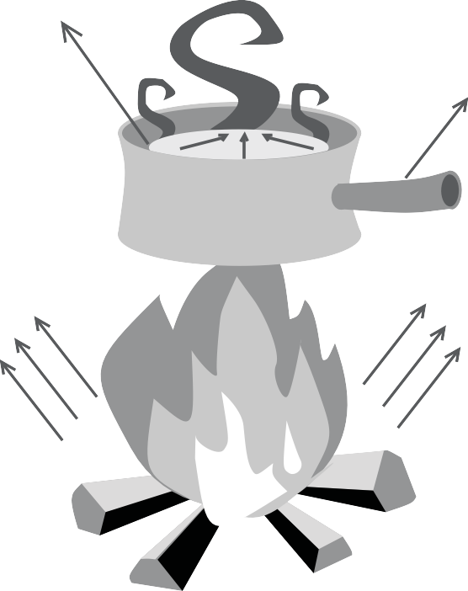As long as you are comparing the solid, liquid, and gaseous state of the same substance, it is safe to say solids have the least amount of thermal energy and gases have the most. However, because different substances have the ability to retain different amounts of thermal energy, it is not always the case. For example, a gram of ice will have more thermal energy than a gram of oxygen gas. The amount of thermal energy a substance can retain is called its specific heat capacity, and it is different for each element or compound. Substances with a high specific heat capacity require a lot of thermal energy to increase in temperature, but they also can hold that energy for a longer time. Glass, water, and ceramics have high specific heat capacities. A substance with a lower specific heat capacity will heat up quickly and cool down quickly. Specific heat capacity factors into whether a substance is used to transfer thermal energy to heat a space.
CONVECTION

CONDUCTION

RADIATION
Thermal energy is transferred via three mechanisms: conduction, convection, and radiation. Conduction occurs when thermal energy is transferred from one object in direct contact with another object. In order for conduction to be feasible, the substance being used to transfer the energy must be a good conductor. In general, metals are good thermal conductors and non-metals are not. That is why cookware is often made of metals like copper, iron, and stainless steel. Metals typically have low specific heat capacities, which is a desired quality in this case because the purpose is not to heat the cooking pot, but to transfer the heat from the burner to the food inside the pot.
Convection transfers thermal energy by heating a fluid, then circulating that fluid. The fluid must have a specific heat capacity large enough to make convection a worthwhile way to heat a space. Water has a very high specific heat capacity, and makes an excellent fluid for convection. The water is heated in a boiler, then circulated through pipes or tubes, releasing some of its energy and returning to the boiler at a lower temperature. Air does not have as high a specific heat capacity as water, but because it is easy to circulate air with fans, it is used in forced-air heating systems.
Radiation is the third mechanism for transferring thermal energy, and it does not require the assistance of a substance like steel or water. Rather, the thermal energy is emitted from the hot object in waves. You have experienced radiation if you’ve ever sat around a fire on a cool evening, toasting marshmallows or warming your hands. The thermal energy source is the combustion of the wood and paper on the fire, and you can feel the thermal energy radiating outward from the fire.
16 ©2019 The NEED Project www.NEED.org Ohio Energy Project www.ohioenergy.org

LESSON 2A: Heating and Cooling
Heating and Cooling Systems

Heating and cooling systems use more energy than any other systems in residential and commercial buildings. Natural gas and electricity are usually used to heat, and electricity is used to cool. The energy sources that power these heating and cooling systems contribute carbon dioxide emissions to the atmosphere. Using these systems wisely can reduce environmental emissions.
With all heating and air conditioning systems, you can save energy and money too, by having proper insulation, sealing air leaks, maintaining the equipment, and practicing energy-saving behaviors.
When we build schools, homes, and office buildings, significant thought is put into how the inside of the building will remain comfortable for the occupants – the people inside. The materials selected must be able to keep warm air from mixing with cool air; they must be good insulators, and limit the transfers of thermal energy.

Programmable Thermostats

Programmable thermostats automatically control the temperature of buildings for time of day and can save energy and money. During heating seasons, for example, they lower the temperature of a building when no one is using it. When people are active in the building, the thermostat automatically raises the temperature. These controls are available for commercial buildings, from as simple as one programmable thermostat to a whole system of temperature sensors connected to a computer, depending on the building’s size. Many newer schools and those that have been upgraded with new heating systems have a central computer that monitors the temperature in each room and adjusts the heating system accordingly.

Insulation and Weatherization

Air leaking into or out of a building wastes energy. Insulation prevents thermal energy transfer to keep the interior room comfortable and separated from the exterior air. Building owners can reduce heating and cooling costs by investing in proper insulation and weatherization products.
The parts of the building that separate indoors from outdoors construct the building envelope. The walls, floor, roof, doors, and windows are parts of the building envelope system. Their purpose is to keep the interior of the building a comfortable, healthy place to work or learn while allowing access into and out of the building.
The space above the ceiling, below the floor, and within walls is filled with insulation, which prevents thermal energy transfer. Insulation is graded by its R-value, which is an abbreviation for its resistance to thermal energy transfer. Different materials have different R-values, and the amount of insulation needed in total R-value varies according to the climate in which you live. Industry professionals calculate the R-value per inch thickness of different materials and builders install the appropriate thickness of locally- available materials to provide the proper amount of insulation. The materials used in buildings in your area depend on what is easily available and how many people are trained in their installation.

INSULATION

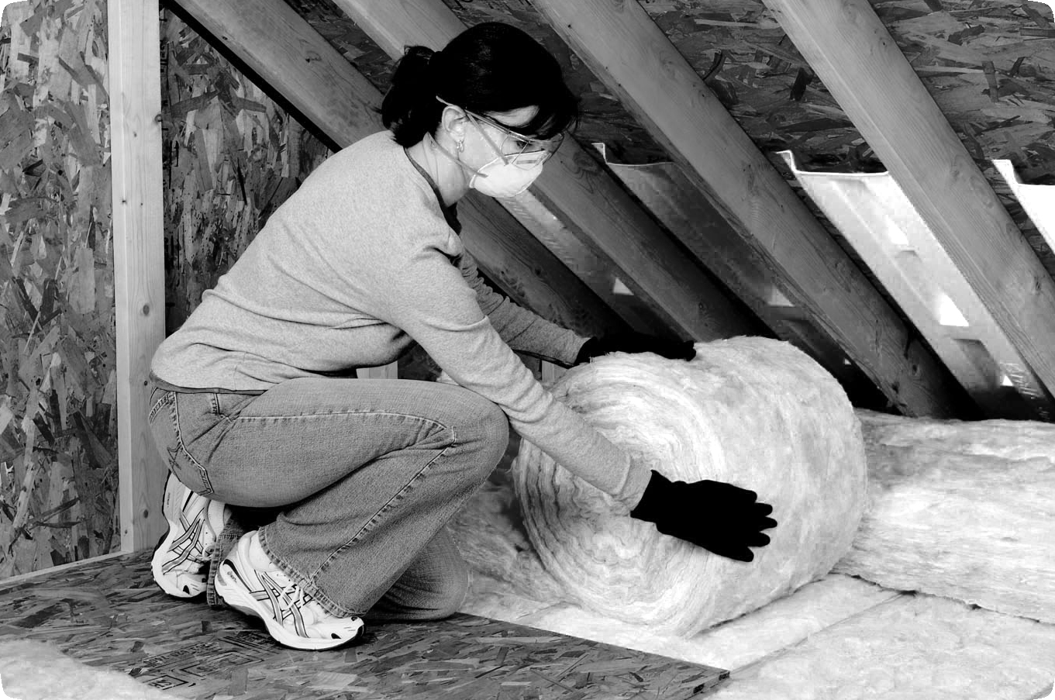PROGRAMMABLE THERMOSTAT

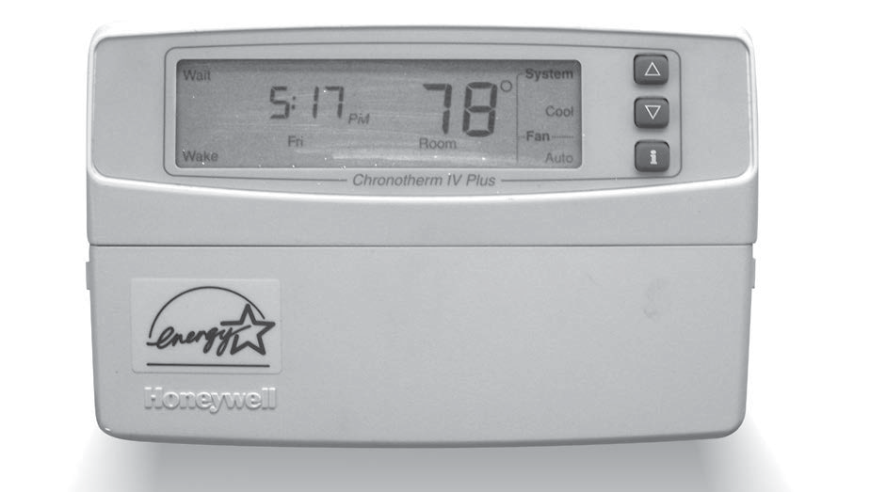Image courtesy of Owens Corning

©2019 The NEED Project www.NEED.org Ohio Energy Project www.ohioenergy.org 17

Doors and Windows
LEAST EFFICIENT MOST EFFICIENT
Window Glazing Types
SINGLE
often has storm window, screen, or combination
DOUBLE TRIPLE
space between glass space between glass may be gas-filled may be gas-filled
glass may be low-E glass may be low-E type with coatings type with coatings
Some air leaks occur around and through the doors and windows. Doors should seal tightly and have door sweeps at the bottom to prevent air leaks. Insulated storm doors provide added barriers to leaking air. School entryways with two sets of doors are designed to keep cold air from blasting inside during the winter and outside during the summer. Both sets of doors should always be kept closed.
Most buildings have more windows than doors. Caulk or seal any cracks around the windows and make sure they seal tightly. With older windows, install storm windows or sheets of clear plastic to create added air barriers. Insulated blinds also help to prevent air flow — during heating seasons, open them on sunny days and close them at night. During cooling seasons, close them during the day to keep out the sun.
The number of panes of glass in a window is important, too. Single- pane windows are not well insulated; double- or triple-pane glass has an insulating space between the glass that allows light in but keeps thermal energy from transferring across the window.

Moisture

Moisture is a term used to describe water in both liquid and vapor form. Like heat and air, it is important to have the right amount of moisture in a building. Most moisture indoors exists as water vapor. The amount of water vapor in the air plays an important role in determining our health and comfort.
What Makes a Window Energy Efficient?
Improved frame materials Multiple panes Wood composites, vinyl, and fiberglass frames Two panes of glass, with an reduce heat transfer and help insulate better. air- or gas-filled space in
the middle, insulate much better than a single piece of glass. Some ENERGY STAR-qualified windows include three or more panes for even greater energy effiency, increased impact resistance, and sound insulation.
Low-E glass
Special coatings reflect infrared light, keeping heat inside in winter and outside in summer. They also reflect damaging ultraviolet light, which helps protect interior furnishings from fading.
Gas fills
Some energy efficient windows have argon, kyrpton, or other gases between their panes. These odorless, colorless, non-toxic gases insulate better than regular air.
Data: ENERGY STAR®
Warm edge spacers
A spacer keeps a window’s glass panes the correct distance apart. Today’s warm edge spacers—made from steel, foam, fiberglass, or vinyl—reduce heat flow and prevent condensation.
Humidity is a measurement of the total amount of water vapor in the air. It is measured with a tool called a hygrometer. Relative humidity measures the amount of water vapor in the air compared to the amount of water vapor the air is able to hold. The relative humidity depends on the temperature of the air.
Think of air as a moisture sponge. See the next page for a visual. Warm air can hold more moisture because the atoms and molecules are moving faster and are more spread out. Warm air is like a bigger sponge. Cool air holds less moisture because the particles are spaced closer together. Cool air is like a smaller sponge. Imagine the sponge can increase or decrease in size as the temperature changes. If you add 100 mL of water to a small sponge, it might be completely saturated – it is holding all of the moisture it can hold. If that sponge expands, but no more moisture is added, it is no longer saturated, and is now holding a fraction of the water that it could potentially hold.
The correct humidity level can also help promote a healthy indoor environment. Humidity levels should be kept between 30% and 60%. Using a dehumidifier in the summer and a humidifier in the winter can help condition the air to maintain appropriate humidity levels.

18 ©2019 The NEED Project www.NEED.org Ohio Energy Project www.ohioenergy.org

Cool air is like a small sponge—it holds a small amount of water. Warm air is like a larger sponge
—it holds more. Warming the air increases the amount of water it can hold, but the relative humidity decreases because no additional moisture is added.
Relative Humidity
Warm Air
Cool Air
100%
50%
25%

Indoor Air Quality

In schools, what is mixed in the air is a major concern because schools tend to be closed up tight all day, everyday. Some classrooms may have an open window here and there, but for the most part, the doors and windows are kept closed. Commercial buildings like schools have HVAC systems – heating, ventilation, and air conditioning. Your home has a heating system and might have an air conditioner, but ventilation is usually accomplished by opening and closing doors and windows. Because you have relatively few people per square foot in your home, adding fresh air is unnecessary. In commercial buildings, it is not only desirable, it is vital to keep the occupants healthy.
Ventilation is measured by the number of air changes per hour. One air change in one hour means enough fresh air is brought into the room such that in one hour all of the air is exchanged. Fresh air exchange is important not only to remove the carbon dioxide produced by the people, but also to keep moisture at a healthy level to prevent mold growth and to remove chemicals from activities like cooking, cleaning, science lab experiments, and art projects.

Different buildings with different uses are required to exchange the air at different rates. Local building codes and regulations also vary. Therefore, what may be sufficient in one school may not meet regulated ventilation requirements in another school. You can check with your school’s maintenance supervisor or your local building code enforcement office to find out how many air changes per hour are needed.

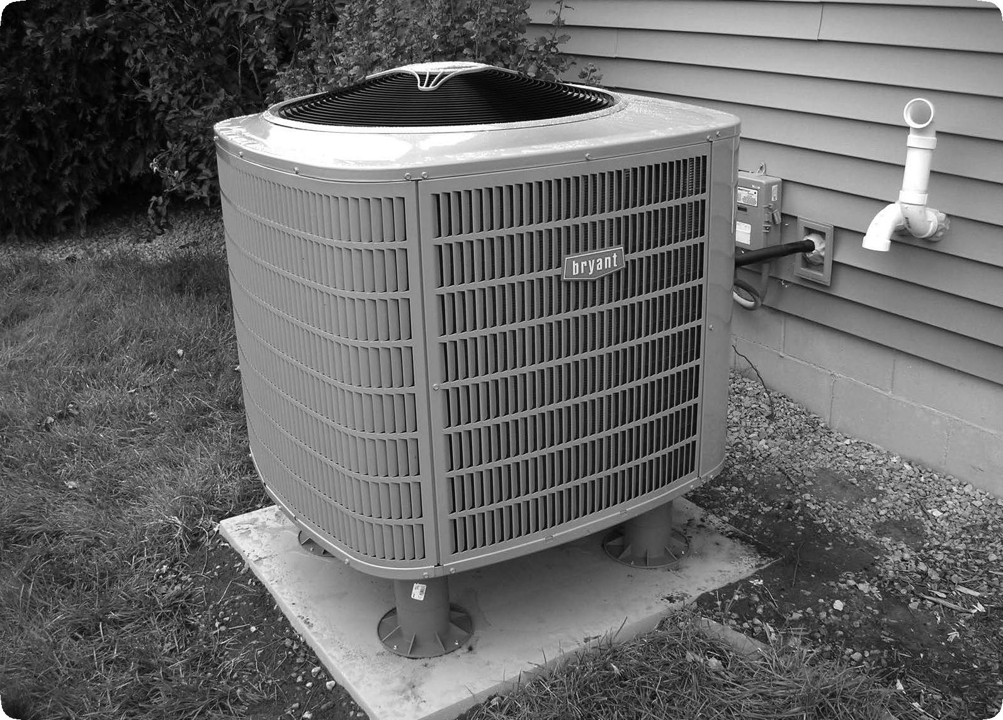AIR CONDITIONING SYSTEM

©2019 The NEED Project www.NEED.org Ohio Energy Project www.ohioenergy.org 19

Landscaping
Although you cannot control the weather, you can plant trees and bushes to block the wind and provide shade. Properly placed landscaping can reduce the energy needed to keep buildings comfortable. Deciduous trees, for example, are good to plant on the south side of a building in the Northern Hemisphere, since their leaves provide shade in summer and their bare branches allow sunlight through in the winter. Clusters of trees can be planted to reduce “heat islands” in areas like parking lots, and act as wind blocks during the winter. In tropical and warmer climates taller trees like palms and shades are used on a building’s exterior to block the sun while allowing a breeze to flow.

Thermometer

BOILING POINT OF WATER

°F °C
220

A thermometer measures temperature. The temperature of a substance is a measure of the average amount of kinetic energy in the substance.
This thermometer is a long, glass tube filled with colored alcohol.
212° F
22211000
200
190
180
110000

90
100° C

Alcohol is used in many thermometers because it expands in direct proportion to the increase in kinetic energy or temperature.
80
170

Temperature can be measured using many different scales. The scales we use most are:
- Celsius
The Celsius (C) scale uses the freezing point of water as 0ºC and the boiling point of water as 100ºC.
- Fahrenheit
The Fahrenheit (F) scale uses the freezing point of water as 32ºF and the boiling point of water as 212ºF.
In the United States, we usually use the Fahrenheit scale in our daily lives, and the Celsius scale for scientific work. People in most countries use the Celsius scale in their daily lives as well as for scientific work.
Notice the numerical difference between the freezing and boiling points of water are different on the two scales. The difference on the Celsius scale is 100, while the difference on the Fahrenheit scale is 180. There are more increments on the Fahrenheit scale because it shows less of an energy change with each degree.

32° F
FREEZING POINT OF WATER
160
150
140
130
120
110
100
90
80
70
60
50
40
333000
20
10
0
-10
-20
70

60

50

40

30

20

10

000

-10

-20

-30

0° C

20 ©2019 The NEED Project www.NEED.org Ohio Energy Project www.ohioenergy.org

LESSON 2A
Insulation Investigation

? Question

Which materials are the best thermal insulators?

Materials

2 Insulation containers with lids
2 Digital thermometers
2 Testing containers
1 Set of insulation materials
Hot water
Measuring cup

Hypothesis

Procedure

- Remove the lids from the insulation containers.
- Place each insulation container in a testing container.
- Loosely pack insulating material around one of the insulation containers. Leave no empty spaces around the container but do not smash the insulating materials in the space.
- The other insulating container will not have any insulating material and will serve as the control.
- Pour 200 mL, or 6 ounces, of hot water into each of your insulation containers.
- Replace the lids of the containers. Insert a thermometer into each container so that it is suspended in the water.
- Wait for the temperature to stabilize, but do not wait longer than one minute. Once the temperature stabilizes read the thermometer and use this reading as your initial or “time zero” measurement.
- Record the temperature of the water every two minutes. To ensure consistency, the same person should read the thermometer each time.
- Calculate the overall change in temperature (∆T) for bother containers. Graph your results.
- Share your data with the class. Compare the results for each type of insulation and determine the best thermal insulator.

©2019 The NEED Project www.NEED.org Ohio Energy Project www.ohioenergy.org 21

 Data
Type of Insulation:

Time (min) | 0 | 2 | 4 | 6 | 8 | 10 | 12 | 14 | 16 | 18 | 20 | ΔT
Insulated
Container
Uninsulated Control

TEMPERATURE (DEGREES CELSIUS)
TIME (MINUTES)
 Conclusion

Answer the questions based on the data you and your classmates collected.
- What was the difference in temperature change between the insulated and control jar?
- According to the class data, which material was the best insulator?
- Using the same insulating material, explain how you can increase the R-value.
- There are three ways that heat can transfer. Which way(s) were involved in this test?
- In addition to the R-value of the insulation, what other properties should you consider when choosing a product?
- Which insulating material or materials would you choose for your home? You may choose different materials for different areas of your home. Justify your answer.
22 ©2019 The NEED Project www.NEED.org Ohio Energy Project www.ohioenergy.org

LESSON 2A
The Value of an R-Value
From our reading, we know that an R-value represents insulation’s resistance to thermal energy transfer. Conduction occurs when thermal energy is transferred from one object in direct contact with another and insulation helps to deter that flow of energy. Insulation with a higher R-value resists or deters energy flow more so than insulation with a lower R-value.
The graphic below indicates which R-values are used in certain geographic zones of the U.S. Use the map and subsequent R- value information to answer the questions below.

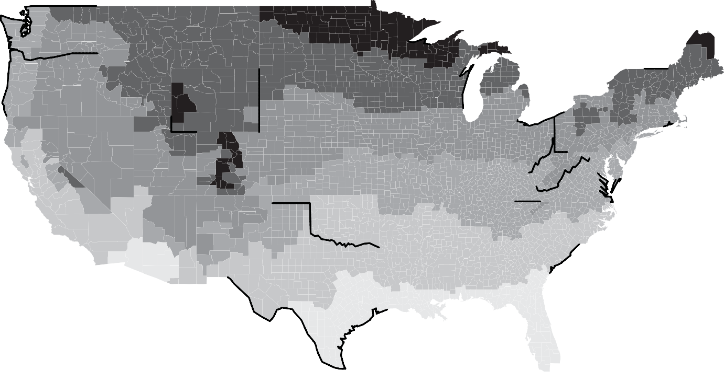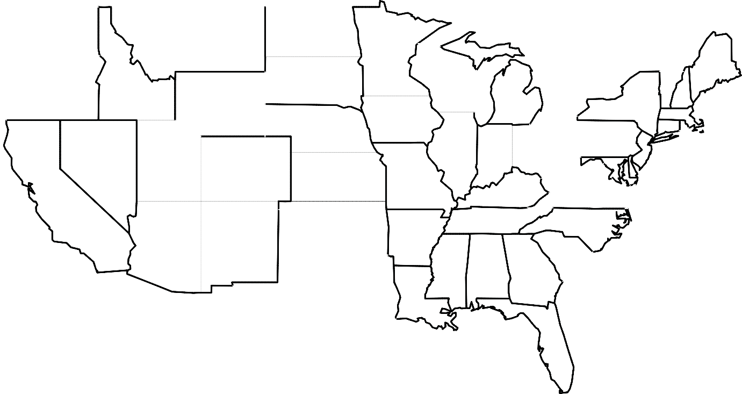Recommended R-Values for New Wood-framed Homes

7
6
4 5 6 6 6
7
6
7 5 5
5
4 4
4 5
3 4 4
4
2 3
3
2
All of Alaska is in Zone 7 except for the
2
following boroughs in Zone 8:
Bethel Northwest Arctic, Dellingham Southeast Fairbanks, Fairbanks N. Star Wade Hampton, Nome Yukon-Koyukuk, North Slope
1
Zone 1 includes Hawaii, Guam, Puerto Rico, and the Virgin Islands.

WALL INSULATION

ZONE

ATTIC
CATHEDRAL CEILING

CAVITY
INSULATION SHEATHING

FLOOR

1
R30 to R49
R22 to R38
R13 to R15
None
R13

2
R30 to R60
R22 to R38
R13 to R15
None
R13, R19 to R25

- R30 to R60
- R38 to R60
- R38 to R60
- R49 to R60
- R49 to R60
8
R49 to R60
R30 to R60
R13 to R21
R5 to R6
R25 to R30
R22 to R38 R30 to R38 R30 to R60 R30 to R60 R30 to R60
R13 to R15 R13 to R15 R13 to R21 R13 to R21 R13 to R21
R2.5 to R5 R2.5 to R6 R2.5 to R6
R5 to R6 R5 to R6
R25 R25 to R30 R25 to R30 R25 to R30 R25 to R30

Data: U.S. Department of Energy
? Questions

- What do the above zones represent?

- In what zone is your school located? Name two other states that are located within this same zone.

- According to the graphic, what is the R-value range used in constructing attic spaces in your zone? How about the R-value range used in constructing floors?

- Compare the two ranges identified in Question 3 above. Why do you think these ranges differ?

- How could you use these zones to discuss regional climate and/or weather patterns?
©2019 The NEED Project www.NEED.org Ohio Energy Project www.ohioenergy.org 23

LESSON 2B: Water
Freshwater and energy are inseparably linked to each other. We need energy to purify or treat our water for drinking and safe use. We also need water to generate electricity. For more information on water used for electricity generation, visit Lesson 3.
When water is extracted from the ground or a surface source such as a river or reservoir, it must be pumped from that site to the water treatment plant. Pumps are used to pull and convey the water to the treatment facility, and each pump uses energy to run.
At the treatment facility, pumps and other machinery are used to filter and clean the water so it is safe to drink. When water leaves the treatment facility, it is carried at a high pressure through pipes to your home or school. Pumps run to keep the water pressure elevated so you can always take a shower or wash your hands when you’d like.
As we use water, we have water softeners that further condition the water, filters that remove unpleasant tastes and odors from the water, heaters that heat the water, and pumps that move it in and out of the machines that use it. All of these devices use energy, too.
Finally, after you’ve finished a water-related task, it has to go somewhere. The drain in your school does not empty into a big hole in the ground. In most areas, water is sent through a series of sewer pipes to a wastewater treatment facility, where pumps and other machinery clean and filter it before releasing it back into the natural environment. Septic systems use gravity to pull water through a series of screens in a septic tank, where sediments are filtered out before the water is drained back into the ground water.
At each of the stages of our own water use listed above, significant amounts of energy are required to extract, clean, distribute, and treat the water we use every day. If you reduce the amount of water you use, you will also be reducing the amount of energy you use, saving your school money on the water bill and reducing the energy demand in your city or town.
Here are some great ways you can reduce the amount of water you use:
- Don’t let the water run needlessly in the restroom or classroom.
- Inform a teacher or other staff member if a faucet or drinking fountain does not turn off properly.
- In the locker room, turn off the shower when finished, don’t allow it to run for the next person.
- Stomp or scrape your boots or shoes before entering the school to avoid the need to extensively clean the floors every evening.

Water Heating
You don’t think too much about the hot water you need at school, but it is definitely needed. At home you probably have a hot water heater that holds 40 or 50 gallons of hot water and is fueled by natural gas or electricity. When you turn the hot water tap on in the kitchen or bathroom, you have to let the water run a bit before it’s warm. However, having one hot water heater in one central location in a school would mean letting the water run for a very long time before it ran warm in rooms far from the heater.

Most schools have one or more 100-gallon (or sometimes even bigger) hot water heaters, and the hot water supply is constantly circulating through the school with a pump. Thus, turning the hot water on in a distant classroom should provide hot water fairly quickly.
The temperature of the water at school is important. At home, you probably have your hot water heater set at 120 - 140 °F, and rarely any higher because of the danger of serious injury by scalding. This is true for the hot water at school except in the kitchen. To comply with health department regulations, the cafeteria workers must wash all dishes and serving equipment in water that is at least 160 °F. But at this temperature, scalding injuries happen very quickly. Very young or distracted students would easily get their hands burned if water came out of the faucet at this temperature.
Most building designs handle this dilemma in one of two ways. One is to have two separate water heating systems, one for the cafeteria and the other for the rest of the school. The cafeteria water supply is kept very hot while the rest of the school is kept at a safer, lower temperature. The other way is to keep the entire school supply at a safe temperature, but have a booster heating system in the cafeteria that heats the water to the necessary temperature for cleaning.

Water Use in Schools, 2016

24 ©2019 The NEED Project www.NEED.org Ohio Energy Project www.ohioenergy.org

LESSON 2B
Water Conservation
Water plays a vital role on Earth. Not only is it essential to the plants and animals on the surface, but it is also a key component in our climate, the shaping of Earth’s surface and ecosystems that support life. With that in mind, water conservation is an important part of our energy conservation measures.

Part 1: Down the Drain
Dripping faucets waste water and money. Such leaks may seem small, but the water loss can add up to be quite large.

? Question
How much water is wasted by a dripping faucet?

Materials

Empty two-quart, cardboard carton (milk, orange juice, etc.)
Water
Small sewing needle or pushpin
Graduated cylinder
Stopwatch

Procedure
Metal rack or objects to support carton
Beaker or cup to fit under rack (to catch dripping water)

- Use the needle to make a very small hole in the bottom of the empty carton. Make this hole as small as possible.
- Support the carton on the rack approximately 15 centimeters (or 6 inches) above the tabletop. Fill the carton with water about half full. Place the beaker or cup under the pin hole opening to catch any drips.
- Leave the beaker or cup under the carton for 10 minutes.
- Using the graduated cylinder, measure the volume of water, to the nearest milliliter, that dripped.
- Using the chart below, calculate and record the rate of water loss.

Water loss after 10 min. Water loss per min. (mL) (mL/min) |  | Water loss per day (x 1,440 min.) | Liters of water lost per day (divide by 1,000) | Liters of water lost per year (daily loss x 365)

©2019 The NEED Project www.NEED.org Ohio Energy Project www.ohioenergy.org 25

LESSON 2B:
Part 2: Personal Water Use Investigation
? Question
How much water do you use in a single day?

Materials

Personal Water Use Survey

Procedure

Day 1
1. Over the next 24 hours, complete the Personal Water Use Survey. Keep track of the amount of time you use water by noting it on the chart. Estimate minutes where appropriate.
Day 2
- Brainstorm some simple, routine ways you could reduce the amount of water used in a day.
- For the next 24 hours, repeat the Personal Water Use Survey. Put into practice some of the water conservation methods brainstormed in Question 1.

 Conclusion

- Where does your community get its drinking water?

- How does saving water also save energy?

- Aside from personal use, what are 5 additional areas of business or manufacturing that are large water consumers?

- Suggest three ways your school could conserve water.

- Could a water shortage or drought occur in your area? If so, list three ways your community could conserve water.

26 ©2019 The NEED Project www.NEED.org Ohio Energy Project www.ohioenergy.org

LESSON 2B
Personal Water Use Survey

 | Water Use | Day 1: Time Spent Using Water | Estimated Gallons | Actual Gallons | Water Conserving Method | Day 2: Time Spent Using Water | Actual Gallons
 | Washing Hands/ Face
 | Showering
 | Brushing Teeth
 | Flushing the Toilet
 | Drinking
 | Washing Dishes
 | Washing Clothes
 | Cleaning the House
 | Watering Plants
 | Other Uses

©2019 The NEED Project www.NEED.org Ohio Energy Project www.ohioenergy.org 27

LESSON 2
Efficiency Kit Materials
- Weather Stripping
- Low Flow Showerhead
- Bath and Kitchen Aerators
- Water Flow Bag
- Thermostat Temperature Guide
- Draft stoppers (if included)
Home & Community

Energy in Action:

- Open your outside doors and check the condition of the weather stripping between the doors and the door frames. Install weather stripping from your efficiency kit in areas where it is missing or worn.

- Check the thermostat settings in your home and record below. Then use the Thermostat Temperature Guide from your efficiency kit to calculate the percentage of energy you are saving or wasting.

Heating Season | My home temp: | Ideal temp:  < 69 °F | % Saved or wasted:
Cooling Season | My home temp: | Ideal temp:  > 74 °F | % Saved or wasted:

- Check the efficiency of your bath and kitchen aerators using the Water Flow Bag in your efficiency kit. If aerators are missing or worn, install the aerators provided in your efficiency kit.

Web Quest:

- Visit your utility partner’s website (refer to Lesson One) and search for information regarding the following:
  - Smart Thermostats
    - Describe the features of Smart Thermostats and the benefits of having one in your home.

  - Weatherization
    - Describe a program(s) that your utility provides that you may share with your family or community members during extreme weather events.

Career Connections:

Hydrologist - Study how water interacts with the Earth’s crust.
Pump Technician – Install and repair pump systems that connect to water sources.
Wellsite Geologist – Supervise the drilling process for oil and natural gas. Analyze rocks from drilling sites to advise on drilling direction.
HVACTechnician – Install, inspect, and repair heating, cooling, and ventilation systems.
Civil Engineer – Oversee design, construction, and maintenance of built environments, such as roads, bridges, dams, pipelines, and more.

28 ©2019 The NEED Project www.NEED.org Ohio Energy Project www.ohioenergy.org

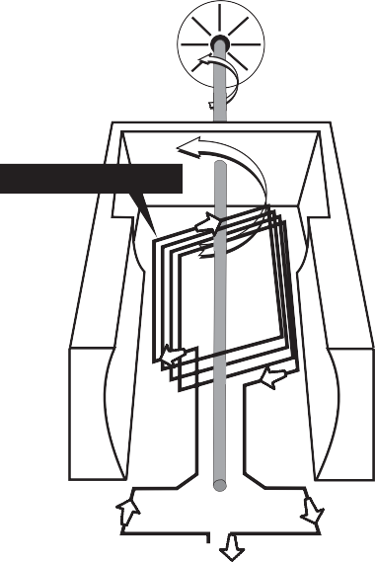LESSON 3
Turbine Generator
TURBINE
TURBINE SPINS SHAFT
Spinning Coil of Wire
North Pole
South Pole
DIRECTION OF ELECTRIC CURRENT
TO TRANSMISSION LINES
Background Information:

Electrical Energy

Magnets Can Produce Electricity

We can use magnets to make electricity. A magnetic field can move electrons. Some metals, like copper, have electrons that are loosely held; they are easily pushed from their levels.
Magnetism and electricity are related. Magnets can create electricity and electricity can produce magnetic fields. Every time a magnetic field changes, an electric field is created. Every time an electric field changes, a magnetic field is created. Magnetism and electricity are always linked together; you can’t have one without the other. This phenomenon is called electromagnetism.
Power plants use huge turbine generators to make the electricity that we use in our homes and businesses. Power plants use many fuels to spin turbines. They can burn coal, oil, or natural gas to make steam to spin turbines. Or they can split uranium atoms to heat water into steam. They can also use the power of rushing water from a dam or the energy in the wind to spin the turbine.
The turbine is attached to a shaft in the generator. Inside the generator are magnets and coils of copper wire. The magnets and coils can be designed in two ways — the turbine can spin the magnets inside the coils or can spin coils inside the magnets. Either way, the electrons are pushed from one copper atom to another by the moving magnetic field.
Coils of copper wire are attached to the turbine shaft. The shaft spins the coils of wire inside two huge magnets. The magnet on one side has its north pole to the front. The magnet on the other side has its south pole to the front. The magnetic fields around these magnets push and pull the electrons in the copper wire as the wire spins. The electrons in the coil flow into transmission lines. These moving electrons are the electricity that flows to our houses. Electricity moves through the wire very quickly.

Another Word about Water

In Lesson 2 we discussed how using water around your home also uses a significant amount of energy. But the relationship between water and energy does not stop there.
Thermoelectrical power plants use water in the form of steam to turn a turbine, which generates electricity. In fact, all thermal power plants are the same from the steam turbine through to the distribution lines; the only difference is the manner in which the water is heated to steam. Coal plants burn coal, natural gas plants burn natural gas, nuclear plants use the thermal energy from uranium atoms splitting, and concentrated solar power plants use the sun’s energy to heat water to steam. In each of these power plants, the goal is to boil water to high-pressure steam to turn a turbine. The water is cooled then condensed back to water, and the cycle repeats.

HYDROPOWER TURBINE GENERATORS

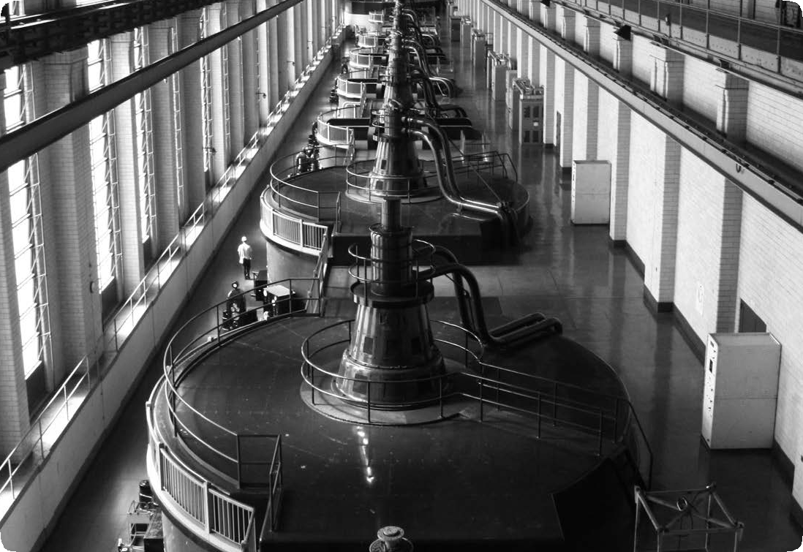
Photo of Safe Harbor Water Power Corporation on the Lower Susquehanna River in Pennsylvania.
U.S. Freshwater Withdrawals
Irrigation 32%
Public Supply 12%

Self-supplied Industrial Use 5%

Aquaculture 3%
Mining 2%
Self-supplied Domestic Use 1% Thermoelectric Power 45%
Data: EPA
*Total does not equal 100% due to independent rounding.

©2019 The NEED Project www.NEED.org Ohio Energy Project www.ohioenergy.org 29

Electricity
Electricity is a little different from the other sources of energy that we talk about. Unlike coal, petroleum, or solar energy, electricity is a secondary source of energy. That means we must use other primary sources of energy, such as coal or wind, to make electricity. It also means we can’t classify electricity as a renewable or nonrenewable form of energy. The energy source we use to make electricity may be renewable or nonrenewable, but the electricity is neither.

Generation
Almost all electricity made in the United States is generated by large, central power plants. There are about 8,000 power plants in the U.S. Most power plants use coal, nuclear fission, natural gas, or other energy sources to superheat water into steam in a boiler. The very high pressure of the steam (it’s 75 to 100 times normal atmospheric pressure) turns the blades of a turbine. (A turbine turns the linear motion of the steam into circular motion.) As we have learned, the blades are connected to a generator, which houses a large magnet surrounded by coiled copper wire. The blades spin the magnet rapidly, rotating the magnet inside the coil producing an electric current.
The steam, which is still very hot but now at normal pressure, is piped to a condenser, where it is cooled into water by passing it through pipes circulating over a large body of water or cooling tower. The water then returns to the boiler to be used again. Power plants can capture some of the heat from the cooling steam. In old plants, the heat was simply wasted.
Not all power plants use thermal energy to generate electricity. Hydropower plants and wind farms use motion energy to turn turbines, turning a generator, which produces electricity. Photovoltaic plants use radiant energy to generate electricity directly.

Efficiency of a Thermal Power Plant
Most thermal power plants are about 35 percent efficient. Of the 100 units of energy that go into a plant, 65 units are lost as one form of energy is converted to other forms. The remaining 35 units of energy leave the plant to do usable work.

Generating Electricity
Three basic types of power plants generate most of the electricity in the United States—fossil fuel, nuclear, and hydropower. There are also wind, geothermal, waste-to- energy, and solar power plants, but together they generate about 8.44 percent of the electricity produced in the United States.

FOSSIL FUEL POWER PLANTS
Fossil fuel plants burn coal, natural gas, or petroleum. These plants use the chemical energy in fossil fuels to superheat water into steam, which drives a steam generator. Fossil fuel plants are sometimes called thermal power plants because they use heat to generate electricity. Coal and natural gas are the fossil fuels of choice for most electric companies, producing
30.59 and 34.03 percent of total U.S. electricity respectively. Petroleum produces 0.60 percent of the electricity in the U.S.
NUCLEAR POWER PLANTS
Nuclear plants generate electricity much as fossil fuel plants do, except that the furnace is a reactor and the fuel is uranium. In a nuclear plant, a reactor splits uranium atoms into smaller elements, producing a great amount of heat in the process. The heat is used to superheat water into high-pressure steam, which drives a turbine generator. Like fossil fuel plants, nuclear power plants are thermal plants because they use heat to generate electricity. Nuclear energy produces 19.89 percent of the electricity in the U.S.
HYDROPOWER PLANTS
Hydropower plants use the gravitational force of falling water to generate electricity. Hydropower is the cheapest way to produce electricity in this country, but there are few places where new dams can be built economically. There are many existing dams that could be retrofitted with turbines

FUEL SUPPLY

FUEL BURNING

THERMAL ENERGY

ELECTRICITY GENERATION
ELECTRICITY TRANSMISSION
ELECTRICAL ENERGY
and generators. Hydropower is called a renewable energy
source because it is renewed continuously during the natural water cycle. Hydropower produces five to ten percent of

100 units of
3 STEAM LINE
BOILER
GENERATOR
the electricity in the U.S., depending upon the amount of

energy go in TURBINE
2 5
SWITCHYARD
6
precipitation. In 2016, hydropower generated 6.45 percent

CHEMICAL ENERGY
1

Fuel Sources

FEED WATER
4

CONDENSER
MOTION ENERGY

35 units of energy come out
of U.S. electricity.

Petroleum Coal Natural Gas Biomass Uranium
How a Thermal Power Plant Works
- Fuel is fed into a boiler, where it is burned (except for uranium which is fissioned, not burned) to release thermal energy.
- Water is piped into the boiler and heated, turning it into steam.
- The steam travels at high pressure through a steam line.
- The high pressure steam turns a turbine, which spins a shaft.
- Inside the generator, the shaft spins a ring of magnets inside coils of copper wire. This creates an electric field, producing electricity.
- Electricity is sent to a switchyard, where a transformer increases the voltage, allowing it to travel through the electric grid.
30 ©2019 The NEED Project www.NEED.org Ohio Energy Project www.ohioenergy.org

Transmission and Distribution
We are using more and more electricity every year. One reason that electricity is used by so many consumers is that it’s easy to move from one place to another. Electricity can be produced at a power plant and moved long distances before it is used. Let’s follow the path of electricity from a power plant to a light bulb in your home.
First, the electricity is generated at a power plant. It travels through a wire to a transformer that steps up, or increases, the voltage. Power plants step up the voltage because less electricity is lost along the power lines when it is at a higher voltage.
The electricity is then sent to a nationwide network of transmission lines. This is called the electric grid. Transmission lines are the huge tower lines you see along the highway. The transmission lines are interconnected, so if one line fails, another can take over the load.
Step-down transformers, located at substations along the lines, reduce the voltage from 350,000 volts to 12,000 volts. Substations are small fenced-in buildings that contain transformers, switches, and other electrical equipment.
The electricity is then carried over distribution lines that deliver electricity to your home. These distribution lines can be located overhead or underground. The overhead distribution lines are the power lines you see along streets.
Before the electricity enters your house, the voltage is reduced again at another transformer, usually a large gray metal box mounted on an electric pole. This transformer reduces the electricity to the 120 or 240 volts that are used to operate the appliances in your home. Electricity enters your home through a three-wire cable. Wires are run from the circuit breaker or fuse box to outlets and wall switches in your home. An electric meter measures how much electricity you use so that the utility company can bill you.

What’s a Watt?

We use electricity to perform many tasks. We use units called watts, kilowatts, and kilowatt-hours to measure the electricity that we use.
Remember, a watt is a measure of the electric power an appliance uses. Every appliance requires a certain number of watts to work correctly.
Remember, we pay for the electricity we use in kilowatt-hours. Our power company sends us a bill for the number of kilowatt-hours we use every month.
TRANSMISSION LINES

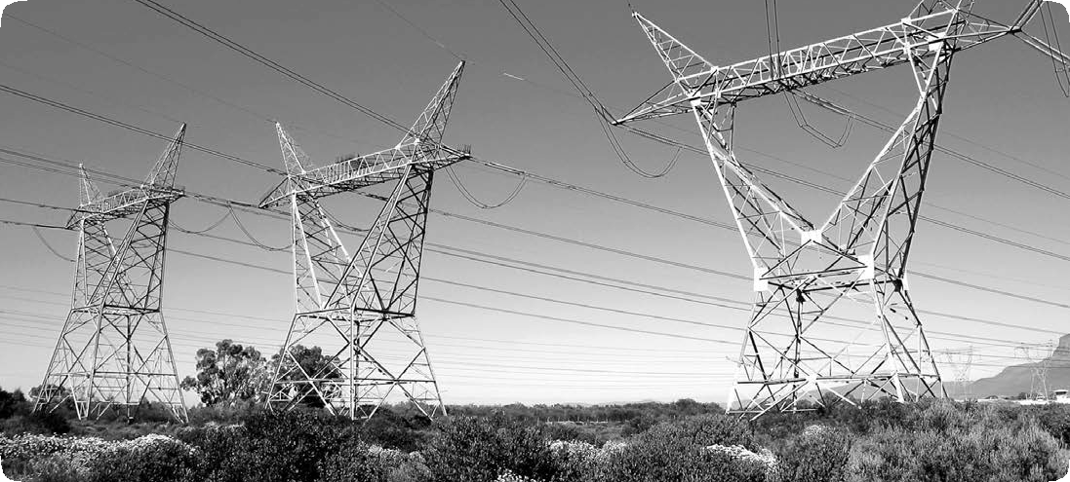
Economics of Electricity
How much does electricity cost? The answer depends on the cost to generate the power (57 percent), the cost of transmission (11 percent), and local distribution (32 percent). The average cost of electricity in Ohio is about 11 cents per kWh for residential customers. A major key to cost is the fuel used to generate the power. Electricity produced from natural gas, for example, costs more than electricity produced from uranium or hydropower. Location also plays a part in electricity costs.
Another consideration is how much it costs to build a power plant. A plant may be very expensive to construct, but the cost of the fuel can make it competitive to other plants, or vice versa. Nuclear power plants, for example, are very expensive to build, but their fuel — uranium — is very cheap. Coal-fired plants, on the other hand, are much less expensive to build than nuclear plants, but their fuel — coal — is more expensive.
Whencalculatingcosts, aplant’sefficiencymustalsobeconsidered. In theory, a 100 percent energy efficient machine would change all the energy put into the machine into useful work, not wasting a single unit of energy. But converting a primary energy source into electricity involves a loss of usable energy, usually in the form of thermal energy. In general, it takes three units of fuel to produce one unit of electricity from a thermal power plant.
But that’s not all. Between three and eight percent of the electricity generated at a power plant must be used to run equipment. And then, even after the electricity is sent over electrical lines, another seven percent of the electrical energy is lost in transmission. Of course, consumers pay for all the electricity generated, lost or not.
The cost of electricity is affected by what time of day it is used. During a hot summer afternoon from noon to 6 p.m., there is a peak of usage when air-conditioners are working harder to keep buildings cool. Electric companies charge their industrial and commercial customers more for electricity during these peak load periods because they must turn to more expensive ways to generate power.

Transporting Electricity
Power plant generates electricity
Transmission lines carry electricity long distances

Distribution lines carry electricity to houses

Transformer steps up voltage for transmission

Power Tower

Step-down transformer reduces voltage (substation)

Electric Poles

Neighborhood transformer on pole
steps down voltage before entering house

©2019 The NEED Project www.NEED.org Ohio Energy Project www.ohioenergy.org 31

LESSON 3A: Appliances

Appliances, machines, and electronic devices use about 18 percent of a typical school’s energy. Any appliance that is designed to change temperature uses a lot of energy.
Look around any classroom and you will see many appliances. A quick survey of the typical classroom and school building reveals many kinds of electrical appliances such as:

How Much Electricity Do Appliances Use?

Dishwasher Microwave

- coffee makers
- computers and monitors
- fans
- desk and table lamps
- microwaves
- refrigerators
- televisions
- DVD players/BluRay players
- window air conditioners
- vending machines
- fax machines
- copiers
- fish tanks
- digital or over head projectors
- ranges and stoves
- vocational equipment
- clocks
- drinking fountains
- pencil sharpeners
Refrigerator/Freezer

Hair Dryer Desktop Computer
Laptop Television
Video Game System

Vacuum

0 100 200 300 400 500 600 700 800
kW/Year

Many of these devices are important to the learning environment.
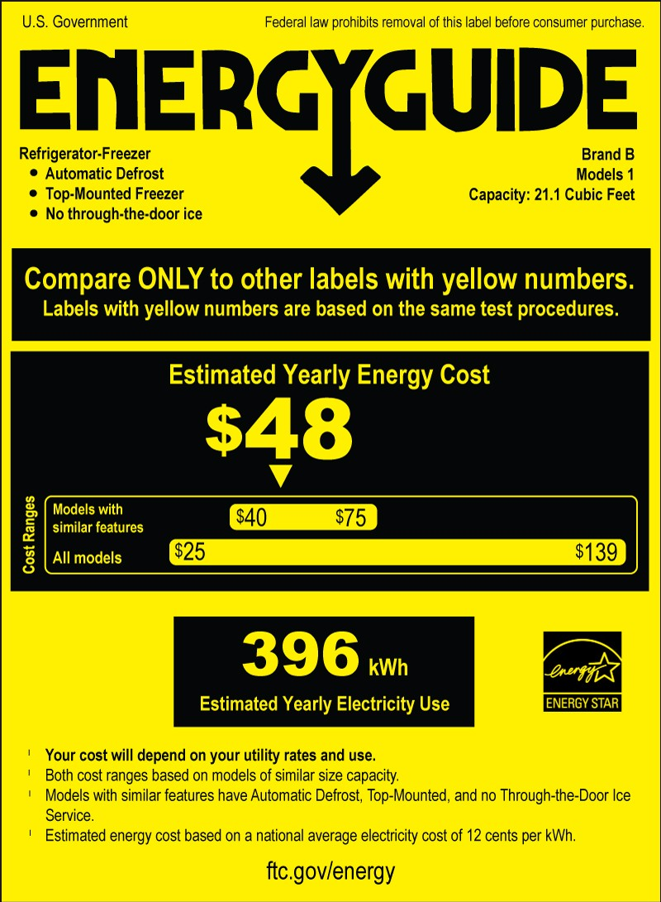In addition, there are appliances that teachers and school staff bring from home that are not related to teaching, but are routine devices found in any office. Many electrical appliances, such as computers, printers, and copiers, waste energy when they are left on 24 hours a day. Often they are left on as a matter of convenience because they have a long warm–up time. Turning these machines off at the end of the day, and turning other machines off when they are not being used, can save a lot of energy.
Federal Government Guidelines for Appliances

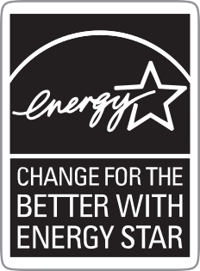When shopping for a new appliance or lighting, look for the ENERGY STAR® label
— your assurance that the product saves energy. ENERGY STAR® appliances have been identified by the U.S. Environmental Protection Agency and Department of Energy as the most energy efficient products in their classes. A list of these appliances and devices can be found on the ENERGY STAR® website at www.energystar.gov.
Another way to determine the efficiency of appliances is to compare energy usage using EnergyGuide labels. The Federal Government requires most appliances to display bright yellow and black EnergyGuide labels. Although these labels do not say which appliance is the most efficient, they provide the annual energy consumption and average operating cost of each appliance so you can compare them.
Data: DOE, Buildings Data Book

32 ©2019 The NEED Project www.NEED.org Ohio Energy Project www.ohioenergy.org

LESSON 3A
Comparing EnergyGuide Labels
As we now know, EnergyGuide labels provide information on the annual energy consumption and average operating costs of an appliance so that you can compare them to similar models. Use the EnergyGuide labels below to fill in the charts.
- How many years will it take before you begin to save money?
- How much money will you have saved after seven years?

Water Heater 1—Purchase Price: $750.00 Water Heater 2— Purchase Price: $650.00

WATER HEATER 1 | EXPENSES | COST TO DATE | WATER HEATER 2 | EXPENSES | COST TO DATE
Purchase Price |  |  | Purchase Price
Year One |  |  | Year One
Year Two |  |  | Year Two
Year Three |  |  | Year Three
Year Four |  |  | Year Four
Year Five |  |  | Year Five
Year Six |  |  | Year Six
Year Seven |  |  | Year Seven

very small | low | medium | high  90 Gallons

very small | low | medium  73 Gallons | high

©2019 The NEED Project www.NEED.org Ohio Energy Project www.ohioenergy.org 33
U.S. Government
Federal law prohibits removal of this label before consumer purchase.
Water Heater - Natural Gas
Tank Size (Storage Capacity): 50 gallons
xx Corporation
Model XXXXXXX
Estimated Yearly Energy Cost
$240
$225
$275
Cost Range of Similar Models

First Hour Rating
(How much hot water you get in the first hour of use)
l Your cost will depend on your utility rates and use.
l Cost range based only on models fueled by natural gas with a high first hour rating (above 75 gallons).
l Estimated energy cost based on a national average natural
gas cost of $1.09 per therm.
l Estimated yearly energy use: 224 therms.

ftc.gov/energy
U.S. Government
Federal law prohibits removal of this label before consumer purchase.
Water Heater - Natural Gas
Tank Size (Storage Capacity): 50 gallons
xx Corporation
Model XXXXXXX
Estimated Yearly Energy Cost
$270
$225 $275

Cost Range of Similar Models

First Hour Rating
(How much hot water you get in the first hour of use)
l Your cost will depend on your utility rates and use.
l Cost range based only on models fueled by natural gas with a medium first hour rating (51-74 gallons).
l Estimated energy cost based on a national average natural
gas cost of $1.09 per therm.
l Estimated yearly energy use: 248 therms.

ftc.gov/energy

LESSON 3A
The Electrical Cost of a Classroom
? Question
How much does it cost to power your classroom?

Materials

Computer spreadsheet program, like Microsoft Excel
Classroom electrical devices
Kill A Watt® meter
Copy of your school’s electric bill

Procedure

Part 1: Classroom Electrical Audit
- Create an individual or class spreadsheet to record data for the Classroom Electrical Audit.
- Survey your classroom for electrical devices. Identify and record all surveyed devices on your spreadsheet. Be sure to include the name of the device as well as the number of those devices in your classroom.
- Using the Kill A Watt® meter, measure the wattage of the surveyed devices and record it on your spreadsheet.
NOTE: Do not unplug a device at school without making sure it’s allowable to do so. Some devices, like copiers, require long start-up times. If you cannot use your Kill A Watt® meter to check a device, ask your school’s facilities team for the information.
- Once the wattage of each device is recorded, calculate the total wattage of each device. Use the example provided below to guide you.
- Add the total wattage of each device.
Sample Spreadsheet

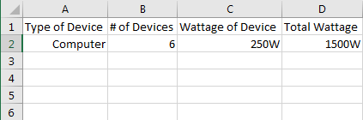

? Question
1. How many total watts does your classroom use?

Procedure
Part 2: Calculating Cost
- Now that we know the total amount of watts your classroom uses, let’s calculate cost. To do this, we’ll need some more information.
Cost of Electricity: The average cost of electricity in Ohio is $0.11 per kilowatt-hour. We are billed for our electricity usage in kilowatt-hours, or how many kilowatts of energy we use each hour.
Operating Hours: Your classroom only operates during certain hours. To calculate the electricity usage of your classroom, we must account for only when your classroom is in use. Work with your teacher to estimate the number of hours your classroom is using electricity in a month.
- Use a spreadsheet program to calculate the cost of the electricity in your classroom for a month. A sample has been provided.
- With help from your teacher, use your school’s electricity bill to compare how much electricity your classroom uses with the electricity consumption of the whole school.

34 ©2019 The NEED Project www.NEED.org Ohio Energy Project www.ohioenergy.org

Sample Spreadsheet

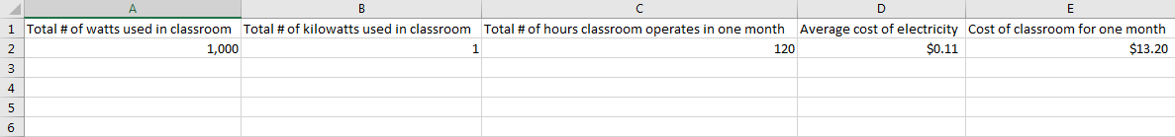

? Questions

- How much does the electricity in your classroom cost for one month?
- List 3 reasons why the electricity consumption of your classroom might look different than the electricity consumption of your whole school.

Procedure

Part 3: Environmental Cost
Now that we understand how much money our school spends on electricity and how much electricity we use in the classroom, let’s talk about environmental costs.
1. Use a spreadsheet program to calculate the number of pounds of carbon dioxide your classroom’s energy usage creates in a month.
NOTE: The average was 1.6 pounds of carbon dioxide per kilowatt-hour consumed in 2016.
Sample Spreadsheet

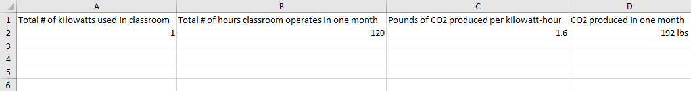

With a knowledge of the environmental cost of the classroom, let’s take a look at some of the efficiency measures that could help save us electricity.
Occupancy Controls – These controls help to power a room when it is actually in use. These systems can be automatic, with special equipment that identifies whether or not anyone is in the room, or manual, with students and teachers
taking action to turn off electrical devices when the room is not in use.
Energy Efficient Devices – Devices that are energy efficient help us to use only the energy we need to be comfortable and accomplish necessary tasks. Talk with your teacher about what devices could be helpful for your classroom.

? Question
Brainstorm 3 ways your classroom could save electricity.

©2019 The NEED Project www.NEED.org Ohio Energy Project www.ohioenergy.org 35

LESSON 3B: Lighting
Lighting is a significant consumer of energy in a school system.
An average school uses about 17 percent of the electricity (9% of the total energy) it consumes to light buildings and outside areas. Much of this can be the result of using inefficient lighting, while some can be attributed to wasteful lighting behaviors. Some schools may still use incandescent lighting in various lamps and fixtures in small spaces. Incandescent lighting is very inefficient, in that only 10 percent of the energy consumed actually produces light. The rest is given off as heat. There are other more efficient lighting choices on the market, including halogens, fluorescents, and LEDs. Halogens are sometimes called energy-saving incandescent bulbs because they last slightly longer, and use less energy than traditional incandescent bulbs, however they can burn hotter than incandescent lights do. Fluorescent lights produce very little heat and are even more efficient. Most schools use fluorescent tube lighting throughout the building, but may use incandescent bulbs in other spaces around the school.
A fluorescent lamp is a glass tube, whose inner surface has a powdered, phosphor coating. The tube is filled with argon gas and a small amount of mercury vapor. At the ends of the tubes are electrodes that emit electrons when heated by an electric current. When electrons strike the mercury vapor, the mercury atoms emit rays of ultraviolet (UV) light. When these invisible UV rays strike the phosphor coating, the phosphor atoms emit visible light. The conversion of one type of light into another is called fluorescence. Fluorescent lights have ballasts that regulate the electricity through the gas inside the bulb. Ballasts are electromagnets that produce a large voltage between the ends of the bulbs so the electricity will flow between them. There are two types of ballasts, magnetic and electronic. Magnetic ballasts produce a frequency of 60 Hertz (Hz), which means the light is flickering on and off 60 times a second. Electronic ballasts produce a frequency of at least 20,000 Hz. Fluorescent lights with electronic ballasts are more energy efficient than those with magnetic ballasts. Electronic ballasts use up to 30 percent less energy than magnetic ballasts. Electronic ballasts operate at a very high frequency that eliminates flickering and noise. Some electronic ballasts even allow you to operate the fluorescent lamp on a dimmer switch, which usually is not recommended with most fluorescents.
Fluorescent lights produce very little heat and are much more energy efficient than either type of incandescent bulb. CFLs use the same technology as overhead fluorescent lights, but they are designed to fit into lamps and other fixtures where incandescents are commonly used. All CFL bulbs have electronic ballasts.
Light emitting diode bulbs are even more efficient than CFL bulbs, last about 25 times longer than incandescent bulbs, and more than two and a half times longer than CFLs. One LED bulb has several tiny LEDs inside of it. LEDs contain semiconductors like solar panels and other diodes, however the difference is in the way the electrical energy is used by the LED. Three layers within the LED–p-type, n-type, and a depletion zone–combine to produce light. Basically, a minimum voltage is needed to energize electrons and they move from the n-layer to the p-layer. When the electrons move back to the n- layer again, they emit light that we see. Although CFLs and LEDs cost more to buy, they save money in the long run because they use 20-25 percent of the energy of incandescent bulbs and last several times longer. Each CFL or LED

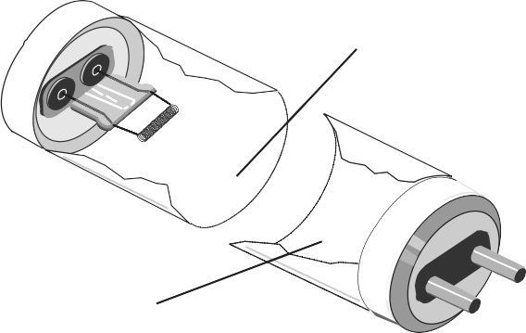
Fluorescent Tube Lamp
Mercury and
inert gases
Phosphor coating

Base with bi-pin plug
In fluorescent tubes, a very small amount of mercury mixes with inert gases to conduct the electric current. This allows the phosphor coating on the glass tube to emit light.

Fluorescent Lighting Efficiency
A T12 bulb consumes up to 40 watts of energy to produce a given amount of light. T8 and T5 bulbs use less energy to produce the same amount of light.
T12
1 ½”
40 watts
T8
1”
32 watts
T5
5⁄a” 24 watts

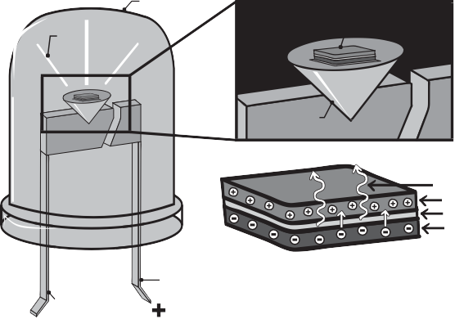
Inside an LED
epoxy case
LED chip
emitted light
reflecting cup
photons
p-type layer
p-n type junction n-type layer
anode lead
cathode lead
installed to replace an incandescent can save about $30-80 over the life of each bulb. Replacing incandescent bulbs with LED or CFL bulbs can also reduce carbon dioxide emissions by hundreds of pounds over the life of the bulb.

36 ©2019 The NEED Project www.NEED.org Ohio Energy Project www.ohioenergy.org

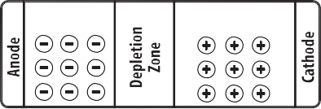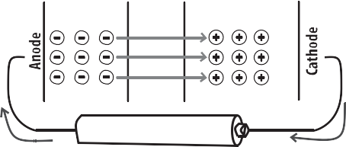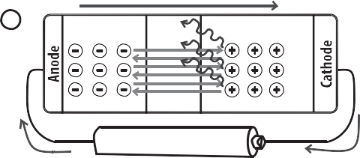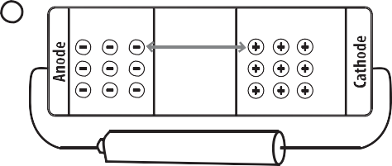How Light Emitting Diodes Work
- Diodes are made of semiconductors and conducting materials that need to be added to the semiconductor. In an LED the most common conductor added is aluminum-gallium-arsenide (AlGaAs). The AlGaAs is “doped” by adding small amounts of another material. One material will have more valence electrons than AlGaAs, and another doping material will have fewer electrons. The two doped materials are put together in a crystal. The material with more electrons is the “n-type” (n for negative) and the material with fewer electrons is the“p-type”(p for positive). When these materials are sandwiched together, the electrons move to balance themselves out. The area between the materials, called the p-n junction, is also called the “depletion zone.”

How Light Emitting Diodes Work
n-type p-type

Current Flow
2 n-type p-type

Battery

- Connecting a power source to the diode, such as a battery, provides

electric current that carries electrical energy. The electrons in the n-type are repelled by the electric current, and move through the depletion zone to the p-type. They are energized, and will want to return to their original, unenergized state in the n-type.
- When the electrons move back through the depletion zone to the n-type, they release energy as light. This is the light that we see from the LED. This process continues over and over again–electrons
Current Flow
- n-type p-type

Battery

absorbing energy, moving, then moving back and releasing the

energy, until the power supply is disconnected or depleted.
- Connecting the power supply in the wrong orientation does not allow the LED to work. Instead, it merely increases the size of the depletion zone. Therefore, it is important that LED’s be wired to their power supply in the correct orientation.
No Current Flows
- n-type p-type

Increased Depletion Zone

Battery

Lighting Controls
Lighting controls are devices that turn lights on and off or dim them.
The simplest type is a standard snap switch. Other controls include photocells, timers, occupancy sensors, and dimmers. Snap switches, located in many convenient areas, make it easier for people in large, shared spaces to turn off lights in unused areas. Photocells turn lights on and off in response to natural light levels. Photocells switch outdoor lights on at dusk and off at dawn, for example. Advanced designs gradually raise and lower fluorescent light levels with changing daylight levels.
Mechanical or electronic time clocks automatically turn indoor or outdoor lights on and off for security, safety, and tasks such as janitorial work. An occupancy sensor activates lights when a person is in the area and then turns off the lights after the person has left.
Dimmers reduce the wattage and output of incandescent and fluorescent lamps. Dimmers also significantly increase the service life of incandescent lamps; however, dimming incandescent lamps reduces their light output more than their wattage, making them less efficient as they are dimmed. Dimmers for fluorescents require special dimming ballasts, but do not reduce the efficiency of the lamps.

Even the best lighting system is not efficient if people do not use it wisely. In most schools, more light is used than needed and lights are often left on when no one is present. All lights that are not necessary for safety should be turned off when rooms are not in use. The same is true for outside lights. Using sunlight is a good idea whenever possible. Studies have shown that students learn better in natural light than in artificial light.

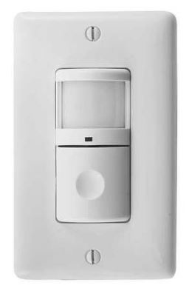©2019 The NEED Project www.NEED.org Ohio Energy Project www.ohioenergy.org 37
Indoor lighting sensor

LESSON 3B
Light Bulb Investigations

? Questions

What is the difference in thermal energy output of different light bulbs?
What is the difference in light output of different light bulbs?
How do light bulbs compare in the amount of energy used?

Materials

3 Lamps
1 Incandescent or halogen incandescent light bulb and its packaging
1 Compact fluorescent light bulb (CFL) and its packaging
1 Light emitting diode bulb (LED) and its packaging
3 Thermometers
Tape
Kill A Watt® meter
Light meter
Ruler or meter stick
Calculators

Hypothesis

Procedure

- Place the incandescent bulb in one lamp, the CFL in another lamp, and the LED bulb in the third lamp. If you do not have three lamps, conduct three trials, one for each bulb.
- 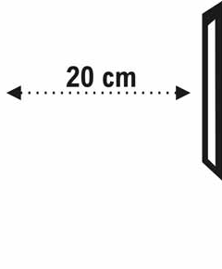Place the lamps on a table about 20 cm away from a blank wall. The light should face the wall.
- Tape the thermometers to the wall so the lamps shine directly on them, as shown in the diagram.
- Record the thermometer readings every two minutes.
- Calculate and record the change in temperature (ΔT) for each bulb.
- Turn on the light meter and remove the cover from the sensor. Place the sensor on the wall in front of the thermometer and record the foot-candles for each bulb.
- Turn off each lamp and unplug them. Plug one into the Kill A Watt® meter and plug the meter into the wall. Push
the Watts button and turn on the lamp. Record the power used by the lamp. Repeat for the other two lamps.
- Answer the conclusion questions.

38 ©2019 The NEED Project www.NEED.org Ohio Energy Project www.ohioenergy.org

 Data

Bulb type | Package stated Wattage | Package stated Lumens |  |  | Temperature (Celsius) |  |  |  |  | Light meter reading | Kill-a- Watt meter reading
 |  |  | 0 min | 2 min | 4 min | 6 min | 8 min | 10 min | ΔT
Incandescent
CFL
LED

 Conclusion

- Rank the bulbs in order of brightness, the first being the brightest. Does this ranking reflect the ranking of the bulbs according to the lumens listed on the package? Explain why you think this is.

- The three bulbs emit light using three different methods. Based on your observations of temperature change, which bulb do you think is most efficient at producing light? Does this agree with the watts recorded on the Kill A Watt® meter?

©2019 The NEED Project www.NEED.org Ohio Energy Project www.ohioenergy.org 39

LESSON 3B
Comparing Light Bulbs
The graphic on the previous page shows four light bulbs that produce the same amount of light. You might use bulbs like these as a bright overhead light. One bulb is an incandescent light bulb (IL), one is a halogen, one is a compact fluorescent light (CFL), and another is a light emitting diode (LED). Which one is the better bargain? Let’s do the math and compare the four light bulbs using the residential cost of electricity in Ohio at $0.11/kWh.
- Determine how many bulbs you will need to produce 25,000 hours of light by dividing 25,000 by the number of hours each bulb produces light.
- Multiply the number of bulbs you will need to produce 25,000 hours of light by the price of each bulb. The cost of each bulb has been given to you in the chart below.
- Multiply the wattage of the bulbs (using the kW number given) by 25,000 hours to determine kilowatt-hours (kWh) consumed.
- Multiply the number of kilowatt-hours by the cost per kilowatt-hour to determine the cost of electricity to produce 25,000 hours of light.
- Add the cost of the bulbs plus the cost of electricity to determine the life cycle cost for each bulb. Which one is the better bargain?
- 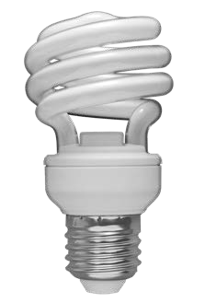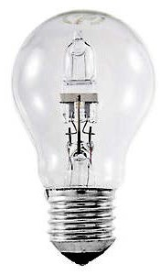Compare the environmental impact of using each type of bulb. Multiply the total kWh consumption by the average amount of carbon dioxide produced by a power plant. This will give you the pounds of carbon dioxide produced over the life of each bulb. Which one has the least environmental impact?

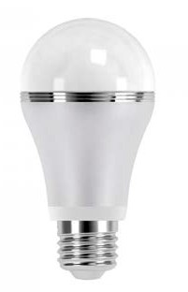
All bulbs provide about 850 lumens of light.
COST OF BULB
INCANDESCENT BULB
HALOGEN
COMPACT FLUORESCENT (CFL) LIGHT EMITTING DIODE (LED)
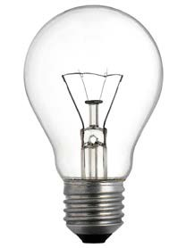Life of bulb (how long it will light) 1,000 hours 3,000 hours 10,000 hours 25,000 hours Number of bulbs to get 25,000 hours
x Price per bulb $0.50 $1.5 $1.5 $1.33

= Cost of bulbs for 25,000 hours of light
COST OF ELECTRICITY
INCANDESCENT BULB
HALOGEN
COMPACT FLUORESCENT (CFL) LIGHT EMITTING DIODE (LED)
Total Hours 25,000 hours 25,000 hours 25,000 hours 25,000 hours
x Wattage 60 watts = 0.060 kW 43 watts = 0.043 kW 13 watts = 0.013 kW 12 watts = 0.012 kW

= Total kWh consumption
x Price of electricity per kWh $0.11 $0.11 $0.11 $0.11

= Cost of Electricity
LIFE CYCLE COST
INCANDESCENT BULB
HALOGEN
COMPACT FLUORESCENT (CFL) LIGHT EMITTING DIODE (LED)
Cost of bulbs
+ Cost of electricity
= Life cycle cost
ENVIRONMENTAL IMPACT
INCANDESCENT BULB
HALOGEN
COMPACT FLUORESCENT (CFL) LIGHT EMITTING DIODE (LED)
Total kWh consumption
x Pounds (lbs) of carbon dioxide per kWh 1.6 lb/kWh 1.6 lb/kWh 1.6 lb/kWh 1.6 lb/kWh

= Pounds of carbon dioxide produced

40 ©2019 The NEED Project www.NEED.org Ohio Energy Project www.ohioenergy.org

LESSON 3
Efficiency Kit Materials
- LED Bulbs
- LED Nightlight
- Refrigerator/Freezer Thermometer
Home & Community

Energy in Action:

- Inspect your home for areas where an LED bulb could replace a less efficient lighting source. Use the LED bulb(s) provided in your efficiency kit to replace the inefficient bulb. If your home is already all LED, brainstorm places where you could install the bulb(s), i.e. friend’s home, relative’s home, at a neighbor’s house, etc.
- Inspect your home for a dimly lit area where a nightlight could come in handy and install the nightlight from the efficiency kit. The cost per year to power the nightlight is $0.02. If you use the nightlight for 80 years, how much would it cost?
- Use the refrigerator/freezer thermometer from the efficiency kit to measure your current refrigerator/freezer settings and record below. Keep the thermometer in place for 24 hours to get accurate results. Adjust the settings, if necessary.
  - Refrigerator temp: ; Safe zone is 36 – 40 °F
  - Freezer temp: ; Safe zone is 0 – 5 °F
- Explain to a family member, friend, or relative what the EnergyStar logo on many common household appliances means. Survey the appliances in your home for the EnergyStar logo. What appliances did you find sporting the logo?

Web Quest:

- Visit your utility partner’s website (refer to Lesson One) and search for information regarding the following:
  - Appliances
    - What are some of the latest and greatest energy efficient appliances and what are their most efficient features? Be sure to search for any rebates that may be helpful for your family now or in future purchases.

Career Connections:

Electrical Engineer – Design, develop, and test electrical equipment, including power generators, navigation systems, and more.
Solar Photovoltaic Installer – Assemble, install, and maintain solar panel systems on rooftops and other structures.
Lineworker – Install, maintain, and repair power lines.
Mechanical Engineer – Design power-producing machines, such as electric generators, turbines, and more.
Electrician – Install, maintain, and repair wiring, control, and lighting systems

©2019 The NEED Project www.NEED.org Ohio Energy Project www.ohioenergy.org 41

LESSON 4
Background Information:
Energy as a System
At this point we have investigated energy use one form at a time. However, the overall energy consumption picture of a school is much more complicated than isolating one classroom or one facet of the building. The lights, heating, and electrical systems throughout the building work with the insulation and building envelope to keep us comfortable while we learn.

When managing the systems of a school to minimize energy consumption, it’s important to maintain the health and comfort of the occupants. After all, the reason energy is being used in the first place is to provide a good learning environment. Human beings have specific requirements for temperature, relative humidity, and general air quality. They also have requirements for the quality and quantity of lighting. If light levels are too low, or of poor quality, they can cause eyestrain, headaches, and safety issues. Energy can be saved by turning off lights and lowering the heat in winter, but doing so thoughtlessly can cause unsafe or unhealthy conditions in the building. When the building is treated as a system, energy is saved while maintaining or improving the indoor environment. The school is not only a system in itself, but also a part of a global energy system that has finite energy resources.
There are many other systems that work together in other ways in your school, but the most important part of those systems is the people who use them. People are the brains of energy use and they are the part of the system that will have the most impact on how much energy they use.

Environmental Implications

Using all this energy to power our lives does not happen without impacting the environment.
Burning coal and natural gas carry with them environmental consequences beyond using the resources themselves. When coal and natural gas are burned, carbon dioxide is released into the atmosphere. You’ve heard of carbon dioxide before – it is a waste product from living cells when they use their own energy sources. Carbon dioxide alone isn’t a problem and is a necessary part of our natural cycles on Earth. However, when too much of it builds up in the atmosphere, it leads to climate change.
The atmosphere around the Earth works just like a blanket on your bed by trapping heat and holding it in. Water vapor, carbon dioxide, and other gases are called greenhouse gases because they absorb thermal energy and hold on to it. This is called the greenhouse effect, and it’s what keeps us from freezing to death every night when we are beyond the sun’s warming energy. But just like too much candy, too much of the greenhouse effect is not a good thing.
For thousands of years, carbon dioxide levels on Earth stayed fairly consistent. However, since the Industrial Revolution, when we as a society started using coal and petroleum for energy to run our large machines, the amount of carbon dioxide in the atmosphere has been increasing. This has led to temperature increases world- wide, and is causing large amounts of ice to melt, raising sea levels. Too much carbon dioxide is causing the atmosphere, and also the oceans, to get warmer than they should be.

Careers in Energy Management

Managing your home is done by one of your parents or another adult in your family. That person controls the thermostat setting and reminds people to turn things off when not in use. Managing the energy use of a home is important, but not overly complicated. However, managing the energy systems in a school is an entirely different situation. People who oversee the maintenance and operation of commercial buildings like schools often have some level of post-secondary training, and often have an associate’s degree in building management. These programs train people in the operation and maintenance of HVAC, water, electrical, and lighting systems. Many community and junior colleges offer programs in building operations and maintenance, and some companies hire and train their own employees to manage their commercial buildings.
Operations engineers are often mechanical or electrical engineers who have taken specialized courses in the operation and maintenance of commercial buildings. In addition to the skills that a building maintenance supervisor would have, operations engineers also know how to upgrade systems and choose the equipment for new construction. Mechanical and electrical engineers might also work in the energy management field by working with construction managers to design systems from one manufacturer to meet the specifications in a building design. They choose the equipment, oversee its installation, and set up the control systems, testing them to make sure they are operational.
Certified Energy Managers are a specific group of people who have gone through training and passed a test certifying that they are qualified to conduct energy audits and manage the energy use of a building. Their responsibilities include maintaining all the energy-using systems in commercial and industrial buildings but can also include conducting formal energy audits for companies who do not employ energy managers full-time.
There are other careers in energy management that are important. Technical writers, accountants, and marketing and advertising people can apply their skills in energy management by working for a company that manages properties or seek employment in a large corporation that has its own energy management staff.

42 ©2019 The NEED Project www.NEED.org Ohio Energy Project www.ohioenergy.org

LESSON 4A: Energy Audit
Everything you have learned has been leading up to Lesson 4 and describing energy audits. It’s time to put it all together, and audit the energy use in your building. An energy audit done by a professional energy manager is a formal, detailed walk-through of the entire building, room-by-room, measuring everything from temperature to relative humidity to airflow, and making detailed notes about what is running, plugged in, or drawing a phantom load, which is the electricity used by devices that are turned off but still plugged into an outlet. A professional energy audit also includes a review of the school’s utility bills and includes a list of recommendations to reduce energy consumption.

Auditing Tools

The most important auditing tools are always with you – your ears and eyes. They will tell you more about how a building is using energy than any other tool. With them you can see and hear things that are running and can ask yourself why. You can see gaps around doors and windows, or hear the whistle of air being forced through a crack on a windy day. You can see lights left on in an empty room. You can see condensation building up, or in bad situations, mold or mildew that you can also smell. Do not discount the importance of good observation skills when you audit your work area.
The other tools you will use are a thermometer, hygrometer, light meter, and Kill A Watt® meter. These will give you objective measurements to use in evaluating the energy use in a room or building. You have already worked with the light meter, thermometer, and Kill A Watt® meter in previous lessons.

Work Areas

You will work in groups and evaluate a work area assigned to you. This may be a single room, or it may be several rooms or spaces such as hallways and stairways. When you enter a work area, first ask the teacher for permission to proceed. Remember to show courtesy and respect by working quickly and quietly and returning things where you found them.

Take Good Notes
The second part of the auditing form has an area for notes. This is where you will record unusual observations, such as a gap around a window, an unusually noisy HVAC unit, etc. If there are things plugged in and running, but you are unable to use the Kill A Watt® meter to measure them, make a note of it.
If you see something potentially dangerous, don’t wait to tell someone. Inform that teacher, your teacher, the principal, or a maintenance staff member about the problem right away.

Summarizing the Audit and Making Recommendations
If you spend all this time collecting data but then do nothing with it, you have just wasted a lot of time. The point of collecting data on an audit is to evaluate it and look for ways your school as a community can improve. As a class, look over all the data collected for each room and see if some trends emerge. Are a cluster of classrooms too hot or too cold? Is an older section of a building more air-tight than a newer section? These are the kinds of things you are looking for. You may also see something that stands out in stark contrast to the rest of the building. If most rooms are a comfortable 72 degrees, but one room is a chilly 66 degrees, something is not right with the HVAC system in that one room.
After you have found trends across the entire building, or anomalies within your data, the next step is to write recommendations. These will probably start as bullet point-type statements, but they should be formulated into complete sentences or paragraphs. State what you found, what it should be, and make a recommendation to amend it. Professional energy audits include recommendations for upgrades and improvements, their cost, and the amount of money saved through reduced energy use. You will not go this far, but do not hesitate to suggest efficiency upgrades where they would obviously make a significant impact on the energy used in school. For example, replacing metal halide lights with LED in the gym has a moderate up-front cost that will yield significant energy savings right away. Whatever recommendations you make, do so with respect, citing the data you collected on your audit. Do not be upset if the authorities in your school district do not take all of your recommendations immediately. If you get them thinking about what they can do to improve, your audit has been successful.

©2019 The NEED Project www.NEED.org Ohio Energy Project www.ohioenergy.org 43

LESSON 4A
Student Audit Recording Form

Date:
Time:
Outdoor Temperature:

Outdoor Relative Humidity: Weather:
Is the heating system in use? yes no Is the cooling system in use? yes no Temperature of air exiting system vent:
Work Area Description:
Who is in the room?
Can you feel any air currents in the room? If so, describe where:
Are there any vents that can be opened to the outdoors? yes no
If yes, are they currently open? yes no Temperature of vent
Number of Outside Windows: Open Closed

Indoor Temperature of Room:
Thermostat setting:

Relative Humidity:
Landscaping and surfaces outside of room
Turn on the water, and start timing until hot water is delivered.

Hot Water Temperature:
Length of Time for Hot Water:

Are there any dripping faucets?
Lighting Types Present:
Light Meter Reading:
Can the lights be dimmed? yes no

Can some lights be turned on, and some left off? | yes | no
Were the lights on when you entered the room? | yes | no
Were the blinds closed when you entered the room? | All | Some | None N/A
Are doors leading outside tightly closed? yes | no | N/A
Are doors leading inside tightly closed? yes | no

44 ©2019 The NEED Project www.NEED.org Ohio Energy Project www.ohioenergy.org

Fill in the table below for every electrical device (plug-in) in the room:

Device | Plugged In | Running | Stand-by | In Use | Watts Used if Running | Watts of Phantom Load
Other notes and comments:

©2019 The NEED Project www.NEED.org Ohio Energy Project www.ohioenergy.org 45

LESSON 4A
School Building Survey
General Information
- When was the school built?
- What changes have been made since the school was built? When were they made?
- What things use energy on the school grounds? Lighted fields? Outdoor lighting?
- What fuels are used in the school? For heating, cooling, water heating, lighting, other?
- How much does the school pay each year for energy (natural gas and electricity)?
- Are there other energy costs that the school pays for, like buses?
- Do other groups that use the school pay for the energy they use?
- Who is in charge of controlling energy use in the school?
- Who is in charge of maintaining energy-use equipment? Is there a maintenance schedule for all energy-using systems?

Building Envelope

- What is the building made of? Is it in good condition?
- In which direction does the front door face?
- How many windows are on each side of the building? Are any windows cracked or broken?
- Are the windows single or double-paned? Can they be opened? Do the windows have adjustable blinds?
- How many outside doors are there? Are they insulated? Are there windows in the doors? Are any cracked or broken?
- Does the building have insulation in the walls and ceiling?
- Are inside stairwells open or enclosed?
- Do windows and doors seal tightly, or do they leak air?
- Are trees placed around the building to provide shade in warm months?
- Are there awnings or overhangs over the windows to shade windows from the overhead direct sun in warm weather, yet allow the slanted rays in winter to enter?

Recycling

- Is the paper recycled by your school?
- Are cans and bottles recycled by your school?
- Is food waste composted by your school?

46 ©2019 The NEED Project www.NEED.org Ohio Energy Project www.ohioenergy.org

Heating/Cooling Systems
- What kind of heating system is used in the school? What fuel does it use?
- How old is the heating system?
- Does the heating system have a programmable thermostat to control temperature? What are the settings?
- What kind of cooling system is used in the school? What fuel does it use?
- How old is the cooling system?
- Does the cooling system have a programmable thermostat to control temperature? What are the settings?
- Is there an air exchange system to provide fresh air when the heating and cooling systems are not operating?
- Are the boilers, pipes, and ducts sealed and insulated?
- Are the heating and cooling systems maintained on a regular basis?
- Does your school make use of passive solar heating?

Water Heating

- What fuel is used to heat water in the school?
- Is there more than one water heater? How many?
- How old are they?
- Do the water heaters have timers?
- At what temperatures are the water heaters set?
- Are the water heaters and water pipes insulated?
- Are there leaks in the hot water system?
- Are flow restrictions used?

Lighting

- What kind of lighting is used in the school? Outside the school? Exit lights?
- Can the lights be controlled with dimmer switches? In which areas or rooms?
- Does the school make use of skylights and natural lighting?
- Are there timers for the outside lights so they go off automatically?
- Are there automatic timers for any of the indoor lights?

©2019 The NEED Project www.NEED.org Ohio Energy Project www.ohioenergy.org 47

LESSON 4A
Findings and Recommendations
Engineers study building systems, then report the results of their investigations and recommend ways to use less energy. Use this form to organize the data you gathered on the Student Audit Recording Forms to prepare a presentation on your findings and recommendations. In your presentation, include an introduction and conclusion that explain your findings and recommendations.

Building Envelope
What We Learned:

Our Recommendations To Save Energy:

Room Temperature and Thermostat Settings
What We Learned:

Our Recommendations To Save Energy:

Windows and Doors
What We Learned:

Our Recommendations To Save Energy:

Lighting
What We Learned:

Our Recommendations To Save Energy:

48 ©2019 The NEED Project www.NEED.org Ohio Energy Project www.ohioenergy.org

Electrical Appliances
What We Learned:

Our Recommendations To Save Energy:

Water Heating
What We Learned:

Our Recommendations To Save Energy:

Windows and Doors
What We Learned:

Our Recommendations To Save Energy:

Recycling
What We Learned:

Our Recommendations To Save Energy:

©2019 The NEED Project www.NEED.org Ohio Energy Project www.ohioenergy.org 49

LESSON 4B
Culminating Project
Now that we have audited our school using the efficiency information provided, let’s demonstrate our knowledge of efficiency outside of the school day. The Culminating Project is a hands-on way for you to get creative and put your knowledge of energy efficiency and conservation to the test in your community. You are welcome to design your own project to answer the question below or use a recommended project design.

? Question
How can my community become more energy efficient?

Recommended Projects

- Energy Efficient Design
- Public Service Announcement
- Energy Campaign

Preparation

With your groupmates, brainstorm a few possible projects that will answer the question above. As a group, choose which project sounds the most interesting and exciting to pursue. Be sure to confirm your project with your teacher before you begin.

Procedure

- After deciding on your project type, work with your group to develop the message of your project. For instance, if pursuing an energy campaign, decide on what you are campaigning for and how you will argue that this campaign will make the community more efficient. Having a goal in place at the beginning will help direct your project.
- Work with your group to decide on your target audience, or who your project will be presented to. Examples include:
Fellow students/peers
School administration
School Board
Community members
City Council
- Work with your group to develop an action plan for your project and divide roles evenly amongst groupmates. Be sure that everyone in your group has a role.
- Submit your action plan to your teacher for approval. No projects should be carried out without prior approval from your teacher.
- Work with your group to carry out your project. Note: Be sure that any materials you need for your project are available to you before beginning. For instance, if you need video equipment, make sure you have access to video equipment before your project begins.
- Check in with your teacher periodically to report your project’s progress. Ask for recommendations and feedback.
- Present your project to your target audience.

50 ©2019 The NEED Project www.NEED.org Ohio Energy Project www.ohioenergy.org

Sample Project 1: Energy Efficient Design

Overview: Research, design, and build an energy efficient prototype, such as a room, vehicle, or other occupied space. You could also design a landscape for your school’s exterior.
Goals:
- Increase awareness of energy use and efficiency in the spaces we occupy;
- Demonstrate how different materials and techniques can have efficient outcomes.

Sample Project 2: Public Service Announcement (PSA)

Overview: Create a public service announcement (not to exceed 1 minute) communicating the importance of a specific topic pertaining to energy efficiency, i.e. water, lighting, weatherization, etc.
Goal:
- Raise awareness about the causes and consequences of energy waste and motivate others to take action in their communities.

Sample Project 3: Energy Campaign

Overview: Enlist the help of other teachers and students groups to conduct an energy savings campaign in the school and/or community. Students can make posters and flyers, and record PSAs to encourage energy conservation and efficiency.
Goals:
- Educate the school community about energy saving practices and their importance;
- Persuade the school community to adopt energy saving behaviors to reduce energy consumption.

©2019 The NEED Project www.NEED.org Ohio Energy Project www.ohioenergy.org 51

LESSON 4
Home & Community

Energy in Action:

- What top three changes would you make to keep your classroom comfortable yet efficient?

- What would happen if your above changes were adopted by the whole student body?

Web Quest:

- Visit your utility partner’s website (refer to Lesson One) and search for information regarding the following:
  - Energy Audit
    - What are some of the auditing tools your utility provider offers? Why might these tools be useful?

Career Connections:

Certified Energy Manager – Implement conservation measures, monitor energy consumption, and assess decisions on sustainability. Seek out opportunities to increase energy efficiency.
Environmental Engineer - Develop solutions to environmental problems through engineering, environmental science, biology, and chemistry.

52 ©2019 The NEED Project www.NEED.org Ohio Energy Project www.ohioenergy.org

Energy Efficiency Post-Poll

is an example of a form of energy.

a. Thermal b. Biomass c. LED d. Lumens

What unit measures power?

  - Inch b. Foot-candle c. Watt d. Work

Which energy sector includes schools?

  - Transportation b. Industrial c. Commercial d. Residential

Energy refers to a behavior that reduces energy usage.

  - Conservation b. Efficiency c. Transformation d. Awareness

refers to the capacity of an insulating material to resist heat flow.

a. Building Envelope b. R-Value c. Weatherization d. System

Of the following, which is the largest consumer of water?

a. Thermoelectric Power Plant b. Residential Homes c. Restaurants d. Schools

The is a nationwide network of transmission lines.

  - Transformer b. Substation c. Distribution Line d. Grid

What label ensures consumers that a product saves energy?

  - Energy Star b. EnergyGuide c. Energy Smart d. Energy Aware

On average, schools use 17% of their electricity consumption to do what?

  - Cook Food b. Operate Computers c. Light Buildings d. Heat Rooms

Which of the following is a career involved with the energy industry?

a. Recycling Coordinator b. LEED Construction c. Mechanical Engineer d. All

©2019 The NEED Project www.NEED.org Ohio Energy Project www.ohioenergy.org 53

LESSON 6
What We Have Learned
Energy is foundational to the things we do every single day. From powering our schools to fueling our bodies, energy is a vital part of life. Knowing that energy is essential, it is important that we use energy in efficient ways. The efficient use of energy helps to eliminate waste, streamline activities, and, overall, reduce our environmental footprint.

Using this curriculum as your guide, we challenge you to stay energy aware in your everyday life. From installing efficiency measures to adopting conservation behaviors, you can take charge of your energy usage in ways big and small. No matter the effort, every little bit counts!

Installation Survey

This program is funded through your local electric and/or natural gas provider. We ask all families to complete this survey to measure the energy savings from the program. Thank you for making a difference and saving money with your energy efficiency actions.

Please visit www.ohioenergy.org to complete the survey.

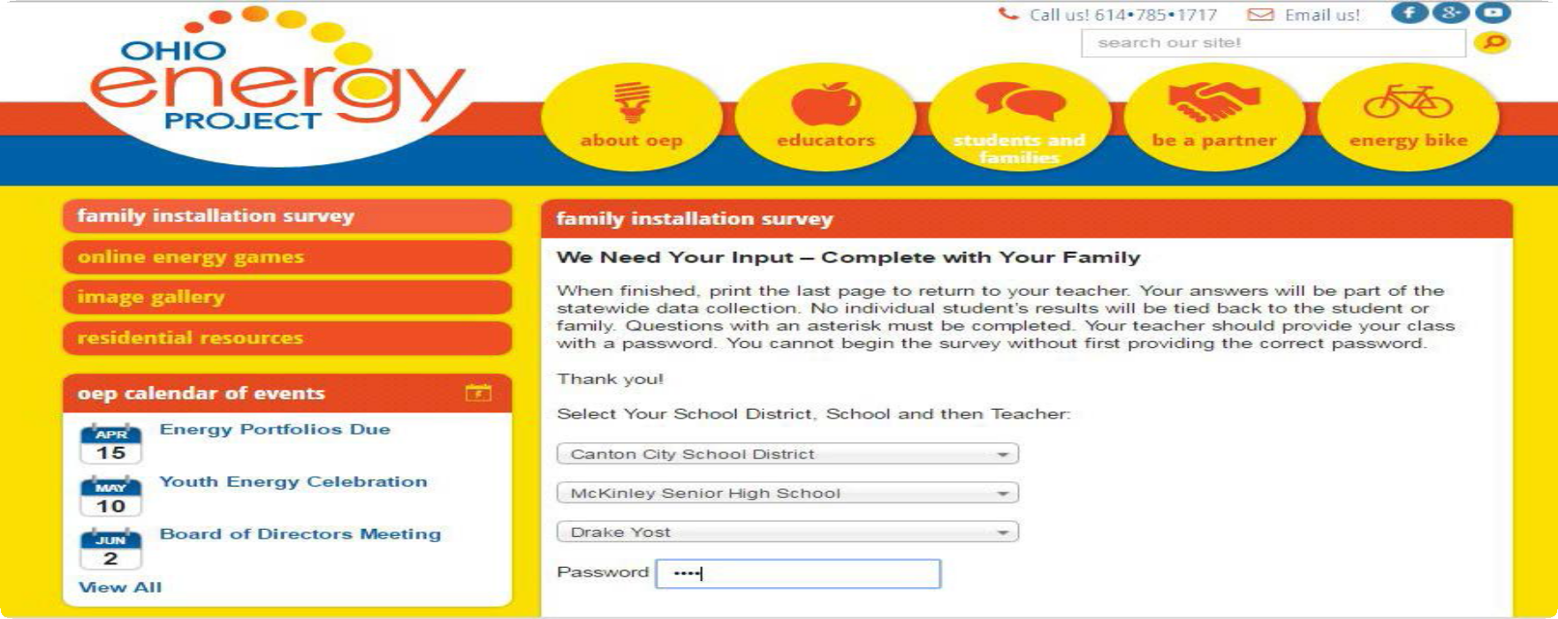

54 ©2019 The NEED Project www.NEED.org Ohio Energy Project www.ohioenergy.org

Saving Energy Glossary

 | appliance |  | any piece of equipment, usually powered by electricity, that is used to perform a particular function; examples of common appliances are refrigerators, clothes washers, microwaves, and dishwashers
 | compact fluorescent |  | a light bulb consisting of a gas-filled tube and a magnetic or electronic ballast; electricity flows from the ballast through the gas, causing it to give off ultraviolet light; the ultraviolet light excites a white phosphor coating on the inside of the tube, which emits visible light; compact fluorescent light bulbs use less energy and produce less heat than a comparable incandescent bulb
 | conductor |  | a material that transfers energy through it well, often metal
 | energy |  | the ability to do work or make a change
 | energy conservation |  | saving energy through behavior changes and installing energy efficient devices
 | energy efficiency |  | the ratio of the energy delivered by a machine to the energy supplied for its operation; often refers to reducing energy consumption by using technologically advanced equipment without affecting the service provided
 | ENERGY STAR® |  | a Federal Government program that recognizes the most energy efficient machines with a logo
 | energy sustainability |  | meeting energy demands without affecting the needs of others for the future
 | EnergyGuide label |  | the label on an appliance that shows how much energy the appliance uses in comparison to similar appliances
 | fossil fuel |  | fuels (coal, oil, etc.) that result from the compression of ancient plant and animal life formed over hundreds of millions of years
 | gauge |  | an instrument for or a means of measuring or testing
 | halogen |  | a type of incandescent light bulb that uses a small amount of a halogen gas and a filament; slightly more efficient than traditional incandescent bulbs
 | incandescent |  | a type of electric light in which light is produced by a filament heated by electric current; the most common example is the type you find in table and floor lamps
 | insulation |  | a material used to separate surfaces to prevent the transfer of electricity, heat, or sound
 | insulator |  | a material that does not transfer energy well
 | Kill A Watt™ monitor |  | a device that measures the amount of electrical energy used by a machine
 | kilowatt |  | a unit of power, used to measure electric power or consumption; a kilowatt equals 1,000 watts
 | kilowatt-hour (kWh) |  | a measure of electricity, measured as one kilowatt (1,000 watts) of power expended over one hour
 | kinetic |  | the energy of motion
 | light emitting diodes |  | energy saving bulb that generates light through the use of a semiconductor
 | lumen |  | a measure of the amount of light produced by a bulb
 | nonrenewable |  | fuels that cannot be renewed or made again in a short period of time, such as petroleum, natural gas, coal, propane, and uranium
 | payback period |  | the length of time you must use a more expensive, energy efficient appliance before it begins to save you money in excess of the additional upfront cost
 | renewable |  | fuels that can be made or used again in a short period of time, such as solar, wind, biomass, geothermal, and hydrometer
 | semiconductor |  | a material that has a conductivity level between an insulator and a conductor
 | temperature |  | a measure of thermal energy
 | thermostat | a device that controls the amount of heating and cooling produced and/or distributed
 | watt | a unit of measure of power
 | weatherization | to make a house better protected against the effects of weather

©2019 The NEED Project www.NEED.org Ohio Energy Project www.ohioenergy.org 55

The Ohio Energy Project thanks The NEED Project for permission to adapt NEED’s Saving Energy curriculum for use with OEP’s energy efficiency education programs.

AEP - 700 Morrison Drive Gahanna, OH 43230
Columbia Gas of Ohio - 290 W. Nationwide Blvd Columbus, OH 43215 Dayton Power & Light - 1900 Dryden Road Dayton, OH 45439
Vectren, A CenterPoint Energy Company - 6500 Clyo Rd. Dayton, OH 45459 Ohio’s Electric Cooperatives - 6677 Busch Blvd. Columbus, OH 43229

