SAVING ENERGY
TEACHER GUIDE
Elementary
2019-2020

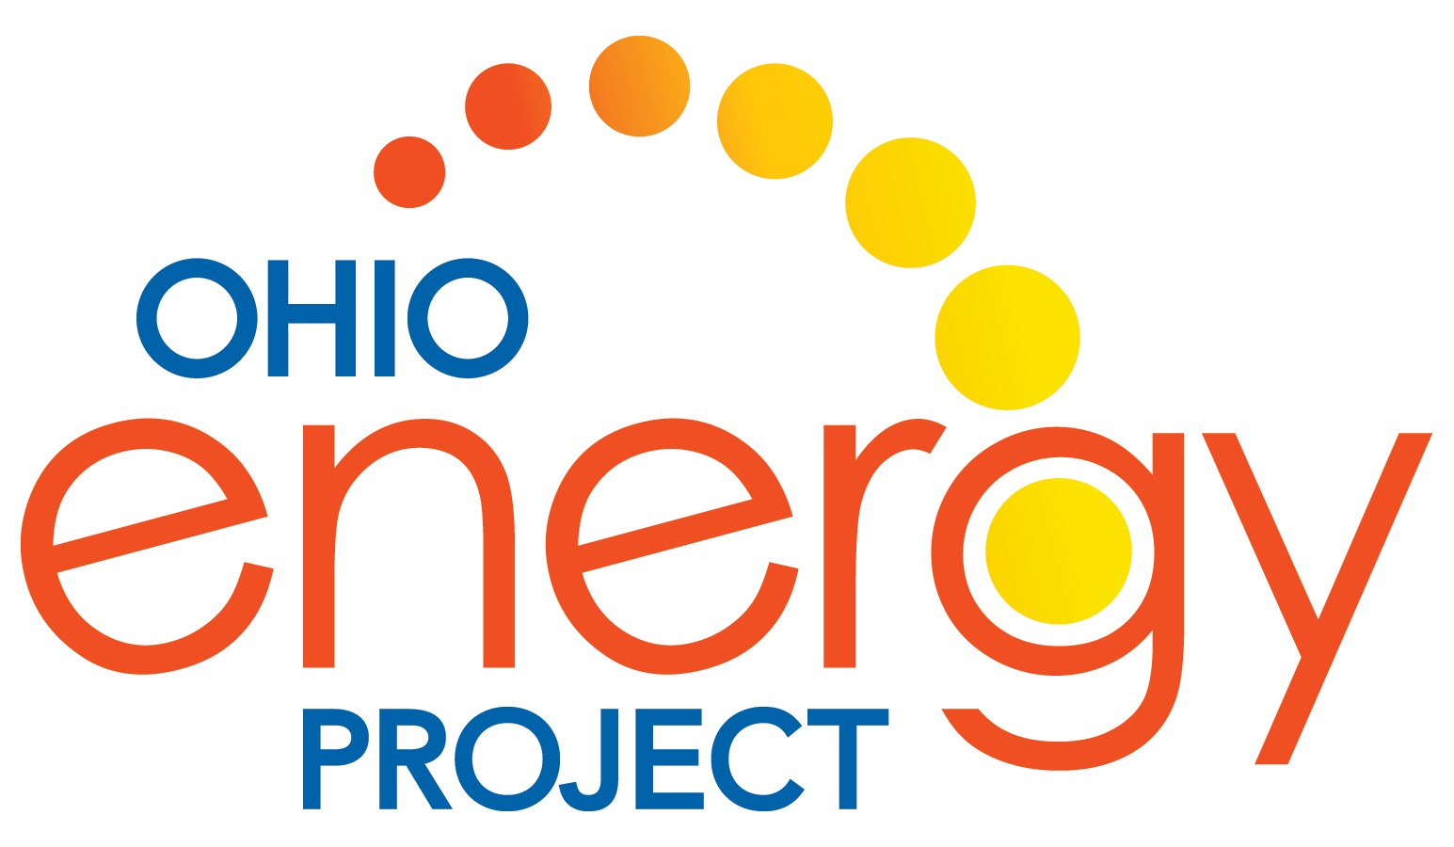

ENERGY EFFICIENCY EDUCATION

Brought to you by:

We spark curiosity about energy.

ENERGY EFFICIENCY EDUCATION

Welcome to Ohio Energy Project’s (OEP) Energy Efficiency Program – providing teachers the training, curriculum, and hands-on laboratory equipment to help spark curiosity about energy in the classroom.

Through an innovative school laboratory approach, students receive a free Energy Efficiency Kit to help educate their families, friends, and communities about responsible energy usage. By installing the efficiency measures provided to them in their own homes or throughout their communities, students are leading the next generation of energy consumers and saving both energy and money. Upon completion of this program, students are asked to fill out an installation survey, which is completely anonymous, to report on the measures most useful to them.

Our energy efficiency education partners generously provide this program at no cost to schools, educators, and families in their service territories. Those partners include:
- AEP Ohio
- Columbia Gas of Ohio
- Dayton Power & Light
- Ohio’s Electric Cooperatives
- Vectren, A CenterPoint Energy Company

Energy Data Used in Materials
Most statistics and data contained within these materials are derived from the U.S. Energy Information Administration. Data is collected and updated annually where available. Where annual updates are not available, the most current, complete data year is accessed. For access to data, visit www.eia.gov.

Ohio’s Learning Standards
All curriculum is aligned to Ohio’s Learning Standards. These standards reflect what all students should know and be able to do to become scientifically literate citizens. These standards equip students with knowledge and skills for the 21st century workforce and higher education. For more information on how the curriculum aligns to your standards, visit:
www.ohioenergy.org.

Program History
Since 2009, many of Ohio’s electric and gas utilities have partnered with OEP to deliver innovative education programs for Ohio’s educators and free energy efficiency kits for Ohio families. The installation of these measures have been claimed as savings to the Public Utilities Commission of Ohio as part of the utilities’ residential efficiency plans.

Who We Are
The Ohio Energy Project (OEP) is a nonprofit organization that has been energizing classrooms since 1984. Serving the Buckeye State, we are committed to inspiring leadership and energy innovation in students and teachers.

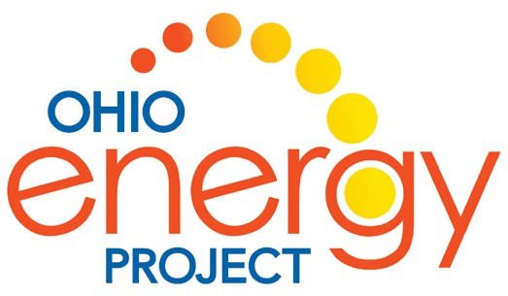
Our Education Partner
OEP partners with the National Energy Education Development (NEED) Project to design an innovative, succinct, and user-friendly curriculum ready for the classroom. The mission of NEED is to promote an energy conscious and educated society by creating effective networks of students, educators, business, government and community leaders to design and deliver objective, multi-sided energy education programs.

2 Energy at Home

SAVING ENERGY AT HOME

TEACHER GUIDE

Classroom Kit
Table of Contents
Program Overview 4
Pre-Poll 5
Lesson 1: What is Energy? 6
Lesson 2: Lighting 21
Lesson 3: Water Heating 34
Lesson 4: Insulation, Heating, and Cooling 41
Lesson 5: Appliances 57
Lesson 6: What Have We Learned? 65
Post-Poll 69
*Some materials may be used for multiple lessons.

New Teachers

NEED Infobooks
Teacher & Student Guide

Energy 101
All About the Bulb
EETop 5
Energy Flows
Energy Sources Poster

Natural Gas/Coal Sequence
Safety Sort

Lesson 1: What is Energy?

Efficiency Kit Materials
*Students receive all materials listed below “Basic Materials” and the materials below their utility sponsor.
Dynamo Flashlight
Energy Baton

Lesson 2: Lighting
CFL Bulbs, LED Bulbs,
Solar Toy

Extension Cords

Basic Materials
• Water Flow Bag
DPL/Vectren
- Aerator - Bath/Kitchen
Incandescent Bulbs
Goose Neck Lamps
Power Strips

- Hot Water Temperature Gauge
• Weather Stripping
• Thermostat Temperature Guide
- LED bulb (2)
Lesson 3: Water Heating

AEP/COH and AEP Only
- Nightlight
- Plumber's Tape
Flow Meter Bag
Hot Water Temperature Card
Natural Gas Poster

- Aerator - Bath/Kitchen
- Refrigerator/Freezer Thermometer
Lesson 4: Insulation, Heating & Cooling

• LED bulb - 9W(2), 11W(1)
- Nightlight
- Plumber's Tape
- Refrigerator/Freezer Thermometer
- Scratch and Sniff (only AEP/COH)
- Showerhead

COH Only
- Aerator Bath/Kitchen
- LED Bulb
- Plumber's Tape
- Scratch and Sniff
- Showerhead
- Scratch and Sniff
- Showerhead

Ohio's Electric Cooperatives
- Door Sweep
- Draft Stoppers
• Thermostat Temperature Guide
- LED bulb (2)
- Nightlight
- Refrigerator/Freezer Thermometer
Carpet/Tile Samples w/ LCD Thermometer
Digital Thermometers

Lesson 5: Appliances
IL Holiday Light Strand
LED Holiday Light Strand

Alumni Teachers
Teacher & Student Guide
Energy Sources Poster
NEED Infobooks
Kids Discover Magazine
Dynamo Flashlight
Insulation Containers
Thermostat Temperature Guides

Kill a Watt® Meter

Hot Water Temperature Cards
IL, CFL, LED Bulbs
Digital Thermometers
Flow Meter Bags
LCDThermometers

©2019 The NEED Project www.NEED.org Ohio Energy Project www.ohioenergy.org 3

Program Overview

OEP Web Login:
Name = teacher email as of 9/1 Password = teacher last name

Materials

LESSON | MATERIALS
1. What is Energy? | NEED Infobooks Energy 101 Energy Sources Poster
2. Lighting | Goose Neck Lamps IL Bulbs  CFL Bulbs LED Bulbs Digital Thermometers
3. Water Heating | Flow Meter Bags Hot Water Temperature Card Natural Gas Poster
4. Insulation, Heating and Cooling | Insulation Containers Digital Thermometers Thermostat Temperature Guides
5. Appliances and Machines | Kill A Watt® Meters

Checklist

TASK | DUE DATE | COMMENT
Confirm Student Count | September | Confirm early to receive kits in a timely manner
Student Kits Shipped | October/November | Count kits as soon as received
Teach Lessons | September – March | Teach lessons as best fits your classroom
Installation Survey | April 15 (no extension available) | Take the online survey or mail in paper copies
Teacher Evaluation | April 15 (no extension available) | Stipends mailed prior to end of school year
NEED Portfolio (optional)  *required to attend Youth Energy Celebration | April 15 | Document efficiency activities as you teach to create a PowerPoint portfolio
Youth Energy Celebration (optional) | May | Student accomplishments are recognized at luncheon

4 Energy at Home

Energy Efficiency Pre-Poll
- What is energy?
  - The ability to produce change or do work b. An odorless fossil fuel c. Organic matter d. Technology

- is a form of kinetic energy.

  - Petroleum b. Elastic Energy c. Thermal Energy d. Chemical Energy

- Energy is an action or behavior that results in using less energy.
  - Efficiency b. Conservation c. Sustainability d. Transformations

- What is the amount of light or brightness of a light bulb measured in?
  - Amps b. Watts c. Inches d. Lumens

- percent of energy consumed by an incandescent bulb produces light.
a. 25 b. 10 c. 70 d. 90

- A water heater should be set at .
a. 120 °F b. 65 °F c. 150 °F d. 100 °F

- Mercaptan is added to natural gas to give it a “ ” smell.
  - Mint b. Skunk c. Sweet d. Rotten Eggs

- Heat flows from areas of to areas of .
  - Higher energy; Lower energy b. Moisture; Dryness c. Lower energy; Higher energy d. Solid; Liquid

- refers to electricity loss when appliances are in standby mode.
  - Energy Star b. Kilowatt-hour c. Vampire Power d. Fuel Cost

- What is the unit of measure of the electric power an appliance uses?
a. Joule b. Volt c. Foot-candle d. Watt

©2019 The NEED Project www.NEED.org Ohio Energy Project www.ohioenergy.org 5

Lesson 1: What is Energy?

LESSON PLAN
Overview
This lesson is a review of basic energy concepts and is broken up into three mini lessons. These mini lessons include energy forms, energy sources, and energy efficiency and conservation. Depending on the prior knowledge of your students, you may want to spend additional time on these topics using the Energy Infobooks available at shop.NEED.org for primary, elementary, intermediate, and secondary reading levels.

Objectives
Students will be able to:
identify the forms and sources of energy;
classify sources as renewable or nonrenewable and forms as kinetic or potential;
identify ways in which the sources are used;
demonstrate how energy is transformed from one form to another;
differentiate between energy efficiency and energy conservation and provide examples of each.

Pre-Poll Answer Key
1. a 2. c 3. b 4. d 5. b 6. a 7. d 8. a 9. c 10. d

OEP Provided Materials
Energy 101
NEED Infobooks
Energy Sources Poster

Procedure
- Distribute one Student and Family Guide to each student.
- Copy and review both sides of the sample family installation survey with students. It is important to understand the “big picture” of learning about energy efficiency, and then apply it at home by installing the kit items. Understanding the survey vocabulary is extremely important as the survey results are reported to the sponsors of this program.
- Introduce the unit as a study of energy—what it is, where we get it, how we use it, how it is transformed and ways we can conserve it.
1Student Guide Lessons Lesson 1A: Energy Sources
Energy Source Matching
- Review the sources of energy.
- Go to the Energy Source Matching worksheet in the Student and Family Guide. Instruct students to match each energy source with its definition and give an example of each.

Lesson 1B: Energy Forms
Energy Forms Matching
- Review the forms of energy.
- Go to the Energy Forms Matching worksheet in the Student and Family Guide. Instruct students to match each energy form with its definition and give an example of each.

6 Energy at Home

Lesson 1C: Energy Efficiency and Conservation
Energy I Used Today
- Review who uses energy and discuss ways in which we can use energy more wisely. Discuss the concepts of energy efficiency and energy conservation.
- Go to the Energy I Used Today worksheet in the Student and Family Guide. Instruct students to record the number of energy bucks used in one day and provide the energy transformations for each activity, if applicable. Instruct students to total their energy bucks. A score of 80 is considered very good in terms of energy savings.
- Go to the Efficiency vs. Conservation worksheet in the Student and Family Guide. Instruct students to define the concepts of efficiency and conservation and provide an example of each.

Supplemental Lessons
Energy Efficiency Top 5
Locate the activity in Energy 101.
Have students guess the top five areas in the home that can be more energy efficient. As students guess, flip the corresponding card.

Energy Flows
Locate the activity in Energy 101.
Review energy transformations.
Use the provided instructions to have students trace the flow of energy for each source.

Home Activity
- Have students share the Student and Family Guide with parents and review the Message to Families.
- Have students complete the Assessment and Connections activities in the Student and Family Guide.

©2019 The NEED Project www.NEED.org Ohio Energy Project www.ohioenergy.org 7

LESSON 1A: Energy Sources
Background Information: What is Energy?
What Is Energy?
Energy makes change; it does things for us. It moves cars along the road and boats over the water. It bakes a cake in the oven and keeps ice frozen in the freezer. It plays our favorite songs and lights our homes. Energy makes our bodies grow and allows our minds to think. Scientists define energy as the ability to do work or cause a change in an object, such as position, shape, or state of matter.
The United States uses a lot of energy—over two million dollars worth of energy per minute, 24 hours a day, 365 days a year. With just less than 4.5 percent of the world’s population, we consume about 18.6 percent of the world’s energy resources.
All of us use energy every day—for getting from one place to another, cooking, heating and cooling rooms, making products, lighting, heating water, and entertainment.
We use a lot of energy to make our lives comfortable, productive, and enjoyable. Most of that energy is from nonrenewable energy sources. It is important that we use our energy resources wisely.

Population Versus Energy Consumption, 2016
UNITED STATES 4.34%
UNITED STATES 17.82%
WORLD
POPULATION
WORLD
ENERGY CONSUMPTION
REST OF THEWORLD 95.66% REST OF THEWORLD 82.18%
Data: Energy Information Administration

8 Energy at Home

Sources of Energy
We use many different energy sources to do work for us. They are classified into two groups—renewable and nonrenewable.
In the United States, most of our energy comes from nonrenewable energy sources. Coal, natural gas, petroleum, propane, and uranium are nonrenewable energy sources. They are used to make electricity, heat our homes, move our cars, and make all kinds of products. These energy sources are called nonrenewable because their supplies are limited. Petroleum, a fossil fuel, for example, was formed hundreds of millions of years ago from the remains of ancient sea plants and animals. We can’t make more petroleum deposits in a short time.
Renewable energy sources include biomass, geothermal energy, hydropower, solar energy, and wind energy. They are called renewable because they are replenished in a short time. Day after day, the sun shines, the wind blows, and the rivers flow. We use renewable energy sources mainly to make electricity.

RENEWABLE energy sources are replenished in a short period of time.
NONRENEWABLE energy sources are limited since it takes a very long time to replenish their supply.

WIND is energy from moving air.
GEOTHERMAL energy is heat from within the earth.

HYDROPOWER is energy that comes from the force of moving water.

SOLAR energy is energy from the sun.

BIOMASS is any organic matter (anything that was once alive) that can be used as an energy source, such as wood, crops, and yard waste.
COAL is a solid, black fossil fuel formed from the remains of plants that lived and died millions of years ago.

NATURAL GAS is a colorless, odorless fossil fuel made mostly of methane.

PETROLEUM is a fossil fuel that looks like a black liquid. It is also known as crude oil.

PROPANE is a fossil fuel refined from natural gas and petroleum.

URANIUM is the fuel used by most nuclear power plants.
During nuclear fission, atoms are split apart to form smaller atoms, which releases energy.

©2019 The NEED Project www.NEED.org Ohio Energy Project www.ohioenergy.org 9

Burning Fossil Fuels to Generate Electricity
HOW WE USE OUR ENERGY SOURCES

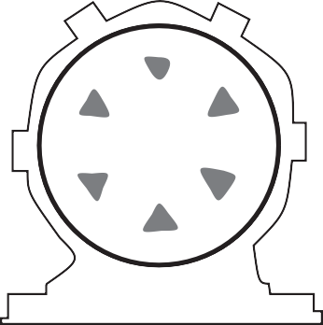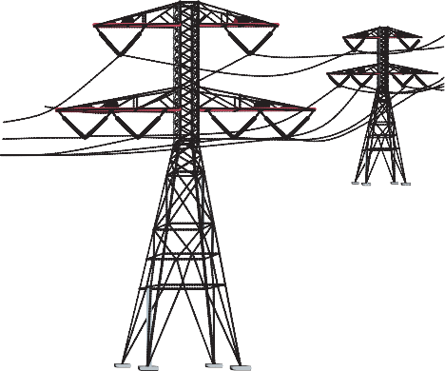FUEL BURNING ELECTRICITY GENERATION
ELECTRICITY TRANSMISSION

COAL
or
3 STEAM LINE
BOILER
TURBINE
GENERATOR
SWITCHYARD

NATURAL
GAS
2
FEED
5
4

6

or
PETROLEUM 1
WATER
CONDENSER

- A fossil fuel is fed into a boiler, where it is burned to release thermal energy.
- Water is piped into the boiler and heated, turning it into steam.
- The steam travels at high pressure through a steam line.
- The high pressure steam turns a turbine, which spins a shaft inside a generator.
- Inside the generator, the shaft spins coils of copper wire inside

MAGNETS COPPER COILS
ROTATING SHAFT

GENERATOR

a ring of magnets. This creates an electric field, producing electricity.
10
Energy at Home
- Electricity is sent to a switchyard, where a transformer increases the voltage, allowing it to travel through the electric grid.

Energy Source Matching
Answer Key

Procedure
- Match the source of energy with the definition and complete the chart.

Wind | Natural Gas | Solar
Uranium | Coal | Geothermal
Biomass | Propane | Hydropower
Petroleum

 | Energy Source | Definition | Example
 | Coal | A solid, black fossil fuel that formed from the remains of plants that lived and died millions of years ago | Can be mined on surface or deep from within the Earth
 | Solar | Energy from the sun | Travels to the Earth as radiant energy
 | Biomass | Any organic matter that can be used as an energy source, such as wood or crops | Energy transformed by photosynthesis in plants
 | Petroleum | A fossil fuel that looks like a thick, black liquid | Can be refined to gasoline and diesel fuel
 | Propane | A colorless, flammable gas refined from petroleum and natural gas | Can be compressed into tanks for grilling food
 | Uranium | The fuel used by nuclear power plants to produce steam | Atoms split (fission) forming smaller atoms and releasing energy
 | Wind | Energy in moving air | Turbines can be located on land or offshore
 | Natural Gas | A colorless, odorless fossil fuel made mostly of methane | Fuel mainly used for heating or transportation
 | Hydropower | Energy that comes from the force of falling water | Dams built to create a reservoir
 | Geothermal | Energy from the heat within the Earth | Volcanoes and geysers are evidence

- Match each example with the energy source and complete the chart.
  - Turbines can be located on land or offshore
  - Fuel mainly used for heating or transportation
  - Volcanoes and geysers are evidence
  - Can be refined to gasoline and diesel fuel
  - Dams built to create a reservoir
  - Atoms split (fission) forming smaller atoms and releasing energy
  - Energy transformed by photosynthesis in plants
  - Travels to the Earth as radiant energy
  - Can be mined on surface or deep from within the Earth
  - Can be compressed into tanks for grilling food

©2019 The NEED Project www.NEED.org Ohio Energy Project www.ohioenergy.org 11

LESSON 1B: Energy Forms
Background Information
All forms of energy fall under two categories:

POTENTIAL
Stored energy and the energy of position (gravitational).

CHEMICAL ENERGY is the energy stored in the bonds between atoms in molecules.
Gasoline and a piece of pizza are examples.

NUCLEAR ENERGY is the energy stored in the nucleus or center of an atom – the energy that holds the nucleus together. The energy in the nucleus of a plutonium atom is an example.

ELASTIC ENERGY is energy stored in objects by the application of force. Compressed springs and stretched rubber bands are examples.

GRAVITATIONAL POTENTIAL ENERGY is
the energy of place or position. A child at the top of a slide is an example.

KINETIC
The motion of waves, electrons, atoms, molecules, and substances.

RADIANT ENERGY is electromagnetic energy that travels in transverse waves. Light and x-rays are examples.

THERMAL ENERGY or heat is the internal energy in substances – the vibration or movement of atoms and molecules in substances. The heat from a fire is an example.

MECHANICAL ENERGY is the movement of a substance from one place to another. Wind and moving water are examples.

SOUND ENERGY is the movement of energy through substances in longitudinal waves.
Echoes and music are examples.

ELECTRICAL ENERGY is the movement of electrons. Lightning and electricity are examples.

12 Energy at Home

Energy Transformations
Conservation of Energy
Yourparentsmaytellyoutoconserveenergy.“Turnoffthelights,”they say.Toscientists, energyconservation is not just about turning off the lights. The Law of Conservation of Energy says that energy is neither created nor destroyed. When we use energy, it doesn’t disappear. We change one form of energy into another form.

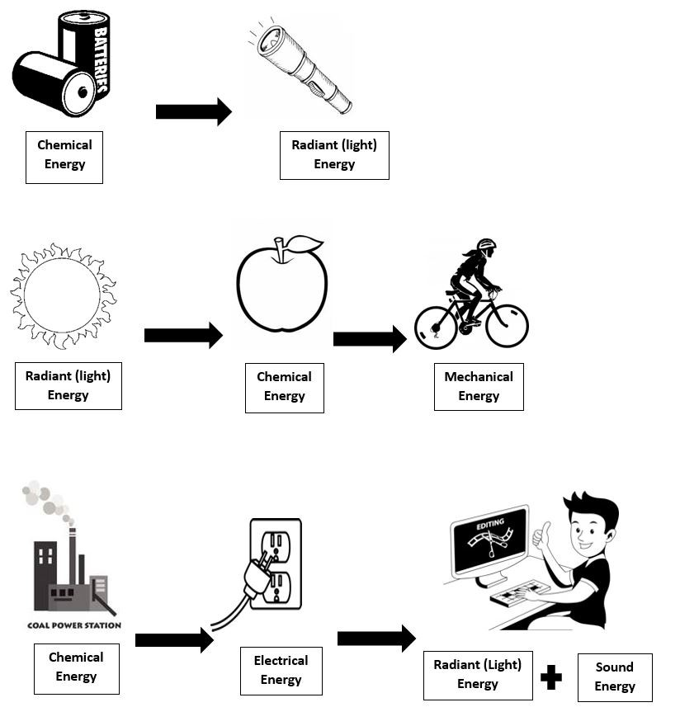

©2019 The NEED Project www.NEED.org Ohio Energy Project www.ohioenergy.org 13

ANSWER KEY
Energy Forms Matching
Procedure
- Match the form of energy with the definition and complete the chart.

Chemical | Nuclear | Gravitational Potential Energy
Elastic | Radiant | Thermal
Mechanical | Sound | Electrical

 | Energy Form | Definition | Example
 | Chemical | The energy stored in the bond between molecules | Gasoline, food, battery
 | Radiant | Energy in the form of electromagnetic waves | Sunlight and x-rays
 | Gravitational Potential Energy | The energy of place or position | A boulder on top of a hill
 | Sound | The movement of energy through a substance in a longitudinal wave | Music, shouting
 | Nuclear | The energy stored in the nucleus of an atom | Uranium and plutonium atomic nucleus
 | Mechanical | The movement of an object from one place to another | Walking, riding a bicycle
 | Electrical | The movement of electrons | Lightning, electricity
 | Elastic | Energy stored by applying force, such as squeezing | Stretched rubber band
 | Thermal | The internal energy in a substance due to the movement of particles | Rubbing your hands together, heat from a fire
- Match each example with the energy form and complete the chart.

Gasoline, food, battery Uranium and plutonium atomic nucleus

Music, shouting Lightning, electricity

Stretched rubber band Rubbing your hands together, heat from fire

Sunlight and X-rays A boulder on top of a hill Walking, riding a bicycle

14 Energy at Home

LESSON 1C: Energy Efficiency and Conservation
Background Information

Energy Efficiency and Conservation
The choices we make about how we use energy have environmental and economic impacts. There are many things we can do to use less energy and use it more wisely. These actions include both energy conservation and energy efficiency.
Energy conservation is any action or behavior that results in using less energy. Drying clothes outside on sunny days is an example of energy conservation. Energy efficiency focuses on technologies that use less energy to perform the same tasks or the same amount of work. Buying a dryer that uses less energy is an example of energy efficiency.

Who Uses Energy?
The U.S. Department of Energy uses categories to classify energy users—residential, commercial, industrial, electric power, and transportation. These categories are called the sectors of the economy.
The residential sector includes houses, apartments, and other places where people live. The commercial sector includes schools, businesses, and hospitals. The residential and commercial sectors are put together because they use energy for similar tasks—for heating, air conditioning, water heating, lighting, and operating appliances.

Home Energy Expenditures
HEATING
29.3%

COOLING
14.3%
REFRIGERATION
5.6%
Data: EIA 2015 RECS
WATER HEATING
16.0%
COMPUTERS/ ELECTRONICS COOKING,
CLEANING, & OTHER 27.0%
LIGHTING 7.9%

U.S. Energy Consumption by Sector, 2016

TRANSPORTATION
28.5%
Top Transportation Sources:
 Petroleum
 Biomass
 Natural Gas
INDUSTRIAL 22.0%
Top Industrial Sources:
RESIDENTIAL 6.2%
Top Residential Sources:
 Natural Gas
 Biomass
 Petroleum

ELECTRIC POWER 38.7%
Top Electric Power Sources:

 Natural Gas
 Petroleum
 Propane
COMMERCIAL 4.5%
Top Commercial Sources:
 Natural Gas
 Petroleum
 Propane
 Natural Gas
 Coal
 Uranium

The residential, commercial, and industrial sectors use electricity. This graph depicts their energy source consumption outside of electricity.
Data: Energy Information Administration
*Total does not equal 100% due to independent rounding.
©2019 The NEED Project www.NEED.org Ohio Energy Project www.ohioenergy.org 15

Industrial Sector
Making the goods we use every day consumes an enormous amount of energy. The industrial sector of the economy consumes almost one-third of the nation’s energy. In industry, energy efficiency and conservation are driven by economics—money. Manufacturers know that they must keep their product costs low so people will buy them.
Since energy is one of the biggest costs in many industries, manufacturers must use as little energy as possible. Their demand for energy efficient equipment has resulted in many new technologies in the last decades. Consumers can have an effect on industrial energy use through the product choices we make and what we do with the packaging and the products we no longer use.

A Consumer Society
Not only is America a consumer society, it is also a ‘throw away’ society. Americans produce more trash than any other developed country. The average person throws away approximately 1,600 pounds of trash a year!
The best way for consumers to reduce the amount of energy used by industry is to avoid buying unnecessary products and to repair and reuse items wherever possible. Buying only those items you need, as well as reusing and recycling products, can reduce energy use in the industrial sector. The 4 R's of an energy-wise consumer are easy to put into practice. Managing waste saves money, energy, and natural resources, and it helps protect the environment.
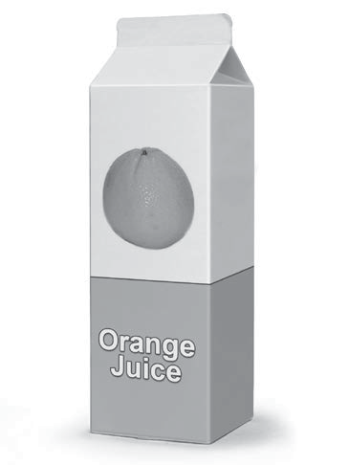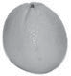Reduce
Buy only what you need. Buying fewer goods means less to throw away. It also means fewer goods are produced and less energy is used to manufacture them. Buying goods with less packaging also reduces the amount of waste and the amount of energy used.
Reuse
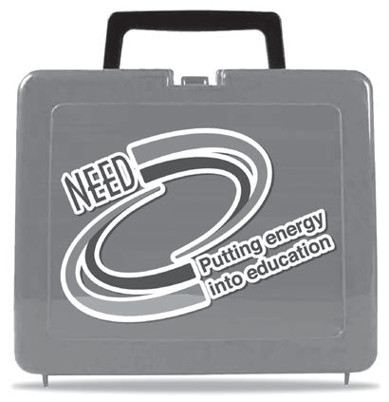Buy products that can be used more than once. If you buy things that can be reused rather than
disposable items that are used once and thrown away, you save natural resources. You will also save the energy used to make them and reduce the amount of landfill space needed to contain the waste. Savings also result when you buy things that are
durable. They may cost more, but they last a long time and do not need to be replaced often, saving money and energy.
Repair
Many people throw away products when they break and buy new ones. Many of these products could be easily and cheaply repaired. Always consider repairing a product before throwing it away. It saves energy, money, and natural resources.

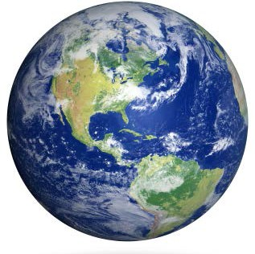
Recycle
Make it a priority to recycle all materials that you can. Using recycled material to make new products almost always consumes less energy than using new materials. Recycling reduces energy needs for mining, refining, and many other manufacturing processes.
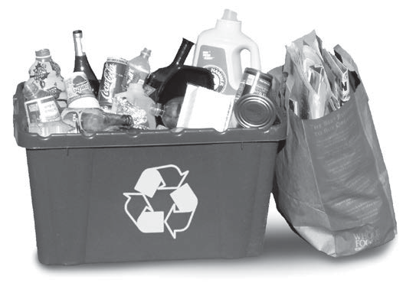Recycling steel saves 75 percent of the energy needed to make products from raw iron ore. Recycling aluminum cans saves 92 percent of the energy required to
produce aluminum from bauxite. Many other products can also be recycled and contribute to savings in energy and resources.
Recycling is only part of the process to save energy.
Consumers also need to make an
effort to buy recycled goods. Many products now have labels that tell consumers how much recycled material they contain.

Energy Sustainability

Efficiency and conservation are key components of energy sustainability—the concept that every generation should meet its energy needs without compromising the needs of future generations. Sustainability focuses on long-term actions that make sure there is enough energy to meet today’s needs as well as tomorrow’s.
Sustainability also includes the development of new clean technologies for using fossil fuels, promoting the use of renewable energy sources, and encouraging policies that protect the environment.

16 Energy at Home

ANSWER KEY

LESSON 1C
The Energy I Used Today

Circle the things you used or did today in the left column. For each item circled, write the number of Energy Bucks (in parenthesis) in the Energy Bucks column. Add them together to find your Total Energy Bucks Used. List the transformation of energy in the right column. The first example has been completed for you.

What device woke me up this morning? ENERGY BUCKS TRANSFORMATION

Alarm Clock/Radio/Cell phone (2 bucks)
What devices were used to make my breakfast?
Microwave (2 bucks)
Stove/Oven (5 bucks)
Toaster Oven/Toaster (3 bucks) Refrigerator (3 bucks)
What devices did I use as I got ready for school this morning?
Air Conditioning/Heating (10 bucks) Gaming System (3 bucks)
TV/DVD Player (3 bucks) Shower/Bath (3 bucks) Hair Dryer (3 bucks)
Curling Iron/Curlers/Flat Iron (3 bucks) Telephone/Cell Phone (2 bucks) Computer (3 bucks)
iPad/Tablet (2 bucks)
2 E S

2 E R T+M
5 E T or C T
3 E R+T
3 E T

10 E M+T or C T+M
3 E S+T+R
3 E S+T+R
3 E T or C T
3 E T+M+S
3 E T
2 E S+R
3 E R+S+T
2 E R+S+T

What rooms had lights turned on this morning?

Bedroom (2 bucks)
Bathroom (2 bucks)
Kitchen (2 bucks) Family Room (2 bucks) Other (2 bucks)
2 E R+T
2 E R+T
2 E R+T
2 E R+T
2 E R+T

©2019 The NEED Project www.NEED.org Ohio Energy Project www.ohioenergy.org 17

ANSWER KEY
How did I get to school today? ENERGY BUCKS TRANSFORMATION

Walk (0 bucks)
Bicycle (0 bucks) School Bus (1 buck) Carpool (2 bucks) Family Vehicle (5 bucks)
What devices did I use after school yesterday?
Air Conditioning/Heating (10 bucks) Travel in Vehicle (5 bucks)
Lights (2 bucks)
Computer (3 bucks)
iPad/Tablet (2 bucks) Gaming System (3 bucks) TV/DVD Player (3 bucks)
Telephone/Cell phone (2 bucks)
0

0 1
2
5

10
5
2
3
2 3
3
2
C M

C M C M
C M

C M

E M+T or C M+T C M
E R+T

E R+T+S

E R+S+T

E R+T+S

E S+R+T
E R+S

What devices were used at home last night?

Air Conditioning/Heating (10 bucks)
Microwave (2 bucks)  Stove/Oven (5 bucks) | 10  2 | E | E | M+T or C M+T R T+M
Toaster Oven/Toaster (3 bucks) | 5 |  | E | T or C | T

Refrigerator (3 bucks)
Grill (2 bucks)
Lights (2 bucks) TV/DVD Player (3 bucks)
Gaming System (3 bucks) Shower/Bath (3 bucks) Hair Dryer (3 bucks)
Telephone/Cell Phone (2 bucks) Computer (3 bucks)
iPad/Tablet (2 bucks)
Total Energy Bucks Used
3

3
2

2 3
3
3
3

2 2
E T+R E T

C T+R

E T+R

E R+T+S

E R+T+S

E T or C T

E T+M+S

E R+S

E R+S+T

18 Energy at Home

ANSWER KEY
19
©2019 The NEED Project www.NEED.org Ohio Energy Project www.ohioenergy.org

LESSON 1C
Efficiency vs. Conservation

Energy efficiency and conservation are both important ways to save energy. Write the definitions for each in the top boxes and examples in the bottom boxes.

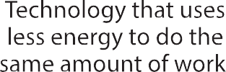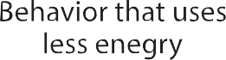
EFFICIENCY
CONSERVATION
EXAMPLES
EXAMPLES

ANSWER KEY

LESSON 1 – What is Energy?
ASSESSMENT

- The energy in petroleum, natural gas, coal and biomass is stored as ?
  - thermal energy b. chemical energy c. kinetic energy d. sound energy

- The energy source that provides most of our transportation needs is ?
  - wind b. petroleum c. propane d. coal

- Which energy source is a type of mechanical energy?
  - uranium b. geothermal c. solar d. hydropower

- Which conservation behavior would save the most energy in your home?
  - turn off an LED light b. open the window instead c. driving to school d. turn off the TV for
of turning on the air conditioning one hour

- What is the most energy efficient way to dry your hair? Explain.
The most energy efficient way to dry your hair would be to allow it to air dry because no electricity or other form of energy is needed.

- You ate a banana for breakfast. List the transformation steps involved in giving you energy for your morning at school.
Chemical (food) Mechanical (motion). Students may also include radiant (light from the sun) used to grow the fruit.

- Appliances are one of the“Top Five” energy users in your home. Describe two ways you can conserve energy with the appliances you use most at home.
Responses will vary.

Connections
- If you could decide on the source of energy used to generate electricity for your community, which energy source(s) would you choose and why?
- Using the forms of energy, describe the transformation of energy in a car.
- After completeing The Energy I Used Today, list five things you could change to save energy.

20 Energy at Home

Lesson 2: Lighting Investigation

LESSON PLAN
Overview
This lesson focuses on energy efficient lighting. Students will compare the heat produced and energy used by different types of bulbs.

Objectives
Students will be able to:
compare and contrast the efficiency of different types of light bulbs;
show how lighting affects their energy usage and that changing the type of light bulb impacts energy costs.

OEP Provided Materials
Light Emitting Diode (LED) bulb, 1 per group
Incandescent (IL) bulb, 1 per group
Compact Fluorescent (CFL) bulb, 1 per group
Lamps, 3 per group
Thermometers, 3 per group

Teacher Provided Materials
Ruler, 1 per group
Powerstrip, 1 per group
Timer, 1 per group

Recommended Activities
All About the Bulb, Energy 101
Coal Sequence, Energy 101

Home Energy Efficiency Kit Materials
Light bulbs
LED Nightlight (if available)

Preparation
Prior to the lesson, assemble and set up the lamps with the various bulbs. Plug all lamps into a single powerstrip, if available, for each group.
Procedure
Light Bulb Investigation
- Introduce the topic of lighting and the three types of light bulbs by reviewing the background information presented on lighting. Review lighting at school and at home and discuss the differences in lighting in both environments.
- Hold up or display the different bulbs to show the difference visually.
- Review the Facts of Light. Discuss the following key vocabulary with the students:
Lumens - a measure of the amount of light falling on an object at a given distance, often referred to as “brightness.”
Watts - units of power, the rate at which a bulb or appliance uses energy.
Kilowatt – 1,000 watts. It is more useful when talking about electricity use than a single watt because we use so many thousands of watts.
Kilowatt-hour - the unit in which we buy electricity. It is a unit for energy. It is equal to 1,000 watts used for one hour. Kilowatt-hours are calculated by multiplying kilowatts by hours used.
©2019 The NEED Project www.NEED.org Ohio Energy Project www.ohioenergy.org 21

- Review the Lighting Investigation procedure.
- Demonstrate how to read the thermometer. For the safest data collection, lay the thermometer under each bulb and tape the thermometer to the table. Remind students to keep thermometers the same distance from each bulb.
- Assign roles to the students. There should be three thermometer readers, a timer and a data recorder.
- Instruct students to record the initial temperature and then record the temperature every minute for 10 minutes on the data table once the bulbs are turned on. After 10 minutes, calculate the change in temperature for all three bulbs. It may be helpful to use an online stop watch projected for the class to keep all groups at the same pace.
- Have students graph the results of the investigation on the graph paper using different color lines for each bulb.
- Discuss why the incandescent bulb gets so much hotter. Explain how the electricity flows through a thin tungsten wire called a filament and actually gets so hot it emits light and glows. This bulb was invented by Thomas Edison in 1879.
- Explain that compact fluorescent bulbs do not have a filament. CFLs are actually a tube of gas. When electricity flows through the gas from a magnetic or electronic ballast, the gas emits ultraviolet light. That ultraviolet (UV) light strikes a painted white phosphor coating on the inside of the tube. Phosphor is a substance that can emit visible light when it is struck by UV light. The coating of the tube is what glows.
- Describe that the LED bulb contains semiconductors like solar panels. There are three layers within the LED that combine to produce light. Voltage is needed to energize the electrons so they move back and forth between the layers and emit light.
- Ask students to list the variables and controls in this experiment. Variable means ‘can change.’
The independent variable is the one you are investigating. It is the one you can manipulate in the experiment. You should only have one independent variable. In our investigation, the type of bulb is the independent variable.
The dependent variable is the variable which you measure to get your results. Often there is only a single dependent variable, but there can be more. The dependent variable in our investigation is temperature, which we measure over 10 minutes.
The independent variable causes change to the dependent variable.
All other variables must be controlled or kept constant so they do not change the result. There are usually many controlled variables in an experiment. Those include distance, thermometers, bases, time interval, location, and lumens.
- Have students complete Lighting Investigation Results.

Facts of Light
- Review the Facts of Light student worksheet to compare the costs of purchasing and operating the three types of bulbs.
- Review the following terms as needed: lumens, watts, kilowatt, kilowatt-hour, life cycle cost.
- If possible, distribute real light bulb packaging or copies and have students complete the Facts of Light worksheet.
- Help students work through the calculations and then review the data, calculations and questions. Have students transfer data to the Facts of Light Summary to review with their family.

Home Action Item and Wrap Up
- Have students complete the Assessment and Connections activities in the Student and Family Guide.
- Review the Home Activity in the Student and Family Guide with the students and assign a completion date.
- Give each student their LED bulbs and LED nightlight, if available.

22 Energy at Home

LESSON 2
Background Information: Lighting
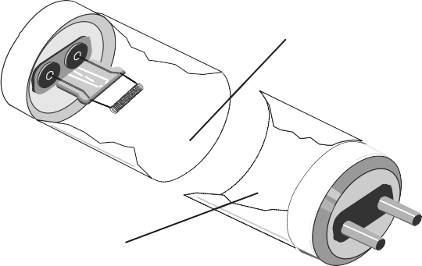Lighting is one of the most important ways we use energy every day. Lighting helps us see our surroundings and can help prevent us from straining our eyes. Traditional light bulbs, called incandescent bulbs, have been replaced by more efficient bulbs like halogens, compact fluorescents, and light emitting diodes (LEDs) on store shelves recently. Let’s read further to investigate why.
Fluorescent Tube Lamp
Mercury and
inert gases
Phosphor coating

Base with bi-pin plug
In fluorescent tubes, a very small amount of mercury mixes with inert gases to conduct the electric current. This allows the phosphor coating on the glass tube to emit light.
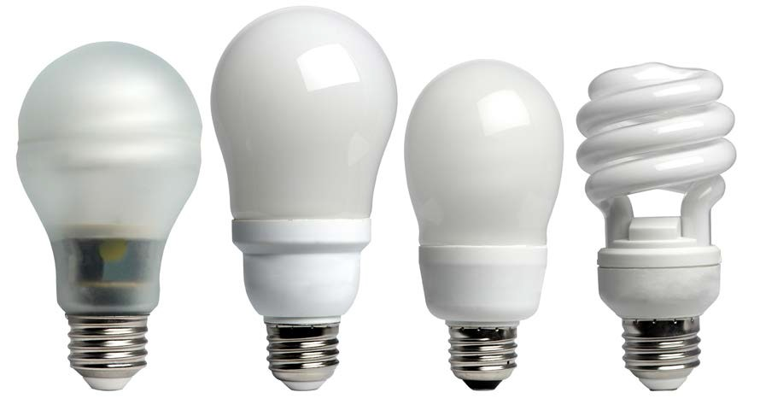Lighting accounts for five percent of a home's energy use, which translates to about 11% of the home's electricity bill. Much of this is the result of using inefficient lighting. Many homes still use incandescent lighting. Only 10 percent of the energy consumed by an incandescent bulb actually produces light; the rest is given off as heat. There are other more efficient lighting choices on the market, including halogens, fluorescents, and LEDs. Halogens are sometimes called energy-saving incandescent bulbs because they last slightly longer, and use less energy than traditional incandescent bulbs, however they can burn hotter than incandescent lights do. Fluorescent lights produce very little heat and are even more efficient. Most schools use fluorescent tube lighting throughout the building, but may use incandescent bulbs in other spaces around the school.
Compact Fluorescent Light Bulbs
CFLs come in a variety of styles for different purposes. CFLs
use about one-third the energy of a halogen incandescent.
Fluorescent lights use 75 percent less energy than traditional incandescents and reduce environmental impacts. Converting to compact fluorescent light bulbs (CFLs) in your home is one of the quickest and easiest ways to decrease your electricity bill. You will save a $30-$80 in electricity costs over the lifetime of every 100- watt incandescent bulb you replace. CFLs provide the same amount of light and save energy.
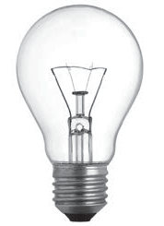A fluorescent lamp is a glass tube lined inside with a phosphor coating. The tube is filled with argon gas and a small amount of mercury. At the ends of the tube are electrodes that generate an electric field when electricity flows through them. The energized electrons cause the mercury gas to emit UV (ultra violet) light. The invisible UV light strikes the phosphor coating, which emits visible light.
Compact fluorescent light bulbs (CFLs) come in a variety of styles for different purposes. CFLs cut lighting costs about 75 percent.
Did You Know?
Only 10 percent of the energy used by a traditional incandescent bulb produces light. The rest is given off as heat.
Fluorescent lights have ballasts that help move the electricity through the gas inside the bulb. There are two types of ballasts, magnetic and electronic. Electronic ballasts are more efficient than magnetic ballasts and can eliminate flickering and noise.

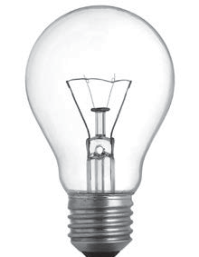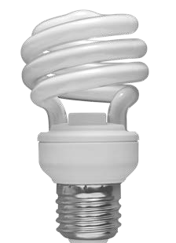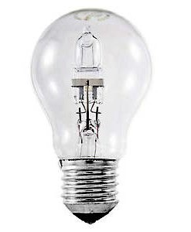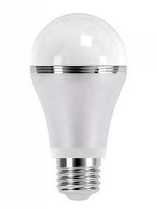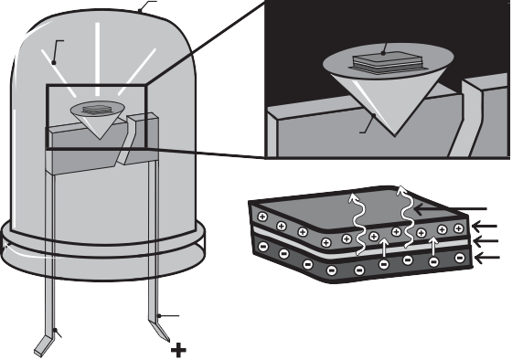
INCANDESCENT BULB HALOGEN BULB CFL BULB LED BULB
LEDs offer better light quality than incandescent bulbs and
halogens, last 25 times as long, and use even less energy than CFLs. LEDs now have a wide array of uses because technology has improved and costs have decreased. It is possible to see CFL use decrease as LED costs continue to improve.
Inside an LED
epoxy case
LED chip
emitted light
reflecting cup
photons
p-type layer
p-n type junction n-type layer
anode lead
cathode lead
©2019 The NEED Project www.NEED.org Ohio Energy Project www.ohioenergy.org 23

LEDs have been commonly found in electronic devices and exit signs. Now they are offered as affordable options for lighting in homes and businesses. Light emitting diodes contain semiconductors like solar panels; the difference is in the way the electrical energy is used by the LED. Three layers within the LED – p-type, n-type, and a depletion zone – combine to produce light. A minimum voltage is needed to energize electrons and they move from the n-type layer to the p-type layer. When the electrons move back again, they emit light that we see.
One of the quickest and easiest ways to immediately decrease your electricity bill is to install CFL or LED bulbs in the place of incandescent or halogen bulbs. For every 100-watt incandescent bulb replaced, a savings of $30-$80 can be realized over the lifetime of the bulb. A CFL uses 75 percent less energy than an incandescent, and an LED bulb uses even less energy. CFL and LED bulbs last longer than incandescent bulbs, too. Each type of bulb has benefits as well as drawbacks. For example, a CFL is less expensive than an LED, but it is more fragile, contains mercury, and is not always dimmable. An LED is more durable than a CFL, but it is heavier and is sometimes more expensive. Both types are available in a wide variety of shapes and light colors. When shopping for a replacement bulb, look for ENERGY STAR® rated bulbs for the best quality and energy efficiency ratings, and make sure the bulb you buy produces the same brightness of light, as measured in lumens.
There are a few ways you can save energy on lighting in the home:
switch incandescent bulbs to CFLs or LEDs;
shut off lighting when exiting the room; and
use natural light by opening blinds or curtains when possible.

Facts of Light
Light bulbs can be compared in a variety of ways. When looking at different light bulbs you must consider:
- Lumens: a measure of the amount of light falling on an object at a given distance, often referred to as “brightness.“
- Watts: unit of power, the rate at which a bulb or appliance uses energy.
- Kilowatts: 1000 watts (It is more useful when talking about electricity use than a single watt because we use so many thousands of watts.)
- Kilowatt-hour: the unit in which we buy electricity. It is a unit for energy. It is equal to 1000 watts used for one hour. Kilowatt- hours are calculated by muiltiplying kilowatts by hours used.

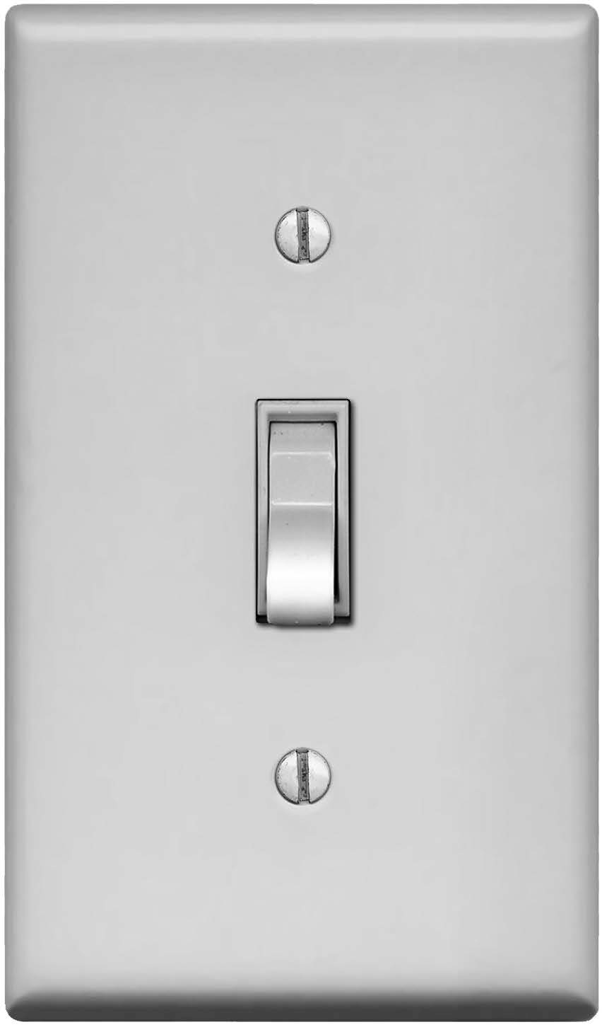

When you leave a room, remember to turn the lights off.

24 Energy at Home

LESSON 2
Lighting Investigation

? Question
Of the three types of light bulbs, incandescent, CFL, and LED, which produces the greatest temperature change in ten minutes?

 Materials

3 lamp bases
1 Incandescent bulb (IL)
1 Compact Fluorescent bulb (CFL)
1 Light emitting diode bulb (LED)
3 Digital thermometers
Ruler

Powerstrip Timer
 Hypothesis

Procedure

- Record student roles for each member in the group:

  - CFL Thermometer Reader
  - IL Thermometer Reader
  - LED Thermometer Reader
  - Timer
  - Data Recorder

- Set up all three light bulbs in their lamp bases and plug each into an outlet.

- Place the digital thermometers on the table beneath each bulb. Be sure to keep everything the same for all three bulbs. Taping the thermometers down works well.

- Take the initial temperature of all three thermometers before turning on the bulbs and record on the data sheet at time“0”. Turn all 3 bulbs on at the same time and begin recording the temperature every minute for 10 minutes.

- After 10 minutes, calculate the change in temperature for each bulb and record.

- Make a line graph of your results. Use a different color line for each of the bulbs. Make a key showing which bulb each color represents. Label the graph and give it a title.

- With your group, answer the questions regarding the results of your temperature investigation.

©2019 The NEED Project www.NEED.org Ohio Energy Project www.ohioenergy.org 25

STUDENT WORKSHEET

LESSON 2
Lighting Investigation
DATA SHEET

 | Time (min) | Temperature of IL Bulb (°F) | Temperature of CFL Bulb (°F) | Temperature of LED Bulb (°F)
 | 0
 | 1
 | 2
 | 3
 | 4
 | 5
 | 6
 | 7
 | 8
 | 9
 | 10
 | Change in Temperature ∆T

26 Energy at Home

Lighting Investigation

GRAPH TITLE

0 1 2 3 4 5 6 7 8 9 10

COLOR KEY: IL CFL LED

©2019 The NEED Project www.NEED.org Ohio Energy Project www.ohioenergy.org 27

ANSWER KEY
Lighting Investigation Results
- Do your results support your hypothesis? Explain.
Responses will vary. Discuss a variety of different ideas from students. Have students show their results on their graphs, which will show the biggest increase in temperature for the IL, then the CFL, and lowest will be the LED.

- What characteristics do the light bulbs have in common?
They all produce light and heat. They each have a metal base.

- How do the light bulbs differ?
They are different shapes and sizes and have different light qualities. Because CFLs have a small amount of mercury, CFLs have a special disposal method. Some lighting types produce less heat than others. The ILs can burn your skin badly if touched, but the other two can be touched. Most LED lenses are made of plastic while CFLs and ILs are made of glass.

- Which light bulb is coolest in temperature when in use?
The LED is the coolest.

- Which bulb is truly a “heat bulb” not a “light bulb?” Explain your answer.
The incandescent bulb is truly a heat bulb because only 10 percent of energy is transformed into light and 90 percent of energy into heat or thermal energy.

- What variables remain controlled?
Variables that were controlled (kept constant) in this investigation were distance of thermometer to the bulb and using the same type of thermometer and lamp. The time intervals and location were kept the same. The lumens are the same for all three bulbs.

- What was your independent variable?
The independent variable is the bulb, which was purposely changed. The way in which each bulb produces light contributes to its change in temperature over time.

- What is the dependent variable?
The dependent variable is temperature, which we are measuring to show the results of the investigation.

28 Energy at Home

STUDENT WORKSHEET
29

LESSON 2
©2019 The NEED Project www.NEED.org Ohio Energy Project www.ohioenergy.org
Facts of Light Worksheet

How Much Can You Save With Energy Efficient Bulbs?
The graphic on the next page shows three light bulbs that produce the same amount of light. You might put bulbs like these into a bright overhead light. One bulb is an incandescent light bulb, one is a compact fluorescent light bulb (CFL), and another is a light emitting diode (LED). Which one is the better bargain? Let’s do the math and compare the three light bulbs using the residential cost of electricity at $0.11/kWh in Ohio.

- Determine how many bulbs you will need to produce 25,000 hours of light by dividing 25,000 by the number of hours each bulb produces light.

- The price of each bulb has been given to you in the chart on the next page.

- Multiply the number of bulbs you will need by the cost of each bulb to determine the cost of bulbs to produce 25,000 hours of light.

- Multiply the number of kilowatt-hours given to you on the next page by the cost per kilowatt-hour to determine the cost of electricity to produce 25,000 hours of light.

- Add the cost of the bulbs plus the cost of electricity to determine the life cycle cost for each bulb.

LIFE CYCLE COST
INCANDESCENT BULB (IL)
COMPACT FLUORESCENT (CFL)
LIGHT EMITTING DIODE (LED)
STUDENT WORKSHEET
30
Energy at Home

LESSON 2
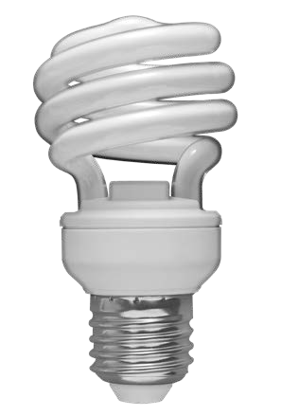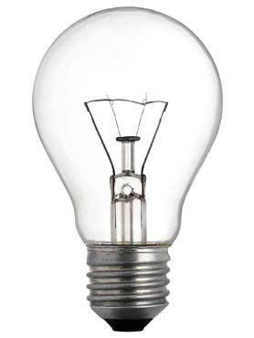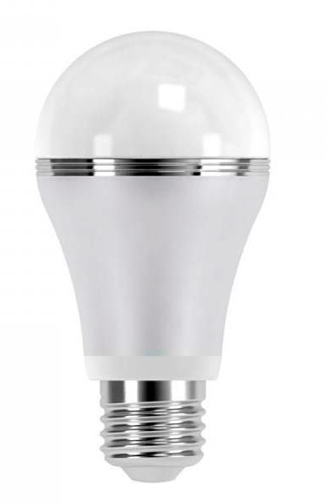Facts of Light

All bulbs provide about 850 lumens of light.
NOTE: When calculating number of bulbs, round up to the nearest whole Number.
COST OF ELECTRICITY
INCANDESCENT BULB (IL)
COMPACT FLUORESCENT (CFL)
LIGHT EMITTING DIODE (LED)

COST OF BULB
INCANDESCENT (IL)
COMPACT FLUORESCENT (CFL)
LIGHT EMITTING DIODE (LED)
Life of bulb (how long it will light) | 1,000 hours | 10,000 hours | 25,000 hours
Number of bulbs to get 25,000 hours
x Price per bulb | $0.50 | $1.50 | $1.33
= Cost of bulbs for 25,000 hours of light

Total Hours |  | 25,000 hours | 25,000 hours | 25,000 hours
x | Wattage | 60 watts = 0.060 kW | 13 watts = 0.013 kW | 12 watts = 0.012 kW
= | Total kWh consumption | 1,500 | 325 | 300
x | Price of electricity per kWh | $0.11 | $0.11 | $0.11
= | Cost of Electricity

Cost of bulbs
+ Cost of electricity
= Life cycle cost

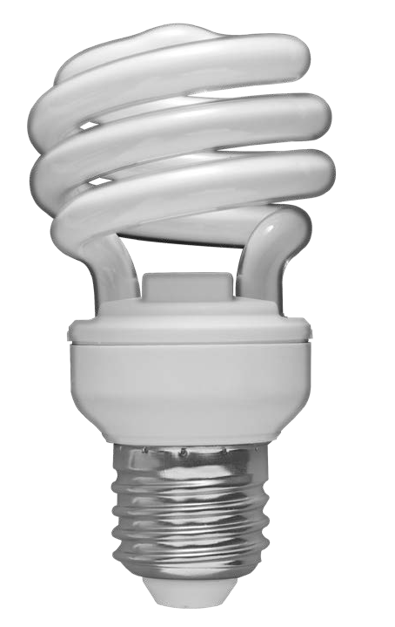ANSWER KEY

Facts of Light Summary: Answer Key
Use the Facts of Light data to show the life cycle cost of each bulb when used for 25,000 hours.

INCANDESCENT  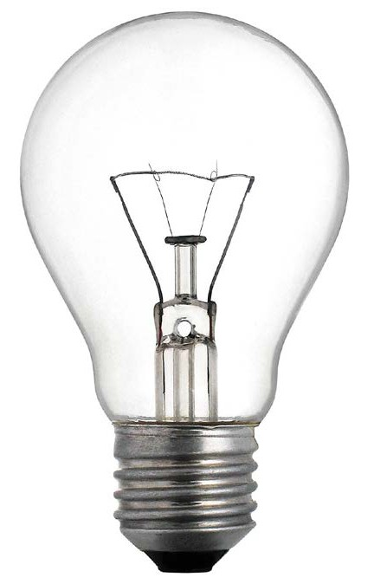 | $12.50  COST OF INCANDESCENT BULBS | $165.00  COST OF ELECTRICITY | $177.50  INCANDESCENT LIFE CYCLE COST
CFL | $4.50  COST OF CFL BULBS | $35.75  COST OF ELECTRICITY | $40.25  CFL LIFE CYCLE COST
LED  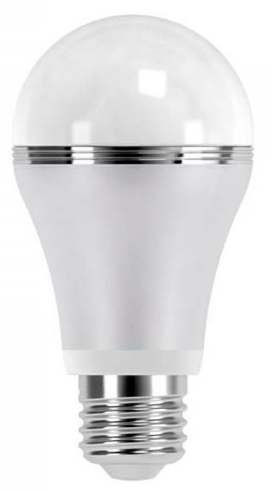 | $1.33  COST OF LED BULBS | $33.00  COST OF ELECTRICITY | $34.33  LED LIFE CYCLE COST

©2019 The NEED Project www.NEED.org Ohio Energy Project www.ohioenergy.org 31

LESSON 2: Lighting Investigation – Answer Key

ASSESSMENT

- A CFL uses about less energy than an incandescent light bulb.

a. 75% b. 10% c. 50% d. 15%

- An incandescent light bulb converts most of its energy into .

  - light energy b. nuclear energy c. thermal energy d. mechanical energy

- The average cost of one kilowatt-hour of electricity for homes in Ohio is .

  - 25 cents b. $1.00 c. 11 cents d. 2 cents

- One of the easiest and cheapest ways to reduce electricity use at home is to .

  - replace windows b. add insulation to the attic

c. replace an old refrigerator d. change an IL to a CFL or LED

- What do the letters LED stand for? Why are LEDs more efficient?
Light Emitting Diode. LEDs are more efficient because of the technology used in the bulb, which allows it to produce more light than heat.

- Why should you replace incandescent light bulbs with CFLs or LEDs and not wait until they burn out?

If you wait until they burn out, you are wasting energy and money that could be saved by replacing immediately with a CFL or LED.

- How do you calculate the life cycle cost of a light bulb?

You calculate the cost of the bulb plus the cost of the electricity to get the life cycle cost of the bulb.

Connections
- Explain how you would convince someone to replace an incandescent bulb with CFLs or LEDs.
- Discuss the energy consumption of a LED versus an IL using the results of the Light Bulb Investigation.
- How did you calculate how much money you could save your family by replacing one incandescent bulb with a LED?

32 Energy at Home

STUDENT WORKSHEET

LESSON 2
Home Activity

Installing Light Bulbs

Safety note: Be sure to have an ADULT help with the installation of all light bulbs.

 Materials

Light Bulbs
LED Nightlight (if available)
Procedure

- Share your Facts of Light Summary with your family. Explain how you collected your data and calculated the life cycle cost of each bulb.

- How many total light bulbs are in your home?

family/living rooms
kitchen (including appliances)
all closets
garage
bathrooms
bedrooms
basement

- How many CFLs or LEDs are in your home?

No CFLs or LEDs 0 points

1-2 CFLs or LEDs 2 points

3-4 CFLs or LEDs 4 points

> 4 CFLs or LEDs 6 points

- Look at the nightlight (if available). The cost per year in electricity for an LED nightlight (plugged in constantly) is about $0.02. If you use the nightlight for 80 years, what would the electricity cost you?

- Install your lightbulb(s) with an adult.

- When you replace an incandescent bulb with a CFL or LED, what measurement should you use to make sure you are getting a comparable light bulb?

- Below, complete the sentences with the type of bulb and wattage for each of the bulbs that you replaced in your home.

  - I replaced a watt bulb with an bulb.
  - I replaced a watt bulb with an bulb.
  - I replaced a watt bulb with an bulb.

©2019 The NEED Project www.NEED.org Ohio Energy Project www.ohioenergy.org 33

Lesson 3: Water Heating

LESSON PLAN
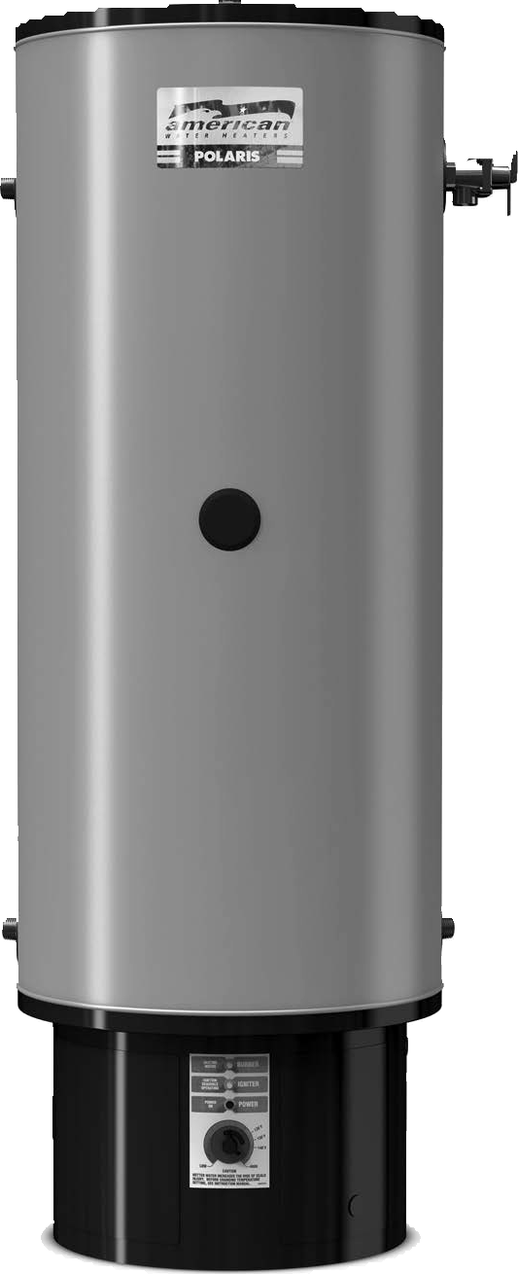Overview
This lesson focuses on heating water and using hot water.

Objectives
Students will be able to:
measure temperature accurately using appropriate tools and converting units;
list and describe methods for conserving water;
explain a water heater’s role in home energy savings.
OEP Provided Materials
Digital thermometer
Flow meter bag
Hot water gauge
Natural gas scratch and sniff (if available)
Recommended Activities
Natural Gas Sequence, Energy 101
Safety Sort, Energy 101
Home Energy Efficiency Kit Materials
Hot water gauge
Flow meter bag
Kitchen sink aerator, bathroom sink aerator, low flow showerhead, teflon tape, natural gas scratch and sniff (if available)
Preparation
Prior to the lesson, arrange to have someone from the maintenance or facilities staff show the students the water heating system(s) and answer questions about the energy sources that fuel the components, the size of the system, the temperature setting, and the location.
Review instructions for the hot water gauge and flow meter bag. Instructions are printed on the bag and gauge.
! Safety Note
The flow meter bag should only be used to measure cold water. Warn the students not to touch the hot water.
Procedure
- Introduce the lesson by discussing how we heat water at school and home. Review the Lesson 3 Background Information.
- List ways hot water is used in schools and homes.
- List ways to cut water-heating bills, i.e. use less hot water, turn down the water heater thermostat, insulate the water heater, use an energy efficient water heater. Emphasize ways to use less hot water, i.e. taking short showers instead of baths, running the dishwasher only when it is full, washing clothes in cold water, filling the sink when hand-washing dishes instead of washing under running water, etc.
- Display the EnergyGuide Label (3-1) master and explain the information it includes. Make sure to explain the difference between yearly cost and hourly availability of water.
- Inspect the school’s water heating system with someone from the maintenance or facilities staff, locating the EnergyGuide label and the thermostat.
- Ask the maintenance person the following questions: At what temperature is the thermostat set? What energy source is used to fuel the water heating system
- Instruct the students to enter the information in the appropriate blanks on the Water Heating Investigation.
- Review the procedure for the rest of the investigation.
- Instruct the students in the correct operation of the hot water gauge and flow meter bag.
- Have students divide into groups and distribute one hot water gauge, one digital thermometer, and one flow meter bag to each team.
- Instruct the students to complete the investigation.
- Review each team’s data so that all students can record the data in their charts.
- Compare recorded water temperatures with recommended temperatures.
- Discuss whether any changes should be recommended based on the results of the discussion.
- Explain that many hot water heaters use natural gas. Natural gas is colorless and odorless, so a chemical called mercaptan is added to the natural gas so that natural gas can be detected. Distribute the natural gas scratch and sniff cards from the Energy Efficiency Kits (if available). Ask students to sniff the cards and to tell an adult and leave their home immediately if they ever recognize that smell at home.

Home Action Item and Wrap Up
- Give each student their hot water gauge and flow meter bag. If available, give students their kitchen sink aerator, bathroom sink aerator, low-flow showerhead, Teflon tape and natural gas scratch and sniff card.
- Have students complete the Assessment and Connections activities in the Student and Family Guide.
- Review the Home Activity in the Student and Family Guide with the students and assign a completion date.

©2019 The NEED Project www.NEED.org Ohio Energy Project www.ohioenergy.org 35

LESSON 3
Background Information: Water Heating
Water Heating
Water Consumption of Common Devices
Clothes
Washer
Shower
= 2 Gallons
Dishwasher
Kitchen/
Bathroom Sink
per minute
Gallons Per Use
Data: DOE, Energy Savers Guide

When appliances and faucets use hot water, you pay for the water and the utility costs to heat the water. Save hot water whenever possible.

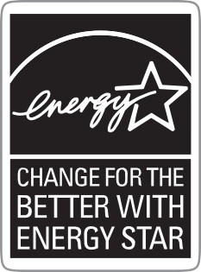Water heating is a significant energy expense in homes. It typically accounts for about 18 percent of the average utility bill. Heated water is used for showers, baths, laundry, dish washing, and cleaning. The greatest cost of washing dishes, bathing, and washing clothes comes from the energy required to heat the water. There are four main ways you can lower your water heating bills:
use less hot water;
turn down the thermostat on your water heater;
insulate your water heater and water pipes; and
buy an ENERGY STAR® or energy efficient water heater, dishwasher, and washing machine.
The easiest way to cut the cost of heating water is to reduce the amount of hot water you use. This can be done with little cost and minor changes in lifestyle. For example, a five minute shower uses 10-25 gallons of water. You can cut that amount in half by using a low-flow shower head.
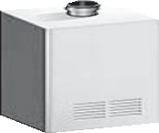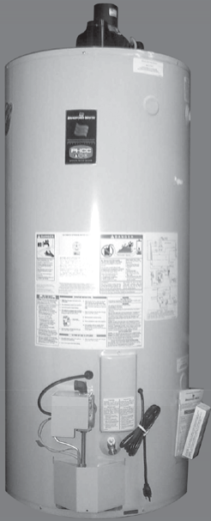Other ways to conserve hot water include taking showers instead of baths, taking shorter showers, fixing leaks in faucets and pipes, and using the lowest temperature wash and rinse settings on clothes washers.
Water Heater Comparison
ANNUAL ENERGY COSTS PER YEAR
$400

$350

$300

$250

$200

$150

$100

$50

$0
STANDARD GAS ENERGY STAR WATER HEATER QUALIFIED GAS TANKLESS
WATER HEATER
Data: ENERGY STAR®
Most water heater thermostats are set much higher than necessary. Lowering the temperature setting on your water heater to 120°F (49°C) saves energy. Lowering the temperature 10 degrees Fahrenheit (6°C) can result in energy savings of $12-
$30 annually. Buying a high efficiency water heater can save
$40-$140 a year.

Natural Gas Safety
Because natural gas is colorless, odorless and tasteless, a chemical called mercaptan is added to the gas before distribution. Mercaptan gives it a “rotten eggs“ smell so that people can detect natural gas leaks.
Natural gas lines are buried underground going to your home. Before your family begins any digging project, be sure to call 811. Local utility companies will mark the utility lines in your yard within 2-3 days of your call so that you can dig safely. It is a law in Ohio to call before you dig!

EnergyGuide Labels

Another way to determine which appliance is more energy efficient is to compare energy usage using EnergyGuide labels. The government requires most appliances to display bright yellow and black EnergyGuide labels. Although these labels do not tell you which appliance is the most efficient, they will tell you the annual energy consumption and operating cost of each appliance so you can compare them.
36 Energy at Home

MASTER 3-1

Interpreting an EnergyGuide Label

U.S. Government Federal law prohibits removal of this label before consumer purchase.

List of key features of the appliance and similar models in the same cost range.

Water Heater - Natural Gas
Tank Size (Storage Capacity): 60 gallons

xx Corporation Model XXXXXXX

The maker and model tell exactly what product the label is describing.

Estimated Yearly Energy Cost

What you might pay to run the appliance for a year, based on its fuel or electricity consumption and the national average cost of the energy. Cost will appear for all models and brands.
$213
$225 $297

Cost Range of Similar Models

First Hour Rating
(How much hot water you get in the first hour of use)

The cost range helps you compare the energy use of different models by showing the range of operating costs for similar models and features.

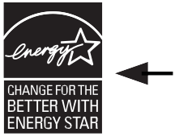
very small | low | medium | high  157 Gallons
l Your cost will depend on your utility rates and use.
If you see the ENERGYSTAR
logo, it means the product is better for the environment because it uses less energy than standard models.
l Cost range based only on models fueled by natural gas with a high first hour rating (over 75 gallons).
An estimate of water available within first hour of use and its comparison to other models.
l Estimated energy cost based on a national average natural
gas cost of $1.09 per therm.
l Estimated yearly energy use: 192 therms.

ftc.gov/energy

©2019 The NEED Project www.NEED.org Ohio Energy Project www.ohioenergy.org 37

LESSON 3
Water Heating Investigation

Question
Is water temperature constant throughout the school and is it set correctly?

 Materials

1 Flow meter bag
1 Hot water gauge
 Hypothesis
Digital thermometer

Procedure

- What energy source fuels the water heating system?
- Record the temperature setting of the hot water thermostat.
With the help of an adult:
- Identify water sources in your school and list them below.
  - With the flow meter bag, measure the water flow of all sources and record on the chart below. FOR YOUR SAFETY: Measure ONLY COLD water with the flow meter bag.
  - With the hot water gauge or digital thermometer, measure the temperature of the hot water at all sources and record on the chart. FOR YOUR SAFETY: BE CAREFUL not to touch the water. NOTE: if there is no color change on the hot water gauge, the temperature is below 120°F.
- Compare the actual temperature to the recommended temperature of 120°F.
- Gather data from the other teams and add below.

LOCATION | WATER FLOW | ACTUAL TEMPERATURE | >, <, OR = TO RECOMMENDED TEMPERATURE OF 120ºF

38 Energy at Home

ANSWER KEY

LESSON 3 – Water Heating
ASSESSMENT

- After heating and cooling, the next largest expense in most homes is .
  - lighting b. heating water c. computers d. refrigeration

- For maximum energy efficiency, the ideal temperature for a water heater is . a. 100⁰ F b. 200⁰ F c. 120⁰ F d. 180⁰ F

- A device used on a faucet that maintains pressure while conserving water is .
  - an aerator b. a water heater c. a flow meter bag d. a filter

- Which of the following is not a possible energy source for a water heater? .
  - natural gas b. electricity c. propane d. wind

- Identify two ways you can save energy while taking a shower.
Possible answers include: Take shorter showers, use a low-flow showerhead, use water at a slightly lower temperature, turn water off to lather and scrub and turn water back on to rinse.

- Describe a flow meter bag and how it is used. When measuring water flow rate, what units are used to describe it. Identify an efficient flow rate for a showerhead.
The flow meter bag was the clear plastic bag with blue markings in the Energy Efficiency Kit. It is used by placing it under the faucet or showerhead and turning the water on full for five seconds. The next step is to hold the bag of water up and read the measurement. Flow rate is measured and reported in Gallons per Minute or GPM and an efficient showerhead flows at 2.5 GPM. The showerhead in the kit uses only 1.25 GPM which saves even more energy and water.

Connections
- What did you learn using the hot water gauge and the flow meter bag?
- Describe 3 ways your family will reduce your hot water use.

©2019 The NEED Project www.NEED.org Ohio Energy Project www.ohioenergy.org 39

LESSON 3
Home Activity

Investigating Home Water Heating and Usage
 Materials

Hot water gauge
Flow meter bag
Kitchen sink aerator (if available)
Bathroom sink aerator (if available)
Low flow showerhead (if available)
Teflon tape (if available)
Natural gas scratch n’ sniff card (if available)
Procedure

With the help of an adult:
- Locate the water heater. Read and record the temperature setting of the water heater.
- Locate the EnergyGuide label and record the estimated yearly energy cost.
- Locate the EnergyGuide label and record the efficiency rating.
uses the most energy 0 points
uses more than average energy 2 points
uses average energy 3 points
uses less than average energy 4 points
uses the least energy 6 points
- Use the hot water gauge to measure the temperature of the hot water in your bathroom sink. Is the temp greater than 120oF?

- Use the flow meter bag to measure how much COLD water your main shower uses. If the showerhead is NOT efficient based on the chart on the bag, install the low flow showerhead, if available. Measure again.
- Use the flow meter bag to measure how much COLD water your main bathroom sink and kitchen sink use. If they are NOT efficient based on the chart on the bag, install the energy efficient aerators, if available. Measure again.

WATER FLOW
Main Shower Main Bathroom Sink
Kitchen Sink
BEFORE INSTALLATION
AFTER INSTALLATION

- Share the natural gas scratch n’ sniff card (if available) with family members to ensure everyone can recognize the smell of a gas leak.
- Visit your local utility’s website (listed on the front cover) to find out about other residential energy saving programs, including rebates and online audits.

The Tools
Hot Water Gauge: Measures the temperature of your hot water. See instructions on plastic card.
Flow Meter Bag: Measures the amount of water flow. Instructions are on the bag.
Aerators and Showerheads: Reduce the water flow without reducing pressure. The smaller aerator is for the main bathroom sink; the larger aerator is for the kitchen sink. Install using instructions for the showerhead.
Teflon Tape: Ensures a tight seal for showerhead and aerators.
40 Energy at Home

Lesson 4: Insulation, Heating and Cooling

LESSON PLAN
Overview
Part 1: This lesson helps students understand that heat transfers from areas of high temperature to areas of low temperature and how insulators and conductors impact heat transfer. Students will learn how to reduce heat transfer in their homes using simple, energy saving measures.
Part 2: Heating and cooling systems use more energy than any other systems in the home. This lesson will focus on the difference between heat and temperature. Students will learn how to use heating and cooling systems efficiently.
Objectives
Part 1:
Students will be able to:
identify that heat transfers from areas of high temperature to areas of lower temperature;
explain that a thermal insulator reduces heat transfer and a thermal conductor transfers heat easily;
identify a material as an insulator or conductor.
Part 2:
Students will be able to:
explain the difference between heat and temperature;
measure temperature accurately using appropriate tools;
explain the importance of properly regulating temperature when considering efficiency and conservation.

Part 1: Insulation Investigation
OEP Provided Materials
2 Insulation containers per group
2 Digital thermometers per group
Ceramic tile with attached thermometer
Carpet sample with attached thermometer

Teacher Provided Materials
Pitcher
Insulating materials (aluminum foil, bubble wrap, cotton sock, etc. )
1 Rubber band per group
Hot water (120-150°F)
Masking tape
Timer

Home Energy Efficiency Kit Materials
Weatherstripping
Door sweep (if available)
Draft stoppers (if available)

2Preparation
Prepare by setting up lab stations – each with 2 insulation containers, 2 thermometers, 1 rubber band, one of the insulating materials, and tape. Make sure you have a source for hot water, a pitcher to dispense it, and a timer.

©2019 The NEED Project www.NEED.org Ohio Energy Project www.ohioenergy.org 41

Procedure
- Introduce the topic by discussing the direction of heat transfer and having students read the Lesson 4 Background Information. Ask, “On a cold winter day, what will happen to energy if you open the door of your home?” (Energy will flow from where it’s warmer inside the house to where it’s colder outside the house. Thermal energy (heat) always moves from an area of greater energy to lesser energy until equilibrium is achieved. In other words, heat moves from HOT to COLD until the amount of energy is equal.)
- Have students turn to the Heat Transfer worksheet. Have students use arrows to show the direction heat will travel for each image.
- Show students the tile and carpet squares. Have one or more students touch both the tile and carpet. (The tile should feel cooler). Explain that both materials have been in the same room and are the same temperature. Show the thermometers on the back of each. The tile feels cooler because heat is transferred from our warm hands to the cooler tile. The tile is a conductor – it transfers heat easily. The carpet has lots of air spaces and resists the transfer of heat from our warm hand. The carpet is an example of an insulator. A thermal insulator is a material that reduces the rate of heat transfer.
- Display the Insulators vs. Conductors (4-2) master. Have students identify which images are conductors and which images are insulators. (Conductors: frying pan bottom, metal spoon, and black top. Insulators: frying pan handle, fiberglass insulation, weather stripping, feather.) NOTE: The frying pan is both an insulator and a conductor.
- Discuss why thermal insulators and conductors are important in the home. Go to the Major Sources of Air Leaks graphic in the Lesson 4 Background Information and discuss places air and heat can leak in the home. Using the diagram, discuss the areas of a home that should be insulated. Discuss which direction heat would travel during the winter and the summer. (Heat travels out of the warm house in the winter and into the air conditioned house in the summer.)
- Go to the Insulation Investigation Part 1. Review the procedure with the students. See Insulation Lab Tips, before you begin.
- Assign each group to a lab station.
- Discuss the different insulating materials they will be investigating and have each group hypothesize which materials are the best insulators. Groups should rank the materials from 1 to 5, with 1 being the best insulator. Record the materials and the class hypotheses on the Insulation Investigation (4-3) master.
- Instruct the groups to insulate the sides of one of their containers with the materials they have been provided.
- Fill all of the containers with the same amount of hot water (approximately 200mL or half full), and instruct the students to replace the tops and insert the thermometers according to the procedure.
- Begin timing when each group is ready. Have the groups record the beginning temperatures and record at one minute intervals on the data table.
- After 10 minutes, have the students calculate the difference between the beginning temperature and the ending temperature of each container and record it in the delta (ΔT) column of the chart on their investigation worksheet.
- Instruct the students to graph their results.
- Display the Insulation Investigation (4-3) master and record the results of the group.
- Compare the groups’ hypotheses with the results.
- Discuss the responses to the lab questions.

42 Energy at Home

LESSON 4
Background Information: Insulation, Heating and Cooling

Heat Seeks Balance
Everything in nature seeks balance. Heat seeks balance, too. Heat flows from areas of higher energy to areas of lower energy and from hotter substances to colder substances. What happens if you pour hot water into a cold tub? The molecules of hot water have more energy. They are fast moving. They crash into the colder molecules and give them some of their energy.

Conductors and Insulators
In some materials, heat flows easily from molecule to molecule. These materials are called conductors. They conduct—or move— heat energy well. Materials that don’t conduct heat well are called insulators.
The molecules in good conductors are close together. There is very little space between them. When they vibrate, they push against the molecules near them. The energy flows between them easily.
The molecules in insulators are not so close together. It is harder for energy to flow from one molecule to another in insulators.

Good Conductor
Good Insulator

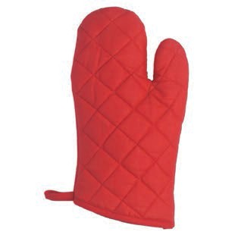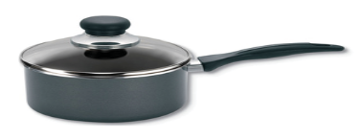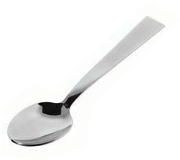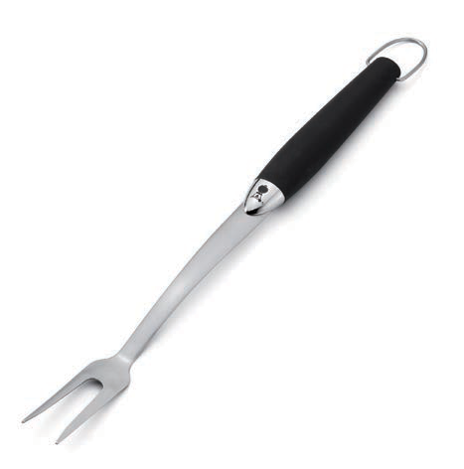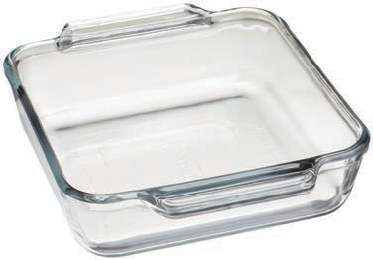Look at the objects to the right. The pot, the spoon, and the fork are made of metal. The pot and the fork have plastic handles. The dish is made of glass. The oven mitt is made of cotton fabric.
Conductors and Insulators
Which materials are the insulators? The insulators are the materials that don’t move heat. They protect us from heat. Our experience tells us that wood, plastic, and cotton are all good insulators. Metals are good conductors. The metal part of the pan moves heat to the food inside to cook the food. The plastic handle protects our hands. The cotton glove protects our hands, too.
What about glass? It is not as good of a conductor or insulator as the other materials. It is used to conduct heat in pots and pans, and can also be used to insulate. Glass was once used on power and telephone lines as an insulator.
Heat and Temperature
Heat and temperature are different things. Two cups of boiling water would have twice as much heat as one cup of boiling water, but the water would be at the same temperature.
Temperature is a measure of the average kinetic energy of molecules. The faster the molecules move, the greater the temperature. Heat (thermal energy) is a form of energy that incorporates both the temperature (the speed of the molecules) and the amount of material, or mass of the substance. A bathtub filled with hot water will have more heat (thermal energy) than a cup of hot water at the same temperature because every drop of water has some heat and the bath tub has many more drops.
Cold things have thermal energy, or heat, even though the molecules are moving slowly and the temperature is low. A giant iceberg would have more heat (thermal energy) than a cup of boiling water, even though its temperature is lower. Each frozen particle in the iceberg has a very tiny amount of heat, but when you add them all together it becomes a significant amount of heat (thermal energy).

We Can Measure Temperature
We use thermometers to measure temperature. Thermometers can measure temperature using different scales. In the United States, we typically use the Fahrenheit (F) scale in our daily lives. Scientists typically use the Celsius (C) scale, as do people in most other countries.

©2019 The NEED Project www.NEED.org Ohio Energy Project www.ohioenergy.org 43

LESSON 4: BACKGROUND INFORMATION
Heating and Cooling Systems
Heating and cooling systems use more energy than any other systems in our homes. Natural gas and electricity are used to heat most homes, and electricity is used to cool almost all homes. About half of the costs for the average family’s utility bills are for keeping homes at comfortable temperatures. The energy sources that power these heating and cooling systems can contribute carbon dioxide emissions to the atmosphere. Using these systems wisely can reduce environmental emissions.
With all heating and air conditioning systems, you can save energy and money by having proper insulation, sealing air leaks, maintaining the equipment, and practicing energy-saving behaviors.
Programmable Thermostats
Programmable thermostats automatically control the temperature of buildings for periods of time and can save energy and money. During heating seasons, for example, they can lower the temperature during the day when no one is home and at night when people are sleeping. In the morning and evening, when people are awake at home, they can automatically raise the temperature. Most consumers set the temperature higher than recommended during heating seasons and lower than recommended during cooling seasons. A temperature setting of 68°F (20°C) during the day and 60-62°F (13-14°C) at night during heating seasons is comfortable, if people dress warmly and use warm blankets. During cooling seasons, a temperature setting of 78°F (25°C) is comfortable, if people dress appropriately and use fans to circulate air. Many programmable thermostats come with pre-loaded settings. Proper use of the pre-programmed settings on a programmable thermostat can save your family about $180 every year in energy costs.
Insulation and Weatherization
Warm air leaking into your home in cooling seasons and out of your home in heating seasons wastes energy. You can reduce heating and cooling costs by investing a few hundred dollars in proper insulation and weatherization products. Insulation is rated using an R-value that indicates the resistance of the material to heat flow. The R-value needed varies, depending on the climate, ceilings, walls, attics, and floors. In very cold climates, a higher R-value is recommended.
Insulation wraps your house in a blanket, but air can still leak in or out through small cracks. Often the effect of many small leaks equals a wide open door. One of the easiest energy-saving measures is to caulk, seal, and weather-strip cracks and openings to the outside. Home performance professionals can seal air leaks in attics and basements. Homeowners typically save up to $200 a
AIR CONDITIONING SYSTEM

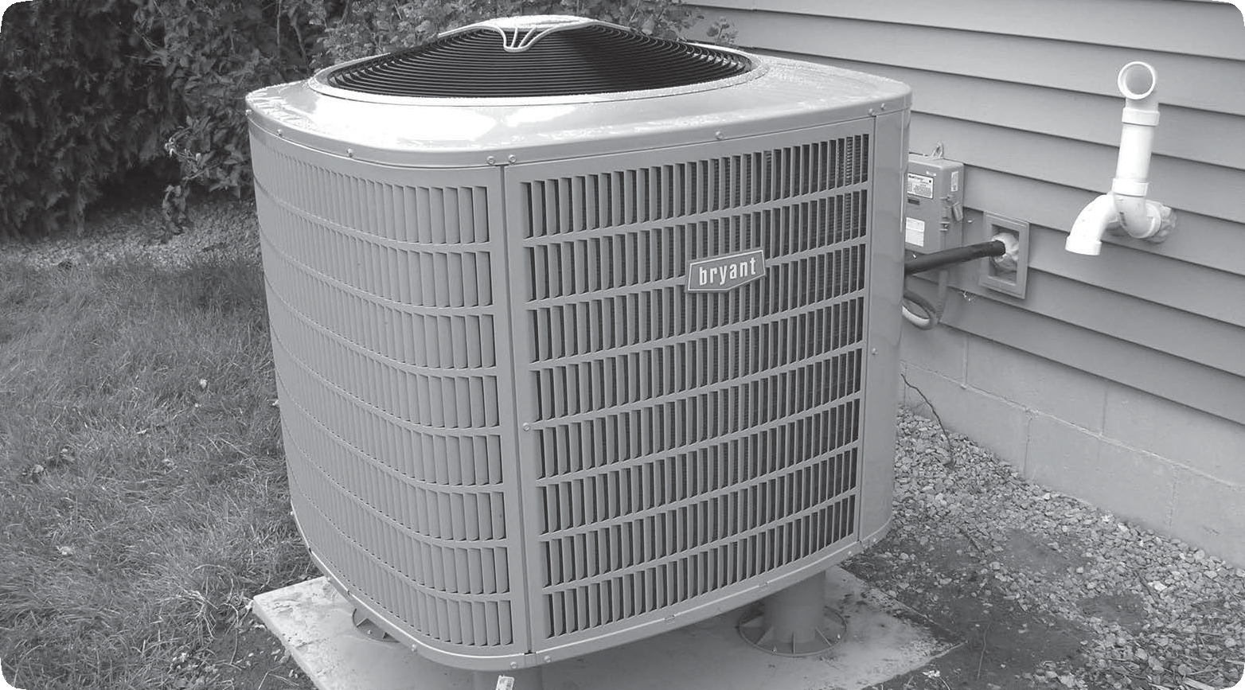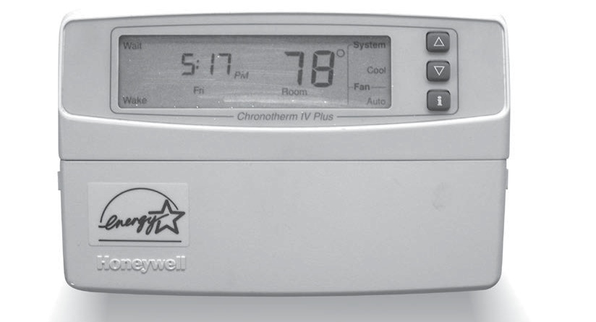PROGRAMMABLE THERMOSTAT

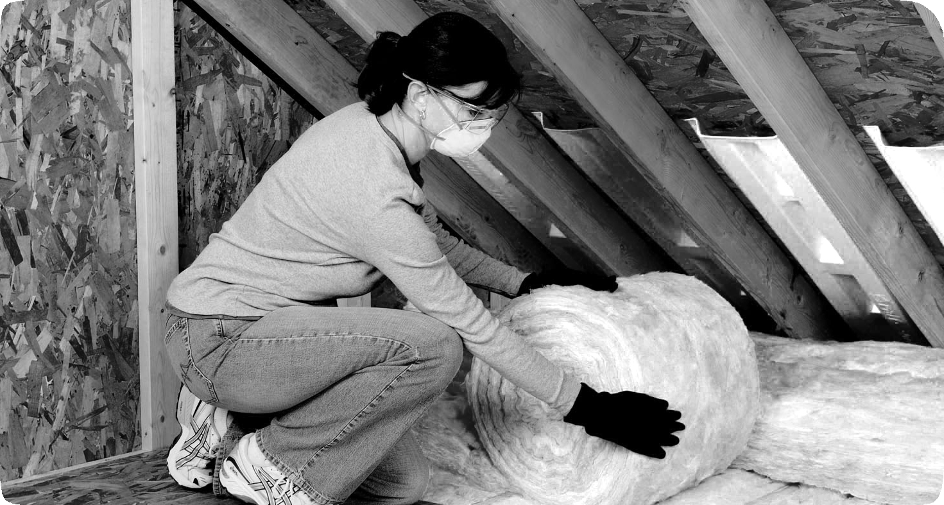INSULATION

Image courtesy of Owens Corning

Major Sources of Air Leaks

Fans and Vents 4%

Doors
11%

Floors, Walls, and Ceilings 31%

year in heating and cooling costs by air sealing their homes and adding insulation.
Doors and Windows
Some of a home’s air leaks occur around and through the doors and windows. Doors should seal tightly and have door sweeps at the bottom to prevent air leaks. Insulated storm doors provide added barriers to leaking air.
Electrical Outlets 2%

Windows
10%

Ducts
15%
Fireplace
14%

Plumbing Entries 13%

Data: U.S. Department of Energy, Energy Savers
44 Energy at Home

Heat Transfer

WHAT IS THE DIRECTION OF HEAT TRANSFER?
Draw arrows to show the direction the heat (thermal energy) is moving in the pictures below.
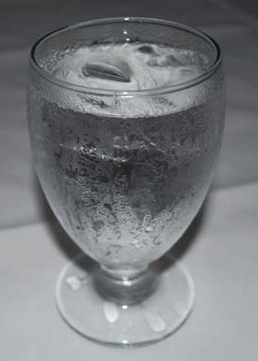Cup of Coffee Glass of Ice Water House on a Summer Day

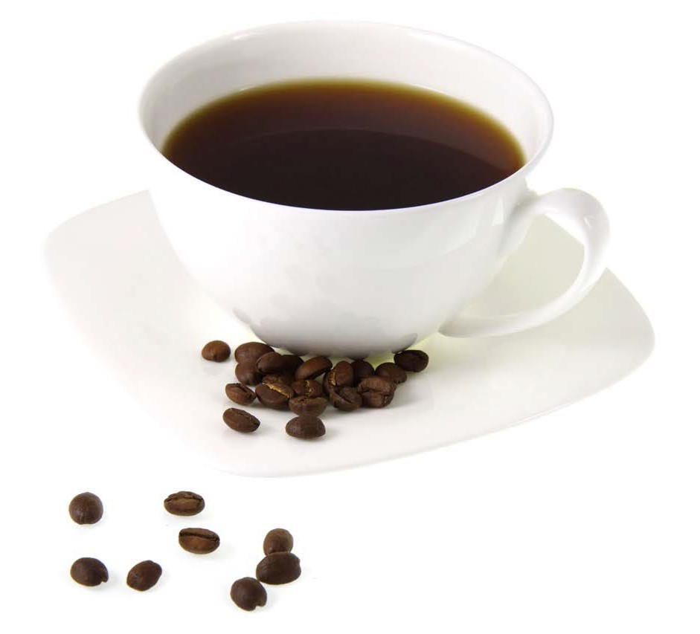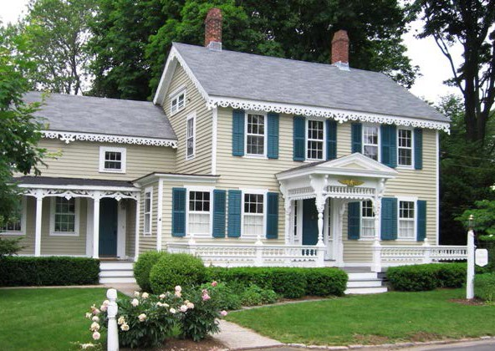

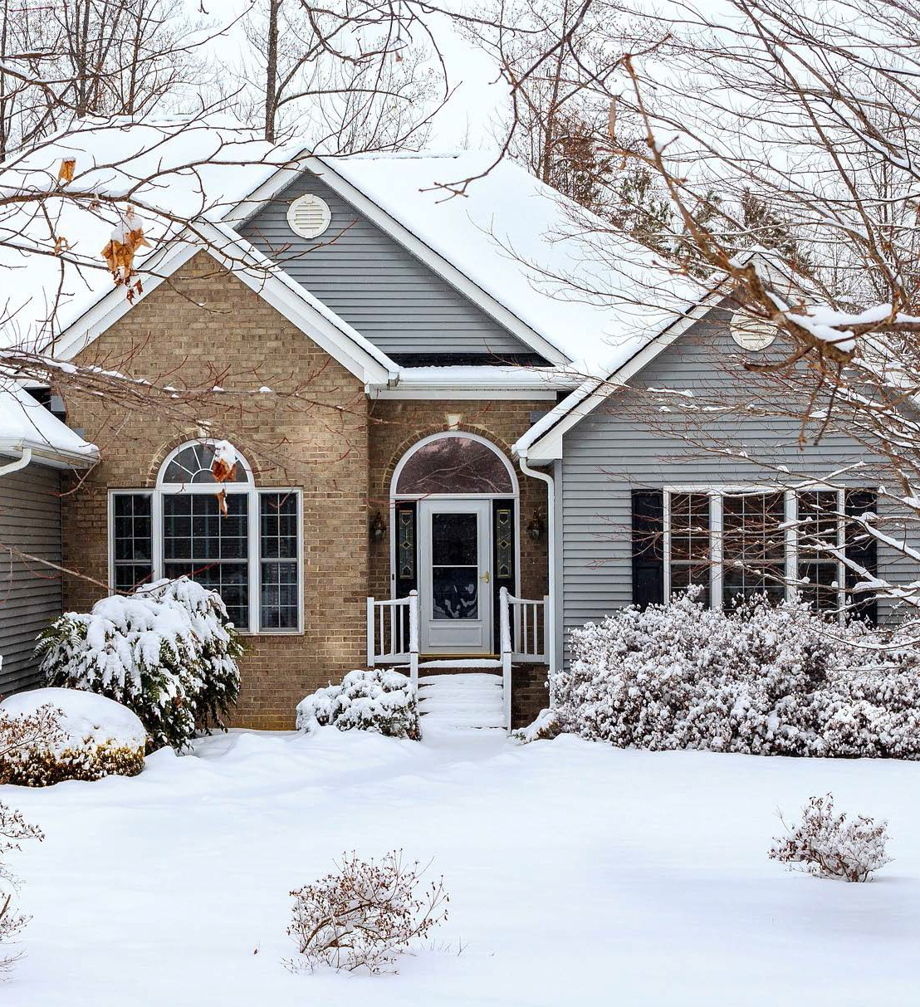House on a Winter Day

Bathtub of Hot Water
Child in the Snow

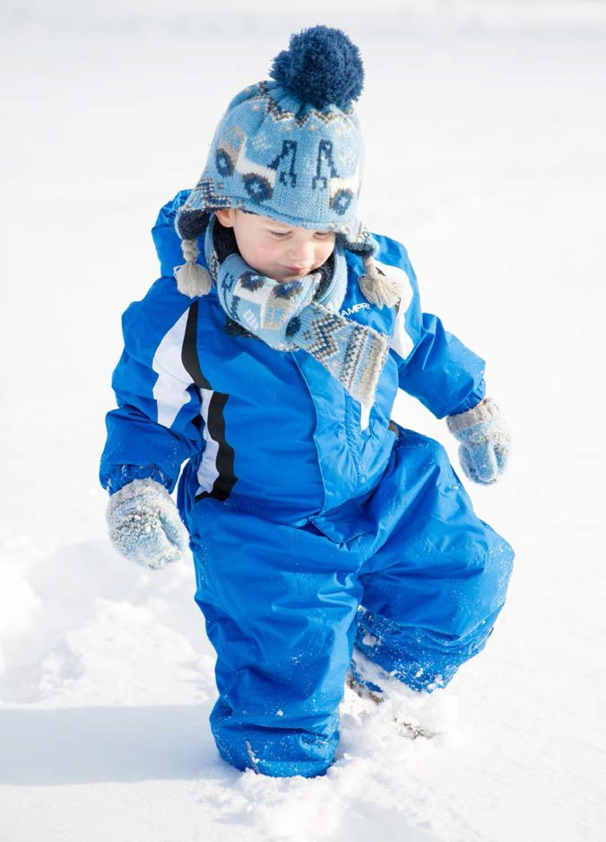
STUDENT WORKSHEET
45
©2019 The NEED Project
www.NEED.org Ohio Energy Project www.ohioenergy.org
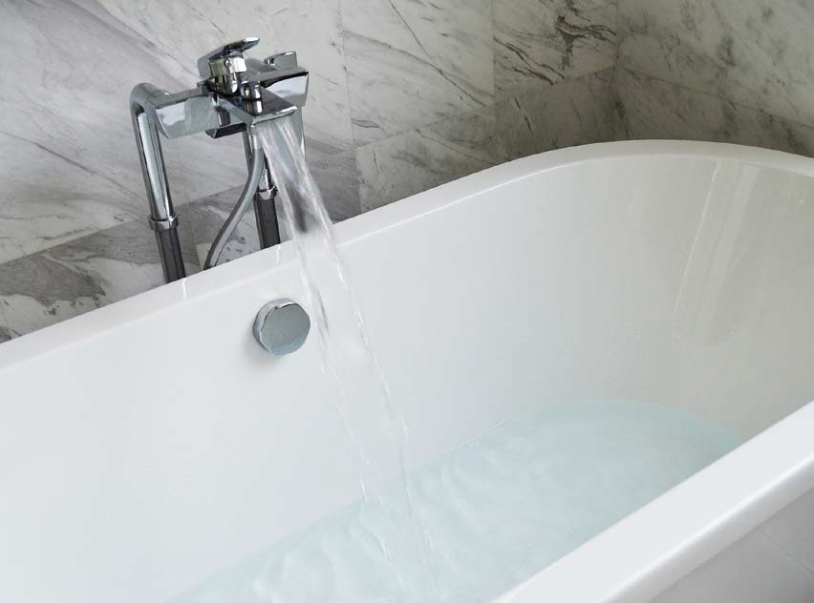

Insulators vs. Conductors
Which of these items are conductors (transfers heat easily)? Which of these items are insulators (resists heat transfer)?
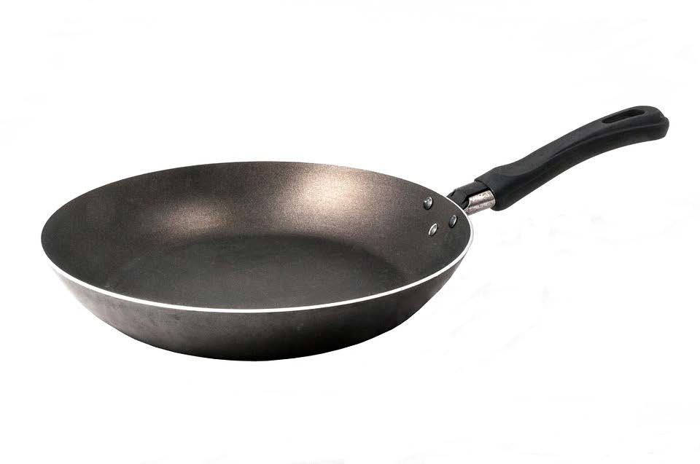Which of these items are both?
MASTER 4-2

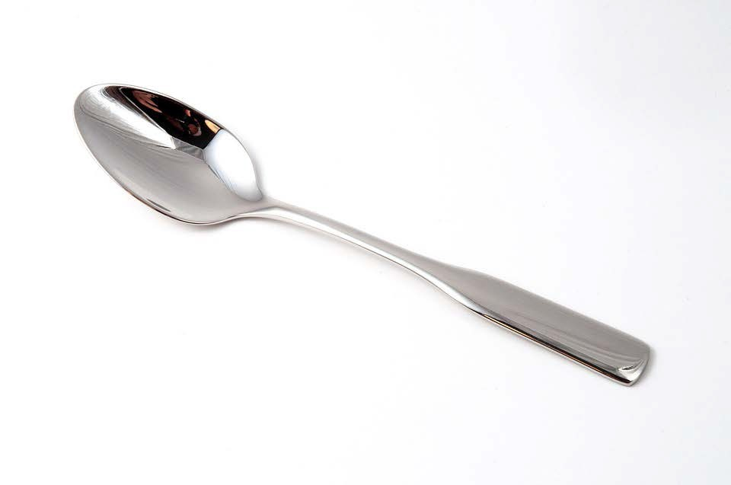
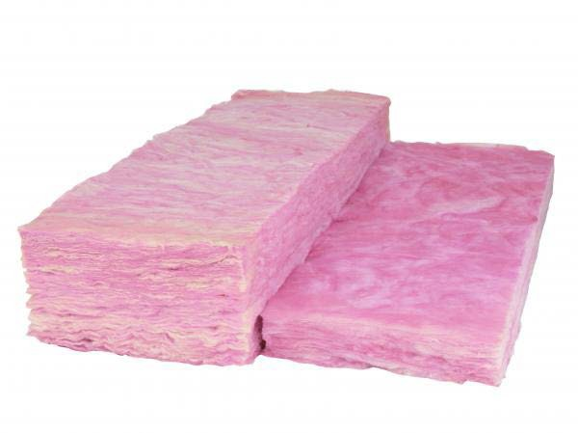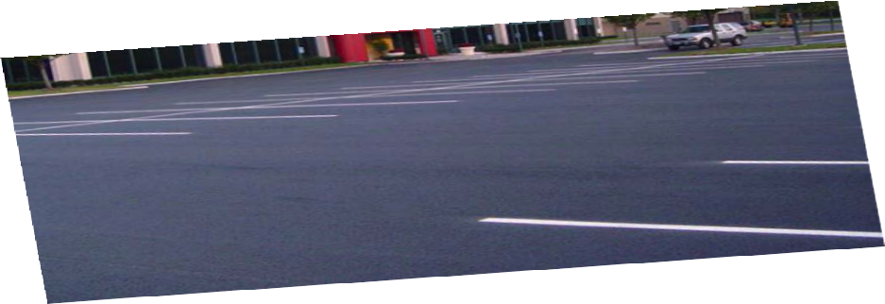

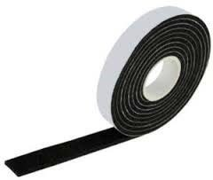46 Energy at Home

STUDENT WORKSHEET

LESSON 4
Insulation, Heating and Cooling Investigation (part 1)

Question
Are certain materials better for insulating than others?
 Materials

2 Insulation containers
2 Thermometers
Insulating material
 Hypothesis
Masking tape
1 Rubber band
Hot water

Procedure

- Remove the tops from the containers.
- Use the insulating material to insulate one container on the sides only. Use the rubber bands or masking tape to hold the insulation in place.
- Ask your teacher to fill both of your containers with hot water. Replace the tops.
- Suspend a thermometer through the hole in each top, making sure it does not touch the bottom or the sides of the containers.
- In the chart below, record the initial temperature (°F) of the water in the container.
- Record the temperture at one-minute intervals for 10 minutes. Calculate the overall change in temperature (∆T) for both containers.
- Graph the results on the space below.

 Data Table

TYPE OF INSULATION:

TIME (MIN)
0
1
2
3
4
5
6
7
8
9
10
∆T
Insulated temperature
Uninsulated temperature

0 1 2 3 4 5 6 7 8 9 10
©2019 The NEED Project www.NEED.org Ohio Energy Project www.ohioenergy.org 47

ANSWER KEY
LESSON 4
Insulation Investigation Questions
- In 10 minutes, how much did the temperature of the water in the uninsulated container change? Sample = 16°F

- In 10 minutes, how much did the temperature of the water in the insulated container change? Sample = 11°F

- After 10 minutes, what was the difference in temperature between the insulated and uninsulated container? Sample = 5°F

- Comparing the class data, which material was the best insulator? Sample = bubble wrap
- Which material was the worst insulator? Sample = aluminum foil

- Draw arrows to show the direction of heat transfer in the experiment.

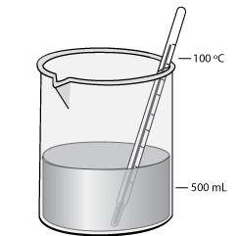

- Heat transfers from areas of high energy to areas of low energy.
- What variables in the experiment might make the results unreliable? Answers may include: amount of insulation, the tops and bottoms of the containers were not insulated, different people reading the thermometers, etc.
- How might you change the experiment to get more reliable results? Answers may include: same amount of insulation on each container, same temperature reader, insulate tops and bottoms of containers, measure water more accurately, etc.

48 Energy at Home

LESSON 4
Insulation Lab Tips

Remember to emphasize that heat energy travels from an area of high energy to low energy.
If you are using HOT water, you are blocking the heat flow out of the container.
Heat the water to no hotter than 120⁰ Fahrenheit
If you are using COLD water, you are blocking the heat flow into the container.
Mix ice with cold water and wait 10 minutes.
Be sure to use only water and no ice in containers.
Use the Fahrenheit scale to get a more visible numerical value change.
If you are distributing the water, each group should be their own timer. If you wait until all the water is distributed, you will have large discrepancies in resultant temperature changes since the water will begin to change immediately after being removed from the distribution container.
From OEP’s experiments, the changes are more impressive with hot water.
It is very difficult to get an accurate temperature reading since the thermometers are very sensitive and they don’t settle in on the tenths of a degree. When the changes slow down, take that number as your initial temperature.
The temperature changes slow down with time.
Sample lab results:

Hot Water Sample Data

 | Insulation | Initial Temperature (OF) | Final Temperature (OF) | Change (∆T)
 | Paper Towel | 121.0 | 113.2 | 7.8
 | Bubble Wrap | 119.0 | 113.0 | 6
 | Aluminum Foil | 120 | 112.8 | 7.2
 | Wool | 119.0 | 109.9 | 9.1
 | Nylon | 120.6 | 110.3 | 10.3
 | Control (nothing) | 118.0 | 106.2 | 11.8

Cold Water Sample Data

Insulation | Initial Temperature (OF) | Final Temperature (OF) | Change (∆T)
Paper Towel | 33.3 | 35.7 | 2.4
Bubble Wrap | 35.2 | 37.3 | 2.1
Aluminum Foil | 35.0 | 37.8 | 2.8
Wool | 34.0 | 36.8 | 2.8
Nylon | 35.0 | 38.3 | 3.3
Control (nothing) | 36.8 | 40.7 | 3.9
*NOTE: OEP used 200 mL of water in each container. The time between initial and final temperature is ten minutes.

©2019 The NEED Project www.NEED.org Ohio Energy Project www.ohioenergy.org 49

Insulation Investigation
MASTER 4-3
50
Energy at Home

TEAM | HYPOTHESIS: RANK THE MATERIALS 1 TO 5. 1 IS THE BEST INSULATOR. | UNINSULATED ∆T | INSULATED ∆T
1.
Material:
2.
Material:
3.
Material:
4.
Material:
5.
Material:

LESSON 4
Insulation Investigation (part 2)

Materials
Digital thermometer or LCD thermometers

Home Energy Efficiency Kit Materials
Thermostat Temperature Guide

2Preparation
Prior to the lesson, arrange to have someone from the maintenance or facilities staff show the students the HVAC (Heating, Ventilation, and Air Conditioning) system and answer questions about the energy sources that fuel the system(s).

Procedure
- Display the Heat vs. Temperature (4-4) master and ask students to identify which images have more heat energy. Review the Heat and Temperature section of the Lesson 4 Background Information. Discuss that heat, or thermal energy, is the energy from moving molecules, and anything with molecules has heat. Even cold things, like ice sculptures, have heat. The molecules of cold things are just moving slower. The glacier has more molecules than the match, so even though it is much colder it has more heat. Although both beakers have the same temperature, the beaker with more water has twice the amount of heat because it has twice the amount of molecules.
- Discuss that temperature is a measure of the “hotness” or “coldness” of an object. It measures the average kinetic energy of the molecules.
- Remind students that heating and cooling homes accounts for the largest percentage of home energy costs.
- Have the students inspect the school HVAC system with someone from the maintenance or facilities staff. Ask the staff member: Which system is in operation (heating or cooling)? What energy source fuels the heating system? What energy source fuels the cooling system?
- Go to the Insulation, Heating and Cooling Investigation (part 2). Review the questions and have students record their hypotheses. Direct students to the Thermostat Temperature Guide on that worksheet.
- Display the Temperature Guide (4-5) master and explain how to read it in both heating and cooling seasons. For example, 72oF wastes 20% in the winter (heating).
- Review the Insulation, Heating and Cooling Investigation (part 2) activity with the students and have them get into their groups. Provide each group with a thermometer for measuring temperature.
- Instruct the students to complete the activity.
- Review the results with the students using the Temperature Guide (4-5) master.
- Discuss whether any action should be taken if temperatures are not within energy saving ranges.

Home Action Item and Wrap Up
- Have students complete the Assessment and Connections activities in the Student and Family Guide.
- Review the Home Activity with the students and assign a completion date.
- Give each student their weatherstripping, door sweep (if available), draft stopper (if available) and LCD thermometer (if available).

©2019 The NEED Project www.NEED.org Ohio Energy Project www.ohioenergy.org 51

Heat vs. Temperature
Circle the item that has more heat (thermal energy).
MASTER 4-4

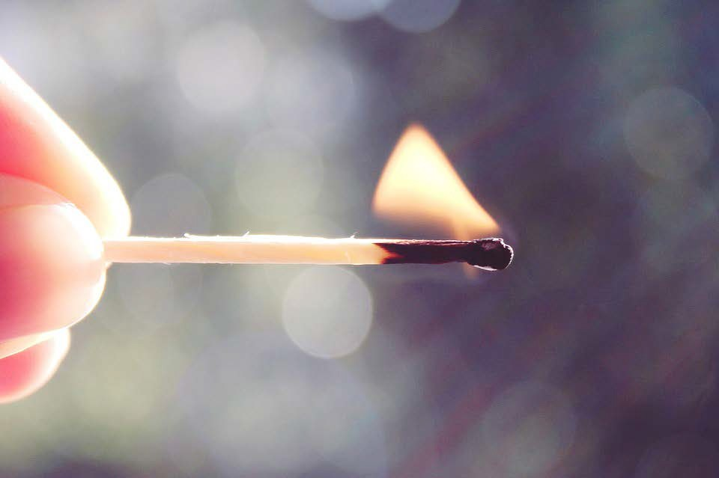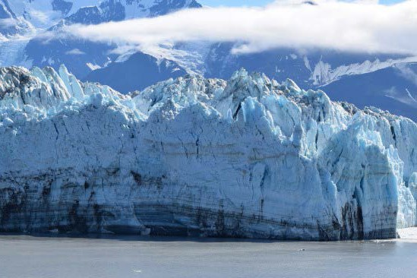

Explain:

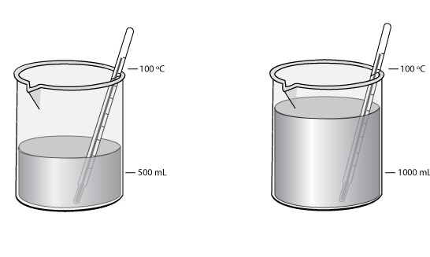
Explain:

52 Energy at Home

STUDENT WORKSHEET

LESSON 4
Insulation, Heating and Cooling Investigation (part 2)
Question
Which rooms in the school will have the highest and lowest temperature?
Which room in the school will have the most heat?
 Materials

Digital thermometer or Thermostat Temperature Guide
 Hypothesis

Procedure

- Find out the answers to the following questions:
Which system is in operation (heating or cooling)?

What energy source fuels the heating system?

What energy source fuels the cooling system?

- Locate the thermostat in the classroom. Record the temperature setting of the thermostat.
- Using the thermometer, record the actual temperature of the classroom.
- Using the Thermostat Temperature Guide at the bottom of the page, determine whether your classroom is saving or wasting energy and by how much.
- Visit other rooms in the school and record the temperature, thermostat setting, and percent of energy saved or wasted in the chart below.

Room | Thermostat Setting (°F) | Actual Temperature (°F) | Energy Saving/Wasting Percentage

- Which room in the school had the highest temperature? The lowest temperature? The most heat (thermal energy)? How was this determined?

- Is your school saving or wasting energy with heating and cooling?
Thermostat Temperature Guide IN FAHRENHEIT
-20% -10% 0% +10% +20% +30% +40% +50%
+30% +20% +10% 0 -10% -20%
RECOMMENDED HEATING
ENERGY SAVING ENERGY WASTING
ENERGY WASTING
ENERGY SAVING

RECOMMENDED COOLING
©2019 The NEED Project www.NEED.org Ohio Energy Project www.ohioenergy.org 53

MASTER 4-5
Energy at Home

Temperature Guide
54

-20% -10% 0% +10% +20% +30% +40% +50%
+30% +20% +10% 0 -10% -20%
RECOMMENDED HEATING
ENERGY SAVING
ENERGY WASTING
ENERGY WASTING
ENERGY SAVING
RECOMMENDED COOLING

Room | Thermostat Setting (°F) | Actual Temperature (°F) | Energy Saving/Wasting Percentage

ANSWER KEY

LESSON 4 - Insulation, Heating & Cooling
ASSESSMENT

- Draw an arrow to show how heat will transfer for the following items:

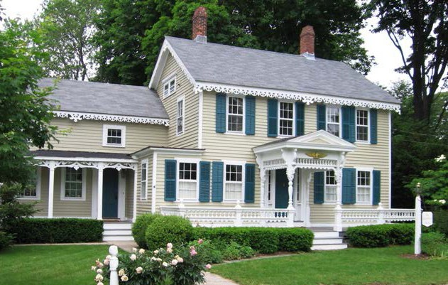Cup of Coffee
House on a Summer Day

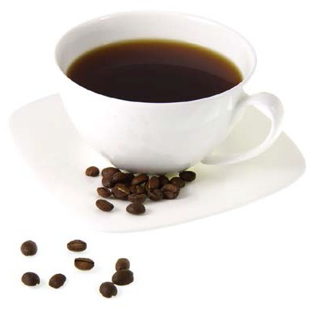

- Weatherstripping resists the transfer of heat and works as a thermal .
  - conductor b. insulator c. contact d. covering

- A material that allows heat to transfer easily (such as a metal pan) is a thermal .
  - conductor b. wave c. insulator d. coat

- Which item would have a higher temperature?
  - small flame from a match c. jug of water
b. glacier d. car

- Which item would have more heat (thermal energy)?
  - small flame from a match c. jug of water
b. glacier d. car

- Explain why insulation is important in your home.
Insulation reduces the transfer of heat to and from the house, saving energy and money.

- Explain where the heat travels when you leave the refrigerator door open.
Heat always travels from hot to cold, or areas of higher temperature to areas of lower temperature, so heat would travel from the warmer kitchen air into the cooler refrigerator.

Connections
- List two animals and discuss how they use “natural” insulation to maintain body temperature.
- What are some ways you can be comfortable in your home without adjusting the temperature and using more energy?
- List and explain two ways your family could save energy when heating and cooling your home.

©2019 The NEED Project www.NEED.org Ohio Energy Project www.ohioenergy.org 55

LESSON 4
Home Activity
STUDENT WORKSHEET

Investigating Home Insulation and Thermostats
 Materials

Weatherstripping
Door sweep and draft stoppers (if available)
Thermostat Temperature Guide on page 41
Procedure

- Open your outside doors and check the condition of the weatherstripping between the doors and the door-frame.
none 0 points
poor 2 points
fair 4 points
good 6 points

- Using the graphic below, “How Air Escapes,” decide with your family the five areas of your home you will check for air leaks.

  - V.

- With the help of an adult, record the thermostat settings for your home:
Cooling Season: Heating Season:

< 74° 0 points
74°-75° 2 points
76°-77° 4 points
> 77° 6 points
>74° 0 points
72°-74° 2 points
69°-71° 4 points
< 69° 6 points

- Using the Thermostat Temperature Guide on page 41, calculate the percent of energy saved or wasted at this temperature setting.

% energy saved OR % energy wasted

- Decide with your family two ways you can save energy on heating and cooling.

How Air Escapes

Windows
10%

Doors 11%

Fans and Vents
4%

Electric Outlets
2%

Floors, Walls,
Ceilings
31%

Actions

- With an adult, install the weatherstripping (and door sweep and draft stoppers, if available).

- Discuss changing the thermostat to the recommended settings of 68oF in the winter and 78oF in the summer.

Plumbing
13%

Fireplaces
14%

Ductwork
15%

Data: DOE, Energy Savers Guide
56 Energy at Home

Lesson 5: Appliances and Machines

LESSON PLAN
Overview
This lesson examines the energy consumption of machines, appliances, and other electrical devices.
Objectives
Students will be able to
quantify their energy consumption by measuring the electrical load of common devices;
calculate energy consumption for different appliances and machines;
explain how the use of electronic devices and appliances contributes to greenhouse gas emissions.
OEP Provided Materials
Watt meters
Teacher Provided Materials
Pluggable appliances
Recommended Activities
Vampire Power: www.occ.ohio.gov/publications/electric/Vampire_Power.pdf. Explore how appliances in standby mode still use electricity.
Home Energy Efficiency Kit Materials
Refrigerator/Freezer thermometer, if available
Preparation
Review the operating instructions of the Kill A Watt® meter on the “Kill A Watt®meter” (5-1) master.
Gather pluggable devices students might see or use in school or at home.
Procedure
Measuring Electricity Use
- Introduce the topic by discussing all of the machines in the classroom that use electricity. Have students read the Lesson 5 Background Information.
- Display the Kill A Watt Meter (5-1) master explaining what it does and how it is operated.

- Review the Appliances and Machines Investigation with the students. Have the students decide as a class which machines in the classroom they would like to investigate with the Kill A Watt® meter.
- Assign student groups to measure machines they would use in the classroom or at home, following the procedure on the Appliances and Machines Investigation activity. Instruct student groups to estimate the hours per week and fill in the Appliance, Hours per Week, and Watts columns in their chart.
- Display the Measuring Electricity Use Chart (5-2) master and review the example. Enter the machines the students investigated and work through the math with students. Have students share their data and complete data calculations independently or with group input.
- Discuss the terms“Vampire Power” or“Phantom Power” with the students by reviewing the“Vampire Power” section in the Lesson 5 Background Information.

Home Action Item and Wrap Up
- Have students complete the Assessment and Connections activities in the Student and Family Guide.
- Review the Home Activity in the Student and Family Guide with the students and assign a completion date.
- If available, give each student a refrigerator/freezer thermometer or make sure they can identify it in their kit and how it can be used. Explain to students that the refrigerator and/or freezer is one of the appliances in their home that uses a large amount of energy. Remind students again that they must have an adult help them with this activity.
©2019 The NEED Project www.NEED.org Ohio Energy Project www.ohioenergy.org 57

LESSON 5
Background Information: Appliances and Machines

Electricity - What’s a Watt?
We use electricity to perform many tasks. We use units called watts, kilowatts, and kilowatt-hours to measure the electricity that we use.
A watt is a measure of the electric power an appliance uses. Every appliance requires a certain number of watts to work correctly. Traditional light bulbs, as well as home appliances, are rated by watts (60, 75, 100), such as a 1500-watt hairdryer. A kilowatt is 1,000 watts. It is used to measure larger amounts of electricity.
A kilowatt-hour (kWh) measures the amount of electricity used in one hour. Sometimes it’s easier to understand these terms if you compare them to a car. A kilowatt is the rate of electric flow, or how much energy you are consuming at a specific instant. In a car, it would be similar to how fast you are driving at one instant. A kilowatt-hour is a quantity or amount of energy, or how much you consumed over a period of time. A kWh is like the distance traveled in a car.
We pay for the electricity we use in kilowatt-hours. Our power company sends us a bill for the number of kilowatt-hours we use every month. Most residential consumers in Ohio pay about 11 cents per kilowatt-hour of electricity. In 2018, Washington state residents paid the least for electricity: 7.94 cents per kilowatt-hour. Hawaii residents paid the most: over 26 cents per kilowatt-hour.

Cost of Electricity
How much does it cost to make electricity? It depends on several factors, such as:
Fuel Cost: The major cost of generating electricity is the cost of the fuel. Many energy sources can be used.
Building Cost: Another key is the cost of building the power plant itself. A plant may be very expensive to build, but the low cost of the fuel can make the electricity economical to produce. Nuclear power plants, for example, are very expensive to build, but their fuel—uranium—is inexpensive. Coal-fired plants, on the other hand, are cheaper to build, but their fuel—coal—is more expensive.
Efficiency: When figuring cost, you must also consider a plant’s efficiency. Efficiency is the amount of useful energy you get out of a system. A totally efficient machine would change all the energy put in it into useful work. Changing one form of energy into another always involves a loss of usable energy.
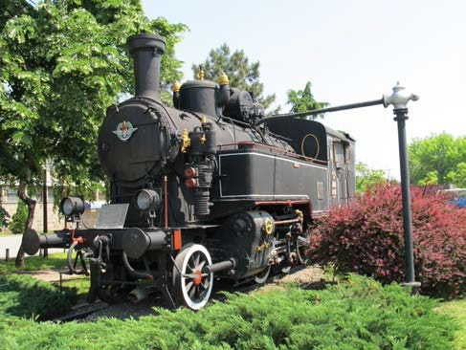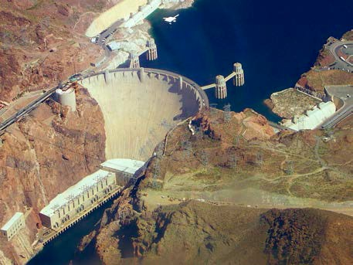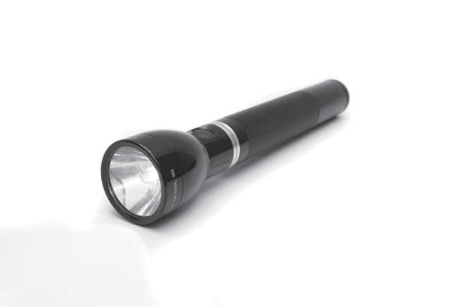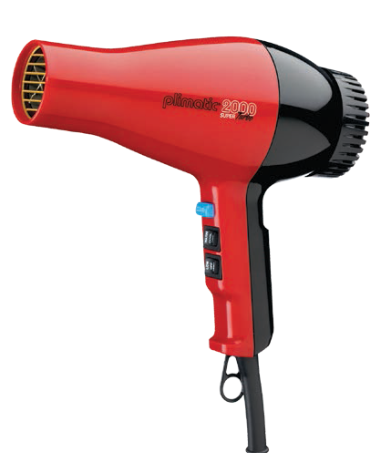In general, today’s power plants use three units of fuel to produce one unit of electricity. Most of the lost energy is waste heat. You can see this waste heat in the great clouds of steam pouring out of giant cooling towers on some power plants. A typical coal plant burns about 4,500 tons of coal each day. About two-thirds of the chemical energy in the coal (3,000 tons) is lost as it is converted first to thermal energy, and then to motion energy, and finally into electrical energy.
How Much Is a Watt?
1 WATT
Small, LED fl t
1.5 KILOWATTS = 1500 WATTS
Blow dryer
3 TO 5 MEGAWATTS = 2 GIGAWATTS =
3,000,000 to 5,000,000 WATTS 2,000,000,000 WATTS
Diesel-electric locomotive engines Peak output of the Hoover Dam

How Much Electricity Do Appliances Use?
Coffee Maker Dishwasher Microwave Refrigerator/Freezer
Hair Dryer Desktop Computer
Laptop Television
Video Game System

Vacuum

0 100 200 300 400 500 600 700 800
kW/Year
Data: DOE, Buildings Data Book

58 Energy at Home

LESSON 5: BACKGROUND INFORMATION
Appliances and Machines
Appliances, machines, and electronic devices use about 24 percent of a typical household’s energy, with refrigerators, freezers, clothes washers and dryers at the top of the list. Any appliance that is designed to change temperature uses a lot of energy. You can save energy by:
turning off appliances and machines when you aren’t using them;
using the energy-saver setting on dishwashers and refrigerators;
keeping the doors closed as much as possible on refrigerators and freezers—know what you want before you open the doors;
being aware that many machines use energy even when turned off—save energy by unplugging them; and
using machines and appliances during the morning and evening, not during peak demand time.
When you shop for a new appliance, you should think of two price tags. The first one covers the purchase price—the down payment. The second price tag is the cost of operating the appliance. You’ll pay the second price tag on your utility bill every month for the next 10 to 20 years. An energy efficient appliance will usually cost more, but it will save a lot of money in energy costs. An energy efficient model is almost always a better deal.
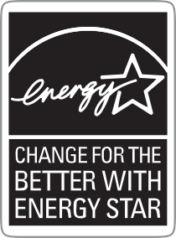ENERGY STAR®
When you shop for a new appliance, look for the blue ENERGY STAR® label—your guarantee that the product saves energy. ENERGY STAR® qualified appliances incorporate advanced technologies that use less energy and water than standard models. A list of energy efficient appliances canbefoundonthe ENERGYSTAR® website at www.energystar.gov.
Vampire Power
Household appliances and electronics contribute to a significant portion of the expenses seen on monthly electric bills. What consumers may not know is a large part of that expense could be a result of items that are not even used. According to energy experts, about 5 to 10 percent of a home’s electricity is used by appliances that are in standby mode. In Ohio, that means approximately $55 to $110 per year could be saved on your electric bill if you knew which electronics and other household items have standby modes and took action to lower this power use. This electricity “loss” is referred to as vampire power.
Many everyday appliances and electronics use significant power while in standby mode. The use and amount depends on the individual product; however, some of these appliances that use vampire power include: clock radios, satelitte/cable boxes and digital video recorder (DVR) equipment, televisions, DVD and VCR players, video game consoles, computers and monitors, printers, and microwaves.

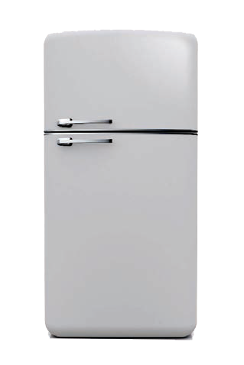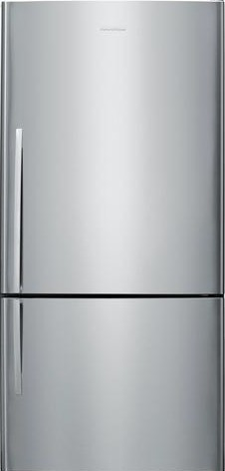
Refrigerator Efficiency
2,500 kWh per year
2,000
2,215 kWh
1,500
1,000
500
0
REFRIGERATORS MADE BEFORE 1980

Data: ENERGY STAR®
420 kWh
2014 ENERGY STAR® QUALIFIED REFRIGERATORS

SMART POWER STRIPS

Many electronics go into standby mode when turned off. Reduce vampire power by plugging electronics into a smart power strip, which can turn electronics off completely.

©2019 The NEED Project www.NEED.org Ohio Energy Project www.ohioenergy.org 59

Kill A Watt® Electricity Consumption Meter
MASTER 5-1

The Kill A Watt® meter allows users to measure and monitor the power consumption of any standard electrical device. You can obtain instantaneous readings of voltage (volts), current (amps), line frequency
(Hz), and electric power being used (watts). You can also obtain the actual amount of power consumed in kilowatt-hours (kWh) by any electrical device over a period of time from one minute to 9,999 hours. A kilowatt is 1,000 watts.
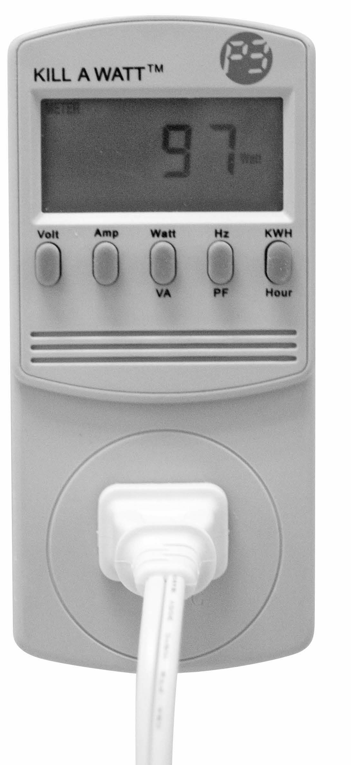Operating Instructions
- Plug the Kill A Watt® meter into any standard grounded outlet or extension cord.
- Plug the electrical device or appliance to be tested into the AC Power Outlet Receptacle of the Kill A Watt®meter.
- The LCD displays all meter readings. The unit will begin to accumulate data and powered duration time as soon as the power is applied.
- Press the Volt button to display the voltage (volts) reading.
- Press the Amp button to display the current (amps) reading.
- The Watt and VA button is a toggle function key. Press the button once to display the Watt reading; press the button again to display the VA (volts x amps) reading. The Watt reading, not the VA reading, is the value used to calculate kWh consumption.
- The Hz and PF button is a toggle function key. Press the button once to display the Frequency (Hz) reading; press the button again to display the power factor (PF) reading.
- The KWH and Hour button is a toggle function key. Press the button once to display the cumulative energy consumption. Press the button again to display the cumulative time elapsed since power was applied.

What is Power Factor?
The formula Volts x Amps = Watts is used to find the energy consumption of an electrical device. Many AC devices, however, such as motors and magnetic ballasts, do not use all of the power provided to them. The power factor (PF) has a value equal to or less than one, and is used to account for this phenomenon. To determine the actual power consumed by an AC device, the following formula is used:
Volts x Amps x PF = Watts Consumed

60 Energy at Home

MASTER 5-2
61

Measuring Electricity Use Chart
©2019 The NEED Project
www.NEED.org Ohio Energy Project www.ohioenergy.org

MACHINE OR APPLIANCE | HOURS PER WEEK  (estimate) | HOURS PER YEAR (x52) | WATTS (W)  (measured) | KILOWATTS (kW) (/1000) | RATE ($/kWh) ($0.11) | ANNUAL COST
Desk lamp | 20 | 1040 | 12 W | 0.012 kW | $0.11 | $1.37

LESSON 5
Appliances and Machines Investigation
Question
Which items are the largest energy consumers in your home?
 Materials
Kill A Watt® meter
Pluggable appliances

 Hypothesis

Procedure

Calculate how much it costs to operate the machines in your classroom or home. You need to know the wattage, the cost of electricity, and the number of hours a week each machine is used. You can find the wattage by plugging the machine into the watt meter.
You can estimate the number of hours the machine is used each week, then multiply by 52 to get the yearly use. Using the desk lamp as an example, if it is used for twenty hours each week, we can find the yearly use like this:
Yearly use = 20 hours/week x 52 weeks/year = 1,040 hours/year

Remember that electricity is measured in kilowatt-hours. You will need to change the reading from the watt meter (in watts) to kilowatts. One kilowatt is equal to 1,000 watts. To get kilowatts, you must divide the watts by 1,000. For example, if the desk lamp used 12 watts on the watt meter you would divide like this:
kW = W/1,000 kW = 12/1,000 = 0.012
The average cost of electricity in Ohio is about eleven cents ($0.11) a kilowatt-hour. You can use this rate or find out the actual rate from your home’s electric bill. Using the average cost of electricity, we can figure out how much it costs to run the desk lamp for a year by using this formula:
Yearly cost | = | Hours used | x | Kilowatts | x | Cost of electricity (kWh)
Yearly cost | = | 1040 hours/year | x | 0.012 kW | x | $0.11/kWh
Yearly cost | = | 1040 | x | 0.012 | x | $0.11/kWh = | $1.37
*Hint: multiply shaded areas to calculate annual cost.

MACHINE OR APPLIANCE | HOURS PER WEEK  (estimate) | HOURS PER YEAR  (x52) | WATTS (W)  (measured) | KILOWATTS (kW)  (/1000) | RATE ($/kWh)  ($0.11) | ANNUAL COST
Desk lamp | 20 | 1040 hours | 12 W | 0.012 kW | $0.11 | $1.37

62 Energy at Home

ANSWER KEY

LESSON 5 – Appliances and Machines
ASSESSMENT

- Most appliances are powered by .
  - natural gas b. electricity c. propane d. petroleum

- One of the appliances that uses the most energy in your home is the .
  - refrigerator b. computer c. radio d. television

- One kilowatt is equal to watts.
a. 10 b. 100 c. 1,000 d. 10,000

- A fan and a hair dryer both move air. How do the watts used by each compare? Explain why there is such a difference.
While a fan and a hair dryer both move air, the hair dryer uses many more watts and uses energy at a greater rate. The reason for the difference is that the hair dryer has a heating element to heat the air. It requires much more electricity to be transformed into both mechanical energy and thermal energy.

- Explain how an appliance could have a lower wattage than another but still cost more per year for electricity. Give examples.
An appliance with a lower wattage could still cost more for electricity to run each year because electricity is measured and consumed in kilowatt-hours (kwh) not just kilowatts. The watts are important but also the time that the appliance is being used. An example of this is that a light bulb that is used often and for long periods of time could have a low wattage and still cost more per year than a hair dryer which is high wattage but only used for very short periods of time.

Connections
- Describe a Kill A WattTM monitor and explain how it can be used to help save energy.
- Looking at the appliances in your home, how can you make your current appliances more efficient? What will you look for when your family purchases a new one?

©2019 The NEED Project www.NEED.org Ohio Energy Project www.ohioenergy.org 63

LESSON 5
Home Activity

APPLIANCES AND ENERGY STAR® LOGOS
 Materials
Refrigerator/freezer thermometer, if available
Dollar bill
Procedure
- With the help of an adult, test the seal on the door of your refrigerator. To do this, you will need a dollar bill. Close the door over the dollar bill so that it is half in and half out of the refrigerator. Grasp the end of the bill with both hands by the corners and pull slowly and steadily. Do not try to jerk it; it might tear. A refrigerator with a tighter seal (dollar bill does not move) is more efficient and uses less energy. You can save energy and money by keeping the refrigerator door closed tightly.
comes out easily 0 points
comes out fairly easily 2 points
comes out with difficulty 4 points
does not move 6 points

- Use the refrigerator thermometer to measure the temperature of your refrigerator and freezer and record in the chart below. Leave the thermometer in place 24 hours to get an accurate reading.

APPLIANCE TEMPERATURE SAFE ZONE (oF)
Refrigerator 37°-40°
Freezer Section 0°-5°
Separate Freezer (if applicable) 0° or Colder

- Look around your house for large or small appliances that have ENERGY STAR® logos on them. Explain to your family that the ENERGY STAR® means the appliances meet strict energy efficiency standards. What ENERGY STAR® appliances did you find?

64 Energy at Home

Lesson 6: What Have We Learned?
Overview
Students review what they have learned and what changes they have made to use less energy.

Objectives
Students will be able to differentiate between energy efficiency and energy conservation, citing examples of each concept.
Student will report the energy efficiency measures installed in their home on the Family Installation Survey.
Recommended Activities

Post Assessment
NOTE: Answer Key provided in Lesson One Lesson Plan.
Procedure
- Discuss what the students have learned from the unit and what they think their families have learned.
- Discuss the successful installation and use of the items in the Energy Efficiency Kit. Have students complete the Family Installation Survey available online at www.ohioenergy.org.
OPTIONAL: Send a paper copy of the Family Installation Survey home with students to have families complete and return it as an assignment. Then take students to the computer lab to input data. Download the current year’s survey at www.ohioenergy.org.
- Have students complete the Connections questions and discuss as a class.
- Complete Your Family Rating guide.
- Discuss of how families can save energy.

Procedure after Completion of Unit
- Have students enter installation survey data (at www.ohioenergy.org) using the school’s computer lab, or mail paper copies of installation survey to:
Ohio Energy Project 200 E. Wilson Bridge Rd. Worthington, OH 43085
- Please have your students write thank you notes/letters to the sponsor(s) of the program. Their addresses are listed on the back of the Student and Family Guide. They appreciate hearing from the students, and it’s a great way to incorporate writing as well!
- Complete the teacher evaluation at www.ohioenergy.org.
- Register for next year’s program at www.ohioenergy.org.

©2019 The NEED Project www.NEED.org Ohio Energy Project www.ohioenergy.org 65

LESSON 6 – What Have We Learned?
CONNECTIONS

- What are the most important things you have learned about energy and how to save it?

- What energy concepts would you like to learn more about?

- What things do you think you and your family will do to save energy at home?

- How will saving energy now impact your life later as an adult?

66 Energy at Home

STUDENT WORKSHEET

LESSON 6:
Home Activity – Your Family Rating

In many of the activities, you and your family rated your energy consumption and efficiency. Now you will add all of those points together to determine your family’s overall rating. Share this information with your family.

Your Ratings
Page 44: Weatherstripping Points: Cooling Points:
Heating Points: Page 35: Water Heater Points: Page 30: Lighting Points: Page 50: Refrigerator Points: TOTAL Points
Rating Guide
28 - 36 EXCELLENT
21 - 27 GOOD START but there’s more we can do
20 or fewer Make a commitment today to save energy at home and at school
Savings Plan
Make a list of things your family can do to save energy and money.

©2019 The NEED Project www.NEED.org Ohio Energy Project www.ohioenergy.org 67

STUDENT WORKSHEET
LESSON 6
What Have We Learned - Family Installation Survey
This program is funded through your local electric and/or natural gas provider. We ask all families to complete this survey to measure the energy savings from the program. Thank you for making a difference and saving money with your energy efficiency actions.
Please visit www.ohioenergy.org to complete the survey.

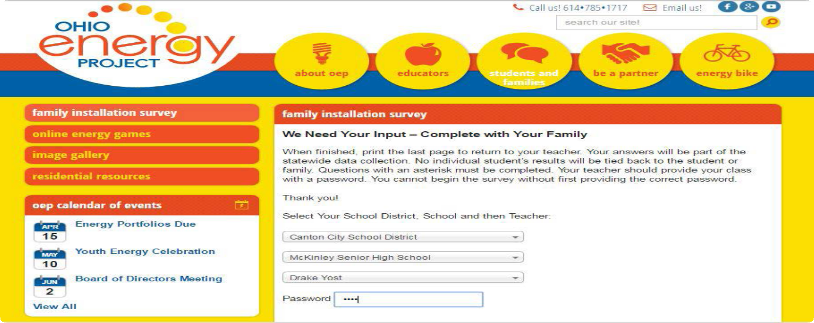

68 Energy at Home

Energy Efficiency Post-Poll
- What is energy?
  - The ability to produce change or do work b. An odorless fossil fuel c. Organic matter d. Technology

- is a form of kinetic energy.

  - Petroleum b. Elastic Energy c. Thermal Energy d. Chemical Energy

- Energy is an action or behavior that results in using less energy.
  - Efficiency b. Conservation c. Sustainability d. Transformations

- What is the amount of light or brightness of a light bulb measured in?
  - Amps b. Watts c. Inches d. Lumens

- percent of energy consumed by an incandescent bulb produces light.
a. 25 b. 10 c. 70 d. 90

- A water heater should be set at .
a. 120 °F b. 65 °F c. 150 °F d. 100 °F

- Mercaptan is added to natural gas to give it a “ ” odor.
  - Mint b. Skunk c. Sweet d. Rotten Eggs

- Heat flows from areas of to areas of .
  - Higher energy; Lower energy b. Moisture; Dryness c. Lower energy; Higher energy d. Solid; Liquid

- refers to electricity loss when appliances are in standby mode.
  - Energy Star b. Kilowatt-hour c. Vampire Power d. Fuel Cost

- What is the unit of measure of the electric power an appliance uses?
a. Joule b. Volt c. Foot-candle d. Watt

©2019 The NEED Project www.NEED.org Ohio Energy Project www.ohioenergy.org 69

Internet Resources

The National Energy Education Development Project
Energy information and activities for students and teachers.
www.need.org

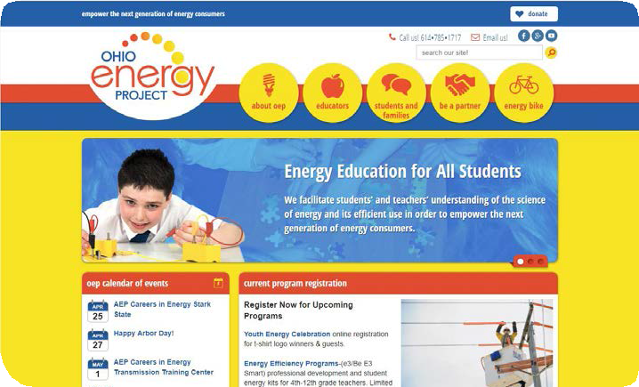Energy Savings at Home
Ohio Energy Project Programs and resources for teachers in grades 3-12. www.ohioenergy.org.

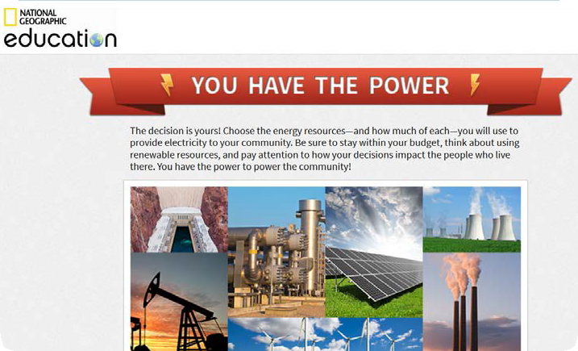
National Geographic
The decision is yours! Choose the energy resources—and how much of each—you will use to provide electricity to your community.
http://media.education. nationalgeographic.com/assets/ richmedia/0/213/project/index. html?page=intro

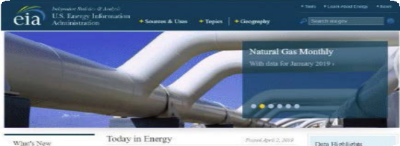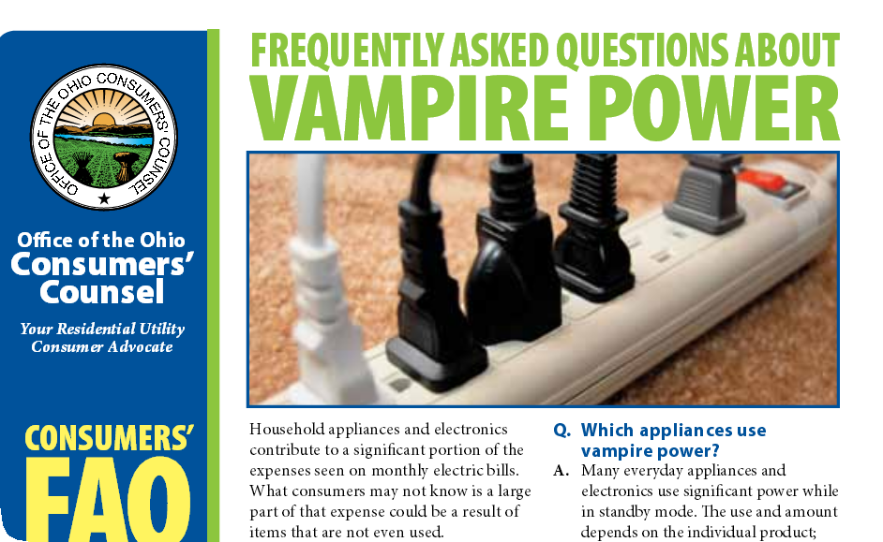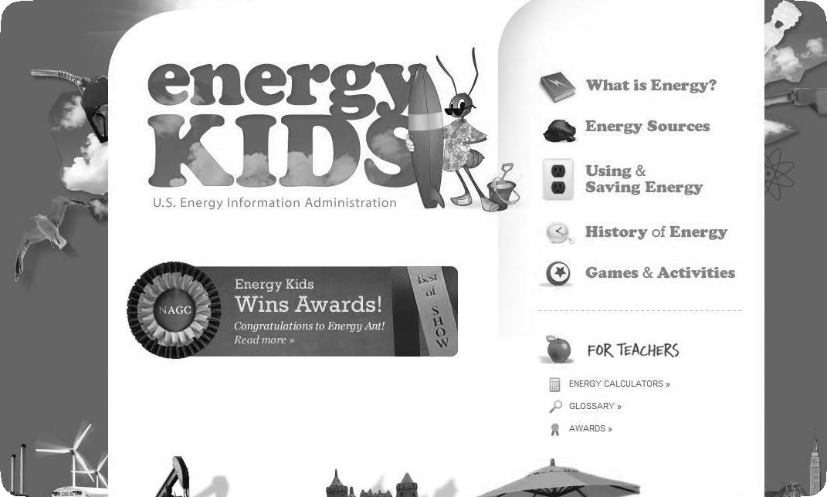

U.S. Energy Information Administration
Learn about the various ways the U.S. uses energy every day.
https://www.eia.gov/
Ohio Consumers Council
Learn ways to save 5-10% of your electric bill by turning off appliances instead of using standby mode.
http://www.occ.ohio.gov/publications/ electric/Vampire_Power.pdf
Energy Kid’s Page
Energy Ant hosts this site containing energy facts, fun and games, classroom activities, and more.
www.eia.gov/kids

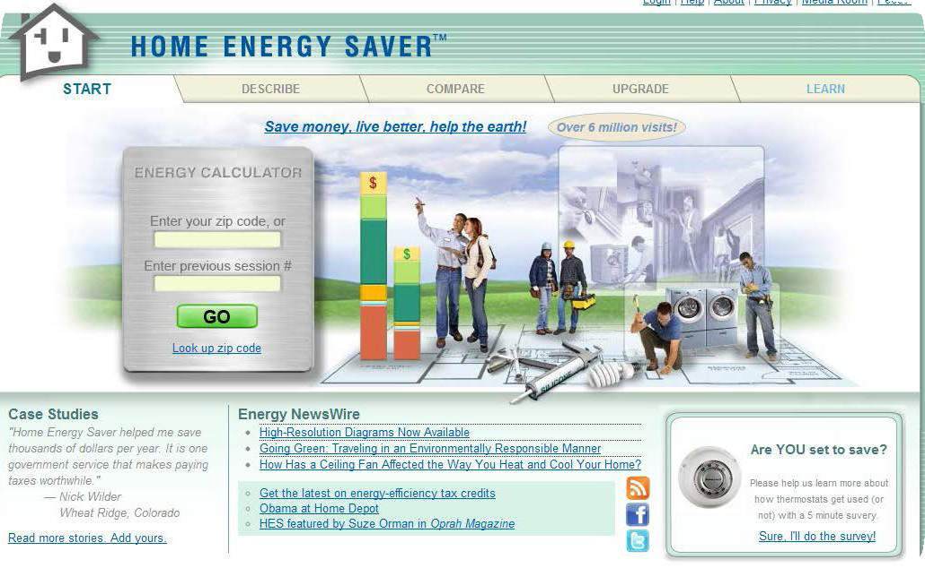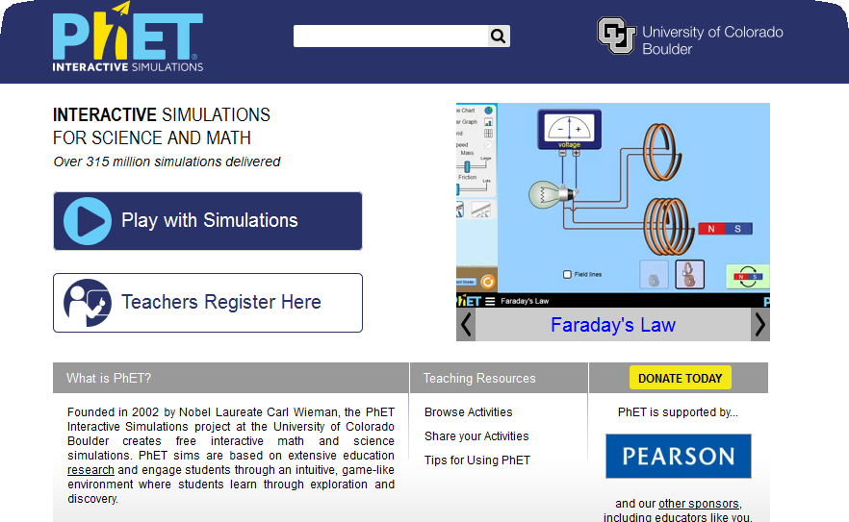

Find Your Efficiency Zone Based on the zip code entered, it will provide a comparison of the energy
costs of an average home and an energy-
efficient home in your area. http://homeenergysaver.lbl.gov/consumer
Argonne National Library STEM resources for both student and teacher.
https://www.anl.gov/education/stem- outreach
Phet
Interactive simulations show how energy works.
http://phet.colorado.edu

70 Energy at Home

The Ohio Energy Project thanks The NEED Project for permission to adapt NEED’s School Energy curriculum for use with OEP’s energy efficiency education programs.

