Safety Sort

Overview – This activity consists of twenty four cards, each with a safety precaution. The students read and then sort the cards as they pertain to one of the following three categories: Electrical Safety, Natural Gas Safety, or Both Electrical and Natural Gas Safety
Teacher Hints - This activity lends well as a two-ring overlay Venn Diagram sorting activity which can be done as a whole group or in small groups. The Venn diagram would be done on a white board or regular chalk board with magnets or masking tape for placing the cards in the correct section of the Venn diagram. Safety Sort will also work well as a Smart board activity, or, with younger students placing themselves on a floor Venn diagram using either yarn loops or a shower curtain where the students stand in the correct loop. In small groups students can place the cards in the correct portion of the Venn diagram on a file folder or poster board while working at their desks or tables.

Both Electrical and Natural Gas Safety
Electrical
Safety
Gas
Safety

ELECTRICAL SAFETY:
Never swim during a storm.
Make sure there are ground fault circuit interrupters in kitchens and bathrooms
Fuses and circuit breakers stop the flow of electrical current when circuits become overloaded. Never touch wires or power lines that are sagging or on the ground.
Use hair dryers and other electrical appliances away from water. Never put your finger or other items into an electrical outlet.
Never climb utility poles or transmission towers. Fly a kite only in open spaces.
Build tree houses and climb trees away from power lines.

NATURAL GAS SAFETY:
If you smell gas, leave the area immediately.
A chemical called mercaptan, which smells like rotten eggs, is added as a precaution. Keep fire extinguishers near appliances with open flames or pilot lights.
A leaking pipe might make a hissing sound that you can hear.
Make sure Carbon monoxide detectors are installed in your living and sleeping areas. Water with bubbles in it or a small area of dead plants is a sign of a leak.
Make sure you have at least 18 inches of clearance around your hot water heater and furnace. If you suspect a leak, don’t flip any switches or use any appliances.
Never use the oven as a heat source for your kitchen or home.

BOTH:
Contact your utility company if you have safety questions or concerns. Always tell an adult right away if you detect unsafe conditions.
When playing outside, stay away from meters and other utility equipment. Call before you dig.
Don’t block access to utility equipment with plants or decorations. Make sure your address is clearly visible from the street.

Never climb utility
poles or
transmission towers.

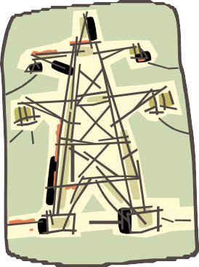

Build tree houses and climb trees away from all power lines.
Fly a kite
only in open
spaces.

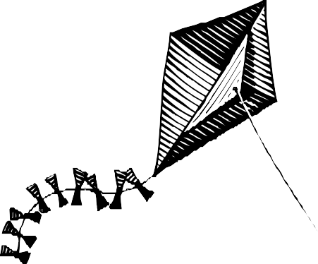

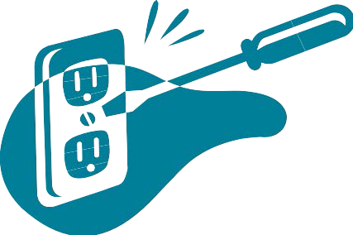Never put your finger or other items into an electrical outlet.

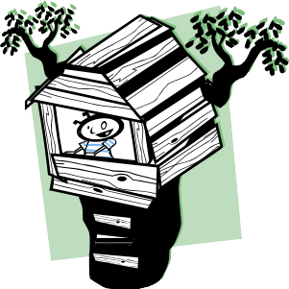

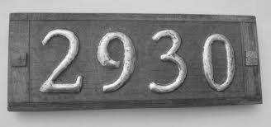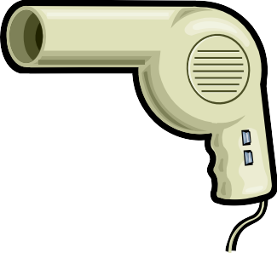Don’t block access
to utility equipment
with plants or decorations.

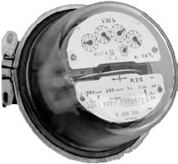

Make sure your address is clearly visible from the street.
Make sure there
are ground fault
circuit interrupters in kitchens and bathrooms.
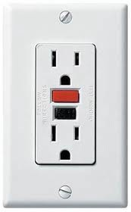

Use hair dryers and other electrical appliances away from water.

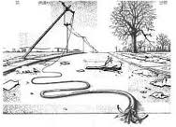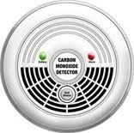Fuses and circuit
breakers stop the
flow of electrical current when circuits become overloaded.

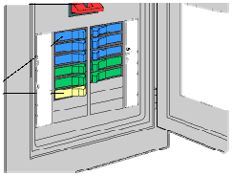

Never touch wires or power lines that are sagging or on the ground.
Never swim
during
a storm.

Make sure carbon monoxide detectors are installed in
your living and sleeping areas.

When playing
outside, stay away
from meters and other utility equipment.
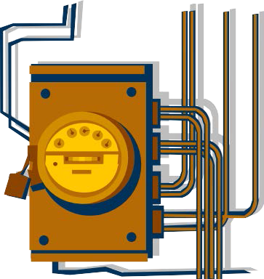

Never use the oven as a heat source for your kitchen or home.
Water with bubbles
in it or a small area
of dead plants is a sign of a leak.

Call before you dig.

Keep fire
extinguishers near
appliances with open flames or pilot lights.
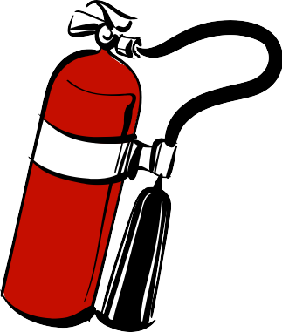

Make sure you have at least 18 inches of clearance around your hot water heater and furnace.
Always tell an adult
right away if you
detect unsafe conditions.
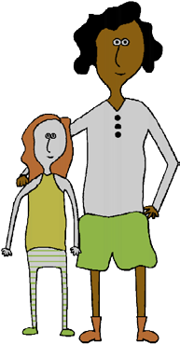

A leaking pipe might make a hissing sound that you can hear.

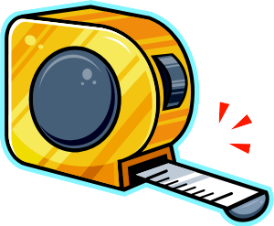

If you smell gas,
leave the area
immediately.

A chemical called mercaptan, which smells like rotten eggs, is added as a safety precaution.
If you suspect a
leak, don’t flip any
switches or use any appliances.

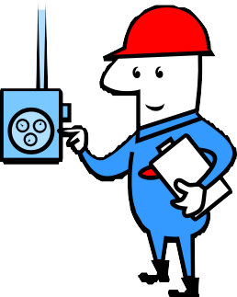Contact your utility company if you have safety questions or concerns.

