Name _______________________________ 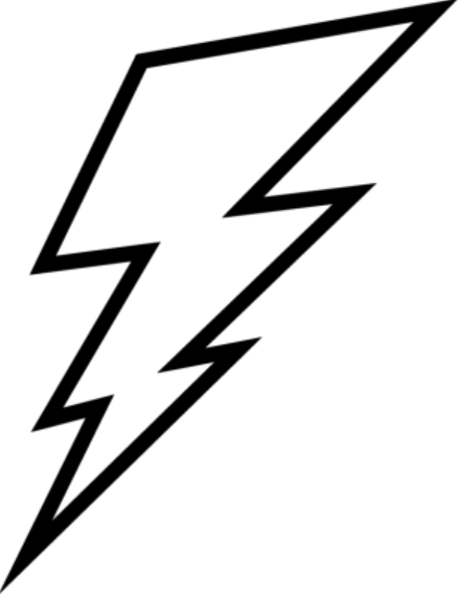
Sources of Energy
Remember that energy is the ability to cause a change in an object.
That change can be:
- moving it
- crushing it
- burning it
- changing its state like melting an ice cube.
We use many different sources of energy to do work
Energy sources can be grouped into two kinds:
RENEWABLE | NONRENEWALBE
This type of energy does not run out. You can get more. It can be replaced in your lifetime. | This type of energy has a limited supply. It takes hundreds of millions of years to form.
Examples:  Solar  Wind  Hydropower  Biomass  Geothermal | Examples:  Coal  Natural Gas  Petroleum or Oil  Propane  Nuclear or Uranium

Each of these sources are obtained or collected in different ways.
Many are found in different places in the country and world.
Many are used to make electricity.
All of them have advantages and disadvantages.
Resource suggestions:
https://www.need.org/need-students/energy-information-resources/
Need Primary or Elementary Energy Infobook

My Energy Source is __________________________________
The definition is ______________________________________________________________
Renewable or Nonrenewable – circle one
Can it be used to make electricity? Yes or No
If renewable, how is it renewed _________________________________________________
If it is nonrenewable, how do we get it?____________________________________________
If it is a fossil fuel, how was it formed?_____________________________________________
Where can it be found? ________________________________________________________
Does it need special machines or changes in the environment to use it? Yes No
Describe the machines ________________________________________________________
Can using this energy source cause any damage to the environment? ___________________
Do we use this energy source in Ohio? Yes No
All energy sources have advantages and disadvantages.
Complete the chart below with three of each.

Use the book, The Shocking Truth about Energy as your first advantage and disadvantage.
Advantage | Disadvantage
If you were going to interview, Loreen Leedy, the author of The Shocking Truth about Energy, what question would you ask her?
_____________________________________________________________________________
_____________________________________________________________________________
Ten Sources of Energy Summary Notes

Source | Renewable or Nonrenewable | Advantage | Disadvantage
Coal

Petroleum

Natural Gas

Propane

Nuclear
Uranium

Solar

Wind

Hydropower

Biomass

Geothermal

