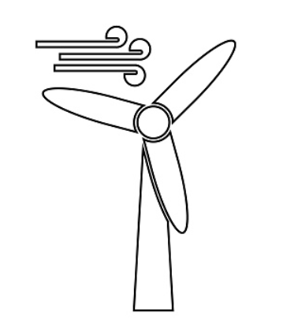 Energy Island by Allan Drummond
Name ___________________
Reading Discussion Questions
What are three character traits of Soren Hemansen in Energy Island?  - __________________________  - __________________________  - __________________________ | I know this because…
Describe the setting of the story | Would you like to live in this setting? Why or why not?
How are the children on Energy Island like you? | List two pictures of things in the book that show how windy it is on Samso Island.  - ____________________________  - ____________________________
In the beginning, compare how the children and grown-ups felt about making the change to renewable energy.  Children: ____________________________  ___________________________________  Grown-ups: ___________________________  ____________________________________ | What event in the story changed the minds of adults?
What are 3 energy sources the Island use to become energy independent?  - _____________________________  - _____________________________  - _____________________________ | Explain why using these sources helped the community …
Explain one way the people of Samso conserved or saved energy | What can you do in your community?

