Sail Car Design
Partners Names ________________________ and ___________________________
In this project, you will be an engineer. Engineers solve problems. They have a process that helps them do that.
Your challenge is to design a sail for your car that will capture the wind from a fan on high speed and make it travel as far as possible.
This is their process.
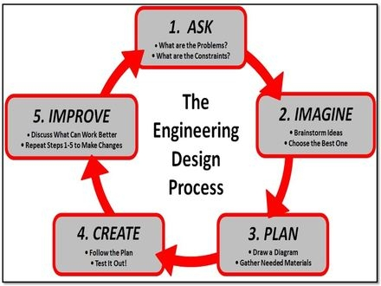
ASK: What is the problem?

What are you trying to do?

IMAGINE: What are some solutions? Brainstorm ideas.
Think about shapes, size, masts and position.
Choose the best one.
PLAN: Draw a diagram.

You can use paper, tape, ruler and scissors.
Shape of sail: ___________
Size: __________________
Height of Mast 1:_________ If using 2 masts Height of Mast 2:_________
Draw where you will place the mast.
CREATE: Follow your plan and create your sail car. Test it out!
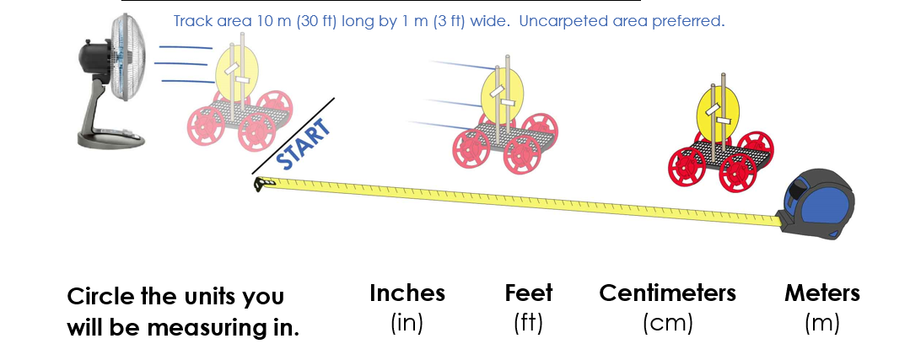
Predict: How far do you think your car will go?_________________________________
Test: How far did it go? ___________________________________________________
IMPROVE: What works? ___________________________________________________
What doesn't? ___________________________________________________________
What could work better? __________________________________________________
Modify your design to make it better. Test it out!
Predict: How far do you think your car will go?_________________________________
Test: How far did it go? ___________________________________________________

