Name: ___________________________________________ ___________________________________
The Sun is Kind of a Big Deal by Nick Seluk
Reading Discussion Questions
- The areas around the equator get the same amount of sun as the poles. Draw a picture to explain why the area around the poles is not as warm.
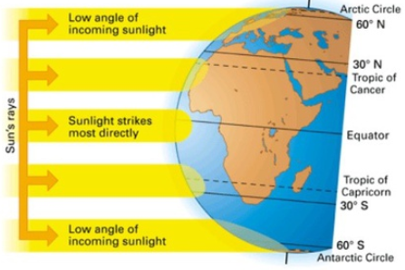

- How many times have you been around the sun on your next birthday? Your age

- How many times does the moon go around the earth in one year? 12 or 13
- What planet has the funniest introduction? Explain why.
Answers will vary
- Find the page that starts, “The Earth is the third planet from the sun.” Each planet says something about themselves. Introduce yourself to a planet by saying something special about you.
Answers will vary
- Find the page with the picture of the Earth wearing earmuffs at the top of the page. How does this picture explain seasons? Hint: Remember the Earth is tilted.
The Earth is spinning on a tilt which is why we have seasons. When the bottom half or the Southern
Hemisphere is tilted toward the sun, it is summer there. The Earth has a duckie swim tube on. At the
same time, the top half or the Northern Hemisphere is tilted away from the sun and it is winter there so
the top half has on earmuffs to keep warm.
- Look at the “Did You Know” section at the end of the book. Explain how you can use the sun to tell time.
The sun’s position in the sky changes throughout the day. If there is a pointer on a sundial, the shadow made would point to different areas depending on where the sun was in the sky. The shadow told you
what time is was.

- The sun has many important jobs. List two. Answers will vary but may include:
Gives us light, keeps us warm, makes plants grow which gives us food and oxygen, helps bring rain, helps make energy with a solar panel
- How does the sun help with making the oxygen we breathe?
Plants use water from the water cycle, carbon dioxide from the air and light from the sun to make food for the plant to grow and oxygen. This is called photosynthesis.

- Which part of the water cycle is the sun most responsible for?
Heat from the sun causes water to mix with air turning it into a gas. This is evaporation.

