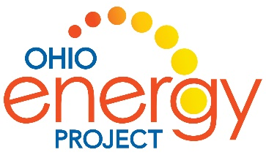***Energy Island*** by Allan Drummond

Name: ___________________________________________ ___________________________________

Reading Discussion Questions

1. How are the children on *Energy Island* like you?

**Children go to school. They play soccer, play at the beach, play video games, have pets, ride bicycles, and “hold onto their hats” in the wind**

1. Describe the setting of the story.

**Samsø is an Island off the coast of Denmark. It has farms, a harbor with ferries and fishing, boats, villages, schools, beaches, stores and uses energy just like us. It has seasons and is very windy.**

1. Would you like to live in Samsø? Why or why not?

**Answers will vary.**

1. List two pictures of things in the book that show how windy it is on Samsø Island.

**Various answers. Examples: any picture holding onto their hats, the pinwheels, flying flags, wind mills and wind turbines**

1. What are three character traits of Soren Hemansen in *Energy Island*?

* **Persistent – he would not give up**
* **Creative – came up with different ways to convince people and solve problems**
* **Helpful – helped people start new energy projects**

**I know this because…see above**

**Additional traits: kind, imaginative, curious, intelligent, honest, courage to try new things**

1. What can you do in your community to conserve or save energy?

**Use more efficient tools and machines, ride bikes, learn about renewable energy, do not waste energy**

1. Explain one way the people of Samsø conserved or saved energy.

**They used electric cars and electric bicycles, installed renewable energy devices, and became aware of**

**wasting energy.**

1. What are 3 energy sources that Samsø used to become energy independent?

* **Wind energy in the turbines**
* **Solar panels**
* **Biomass burning straw, wood and canola oil**

Explain why these sources helped the community. **They do not need oil tankers to bring**

**oil. They do not need electricity from the mainland and on somedays, they can sell back electricity for**

**the mainland to use. They have reduced their carbon emissions by 140%. People come to the new**

**Energy Academy to learn about saving energy.**

1. What event in the story changed the minds of the adults?

**Two people decided to install wind turbines, one large and one small. Then one winter night, there was**

**a storm and the entire island lost electricity except for the two people who had wind turbines.**

1. In the beginning of the story, compare how the children and the grown-ups felt about making the change to renewable energy.

**Children:** Children were excited and at school they suggested several different ways to become energy independent

**Grown-ups:** It took a while for them to catch on. Some thought it would cost too much, some did not want to change, some did not think it would make a difference.