The Electromagnetic Spectrum
Energy from the Sun
What wavelength of light causes a change in the UV beads?
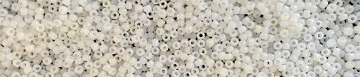
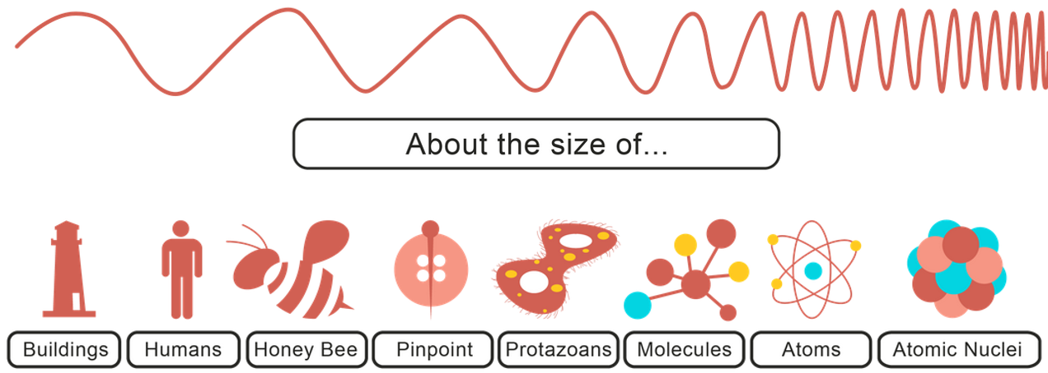
Wavelength

