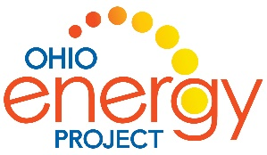 Name: ______________________________________

Sources of Energy Research Project
Energy is the ability to cause a change in an object.
That change can be:
- moving it
- crushing it
- burning it
- changing its state like melting an ice cube.
We use many different sources of energy to do work
Energy sources can be grouped into two types:
RENEWABLE | NONRENEWALBE
This type of energy does not run out. It can be made in a short time or will always be there. | This type of energy has a limited supply. It takes millions of years to form.
Examples:  Biomass  Geothermal  Hydropower  Solar  Wind | Examples:  Coal  Natural Gas  Petroleum or Oil  Propane  Nuclear or Uranium

Each of these sources are obtained or collected in different ways.
They are found in different places in Ohio, the United States and around the world.
Many are used to make electricity.
All of them have advantages and disadvantages.
Resource suggestion:
https://www.need.org/need-students/energy-information-resources/
NEED Primary or Elementary Energy Infobook

Ten Sources of Energy Research Project Presentation Notes
As each team is presenting, note facts about each source of energy.

Source | Renewable or Nonrenewable | Advantage | Disadvantage
Coal

Petroleum

Natural Gas

Propane

Nuclear
(Uranium)

Solar

Wind

Hydropower

Biomass

Geothermal

