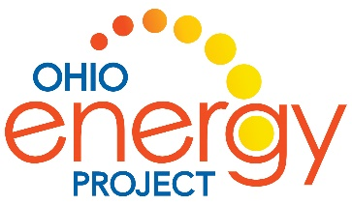
Name: ___________________________________________ ___________________________________
The Shocking Truth about Energy by Loreen Leedy
Reading Discussion Questions
- These are the steps to change a fossil fuel into electricity:
- Burn fuel to create heat
- Hot water becomes _________________________
- Steam makes a turbine __________________________
- The turbine spins a magnet in a _________________________
- _________________________ moves through wires to your house.
- Name two ways you used electricity today.

- _________________________________________________________________________________

- _________________________________________________________________________________

- Tell how you transfer energy when you play at recess.
______________________________________________________________________________________
______________________________________________________________________________________
______________________________________________________________________________________
______________________________________________________________________________________
- You cannot create or destroy energy, but you can change it from one form to another. Explain how this idea works when cooking a hotdog.
______________________________________________________________________________________
______________________________________________________________________________________
______________________________________________________________________________________
______________________________________________________________________________________

- What are two energy savings tips for grownups?
- _______________________________________________________________
- _______________________________________________________________
- What are two energy savings tips for kids like you?
- _______________________________________________________________
- _______________________________________________________________
- Explain why the picture on page 18 is an idiom.
______________________________________________________________________________________
______________________________________________________________________________________
- Where have you seen a wind turbine?
_____________________________________________________________________________________
- How might these problems affect you and your community?
______________________________________________________________________________________
______________________________________________________________________________________
______________________________________________________________________________________
______________________________________________________________________________________
- Describe three problems of a warmer Earth:
- ____________________________________________________________
- ____________________________________________________________
- ____________________________________________________________

