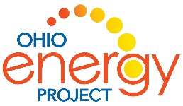
Sources of Energy Project Rubric

Team Members: _____________________________________________________
Energy Source: ___________________________________
 | 1 | 2 | 3 | 4
Completeness and Accuracy of Research | Most of the required information is not included. | More than half of the required information is missing. | Some required information is missing or inaccurate. | All information is complete and accurate.
Knowledge and Understanding | Student does not understand information. | Student understands information but cannot  explain or apply it. | Student understands most information and can explain it. | Student  understands all information  and can explain and apply it.
Communication of presentation | Presented information was poorly organized, hard to understand. | Presented information was poorly organized or was difficult to understand some of the time. | Presented most of the information in a clear and organized way. | Presented all information in a clear and organized way.
Neatness and Clarity | The majority of the display was messy or unclear. | Much of the visual display was unclear. | One or two parts of the visual display was not neat or creative. | Visual display was creative, neat and appealing.
Group work | Student needs to learn to work together and offer help to others | Student needs to contribute more to the project and work more with their team mates | Student cooperates with the team but does not help solve problems. | Student helped the team work together and solve problems.

Total _________/25
Teacher comments:
__________________________________________________________
__________________________________________________________
__________________________________________________________

