Sail Car Design Challenge

Name: ______________________________________________

Partner’s Names: _________________________ and ___________________________

In this project, you will be an engineer. Engineers solve problems. They have a process that helps them do their work. This is their process.
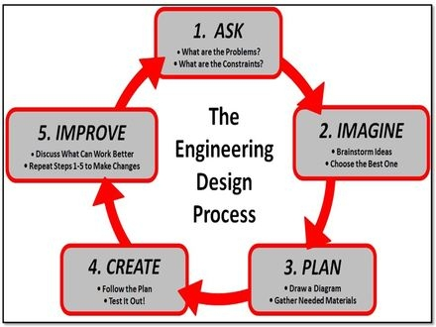

Your challenge is to design a sail for your car that will capture the wind from a fan on high speed and make it travel as far as possible.

ASK:

What is the problem?
What are you trying to do?
IMAGINE:

Shape: ______________________________________________

Size: ________________________________________________

Position and Number of Mast(s): _________________________

____________________________________________________
What are some solutions? Brainstorm ideas.

Think about shapes, size, position and number of masts. List your ideas in the box.

PLAN:

Draw a diagram of your sail car.

You can use paper, tape, ruler and scissors.

Shape of sail: ___________

Size: __________________

Height of Mast 1:_________

If using 2 masts, height of
Mast 2:_________

Draw where you will place the mast.

Before you get your materials, your teacher must see and initial your diagram. __________

CREATE:
Follow your plan and create your sail car. Test it out!
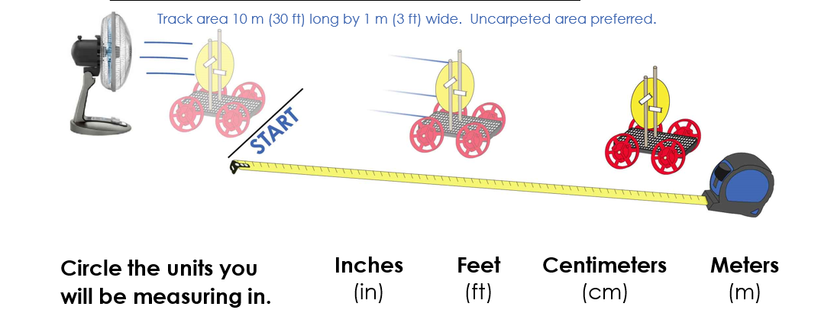

Predict: How far do you think your car will go? ______________________________

Test: How far did your car go? ___________________________________________

IMPROVE:

What worked well with your design? __________________________________________________________________________

__________________________________________________________________________
What did not work well with your design? ____________________________________________________________________________________________________________________________________________________
What could work better? _____________________________________________________
__________________________________________________________________________

Modify your design to improve it.

Draw your new sail design in the box.

Predict:
How far do you think your car will go in trial #2?

____________________________

Test:
How far did your car go in trial #2?

_____________________________

FINAL QUESTIONS:

- What other materials could you use to make your car go farther? __________________________________________________________________________________________________________________________________________

- Engineers solve problems. There are many different types of engineers: Mechanical, Electrical, Civil, Chemical and others. What type of engineer would you like to be?

____________________________________________________________________

Why? ________________________________________________________________
_____________________________________________________________________

