Wind Energy and Sail Car Design
Teacher Lesson Plan

Part 1: Energy Island

Background Information:
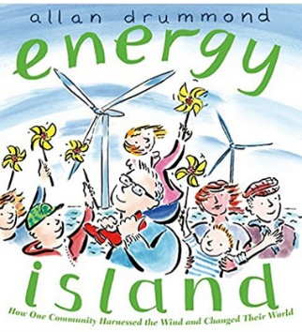
Energy Island by Allen Drummond is a nonfiction story about how the island of Samsø in Denmark decided to become energy independent. After attending the United Nations Climate Summit in 1997, the Minister for the Environment, Svend Auken, set up a competition between municipalities in Denmark to become carbon neutral in 10 years. On the island, the effort was led by science teacher, Soren Hermansen. Samsø’s proposal won the competition. Hermanson brought together neighbors to community meetings to learn about utilizing the renewable resources on the island namely wind, solar and biomass. After addressing the fear of change, residents embraced the new technologies based on financial, environmental and personal improvements.
The story introduces the readers to the island and its residents, many of whom are like people in your community. By educating the children in class and the neighbors at community meetings, the people recognized the benefits from using the renewable resources available on Samsø. The wind turbines and solar arrays for electrical power and biomass plants to produce heat have allowed the island to produce enough energy for itself and export the extra to the mainland.
Armed with this knowledge and expertise, Samsø’s Energy Academy has opened its doors to people around the world. The goal of the academy is to share ideas for creating, sharing and saving energy. What energy sources are plentiful on your “island”?

Key Vocabulary:
- Energy Independence- When a country produces enough of its own energy to meet its own demands
- Renewable Energy- Energy from sources that will not run out or can be replenished in our lifetime. Examples: Biomass, Geothermal, Hydropower, Solar, Wind
- Nonrenewable Energy- Energy from sources that will run out or cannot be replenished within our lifetime. Examples: Coal, Natural Gas, Nuclear, Petroleum, Propane
- Wind Turbine- Wind turbines use the power of wind to make electricity. The wind turns the turbine blades, which spin a shaft, which connects to a generator and makes electricity.

Using Google Earth, locate Samsø Island, Denmark:
- https://www.google.com/earth/
- Locate the mainland of Denmark and neighboring countries.
- Using the pictures feature, explore some of the locations on the island.

Book Talk:
Now that you have seen the island of Samsø and you know all about the 10 sources of energy, I want you think about how great it would be to rely on your own energy sources? You could help save the earth from harmful pollution! This is exactly what the community in Samsø, Denmark did. They learned to use energy from the wind, sun and even plants to create electricity and heat for their homes, schools and businesses. Do you want to know how they did this? Let’s read Energy Island and find out!

Read Energy Island:
- Before reading Energy Island, pass out discussion questions to students. Have students pre-read the questions to get an idea of what they should be listening for while you read.
- While reading book, students answer reading discussion questions
- Give time to complete questions after reading.
- Discuss answers to questions.
- Additional Ideas for Discussion Questions:
  - If the entire page of questions is too much for your students, consider breaking up the questions, assigning each student 1-2 questions to answer while you read.
  - When you are done reading have students find someone with the SAME question and meet to discuss their answers, looking for similarities and differences in their thinking
  - Likewise, you may choose to have students find someone with a DIFFERENT question and meet to share their answers.

Assessment:
- Distribute Energy Island Problem and Solutions Student Worksheet.
- Students will respond to the following prompt on their assessment sheet.

“In the book Energy Island, you found out the island was chosen by the Danish Ministry of Environment and Energy to become independent of nonrenewable energy. Samsø was getting its energy from the mainland. It was not an easy change. In the first box, write out at least three problems Soren Hermansen faced. In the second box, list some of the solutions to those problems that the people of Samsø used.”

Part 2: Sail Car Design-Putting Wind Energy to Work

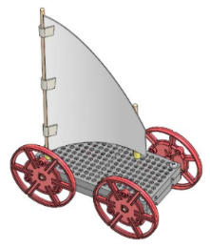
Utilizing the Engineering Design Process, students will design a sail for a car that will capture wind energy from a fan and make it travel as far as possible.

Objectives:

In this activity students will:
- Utilize the Engineering Design Process to design the sails for the car.
- Plan and create sails of different sizes and shapes and position of the mast(s) to capture the wind and make it travel as far as possible.
- Work as a collaborative team.
- Test and modify their product to improve their results.
- Discuss and share their results with other teams.
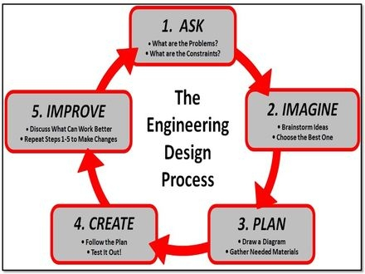

Materials List:
- Sail Car 10-pack, tools (multi-cutter & reamer) and TeacherGeek’s Sail Car Building Instructions Note to teachers: Teachers that participated in a pilot program using the sail cars recommended pre-building the cars in advance. The student design project would only include designing the sails. Pre-built cars can be reused.
- Sail materials (examples: paper, cardboard, fabric, aluminum foil, plastic)
- Scissors and tape
- 25-foot tape measure
- Fan (not provided)
Engage:
- Real world application. Show the video on Extreme Land Yachts and discuss with students: https://www.youtube.com/watch?v=oieUfXyYUBI
- Show students the body of car. Explain the sail car challenge.

Explain:
- Explain the Engineering Design Process using the Sail Car Student Worksheet.
- Place students in groups of two or three.
- Discuss possible shapes of sails that they have seen on boats, kites, sail cars in the video, etc.

Explore:
- Students complete Ask, Imagine, and Plan sections on worksheet.
- Sign off on student plans before they Create and follow their design plan.
- Predict how far car will travel.
- Test cars. Classroom Set-Up: An empty hallway (ideally without carpet) is a great place to test cars. Colored tape can be used to mark the car’s distance on the floor while students measure. Depending on how much room you have, be sure that the fan is on the same setting (high/medium/low) for every trial.

Elaborate:
- Improve your design. What worked? What could be done better?
- Modify design.
- Predict how far the car will travel with your redesign.
- Test car for Trial 2.

Evaluate:
- See Sail Car Rubric

