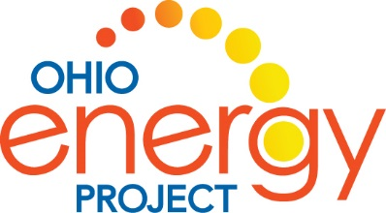
Solar Energy
Teacher Lesson Plan

Part 1: What is Solar Energy?
Background:
The sun is a powerful source of renewable energy. In fact, the sunlight that shines on the Earth in just one hour could meet world energy demand for a whole year. People have used the sun as a light and heat source for thousands of years. In the 1200’s the ancestors of the Pueblo’s built their cliff dwellings facing south to capture the heat of the sun.
Radiant (light) energy from the sun is a result of ongoing nuclear fusion. Solar radiation reaches the Earth at the speed of light. We use that power as an energy source.
Solar energy can be converted to electricity using a photovoltaic cell. These cells can be used in space to power satellites, in solar power plants, on your homes or even on calculators and toys.
The light from the sun is a wave of alternating electric and magnetic fields. Scientists call this a spectrum. Different parts of the spectrum can be used to accomplish many different things ranging from radio waves to medical x-rays.

Objectives:
In this unit students will understand:
- The sun is the source of most energy on Earth.
- This energy is variable depending on the location and the season.
- The sun’s energy can be transformed into other forms of energy including chemical energy in the process of photosynthesis.
- The sun’s energy is made of many different wavelengths of light including ultraviolet.
- Photovoltaic cells can convert solar energy into electrical energy which can do work for us.
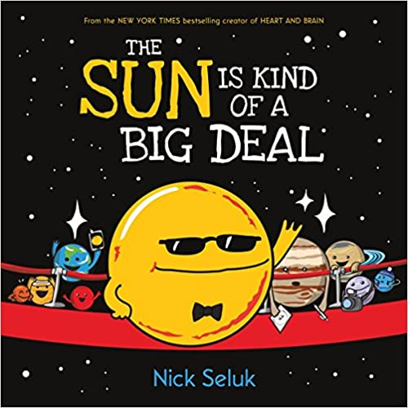
The Sun is Kind of a Big Deal by Nick Seluk

Key Vocabulary:
- Solar System-Consists of a star and all the other objects that travel around it. The Sun is the star in our solar system.
- Galaxy-A very large group of stars and planets. Our galaxy is called the Milky Way. Together, galaxies make up the universe.
- Orbit-The curved path followed by a moon, planet or satellite as it circles a planet or the Sun.
- Equator-The imaginary line around the middle of the Earth. It separates the top and bottom halves of the Earth. It is the part of the Earth closest to the sun.
- Evaporation-The process of changing a liquid into a gas. Heat from the sun causes water to mix with air turning it into water vapor.
- Condensation-The process changing a gas into its liquid form. Water vapor gathers together to make clouds.
- Precipitation-The falling of water from the sky in the form of rain, sleet, hail or snow.
- Photosynthesis-The process where a plant uses light from the Sun, water from the water cycle and carbon dioxide from the air to make food and energy to help it grow. Plants produce oxygen as a by-product of photosynthesis.

Introduction/Engage:
- Place a picture of the sun on a wall or draw on flip chart.
- Give each student a post-it note.
- Ask the students: What is one thing they know about the sun?
- Have them write it on their paper. Bring their note up and place it around the picture of the sun.
- As you listen to the book, listen for your answer.

Book Talk:
What would our world be like without the Sun? The answer: it wouldn’t exist! The sun keeps our solar system together, gives Earth day and night, keeps us warm and so much more. The sun never stops working to keep things on Earth running smoothly. In fact, out of all the planets, the Sun has earned Employee of the Year for 4.6 billion years, impressive, right?! The Sun deserves lots of attention for being our solar system’s very own star and having a very big job. Let’s read this book to learn more about the Sun and see why it’s kind of a big deal.

Read The Sun is Kind of a Big Deal:
- Before reading the book, pass out discussion questions to students. Have students pre-read the questions to get an idea of what they should be listening for while you read.
- While reading book, students answer discussion questions.
- Give time to complete questions after reading.
- Discuss answers to questions.
- Additional Ideas for Discussion Questions:
  - If the entire page of questions is too much for your students, consider breaking up the questions, assigning each student 1-2 questions to answer while you read.
  - When you are done reading have students find someone with the SAME question and meet to discuss their answers, looking for similarities and differences in their thinking
  - Likewise, you may choose to have students find someone with a DIFFERENT question and meet to share their answers.

Reinforcement/Assessment:
- Distribute a different color post-it note to each student.
- Students will write a new fact they learned about the sun.

Part 2: Exploring Solar Energy

Activity 1: Exploring with Ultraviolet (UV) Beads

Background:

There are many more forms of radiant (light) energy that we cannot see. In fact, most of the light in the universe is invisible to us. The electromagnetic spectrum is the term used by scientists to describe the entire range of light that exists. Light is a wave of alternating electric and magnetic fields.

Just like waves in the ocean, some waves are long and some are short. This makes them different. Light waves are also long and short. They have different amounts of energy. The only light waves that we can see are called visible light waves. Each color has its own wavelength with red being the longest and violet being the shortest. See the Electromagnetic Spectrum Handout.

Even though we do not see the other wavelengths of light energy, you have used them. Have you ever listened to a radio? Warmed hot chocolate in the microwave? Had to get an x-ray? If you had any of these experiences, then you have used different wavelengths of light energy.

Ultraviolet (UV) light is part of the electromagnetic spectrum from the sun, but invisible to our eyes. It can burn our skin and cause cancer. It can damage our eyes and destroy cells. Luckily, most UV is blocked by our Earth’s ozone layer and atmosphere, but some still gets through. Ultraviolet beads contain a pigment that changes color when exposed to ultraviolet light from the sun, or other UV sources. They are not affected by visible light and do not react to indoor light or when shielded from UV radiation. If sunlight is not available, a black light works well.

Objectives:
In this activity, students will understand:
- The energy from the sun is made of many different wavelengths of light, including ultraviolet.
- Ultraviolet light can damage living things.
- The Earth’s atmosphere blocks most ultraviolent waves, but some get through.
- We can use tools to detect ultraviolet waves and protect ourselves from their damage.

Materials:
For each student
- 3-5 UV (solar) beads
- 1 pipe cleaner or string
- UV Solar Bead Student Worksheet
For the class
- Materials to test blocking UV light: water, sunscreen (if possible, use two different SPF), orange pill bottles, sunglasses, ball cap, fabric, plastic, light with various types of bulbs (IL, CFL and LED) and your choice of testing materials
- Electromagnetic Spectrum Chart
- UV Light (black light flashlight or sunlight from window)

Engage:
Ask: Why do you wear sunscreen? Students discuss reasons.
Summarize the above background information with class.

Explain/Explore:
- Distribute materials.
- Explain that these beads contain a special chemical that changes color when exposed to ultraviolet (UV) light. Remember, most UV is blocked by our Earth’s ozone layer and atmosphere, but some still gets through. These beads will only turn bright colors when exposed to UV from the sun or from a UV or “black” light. The darker the color of the bead, the more UV rays they are detecting. When you bring the beads back inside, they will return to white again.
- You will explore different materials to test how well they block UV waves.
- Complete student worksheet.

Elaborate:
- Discuss with students how UV light can damage living things.
- After the experiment, discuss what materials were most effective at blocking UV light.
- Discuss, do you need the same precautions for themselves in the morning as mid-day? Is the risk the same for all the seasons?

Evaluate:
- Students will write a paragraph in which they will describe an outfit they might wear to a noon baseball game and what other precautions they can take to protect themselves from UV light damage.

This lesson was adapted from Experimenting with UV beads, a lesson supported by NASA and the Stanford Solar Center. It was written by Deborah Scherrer.

Activity 2: Exploring with Solar Toys

Background:
The Sun is a star that is a giant ball of gas. It sends out huge amounts of energy every day. Most of this energy goes out into space. Only a small amount reaches the Earth, but this amount is large enough to provide energy for many things. We have already considered how the Sun provides the Earth with light and thermal (heat) energy and powers photosynthesis allowing plants to grow.

Solar energy can also generate electricity. Solar energy is free and clean, and it will never run out. That makes it a renewable energy source. If energy from the Sun is so abundant, why don’t we use it for all our energy needs? The hard part is capturing the sunlight so it can be transformed into electricity.

A solar panel (or photovoltaic cell) can turn solar energy into electricity. It captures the Sun’s light energy and transforms it into electricity that we can use in our homes and schools. Electricity generated by solar energy is clean. That means it does not cause air pollution or contribute to climate change. One of the biggest challenges in generating electricity with solar energy is that it is difficult to store generated electricity. Batteries are available for individual homes, but they are costly. Utility scale batteries storing electricity for a neighborhood or city are not yet available. (This would be a great problem for your 3rd grade scientists to explore when they are grown-ups!) Because of the difficulty in storing electricity, solar energy is not considered to be reliable because we cannot use it at night or on cloudy days.

Objectives:
In this activity, students will understand:
- Energy from the Sun can be used to generate electricity.
- Solar energy is renewable and does not cause air pollution or climate change.
- Electricity from solar energy is not reliable because the Sun is not always shining.

Materials:
- Solar toys
- 100-watt incandescent light bulb or a sunny day
- 8”x11” piece of cardboard to other shielding material
- Cardboard box with one side cut away (only needed if doing the experiment outside)
- Solar Toy Exploration Student Worksheet

Engage:
Ask: How can we use energy from the Sun? Students discuss.
Summarize the above background information with class.

Explain/Explore:
- Distribute materials and determine if you will be experimenting outdoors with the sun or indoors with a light bulb.
- Before turning on the light or going outside, allow students to examine the solar panel on the toy. What observations can they make?
- Turn on the light or set the toy in the sun. What do students observe?
- Now, turn off the light or put the box over the solar toy? What do students observe? The toy will immediately stop. This is what happens at night. Because the sun is not shining, no electricity is produced.
- Turn the light back on or remove the box. Use the cardboard piece to slowly cast a shadow over the solar panel. What do students observe? The toy will begin to slow down as the cardboard’s shadow covers the panel until it stops. This is like what would happen with a cloud or leaves from a tree. That is why solar panels should never be mounted in places where a shadow (like leaves from a tree) could cover them.
Elaborate:
- If you are using a lamp, experiment with different angles. Is the movement of the toy impacted by the angle of the sun? Compare a 45-degree angle vs. a 90-degree angle over the top of the toy.
- After the experiment, ask students where they have seen solar panels around their community.

Evaluate:
Have students complete the paragraph at the bottom of the student worksheet using the word bank.

