Name: ________________________________________

How Does the Greenhouse Effect Work?
One of the reasons that Earth is the perfect planet for us is because of its atmosphere. It is the perfect mixture of nitrogen, oxygen, water vapor, carbon dioxide and other gases. The atmosphere acts like a blanket to allow radiant energy to light and warm the Earth but also allows some heat to escape into space.
A greenhouse acts in the same way. It allows light and heat in through the glass to help plants grow. At night, the heat slowly escapes.
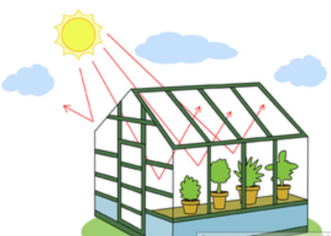
Let’s do an activity to see how this works.
Materials:
2 thermometers 2 plastic cups
Plastic wrap 2 cups of soil
Rubber band or tape
Procedure:
- Fill each cup with 1 cup of soil. You want to have the same amount of soil in each cup.
- Place the thermometer in each cup one inch deep into the soil. You can lean it against the side of the cup.
- Cover one cup with plastic wrap. Secure with a rubber band or tape.
- Take a starting temperature and record it on the chart.
- Place the cups next to each other in the sun.
- Record the temperature every 15 minutes for one hour.
- Calculate the temperature change.
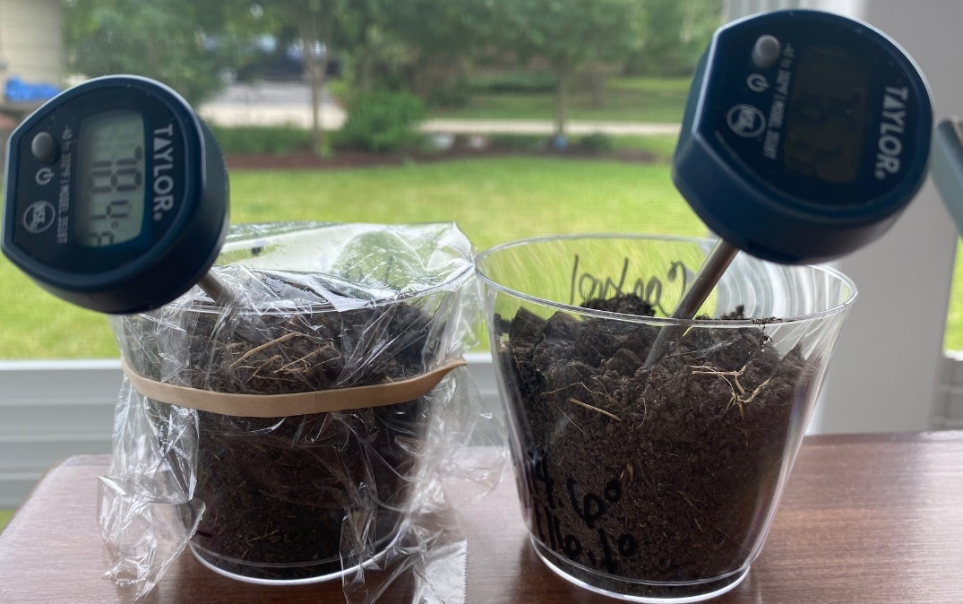

Time | Covered | Uncovered
Starting Temperature

15 minutes

30 minutes

45 minutes

Final Temperature
60 minutes

 | Covered | Uncovered
Final Temperature

Starting Temperature

Change in Temperature
(Final-Start = Change)

Answer the following questions.
2. Explain why do you think this happened?
_____________________________________________________________________________
_____________________________________________________________________________

______________________
- Compare the temperature at the beginning of the experiment and after 60 minutes.
____________________________________________________________________________________
_____________________________________________________________________________

3. Explain how the plastic wrap acts like the atmosphere of the Earth?
_____________________________________________________________________________________
_____________________________________________________________________________________

4. Predict what would happen if you did this experiment again with two pieces of plastic wrap?
______________________________________________________________________________
______________________________________________________________________________

