Name: _____________________________________

KidWind Design Challenge Student Datasheet

Team Name: Turbine Name:
______________________________________ __________________________________________

Turbine Blade Measurements:
Describe your blade design: _____________________________________________________________
Draw your blade shape

Explain why you chose this shape: ________________________________________________________
____________________________________________________________________________________

Blade Measurements (in centimeters):
Length  Note: Use blade length as the radius in calculations below | Width at Top | Width at Bottom
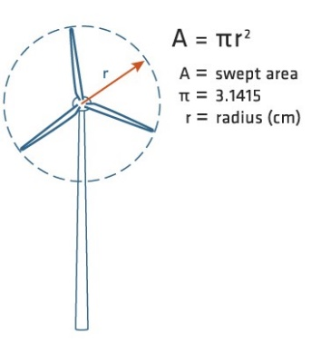
Number of Blades
Blade Pitch
Material(s) Used
Average Mass of Blades

Vocabulary:
Define Voltage: _____________________________________________________________________________________
Explain voltage in terms of your turbine: _________________________________________________________________
__________________________________________________________________________________________________

Define Current: ___________________________________________________________________________________
Explain current in terms of your turbine: _________________________________________________________________
__________________________________________________________________________________________________

Turbine Performance:
Trial #1
Wind Speed (meters per second)  If an anemometer is not available, use the wind speed estimator sheet | m/s
Turbine Rotor Swept Area (centimeters squared)  Calculate using the formula Area=πr² | cm²
Resistor Value (ohms)  Note: If using resistor in KidWind kit, the value is 30 ohms | Ω
Turbine Voltage (millivolts)  Reading from multimeter-the multimeter unit is millivolts (1V=1000mV) | mV
Turbine Current (amperes/amps)  Reading from multimeter-the multimeter unit is milliamperes (1A-1000mA) | mA
Turbine Power (milliwatts)  Calculate using the formula Power=voltage X current | mW
Turbine Efficiency Percentage  This field will autocalculate on the KidWind site | %

Trial #2
Describe the modifications made on your wind turbine.
_____________________________________________________________________________________________
_____________________________________________________________________________________________
_____________________________________________________________________________________________

Wind Speed (meters per second)  If an anemometer is not available, use the wind speed estimator sheet | m/s
Turbine Rotor Swept Area (centimeters squared)  Calculate using the formula Area=πr² | cm²
Resistor Value (ohms)  Note: If using resistor in KidWind kit, the value is 30 ohms | Ω
Turbine Voltage (millivolts)  Reading from multimeter-the multimeter unit is millivolts (1V=1000mV) | mV
Turbine Current (amperes/amps)  Reading from multimeter-the multimeter unit is milliamperes (1A-1000mA) | mA
Turbine Power (milliwatts)  Calculate using the formula Power=voltage X current | mW
Turbine Efficiency Percentage  This field will autocalculate on the KidWind site | %

Trial #3
Describe the modifications made on your wind turbine.
_____________________________________________________________________________________________
_____________________________________________________________________________________________
_____________________________________________________________________________________________

Wind Speed (meters per second)  If an anemometer is not available, use the wind speed estimator sheet | m/s
Turbine Rotor Swept Area (centimeters squared)  Calculate using the formula Area=πr² | cm²
Resistor Value (ohms)  Note: If using resistor in KidWind kit, the value is 30 ohms | Ω
Turbine Voltage (millivolts)  Reading from multimeter-the multimeter unit is millivolts (1V=1000mV) | mV
Turbine Current (amperes/amps)  Reading from multimeter-the multimeter unit is milliamperes (1A-1000mA) | mA
Turbine Power (milliwatts)  Calculate using the formula Power=voltage X current | mW
Turbine Efficiency Percentage  This field will autocalculate on the KidWind site | %

