Name: _____________________________________

MacGyver Wind Lift Design Challenge
Student Datasheet
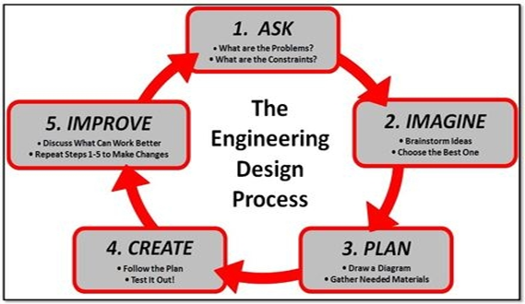
In this project, you will be an engineer. Engineers solve problems. They have a process that helps them do their work. This is their process.

Your challenge is to design a hand-held MacGyver Wind Lift that will capture wind from a fan to lift a cup of pennies.
Why is it called a MacGyver Wind Lift? MacGyver is a fictional TV character with an extraordinary knack for unconventional problem solving and an extensive bank of scientific knowledge. He would improvise to solve a problem with whatever items he might have in his pockets. Today it means to make or repair something "in an improvised or inventive way, making use of whatever items are at hand.” That is what you will be doing, designing a wind turbine to lift as many pennies as possible using materials from your classroom, home or recycling container.

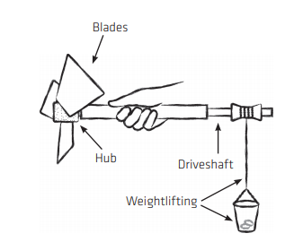
Materials:
Hub:
Pool noodle
Blades:
Bamboo sticks and material of your choice for blades
Driveshaft:
Dowel rod and plastic smoothie Straw
Lift:
String, cup, and wooden spool, Pennies for lift weight

ASK:
- What is the problem?

__________________________________________________________________________
- What are you trying to do? _________________________________________________________________________________________________________________________________________________________________________________________________________________________________
IMAGINE:
Brainstorm ideas for your wind turbine and blades. Think about the blades shape, size, length, number and pitch(angle of blades).
Number of blades:______________________________________________________________
Shape of blades:________________________________________________________________

Why are you considering this shape?_______________________________________________

_____________________________________________________________________________

_____________________________________________________________________________
Size and length of blades (small, long, etc.): ___________________________
Draw your blade design in the box.
Why?________________________
____________________________

Pitch/angle of blades:______________

What material(s) will you use to build your blades:______________________
________________________________

Hypothesis: How many pennies do you think your turbine will lift?____________________________

CREATE:
Follow your plan to create your wind turbine. Test it out and record your results below.
To find the power of your wind machine, there are a few steps. The units are probably not familiar, but your teacher will help. Force is calculated by the number of pennies your device lifted. You will need the chart from your teacher to enter the force.
Trial | # of pennies | Force  (newtons)  copied from chart | X | Length of string  (meters) | = | Work  (joules) | ÷ | Time  (seconds) | = | Power  (watts)
Sample | 16 | .4 | X | .5 | = | .2 | ÷ | 8 | = | .025
Design #1 |  |  | X | .5 | = |  | ÷ |  | =

IMPROVE: Answer the questions below to reflect on your design process
- What part of your turbine worked best in your first round of testing and why?
________________________________________________________________________________________________________________________________________________________________________________________________________________________
- What was the most difficult part of the design process?
________________________________________________________________________________________________________________________________________________________________________________________________________________________
- Where was there anything rubbing against your blades? Could you fix this? ________________________________________________________________________________________________________________________________________________
- How did you pitch or angle the blades?
________________________________________________________________________________________________________________________________________________
Testing Round 2:
Modify your design to improve it. Draw your NEW ideas in the box.
Label the changes you made to your design
Now test your new design and record results below:
Trial | # of pennies | Force  (newtons)  Copied from chart | X | Length of string  (meters) | = | Work  (joules) | ÷ | Time  (seconds) | = | Power  (watts)
Design #2 |  |  | X | .5 | = |  | ÷ |  | =

Testing Round 3:
Modify your design to improve it AGAIN. Draw your NEW ideas in the box.
Label the changes you made to your design

Test your last design and record results below:
Trial | # of pennies | Force  (newtons)  Copied from chart | X | Length of string  (meters) | = | Work  (joules) | ÷ | Time  (seconds) | = | Power  (watts)
Design #3 |  |  | X | .5 | = |  | ÷ |  | =

Results:
Power for Design #1
Power for Design #2
Power for Design #3

Out of your three designs, which had the most power and why?
_______________________________________________________________________________________________________________________________________________________________________________________________________________________________________

CONCLUSION
- Explain which design had the best results. Why do you think this design worked the best? _________________________________________________________________________________________________________________________________________________________________________________________________________________________________
- If you had to do it all over again, describe how you would change your design? Why? _________________________________________________________________________________________________________________________________________________________________________________________________________________________________
- How many blades worked the best for lifting weight? Did more blades mean you could lift more weight?
_________________________________________________________________________________________________________________________________________________________________________________________________________________________________
- Was the best pitch closer to 0, 50 or 90 degrees? ______________________________________________________________________________________________________________________________________________________
- Describe a challenge you faced in the engineering process. How did you problem solve to reach a solution?

____________________________________________________________________________________________________________________________________________________________________________________________________________________________________________________________________________________________________________

