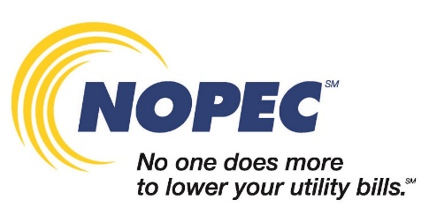
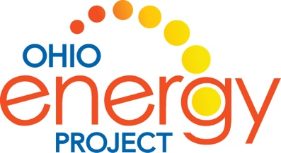

For Immediate Release: Contact: Mary Ripley
January 19, 2021 Assistant Marketing Director
NOPEC
440-249-6119
mripley@nopec.org

Sue Tenney
Ohio Energy Project
614-785-1717
stenney@ohioenergy.org

NOPEC Sponsors Ohio Energy Project STEM Design Challenge
at 4 Summit County Schools

Ohio Energy Project (OEP), in partnership with NOPEC, is helping energize in-person and virtual classrooms this school year with STEM (Science, Technology, Engineering, Math) Design Challenges meant to spark curiosity about energy and promote creative problem solving and critical thinking. These challenges, which require students to experiment with various materials, not only teach students about wind energy but also get students thinking about where energy comes from and how to use energy more efficiently. Designs will then be submitted for judging and prizes will be awarded for the best designs.

Fifteen hundred students from a total of 25 Ohio schools will be participating in the program which, thanks to NOPEC’s sponsorship, is being offered at no-cost to participating schools in NOPEC member communities. Students in grades 7 – 12 will be tasked with designing and engineering unique wind turbine blades and then test their design to see how much energy they create and how efficient their blades are at creating energy. Students in grades 3 – 6 will participate in the MacGyver Windmill Lift project that challenges students to build, test, and improve upon a windmill, and use that energy to lift weights and calculate force.

Participating Summit County schools include Dewitt Elementary School, Manchester Middle School, Seton Catholic School, and Silver Lake Elementary School.

NOPEC has been partnering with OEP for 6 years on energy education for students and teachers in Ohio. “As a non-profit energy aggregation for 240 Ohio communities, a core component of NOPEC’s mission is to give back to our member communities. Providing Ohio students with the tools and resources to learn about energy generation and the importance of energy efficiency is one way that NOPEC is helping to educate tomorrow’s energy decision makers,” said NOPEC’s Executive Director Chuck Keiper.

As a nonprofit organization, OEP aims to inspire leadership and energy innovation in Ohio students and teachers. Their programs have been empowering classrooms since 1984 and continue to spark curiosity in budding young scientists.

For more information about the STEM Design Challenges and a full list of participating schools, visit nopec.org/education.

About NOPEC: NOPEC is a non-profit group of 240 communities that negotiates lower utility rates. As Ohio’s largest governmental energy aggregator, NOPEC buys gas and electricity in bulk to help lower your utility bills. Since 2001, NOPEC has saved Ohio consumers hundreds of millions of dollars on their energy costs.

For more information about NOPEC, visit us at nopec.org.

