Name: ________________________________ Class: ____________

Earth Day Challenge: Home Light Bulb Audit
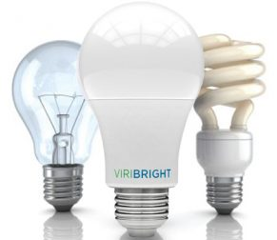
Your mission, should you choose to accept it, is to count the number of light bulbs in your home and calculate the savings if you switched to energy efficient lighting.

Record the number of light bulbs of each type in your home. Don’t forget closets, the basement and the garage.

Most Energy Efficient Lighting

Number LED Bulbs: _____________ Number Fluorescent (CFL or tube): ___________
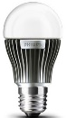
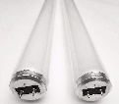
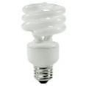

Less Energy Efficient Lighting

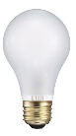
Number Incandescent Bulbs: _______ Other Light Bulbs: __________________

Potential Cost Savings by Installing Energy Efficient Lighting

x
=

Potential Lifecycle Cost Savings by installing efficient lighting
Number of less efficient bulbs that could be replaced in your home
(from numbers above)
Lifecycle cost saving for replacing 1 less efficiency bulb
(from reverse side)
Calculate the Savings of LED Light Bulbs
