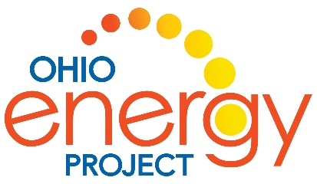
You Wouldn’t Want to Live Without Electricity
By: Ian Graham

Activity: History of Electricity

People have known about electricity for thousands of years, however, it has only been in use for about 200 years. During this time, people have learned to make it, control it, store it, transport it and use it for many different things. Heating, lighting, communication, travel, entertainment and education depend on electricity.
As you read this book, you will learn about some scientists and discoveries that have helped shape our lives. Working with a partner, you will research the person, discovery or event that is covered in the book. You will complete the information square and place it the proper location on the timeline.

Person/Discovery/Event | Date
Static Electricity | Ancient Greece – about 500 BC
James Watt | 1776
Benjamin Franklin | 1762
Michael Faraday | 1821
Hippolyte Pixii | 1832
Thomas Edison | 1877
First Earth Day | 1970
First public power station was built | 1882
Alessandro Volta | 1800
Leyden Jar | 1745
Hans Christian Oersted | 1820
Andre-Marie Ampere | 1827
J.J. Thomson | 1897
James Clerk Maxwell | 1865
Industrial Revolution (connection to electricity) | 1760 to 1840
First photovoltaic cell (solar panel) | 1954

NOTE: Dates of discoveries are approximate. It took years of research for discoveries and tools to be invented. Some dates are dates of published papers.

- Circle your person, discovery or event in the list above.
- Using the book, You Wouldn’t Want to Live without Electricity!, research to complete your information card. You can also use one other reference to find information beyond what is given in the book.
- Cut out your card and place it in the correct place (year) on the class timeline.
- Be prepared to discuss your findings with the class.

Person, Discovery or Event

When:

Where:

What:

How:

Interesting Fact:

Current Event:
(optional)
Partner Names:

When complete, cut out the chart and place on the classroom timeline.

Chart Contents:
Person, Discovery or Event: Write from the list on the front
When: Date or Date Range of person, discovery or event
Where: City and/or Country
What: Significance of the person, discovery or event specifically related to the discovery or use of electricity
How: What did the person, discovery or event do to advance the use of electricity?
Interesting Fact: What is fascinating to you and your partner about your person, discovery or event?
Current Event: What else is happening in the world at the time of your person, discovery or event? For example, maybe your person lived during World War 2 or list the US President when your event occurred.
Partner Names: List the partners in your group.

