Name: ________________________________________________
Life Cycle of a Snowman
Write and draw about what happens to the snowman during his lifetime.
First
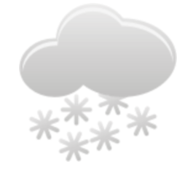

He was a (solid / liquid / gas).

Then

He was a (solid / liquid / gas).

Finally

He was a (solid / liquid / gas).

