Name: ________________________________________________

States of Matter-Wall Graphic Student Worksheet

 | New State of Matter  Solid-Liquid-Gas | Process  Melt-Freeze-Condense-Evaporate
Solid + Energy (heat) =
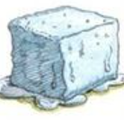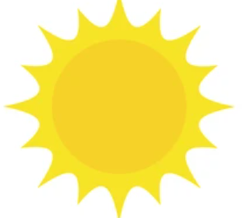
Liquid + Energy (heat) = 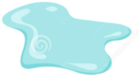
Liquid - Energy (Heat) =
Gas - Energy (Heat) =
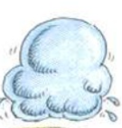

Fill in the Blanks. Tell what is happening using one of these words.
Condenses Melts Evaporates

- When you heat butter, it _________________________________.
- When water vapor in a cloud cools, it __________________________________.
- When a mud puddle disappears outside, the water _____________________________.

Fill in the blanks with the correct state of matter.
Solid Liquid Gas

- The two states of matter that have a definite volume are: ___________________ and __________________.
- The two states of matter that can flow are: _______________________ and ________________________.

Circle whether the object is heated or cooled to make the second object.

Flowing Lava | Heated or Cooled | Rock
Ice | Heated or Cooled | Water
Clouds | Heated or Cooled | Rain / Water
Water | Heated or Cooled | Steam

