Name: _____________________________________

MacGyver Wind Lift Design Challenge
Elementary Student Datasheet
Engineering Process Steps

ASK:
How can we design a MacGyver Wind Lift that will capture the wind from a fan to lift a cup of pennies?

IMAGINE:
With your group, brainstorm a list of variables (things that can be changed) for your blade design. Record all your ideas below.
Number of Blades: ____________________________________________________________________
Blade Shape: _________________________________________________________________________

Blade Length: ________________________________________________________________________
Blade Material(s): _____________________________________________________________________
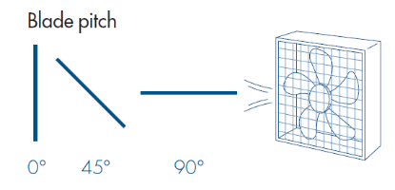
Blade Pitch/Angle: _________________________________

Draw your blade design | Blade Design #1 Specs  Number: _____________________  Shape: _______________________  Length: _______________________  Material: _____________________  Pitch/Angle: __________________  Number of Pennies Lifted: _______
CREATE:
Follow your plan to build your wind turbine.

TEST:
Test wind lift and record your results on the chart.

REDESIGN:
As a group, discuss possible changes you could make to your wind lift to increase the number of pennies it lifts. Record your new ideas on the chart.

Draw your blade design | Blade Design #2 Specs  Number: _____________________  Shape: _______________________  Length: _______________________  Material: _____________________  Pitch/Angle: __________________  Number of Pennies Lifted: _______

FINAL RESULTS:
Test | Number of Pennies Lifted
Design #1
Design #2

CONCLUSION
Use your results and class results when answering these questions.
- Explain which design had the best results. Why do you think this design worked the best?

The best design was _________________________________________________________.

This worked best because _____________________________________________________

__________________________________________________________________________.

- If you had to do it all over again, describe how you would change your design? Why?

I would change my design by ___________________________________________________

__________________________________________________________________________.

- How many blades worked the best for lifting weight? _______________ blades

Did more blades mean you could lift more weight? ________________________________

___________________________________________________________________________

- Pitch is ____________________________________________________________________.

Did flat or angled blades catch more wind? Circle one: Flat Angled

- Describe a challenge you faced in the engineering process. How did you problem solve to reach a solution?

A challenge I faced in the process was ___________________________________________
__________________________________________________________________________.
I solved the problem by _______________________________________________________
__________________________________________________________________________.

