**Snappy Circuits** 

**Student Worksheet**

Name:________________________________________________

|  |  |  |  |
| --- | --- | --- | --- |
| **Part** | **I notice…** | **I wonder…** | **I learned…** |
| Battery |  |  |  |
| LED |  |  |  |
| Buzzer |  |  |  |
| Alligator Clips |  |  |  |

Something I hope to learn by building scrappy circuits is________________________________________

_____________________________________________________________________________________

____________________________________________________________________________________.

*Turn and Talk-Share what you hope to learn with the other members of your group. Listen to what they want to learn.*

**Project 1: LED Light and Battery**

Directions: Build a circuit with one LED light and one battery.

1. When the circuit is open, the light is ______________________ (on or off).

2. In which picture should the light be on? (A or B)________ 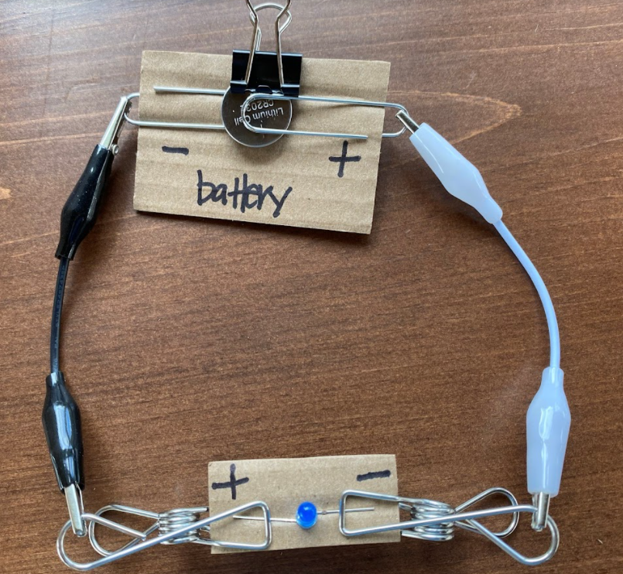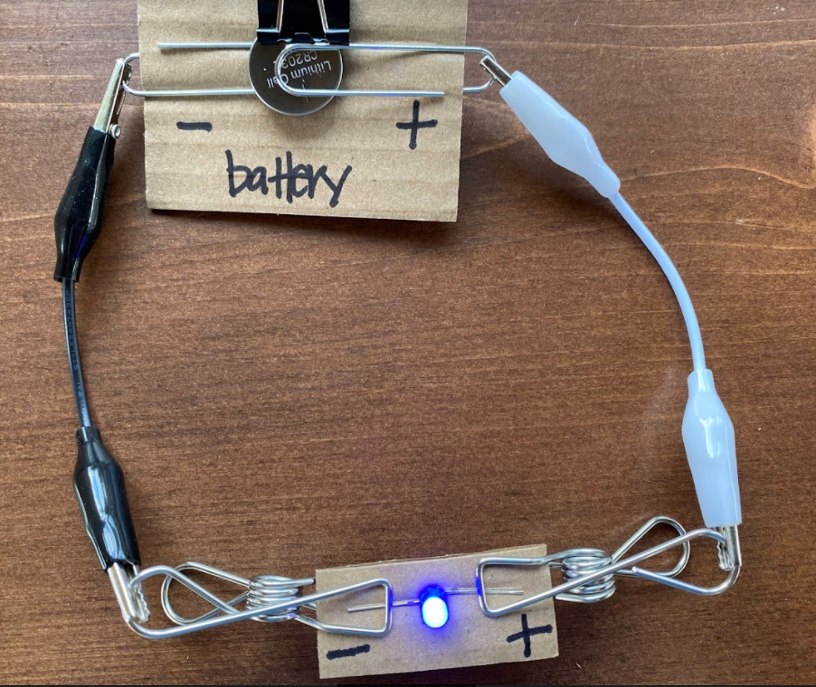

1. B.



Why?_____________________________________________________________________________

____________________________________________________________________________

**Project 2: LED Light, Battery and Switch**

Directions: Build a circuit with an LED light, battery and switch.

1. If the switch is open, the light is ______________ (on or off)
2. What happens if you switch the direction of the LED light?

______________________________________________________________________

**Project 3: Buzzer and Battery**

Directions: Build a circuit with a buzzer and battery.

1. What happens to the light if the red wire from the buzzer is connected to the positive end of the battery? (on or off) _____________________
2. What happens to the light if the red wire from the buzzer is connected to the negative end of the battery? (on or off) ___________________
3. What charge is the red wire? (positive or negative) _____________________________

**Project 4: Buzzer, Battery and Switch**

Directions: Build a circuit with a buzzer, battery and switch.

1. If the switch is closed, the buzzer is ______________ (on or off)
2. The diagram below is known to engineers as a ***schematic***. These special diagrams use symbols to show how electricity flows through a circuit. The “X” represents a light, and the two circles with the line show a switch. Look at the schematic below. Which circuit will turn the light on? (A or B)

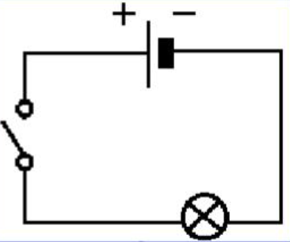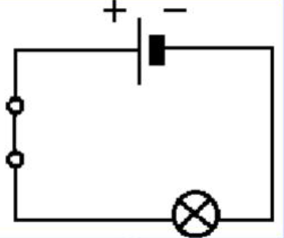

A. B.

1. How could you make the buzzer louder? Explain:

______________________________________________________________________________

______________________________________________________________________________

**Project 5: Series Circuits**

Directions: Build a circuit with an LED light, buzzer and batteries.

1. Draw a diagram of your circuit once everything is working. Label the light, buzzer, battery, and positive and negative charges.
2. Describe how the electrons are flowing through the circuit:

__________________________________________________________________________________________________________________________________________________________________________________________________________________________________________

**Project 6: Parallel Circuits**

Directions: Build a parallel circuit. It must include at least one battery and two LED lights.

1. Draw a picture of your parallel circuit once it is working. Label each part.
2. How many paths are there for electrons to flow?________________________________

**Optional Extension: Scrappy Clips**

1. You were given alligator clips to connect your bricks into circuits. Why do you think alligator clips were used?

______________________________________________________________________________

______________________________________________________________________________

1. Imagine alligator clips were not available. What is another material you could use to connect your bricks? If time allows, test your idea. Did it work?

______________________________________________________________________________

______________________________________________________________________________